MATeF-2 EM Test Report

*Qualification Testing*

Table of contents

1 Engineering Model 3

2 Integration Test 4

2.1 Test results 5

3 Thermal Chamber Test 6

3.1 Thermal tests: 6

3.2 Test results 7

4 Accepted System for Flight Model 8

4.1 OBC 8

4.2 COM (UHF) 8

4.3 APRS 8

4.4 GPS 8

4.5 EPS 8

# Engineering Model

For the qualification testing the MATeF-2 Engineering Model (EM) was used. For Integration Tests the EM was assembled in breadboard/test board configuration:

* Sub-modules were connected by ribbon cable
* Bus analyzer was added
* Bypass module was added for current measurement

EM components have the same HW configuration as in the planned Flight Model (FM), but have lower requirements on manufacturing.

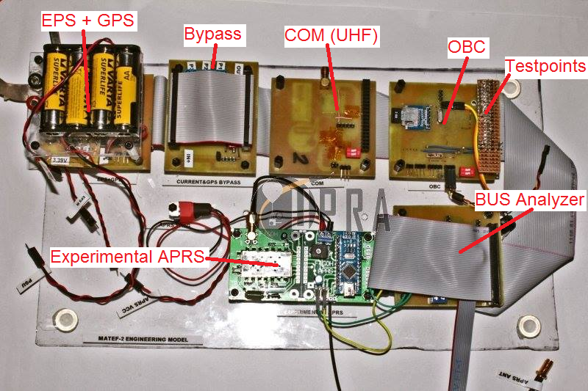

Engineering Mode in Breadboard/Test board configuration

# Integration Test

Integration Test was run at room temperature, the EM was powered by bench PSU. Operational tests and parameter measurements were conducted during the test.

## Test results

|  |  |  |  |
| --- | --- | --- | --- |
| **Test Suite** | **Test Case** | **Result** | **Notes** |
| Preconditions | matef-85:Inegrated Tests | Passed |  |
| OBC.mega328 | matef-1:Startup | Passed |  |
| OBC.mega328 | matef-3:Outgoing Telemetry | Passed |  |
| OBC.mega328 | matef-4:Outgoing COM-housekeeping request | Passed |  |
| OBC.mega328 | matef-5:Incoming COM-housekeeping | Passed |  |
| OBC.mega328 | matef-89:Current Consumption | Passed | SD CARD current consumption is ~30mA by datasheet |
| OBC.mega328 | matef-90:Voltage Drop | Passed |  |
| OBC.mega328 | matef-6:Timing | Passed |  |
| COM.RFxxx | matef-9:Startup | Passed |  |
| COM.RFxxx | matef-10:Incoming Telemetry message | Passed |  |
| COM.RFxxx | matef-88:Current Consumption | Passed |  |
| COM.RFxxx | matef-15:Voltage Drop | Passed |  |
| Integrated Flight System/Flight Operations | matef-30:Telemetry - Valid GPS | Passed |  |
| Integrated Flight System/Flight Operations | matef-32:House keeping | Passed |  |
| Integrated Flight System/Flight Operations | matef-33:Environmental Data | Passed |  |
| Integrated Flight System/Flight Operations | matef-34:Radio Downlink | Passed |  |
| Integrated Flight System/Flight Operations | matef-39:Complete Flight - over 18K - no limit | Passed | 'quick log' was used |
| Integrated Flight System/Flight Operations | matef-82:Telemetry - No GPS Connection | Passed |  |
| Integrated Flight System/Flight Operations | matef-91:Current Consumption After EPS | Passed | proper 500 ohm APRS antenna |
| Integrated Flight System/Flight Operations | matef-92:Current Consumption Before EPS | Passed | proper 50 ohm APRS antenna |
| Integrated Flight System/Flight Operations | matef-93:BEACON mode | Passed |  |

# Thermal Chamber Test

Thermal tests were conducted at 28°C – (-16)°C temperature. The flight system were running on internal power, GPS signal was provided by GPS Signal-simulator.

## Thermal tests:

**COOL DOWN test**

1. Start system at room temperature
2. Start thermal chamber (TC)
3. Decrease temperature to the designated value while the system is running

**SYSTEM COLD OUT test**

1. Stop the system
2. Leave at the designated tepmerature for at least 30mins while not running

**COLD START test**

1. Start the previously cooled down system
2. Decrease the temperature to the designated value
3. Leave the system running for at least 30mins

**WARM UP test**

1. Stop the TC and open the door
2. Increase the temperature to room temperature while the system is running

## Test results

|  |  |  |  |
| --- | --- | --- | --- |
| **Test Suite** | **Test Case** | **Result** | **Notes** |
| OBC.mega328 | matef-1:Startup | Passed |  |
| OBC.mega328 | matef-3:Outgoing Telemetry | Passed |  |
| OBC.mega328 | matef-3:Outgoing Telemetry | Passed | Altitude Variable overflow over 33000m  Not Thermal related! |
| OBC.mega328 | matef-4:Outgoing COM-housekeeping request | Passed |  |
| OBC.mega328 | matef-5:Incoming COM-housekeeping | Passed |  |
| OBC.mega328 | matef-22:Internal Temperature | Passed |  |
| OBC.mega328 | matef-6:Timing | Passed |  |
| COM.RFxxx | matef-9:Startup | Passed |  |
| COM.RFxxx | matef-10:Incoming Telemetry message | Passed |  |
| COM.RFxxx | matef-11:Incoming Housekeeping request | Passed |  |
| COM.RFxxx | matef-23:Internal Temperature | Passed |  |
| OBC.mega328 | matef-24:External Temperature | Passed |  |
| Main GPS | matef-26:Below 18K | Passed |  |
| Main GPS | matef-27:Over 18K | Passed |  |
| Integrated Flight System/Flight Operations | matef-30:Telemetry - Valid GPS | Passed |  |
| Integrated Flight System/Flight Operations | matef-32:House keeping | Passed |  |
| Integrated Flight System/Flight Operations | matef-33:Environmental Data | Passed |  |
| Integrated Flight System/Flight Operations | matef-34:Radio Downlink | Passed |  |
| Integrated Flight System/Flight Operations | matef-82:Telemetry - No GPS Connection | Passed |  |
| Integrated Flight System/Flight Operations | matef-93:BEACON mode | Passed |  |
| Preconditions | matef-85:Inegrated Tests | Passed |  |
| Preconditions | matef-86:UPRA Thermal | Passed |  |
| Thermal | matef-94:Low Temperature Operation | Passed |  |
| Thermal | matef-95:COOL DOWN test | Passed |  |
| Thermal | matef-96:SYSTEM COLD OUT test | Passed |  |
| Thermal | matef-97:COLD START test | Passed |  |
| Thermal | matef-98:WARM UP test | Passed |  |

# Accepted System for Flight Model

## OBC

* **HW:** OBC.mega328
* **Bootloader:** Arduino/Genuino uno18v (1.8V brownout)
* **Firmware:** 2018_01_10_2129

## COM (UHF)

* **HW:** COM.rf69HCW
* **Bootloader:** ATmega328 on a breadboard (8 MHz internal clock, 1.8 V BrownOut)
* **Firmware:** 2017_11_28_2308
* **Callsign:** TBD

## APRS

* **HW**: DARPS (Experimental APRS Module)
* **Bootloader:** Arduino nano
* **Firmware:** DARPS default
* **Callsign:** HA3PL

## GPS

* **HW:** uBlox NEO 6M
* **Operation Mode:** Airborne 1

## EPS

* **HW:** EPS Proto V2
* **Interface PCB:** PDU V3