| Software design |
| --- |
| Work Management Stable |
| Version 2.0 |
| Prepared by class SE1432, Group 6  Nguyen Dac Dung  Dam Huy Nam Anh  Dao Minh nguyet  Nguyen Huu Dai  Vu Hoang Minh Quan  Nov 11, 2023 |

# 

# 

# 

# 

# 

# 

# 

# Content Table

**1.Document description** **2**

**2.SRS overview** **2**

2.1. List of system users 2

2.2. List of use cases 2

2.3. Use case diagram 3

2.3.1. Preliminary use case diagram 3

2.3.2. Use case detail diagrams 3

2.3.2.1. Use case “Apply jobs (apply by CV)” 3

2.3.2.2. Use case “Manage user’s details (information, CV)” 4

2.3.2.3. Use case “List company, List job” 4

2.3.2.4. Use case “Manage post of hiring employee” 5

2.3.2.5. Use case “Register/Login for users” 5

2.4. Activity diagrams for use case “Apply Jobs” 8

**3.Data model** **9**

3.1. Entity Relationship Diagram 9

3.2. Table details/Chi tiết các bảng 10

3.2.1. Table name: Accounts 10

3.2.2. Table name: CVFiles 10

3.2.3. Table name: Posts 11

3.2.4. Table name: Companies 12

3.2.5. Table name: AppliedUser 12

**4. Class diagram** **13**

4.1. List of classes in the Layers 13

4.2. Modeling the Class Behaviors - sequence diagrams for use case “Apply Jobs” 14

# 

# 1.Document description

This document describes OO solution version 1.0 for the Library system. It is divided into the following sections:

* In section 2 an overview of the Work Management’s requirements will be provided, including a list of system users, use cases, use case diagrams, and activity diagrams that describe the most important use case scenarios.
* In section 3 an E-R diagram and all tables of the Work Management in detail will be presented.
* In section 4 all classes organized in the layers and their behaviors (sequence diagrams) for the most important use cases will be presented.
* In section 5 the most screen prototypes will be presented.

# 2.SRS overview

## 2.1. List of system users

1. Recruiter: The person is working in company who want to hire Applicant

2. Applicant: The person want to find the job

## 2.2. List of use cases

1. Apply jobs (apply by CV)

2. Manage user’s details (information, CV)

3. List company, list job

4. Manage post of hiring employee

5. Register/Login for users

## 2.3. Use case diagram

### 2.3.1. Preliminary use case diagram

### 02.3.2. Use case detail diagrams

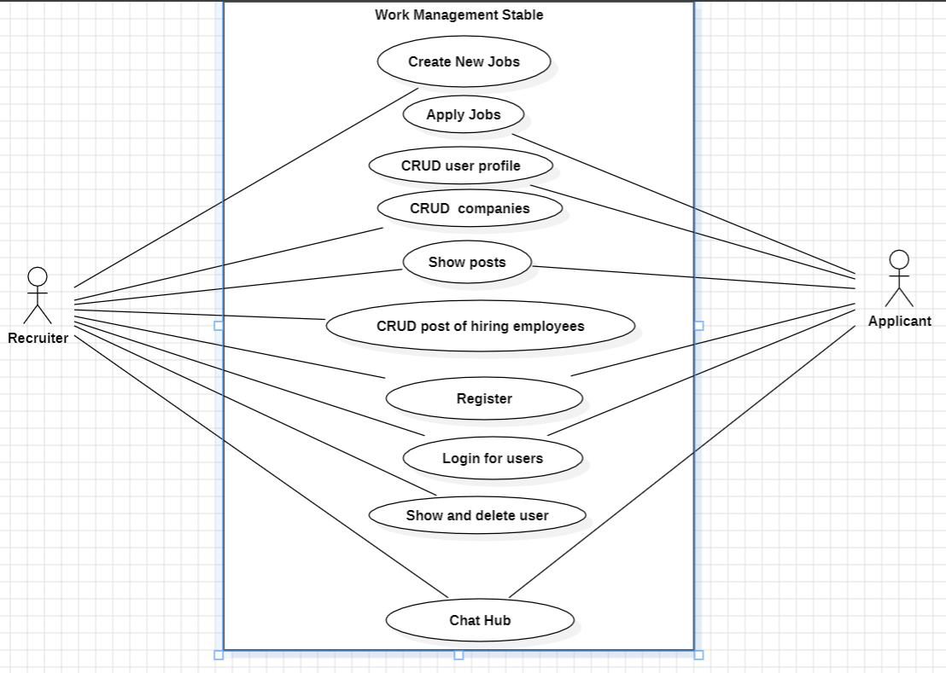

#### 2.3.2.1. Use case “Apply jobs (apply by CV)”

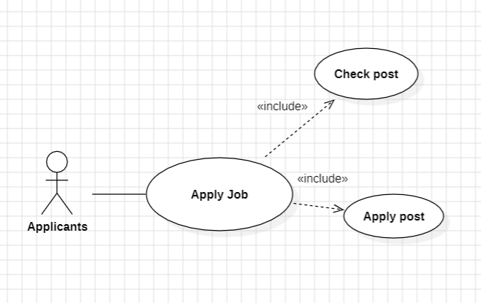

#### 2.3.2.2. Use case “Manage user’s details (information, CV)”

#### 

#### 2.3.2.3. Use case “List company, List job”

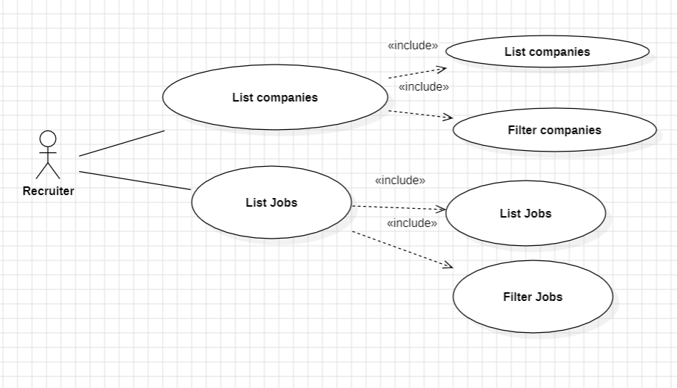

#### 2.3.2.4. Use case “Manage post of hiring employee”

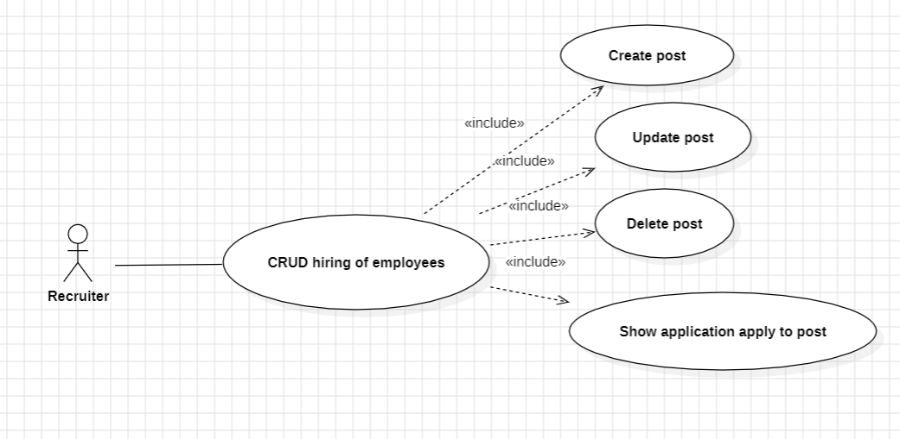

#### 2.3.2.5. Use case “Register/Login for users”

#### 

## 2.4. Activity diagrams for use case “Apply Jobs”

# 

# 

# 3.Data model

## Entity Relationship Diagram

<https://app.diagrams.net/#G16EkI4yM0RqeKby0XM-njeixWmzC1Qd_w>

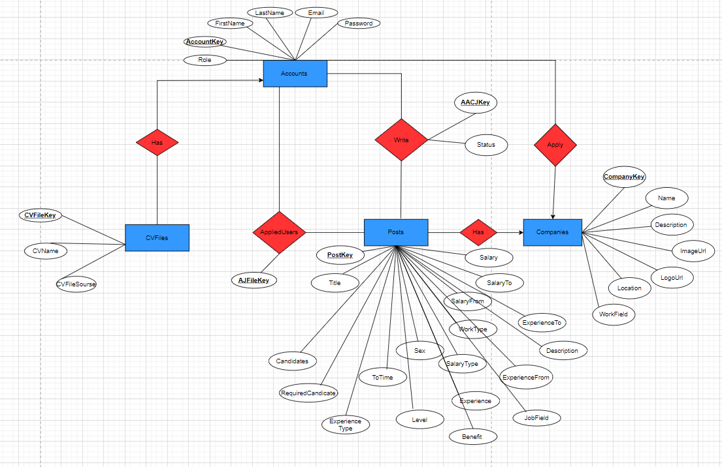

## 

## Table details/Chi tiết các bảng

Note: Attribute with underline is Primary key

### Table name: Accounts

| **Field name** | **Type** | **Size** | **Note** |
| --- | --- | --- | --- |
| AccountKey | Int | 10 | Primary key, Identity |
| FirstName | Nvarchar | 50 | Not null |
| LastName | Nvarchar | 50 | Not null |
| Email | Varchar | 255 | Not null |
| Password | Varchar | Max | Not null |
| Role | Varchar | 50 | Not null |
| CompanyKey | Int | 40 | Foreign key, refers to Companíe table |

### Table name: CVFiles

| **Field name** | **Type** | **Size** | **Note** |
| --- | --- | --- | --- |
| CVFileKey | Int | 10 | Primary key, Identity |
| CVName | Nvarchar | 255 | Not null |
| AccountKey | Int | 40 | Foreign key, refers to Accounts table |
| CVFileSource | Text | 16 | Not null |

### Table name: Posts

| **Field name** | **Type** | **Size** | **Note** |
| --- | --- | --- | --- |
| CompanyKey | Int | 10 | Foreign key, refers to Companies table |
| PostKey | Int | 10 | Primary key, Identity |
| Title | Varchar | 500 | Not null |
| ToTime | Datetime | 8 | Not null |
| SalaryType | Varchar | 100 | Not null |
| Salary | Int | 4 | Allow null |
| SalaryFrom | Int | 4 | Allow null |
| SalaryTo | Int | 4 | Allow null |
| WorkType | Varchar | 50 | Not null |
| Sex | Varchar | 50 | Not null |
| Candidates | Int | 4 | Not null |
| [Level] | Varchar | 255 | Not null |
| ExperienceType | Text | 16 | Allow null |
| Experience | Int | 4 | Allow null |
| ExperienceFrom | Int | 4 | Allow null |
| ExperienceTo | Int | 4 | Allow null |
| Description | Text | 16 | Not null |
| Required Candidate | Text | 16 | Not null |
| Benefits | Text | 16 | Not null |
| JobField | Varchar | 100 | Not null |

### Table name: Companies

| **Field name** | **Type** | **Size** | **Note** |
| --- | --- | --- | --- |
| CompanyKey | Int | 4 | Primary key, Identity |
| Name | Nvarchar | 255 | Not null |
| Description | Text | 10 | Not null |
| ImageUrl | Text | 16 | Not null |
| LogoUrl | Text | 16 | Not null |
| Location | Varchar | 500 | Not null |
| WorkField | Varchar | 100 | Not null |

### Table name: AppliedUser

| **Field name** | **Type** | **Size** | **Note** |
| --- | --- | --- | --- |
| AUFJKey | Int | 4 | Primary key, Identity |
| AccountKey | Int | 4 | Foreign key, refers to Accounts table |
| PostKey | Int | 4 | Foreign key, refers to Posts table |
| CVFileKey | Int | 4 | Foreign key, refers to CVFiles table |

3.2.6. Table name : AppliedAndCared

| **Field name** | **Type** | **Size** | **Note** |
| --- | --- | --- | --- |
| AACJKey | Int | 4 | Primary key, Identity |
| AccountKey | Int | 10 | Foreign key, refers to Accounts table |
| PostKey | Int | 10 | Foreign key, refers to Posts table |
| Status | Varchar | 50 | Not null |

# Class diagram

## List of classes in the Layers

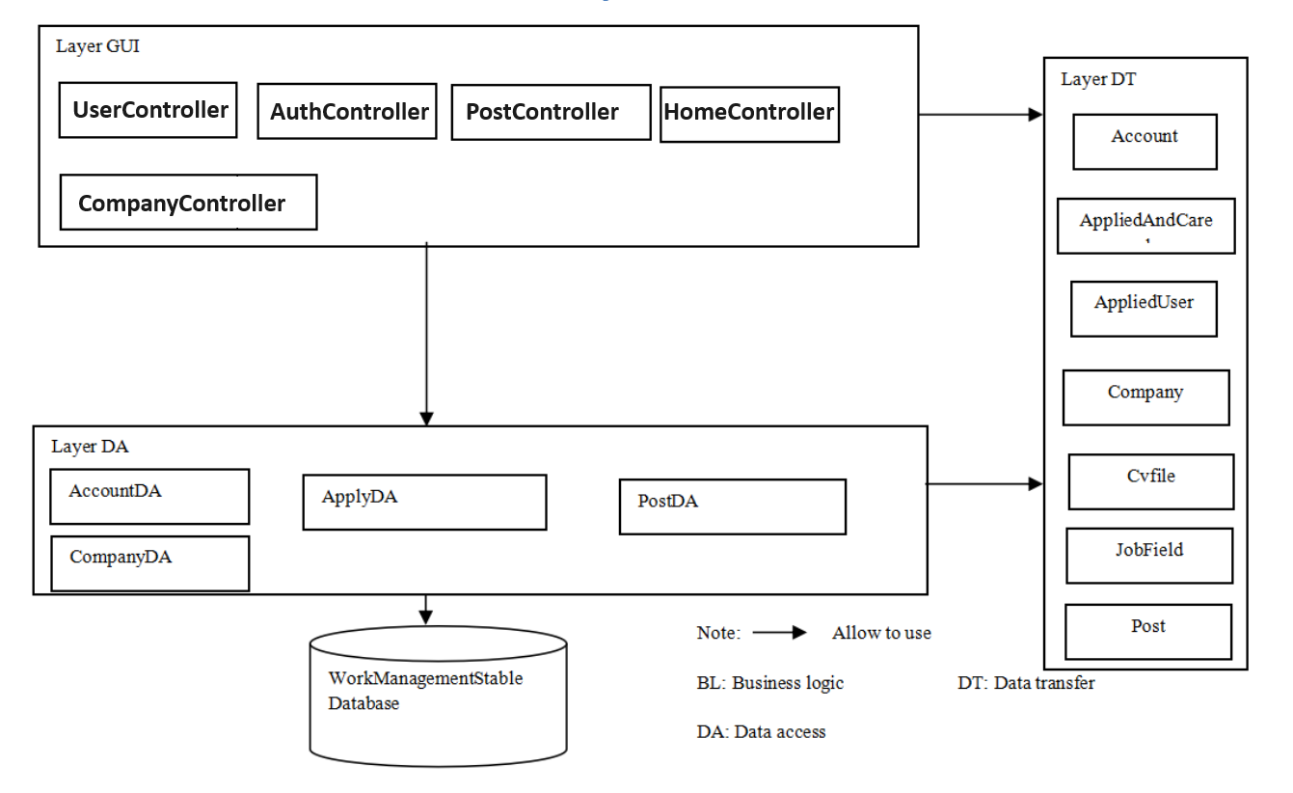

## Modeling the Class Behaviors - sequence diagrams for use case “Apply Jobs”

# 

# 5. User Interface Model Design

## 5.1 User interface model design

**5.1.1. Screen “Manage User”**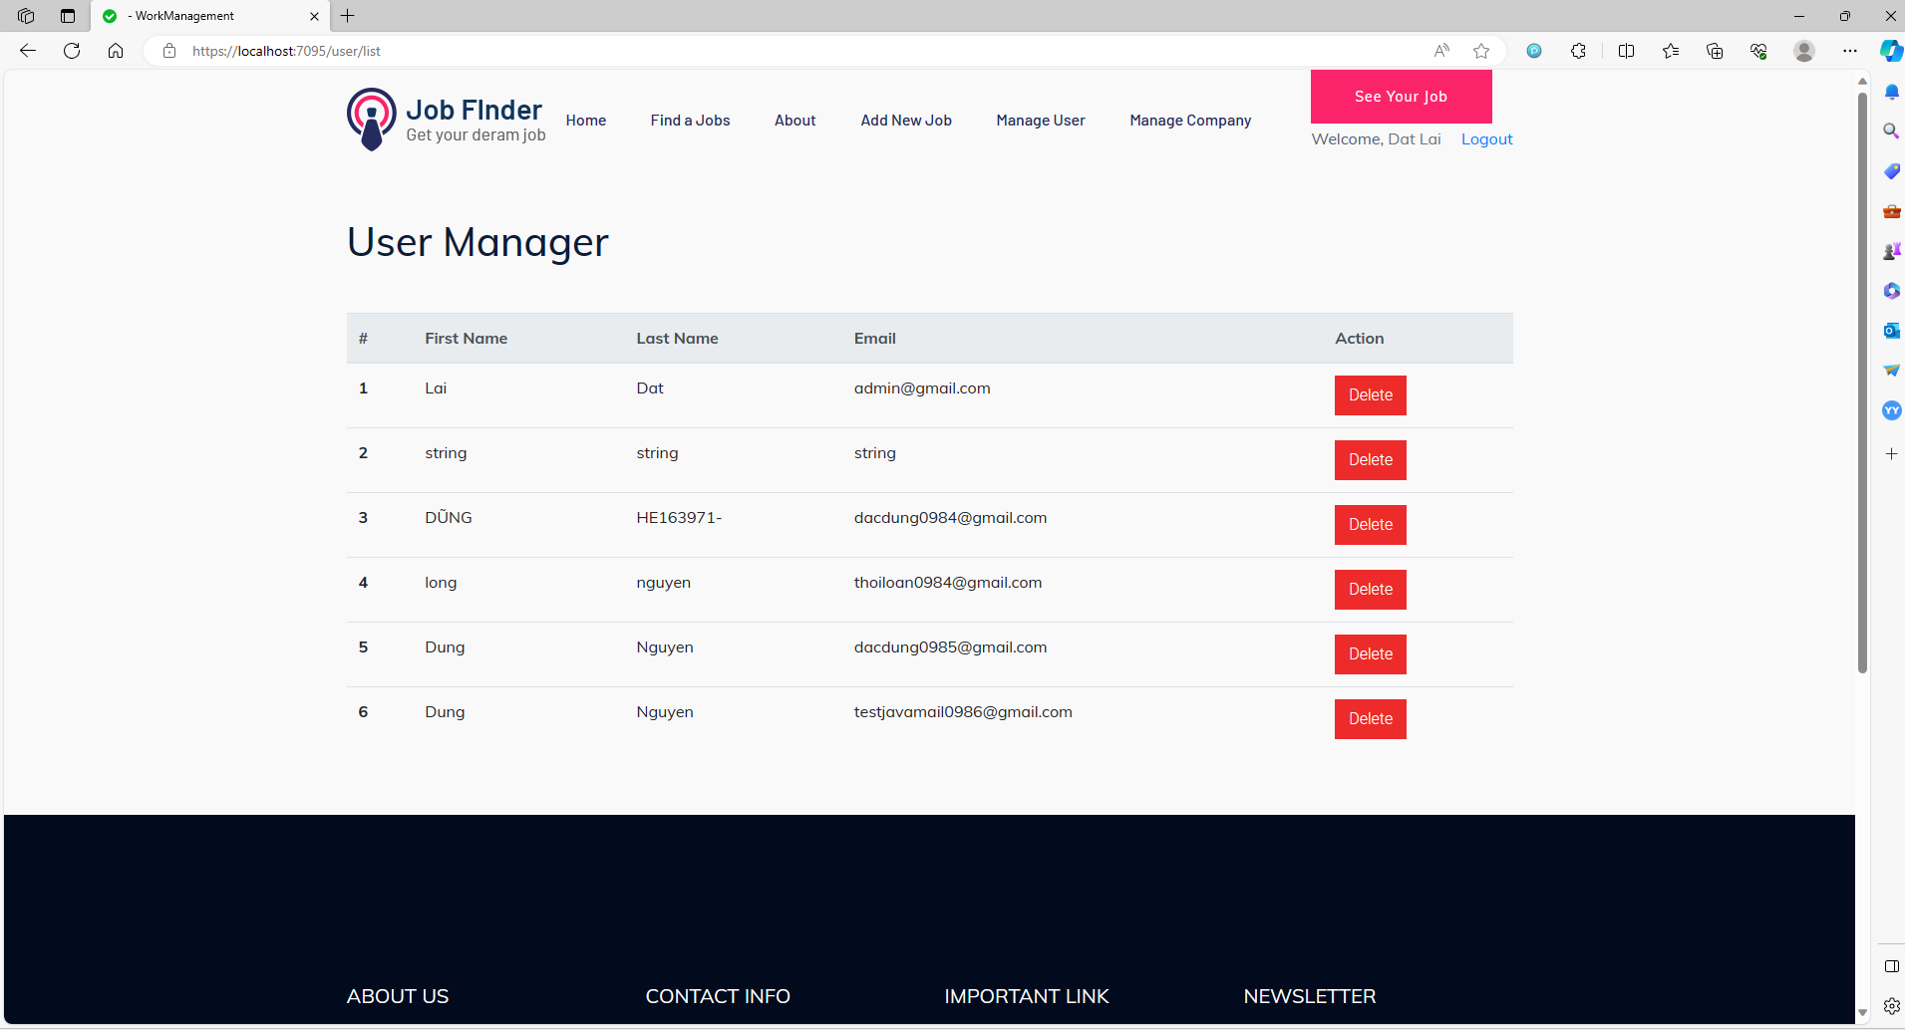

### 5.1.2. Screen “Manage Company”

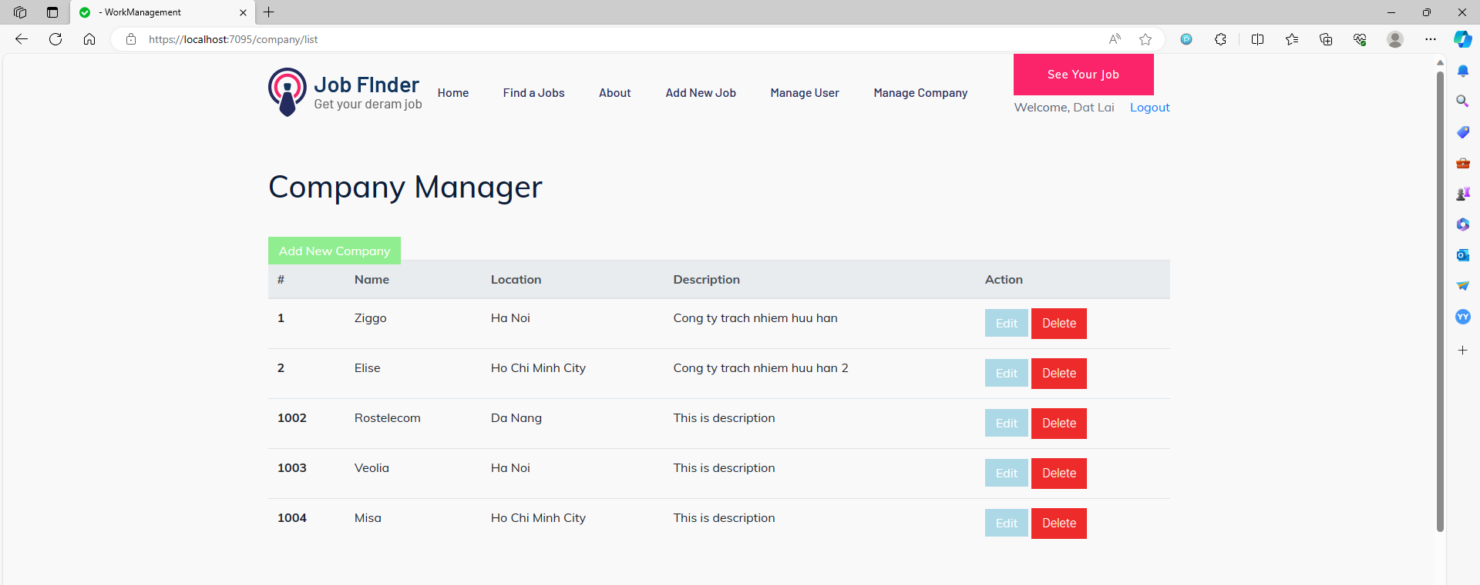

### 5.1.3. Screen “Show User Job”



### 5.1.4. Screen “View Profile”

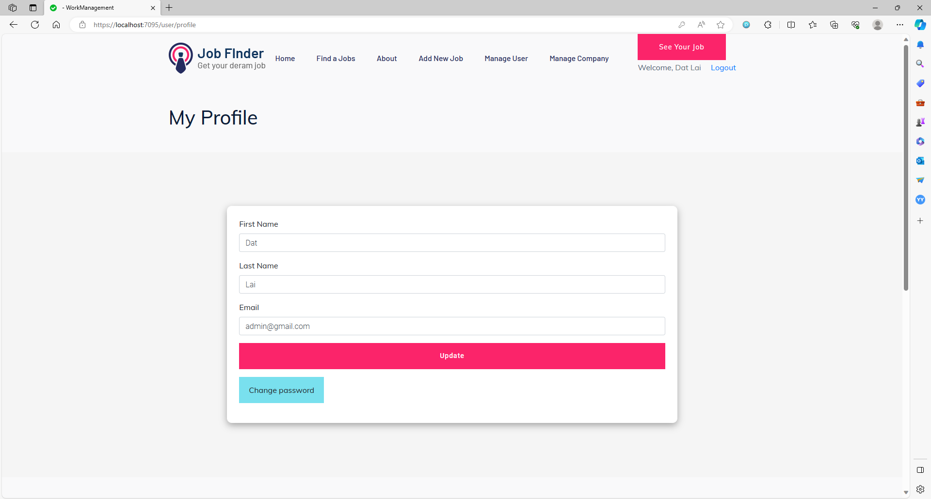

### 5.1.5. Screen “Register”

## 

### 5.1.6. Screen “Register”

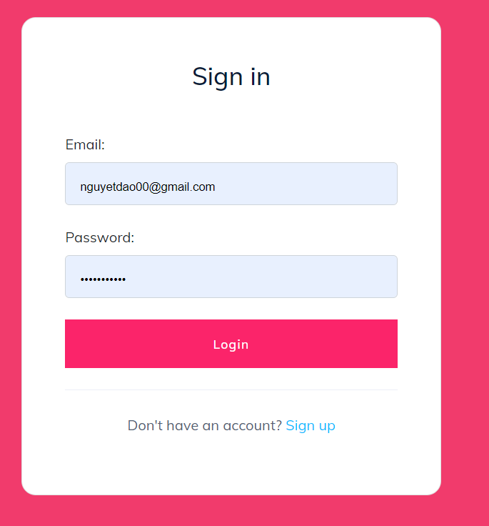

**5.1.7. Screen “Find Job”**

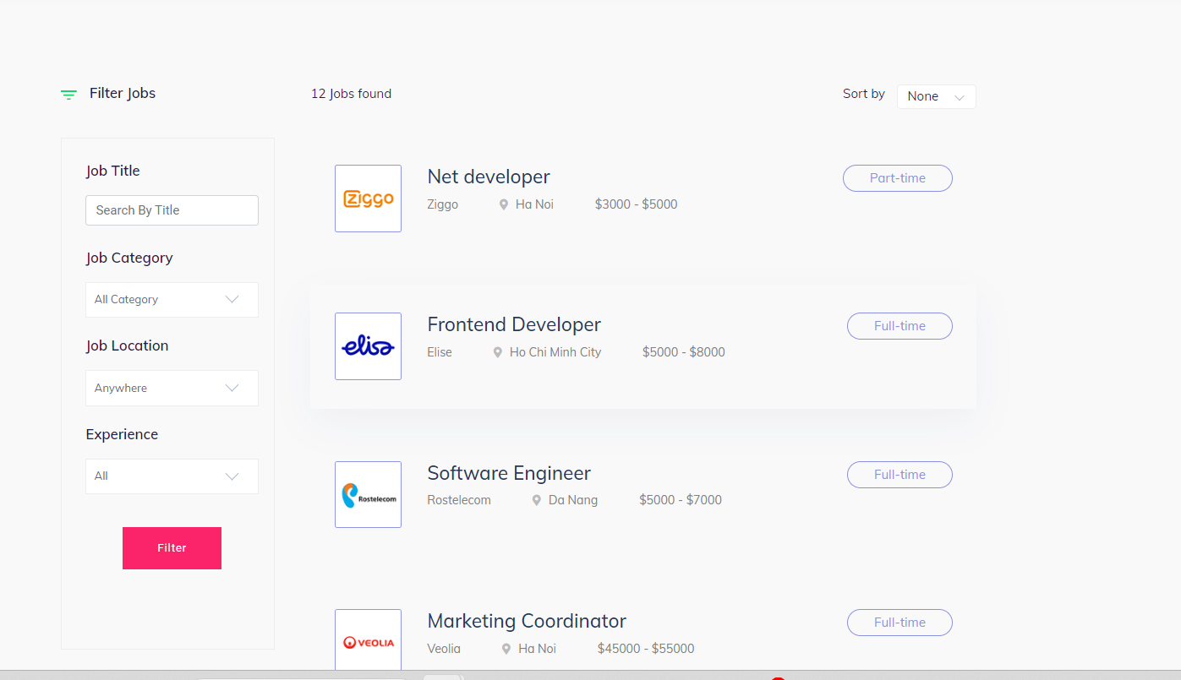

**5.1.8. Screen “Add new Job”**

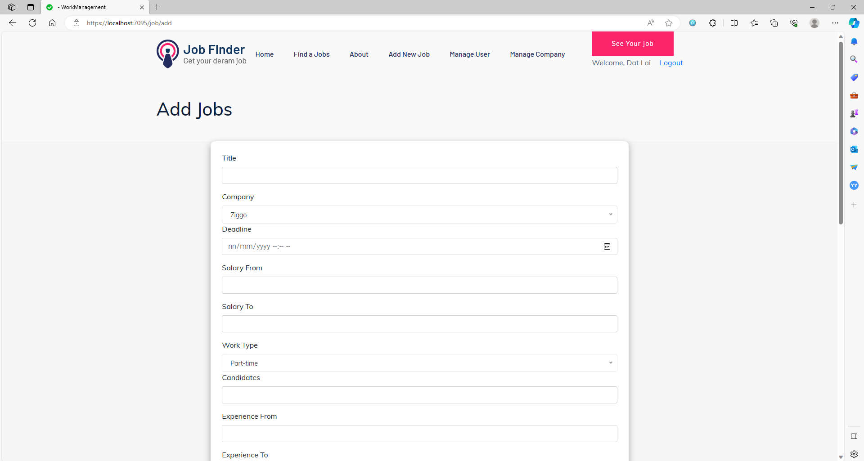

**5.1.9. Screen “Change password ”**

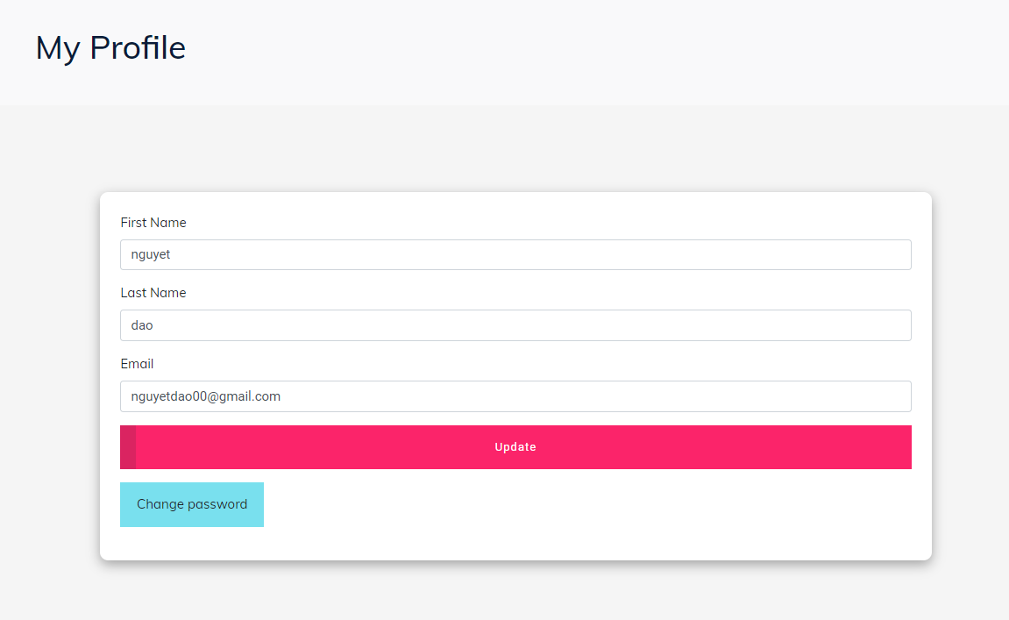

**5.1.10. Screen “Chat Hub”**

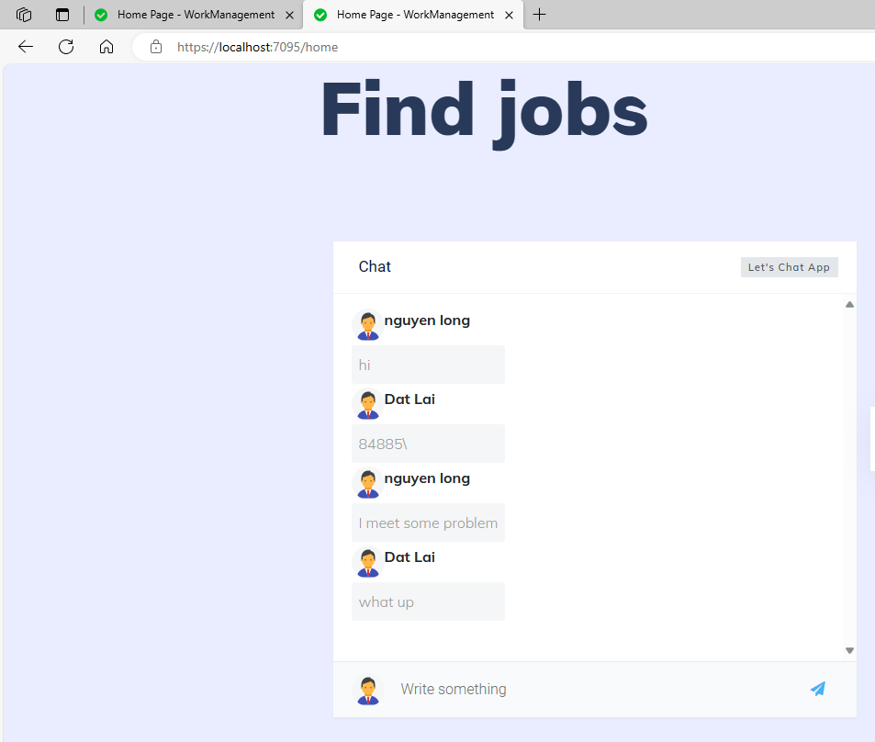

## 5.2 Interface Flow Diagrams

## 

