**Initio Programming: Exercises with Sensors**

**Aim:** This exercise sheet provides additional activities for investigating the Initio robot sensors. It assumes familiarity with the material in the Initio Programming Worksheets 1-4.

**Exercise 1:** Because the ultrasonic sensor uses echoes to detect distances it can be affected by the angle at which its sound wave hits an object.

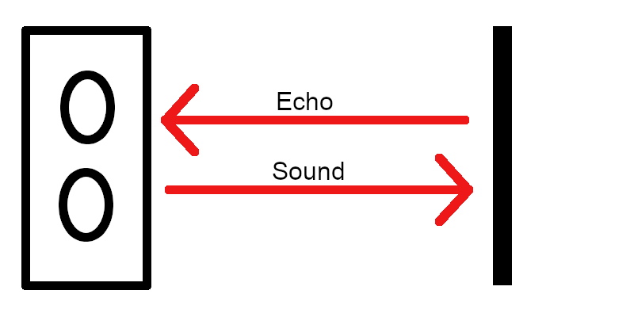

Ultrasonic Sensor with Obstacle Directly in Front of It

When the sound from the ultrasonic sensor hits an obstacle squarely then the echo bounces straight back to the sensor.

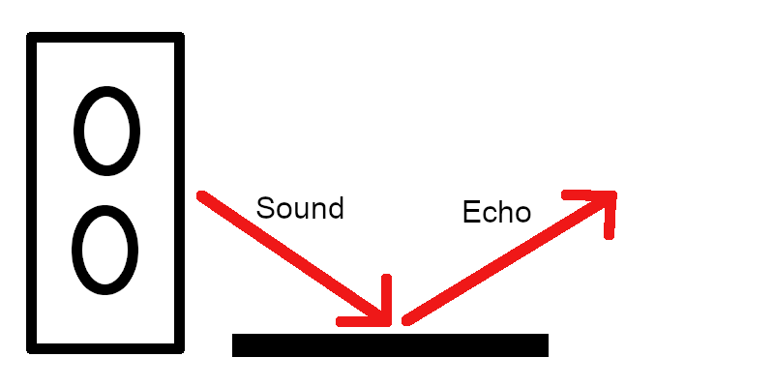

Ultrasonic Sensor with an Obstacle at an Angle to it.

When the sound from the ultrasonic sensor hits an obstacle at an angle then the echo can bounce away from it.

**Experiment Aim:** The aim of this experiment is to discover the angle at which your Initio robot’s ultrasonic sensor can not detect an object.

**Method:** To perform the experiment place the robot directly facing a flat surface such as a wall. The pan/tilt servos should be set so the ultrasonic sensor is panned to 0 degrees (that is it is facing forward).

Take a distance reading from the ultrasonic sensor for each angle from 0 to 90 and check the accuracy of the distance. You may well need a tape measure as the angle increases.

**Results:** Record your results and state at what angle the sensor could no longer detect the obstacle.

**Exercise 2:** The same effect can be observed with the infrared sensors but will be harder to detect. Firstly, you can not rotate the sensors you will need to rotate either the robot or the obstacle. Secondly the sensors just return True or False depending upon how close the object is so you will have to make sure your flat surface is always close enough to the robot that it should return True.

Devise and run an experiment to find out at what angle the infrared sensors stop being accurate.



University of Liverpool, 2019

This work is licensed under a [Creative Commons Attribution-NonCommercial-ShareAlike 4.0 International License](https://creativecommons.org/licenses/by-nc-sa/4.0/).