**Virtual Initio Programming: Worlds**



**AIM:** This exercise sheet provides additional activities for investigating the Initio robot sensors. It assumes familiarity with the material in the Initio Programming Worksheets 1-4.

**Exercise 1**:

So far we have used our Initio simulation only in default_world.xml.

For this exercise we will look at a different world.

If the simulator is currently running you need exit default_world.xml (by clicking on close) and disconnect your virtual Initio robot by typing initio.cleanup() in the IDLE window where you have been doing the previous exercises.

Open maze1.xml. In the IDLE window where you have been doing the exercises, reconnect your virtual initio by typing initio.init();

What are the values returned by the ultrasonic sensor and the two infrared distance sensors in this world?







Drive the Initio using the motor commands to another part of the world and take new values for the ultrasonic and infrared sensors.



What happens if the Initio hits one of the blocks?



**Exercise 2:** Move the robot so that it is facing a block square on like in the picture below.

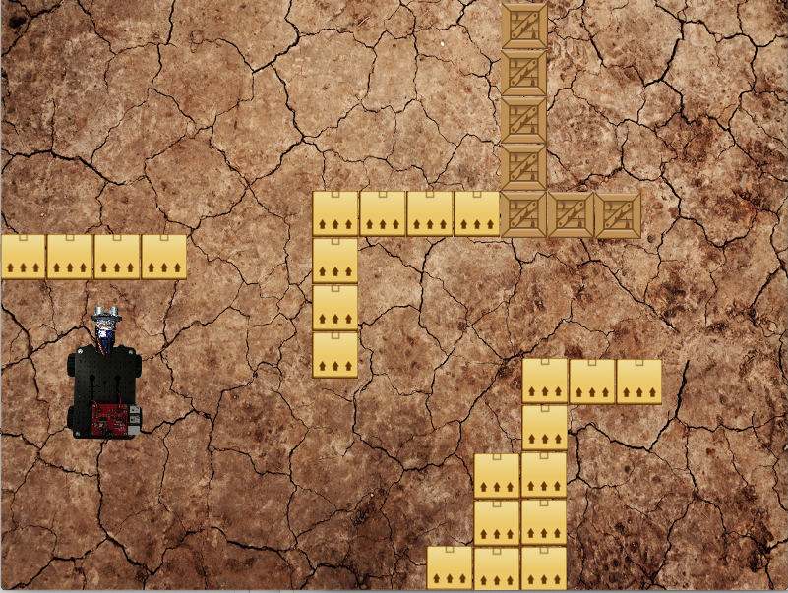

Now pan the ultrasonic sensor through every angle from -45 to 45 and record the value it returns.

Can you explain the differences in all these values?











**Exercise 3:**

Exit maze1.xml and disconnect your virtual Initio robot by typing initio.cleanup() in the IDLE window where you have been doing the exercises.

Open linefollowing.xml. In the IDLE window where you have been doing the exercises, reconnect your virtual Initio robot by typing initio.init()



What are the values returned by the two infrared line sensors in this world?



Move the robot backwards and forwards until you find a spot where the two infrared line sensors both return 1 (NB. this can be a bit tricky).



University of Liverpool, 2019

This work is licensed under a [Creative Commons Attribution-NonCommercial-ShareAlike 4.0 International License](https://creativecommons.org/licenses/by-nc-sa/4.0/).