**Virtual Initio Programming: Simple Programs**



**AIM:** This exercise sheet provides additional simple programs for you to write for your virtual Initio. It assumes familiarity with worksheets 1-6.

**Exercise 1**: Write a program that will spin the robot for 2 seconds, then take a distance sensor reading and print it to the screen and stop.

To print the value of the sensor use: print(initio.getDistance())

**Exercise 2**: Write a program which will make the robot pan its ultrasonic sensor right for 5 seconds, then left for 5 seconds and then return it to the centre.

**Exercise 3**: Write a program so that your robot drives around in a circle taking readings from its two infrared distance sensors roughly every quarter circle. Some experimentation will be needed to work out how long a quarter turn takes for your robot.

**Exercise 4:** Write a program where the robot moves forward changing speed every 10 seconds for a total of 30 seconds.

**Exercise 5**: Write a program so that the robot *shakes its head* (pans its ultrasonic sensor left and then right as in exercise 2). Then it moves forward for 10 seconds and shakes its head again. Then it spins on the spot for 10 seconds and shakes its head again. Then it reverses for 10 seconds and shakes its head a final time.

**Exercise 6**: Exit the default_world.xml (by pressing Close) and disconnect your virtual Initio robot by typing initio.cleanup() in the IDLE window where you have been doing the previous exercises.

Now open maze1.xml. In the IDLE window where you have been doing the exercises, reconnect your virtual initio by typing initio.init();

Write a program that will move your robot from the start position to the top right hand corner (without you clicking and dragging the robot). To do this you will need to experiment to find out how long it needs to move forward in each stage and how long it needs to turn for in each stage.

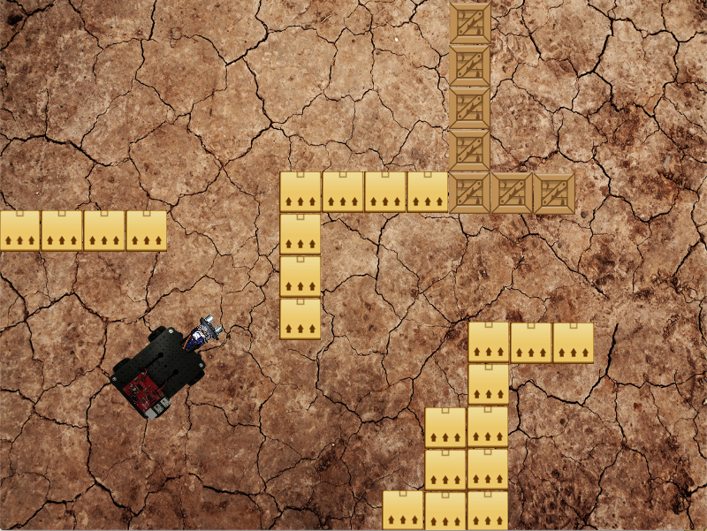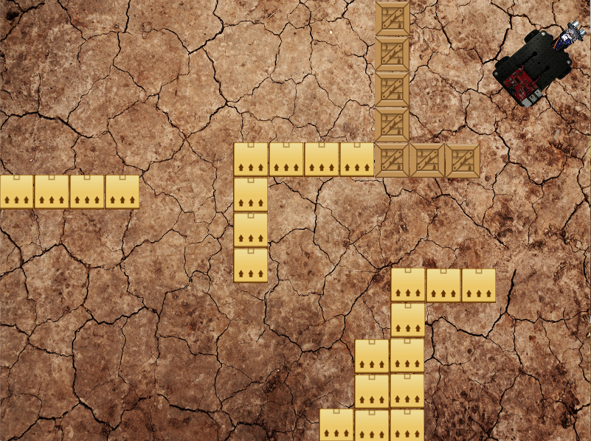

Move the robot from the position on the left to the position on the right.



University of Liverpool, 2019

This work is licensed under a [Creative Commons Attribution-NonCommercial-ShareAlike 4.0 International License](https://creativecommons.org/licenses/by-nc-sa/4.0/).