**Virtual Initio Programming: Getting Started**



**AIM:** After completing this worksheet you should be able to start the virtual Initio simulator and change the simulation environment for the virtual robot by adding and removing boxes, lines and light sources.

**Before you start:** You need to have installed our simulator somewhere. It should be in a folder called pirover_simulator. You will find the simulator in this folder. It is called pysim.py (Windows and Linux) or pysimosx.py (Macs).

To start you need to run the simulator. You can run it either from the *command line* or from IDLE.

**From the Command Line (Windows and Linux):** Type python3 pysim.py then press return.

**From the Command Line (Macs):** Type python3 pysimosx.py then press return.

**From IDLE:** Start IDLE. A window will open and you should see something like:

Python 3.7.2 (v3.7.2:9a3ffc0492, Dec 24 2018, 02:44:43)

[Clang 6.0 (clang-600.0.57)] on darwin

Type "help", "copyright", "credits" or "license()" for more information.

>>>

Open pysim.py (pysimosx.py on Macs) from the File Menu.

This file will open in a new IDLE window, including a new menu item **Run**.

From **Run** select **Run Module.**

You should see: You should see: 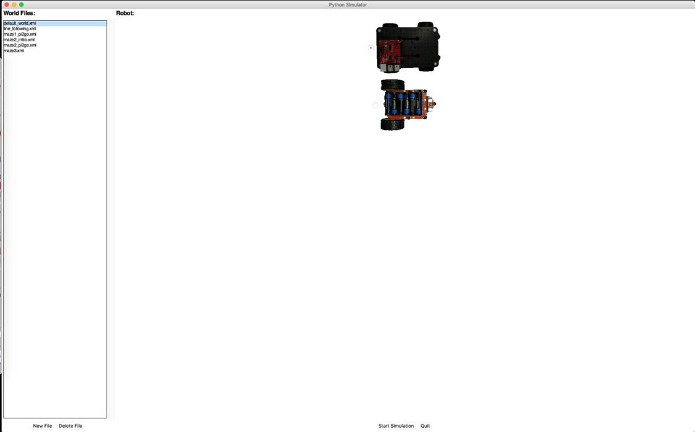

From here you can start a simulation for either the Initio robot (the top image) or the Pi2Go robot (the bottom image) in a number of settings (the “World Files” on the left).

Select the Initio robot and the default_world.xml.

Then click on *Start Simulation*

Once the simulation has started, you can stop it by clicking *Close* in the Pi2Go window.

You can exit the simulator by clicking *Quit.*

**Opening the Edit Window**

You can change the environment your virtual Pi2Go encounters by using objects from the Edit window.

Click on *Edit* in the Pi2Go Simulator. A second window, the Objects window, should open as shown in the screenshot below

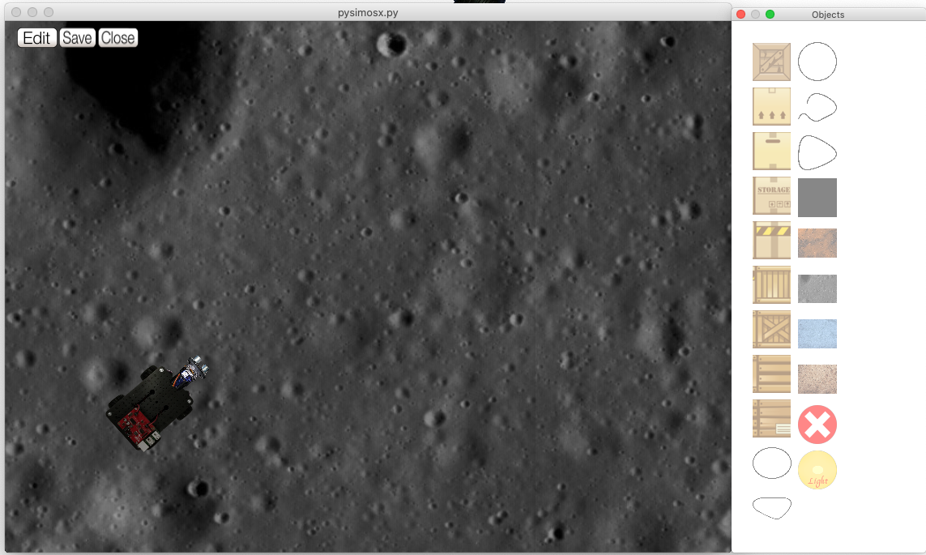

The Objects Window contains 8 blocks, 5 lines, a Black Square, 4 backgrounds, a Delete button and a Light source.

1. Select the Objects Window
2. Click on the top block
3. Select the Simulation Window
4. Right click somewhere.

**Question 1:** What happens?

1. Select the Objects Window
2. Click on the Delete Button
3. Select the Simulation Window
4. Right click on the Block



**Question 2:** What happens?

1. Select the Objects Window
2. Click on the Black Square
3. Select the Simulation Window
4. Right click somewhere

(the Black Square should appear)

1. Left click on the Black Square in the Simulation Window

and use the mouse to drag it around.

**Question 3:** If you drag the Black Square to the same space as the robot does it appear over or under the robot?

Add a block object and drag it around with the mouse.



**Question 4:** What happens when the block is dragged over the robot?

Try adding and removing and moving:

1. Lines
2. Backgrounds
3. Light Source

Can backgrounds be moved by clicking and dragging? YES/NO



**Question 5:** How do you move the ray of light from the Light Source?

When you have altered a world you can save it by clicking *Save* but you will need to change its name.

When you want to exit the simulator, select click *Close* in the Pi2Go world window, followed by *Quit* in the simulator window.



University of Liverpool, 2019

This work is licensed under a [Creative Commons Attribution-NonCommercial-ShareAlike 4.0 International License](https://creativecommons.org/licenses/by-nc-sa/4.0/).