**Virtual Initio Programming: Command Lines**



**AIM:** After completing this worksheet you should be able to start and stop the IDLE integrated development environment and use simple commands.

**You Need:** To complete this worksheet you need to have access to IDLE.

You should have the virtual simulator running and have selected the Initio robot and the default_world.xml world (WS1).

For simple programming tasks we can use the *Python Command Line Interpreter*. We are going to use this from within an *integrated development environment* called IDLE.

Start IDLE (if you already have IDLE running for the simulator you should start a *new IDLE window* for programming the virtual robot).

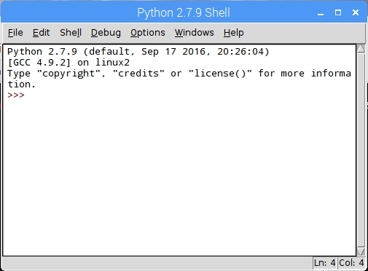





The Python Command Line Interpreter in IDLE

You should now be in the Python Interpreter which should look like the above. You DO NOT need to type the “prompt” (**>>>**) before any python commands.

**print(“Hello World”)**

followed by Return.



What happens?

We will now try to import a module for our Initio robot.

Type

**import simclient.simrobot as initio**

followed by Return.

**IMPORTANT:** if you get an error at this point that says

ModuleNotFoundError: No module named 'simclient.simrobot'

Then you need to add the simulator to your PYTHONPATH. **To do this see the box at the end of this worksheet.**

open the file setup_programming.py using the File menu (you will find setup_programming.py in the pirover_simulator folder). Once this file is open select **Run Module** from the **Run** menu.

This will print the path to the simulator directory. You can ignore this for now, but will need it when you start using files for your programs.

Then try

**import simclient.simrobot as initio**

followed by Return.

Now type the following commands one after another, each followed by Return.

**initio.init()**

**initio.forward(10)**

**initio.stop()**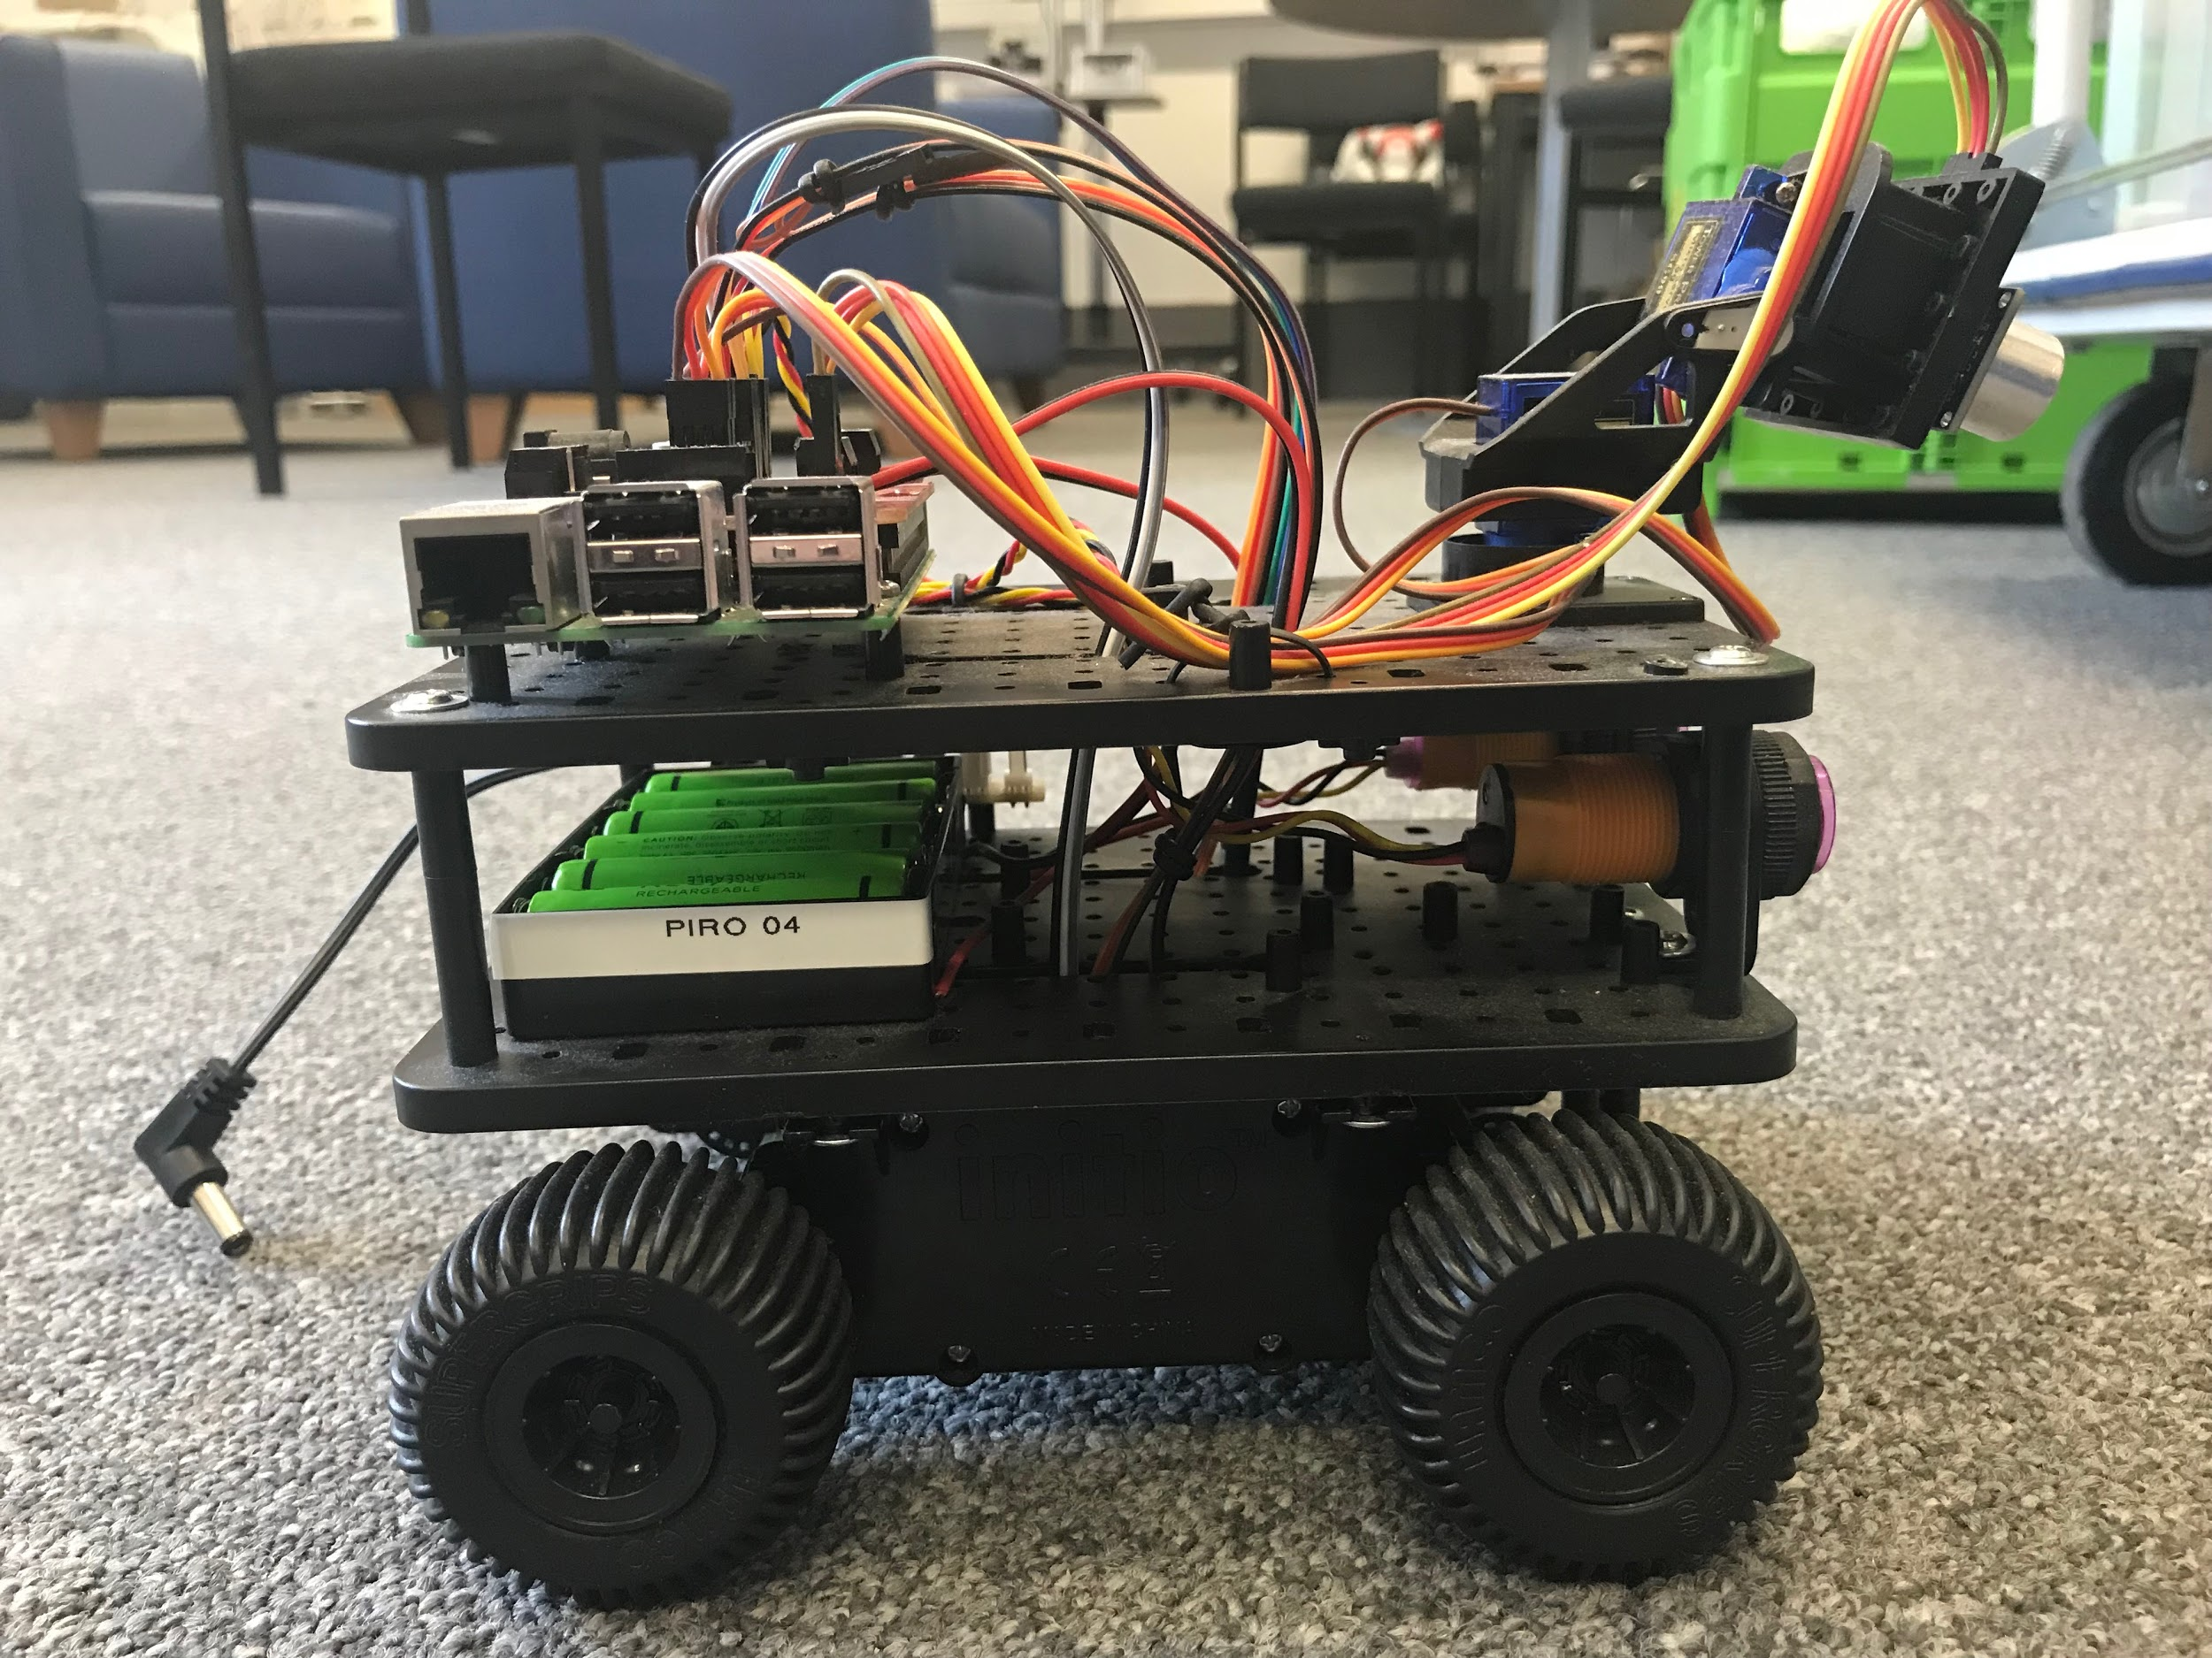



What happens?

You can use *alt-p* (pressing the Alt key and P at the same time) to scroll back through previous commands.

Try replaying some commands using *alt-p*

You will learn more about controlling the Initio robot from the Python Command Line in worksheet WS3.

If you have finished working with your robot type:

**initio.cleanup()**

Otherwise carry on to worksheet 3.



University of Liverpool, 2019

This work is licensed under a [Creative Commons Attribution-NonCommercial-ShareAlike 4.0 International License](https://creativecommons.org/licenses/by-nc-sa/4.0/).