**Virtual Initio Programming: Sensors**



**AIM:** After completing this worksheet you should be able to describe the sensors on the Initio simulation and use Python to get information from them.

**You Need:** To complete this worksheet you need to have to have a virtual Initio simulator (see WS1), understand how to control it from the IDLE command line (see WS2), and how to control the pan/tilt servos (see WS3).

**If the simulator isn’t already running:**

Start it (see WS1) and select the Initio robot and default_world.xml. Now open a new IDLE window.

An Initio robot has two different kinds of sensors:

1. **Ultrasonic:** It has an ultrasonic sensor which uses sound and echoes to measure distances.
2. **Infrared:** It has several infrared sensors that measure how much infrared light is reflected. These can be used both to measure distances (like with the ultrasonic sensor) and to measure colour – for instance a black surface reflects less infra-red light than a white surface.

These sensors are all simulated on your virtual Initio and you can use Python to get values from the sensors.

**The Ultrasonic Sensor**

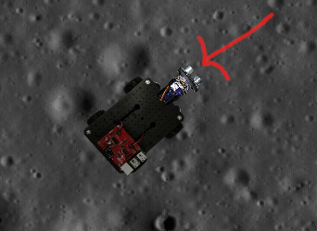

The Ultrasonic Sensor

Locate the ultrasonic sensor on your virtual Initio.

There is one command you can use to get information from the ultrasonic sensor. This is:

>>> initio.getDistance()

initio.getDistance() returns the distance in cm to the nearest reflecting object. A value of zero means it does not detect an object

Type initio.getDistance()



**Question 1:** What value do you get?

Let us put something in front of the virtual Initio.

Type E anywhere in the Simulator Window to open the Objects window and place one of the blocks in front of the Initio’s distance sensor.



Try getting the distance using the Python command.

**Question 2:** What value do you get?

Now try moving the object closer to the sensor, using the mouse to click and drag it.



**Question 3:** What value do you get?

The ultrasonic sensor is the sensor you can move using the initio.setServo command discussed in WS3.

Move your block a little to one side of the ultrasonic sensor.

Use initio.setServo to move the sensor and see what difference it makes to the result from initio.getDistance()



**Question 4:** What command(s) did you type to move the sensor in order to detect the object?

**Infrared Sensors**

The Initio’s infrared sensors are organised into two groups: sensors for detecting obstacles and sensors for detecting lines.

There are two sensors for detecting obstacles at the front of the robot:

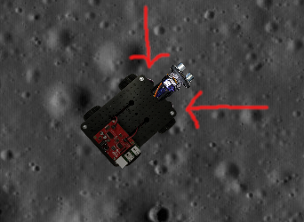

The locations of the InfraRed Obstacle Sensors

There are three commands for getting information from the obstacle sensors:

>>> initio.irLeft()

returns 1 (meaning **True**) if the Left IR Obstacle sensor detects an obstacle

and 0 (meaning **False**) otherwise

>>> initio.irRight()

returns 1 (meaning **True**) if the Right IR Obstacle sensor detects an obstacle

and 0 (meaning **False**) otherwise

>>> initio.irAll()

returns 1 (meaning **True**) if either of the Obstacle sensors detects an obstacle

and 0 (meaning **False**) otherwise

Using the Objects Window place blocks so that initio.irAll()returns 1.

**Question 5:** How many blocks did you need?

The Initio’s other infrared sensors are used to detect how dark the colour of the surface the robot stands on is. These are referred to as “line sensors” since their primary use is for detecting black lines on white surfaces.

There are two line sensors.

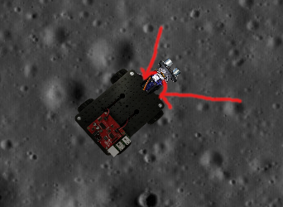

The Line Sensors

There are two command for getting information from the line sensors:

>>> initio.irLeftLine()

returns the state of Left IR Line sensor

>>> initio.irRightLine()

returns the state of Right IR Line sensor

In the Objects Window select the Black Square and place it under the front of the robot.

**Question 6:** What do the python commands return if the Initio is over the black square?

**Question 7:** What do they return if the Initio is over the background?

**Remember:** If you have finished working with your robot type:

**initio.cleanup()**



University of Liverpool, 2019

This work is licensed under a [Creative Commons Attribution-NonCommercial-ShareAlike 4.0 International License](https://creativecommons.org/licenses/by-nc-sa/4.0/).