**Pi2Go Programming: Getting Started**

**AIM:** After following this worksheet you should be able to connect a keyboard, mouse and monitor to your Pi2Go robot and switch it on ready for use.

Your Pi2Go robot has several USB ports, an HDMI port and a micro USB port.

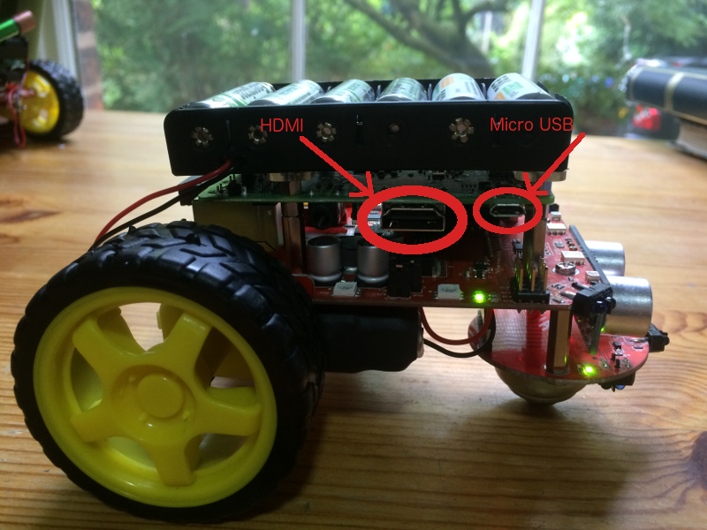

HDMI and Micro USB port locations

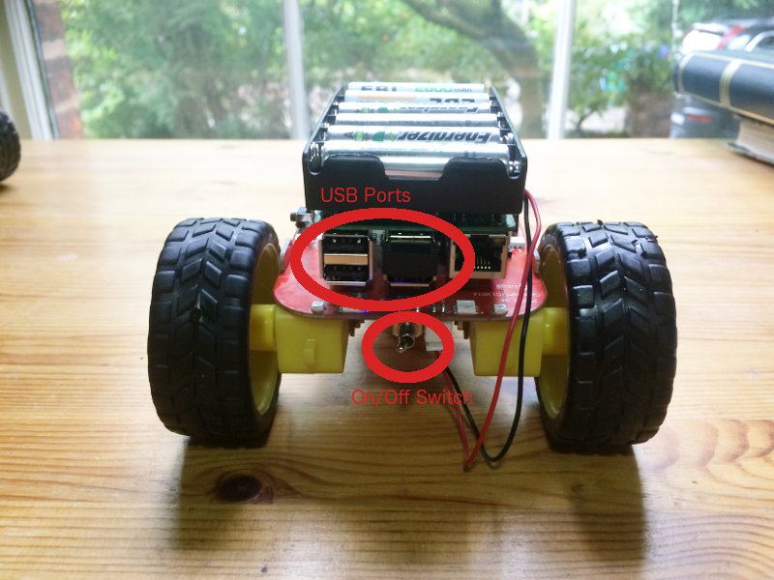

USB Ports and On/Off Switch

You should **connect your monitor** to the HDMI port and **your keyboard and mouse** to two of the USB ports.

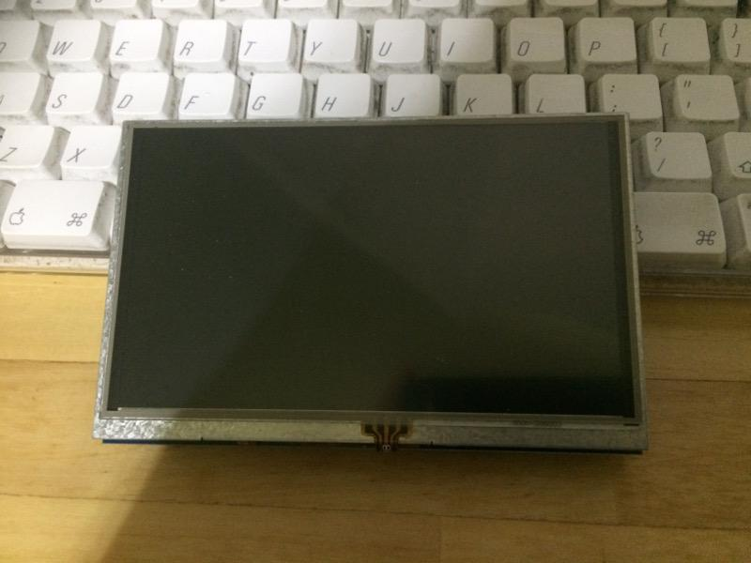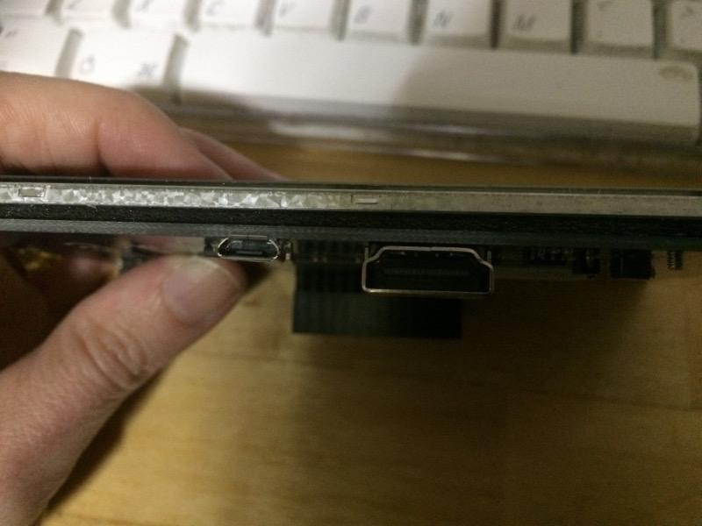

The Elecrow 5 inch monitor: USB port (for power) and the HDMI Port

If you are using the Elecrow 5 inch monitor then it can be powered from the Pi2Go. Connect one of the USB ports on the Pi2Go to the Micro USB port on the monitor.

If you also have an external power supply it can be connected to the Micro USB port on the Pi2Go.

**Switch your robot on using the On/Off Switch.**

Your final setup should look something like this.

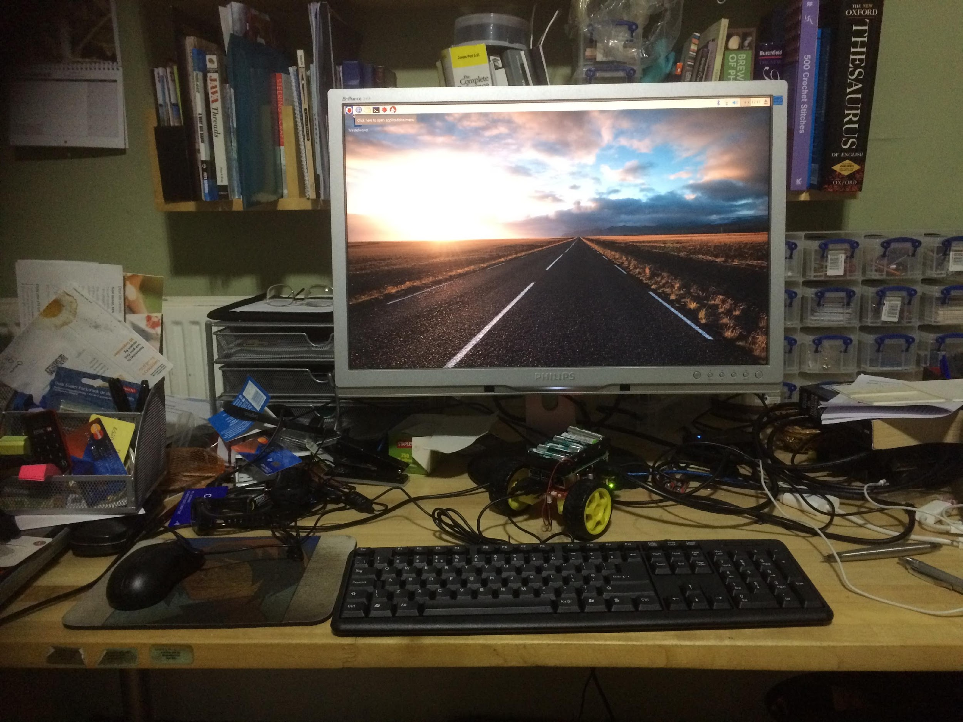

or (if you are using the Elecrow 5 inch monitor):

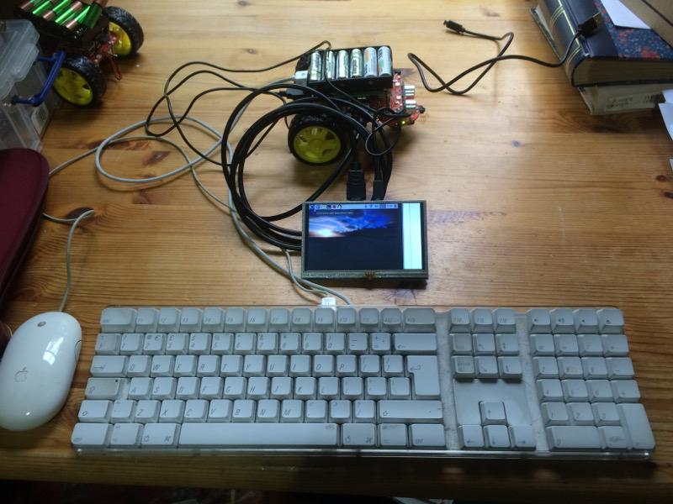



University of Liverpool, 2019

This work is licensed under a [Creative Commons Attribution-NonCommercial-ShareAlike 4.0 International License](https://creativecommons.org/licenses/by-nc-sa/4.0/).