**Virtual Pi2Go Programming: Simple Programs**



**AIM:** This exercise sheet provides additional simple programs for you to write for your virtual Pi2Go. It assumes familiarity with worksheets 1-6.

**Exercise 1**: Write a program that will spin the robot for 2 seconds, then take a distance sensor reading and print it to the screen and stop.

To print the value of the sensor use: print(pi2go.getDistance())

**Exercise 2**: Write a program which will make the robot’s LEDs flash blue for 5 seconds, then green for 5 seconds and then red for 5 seconds.

**Exercise 3**: Place a Light Source in the world. Write a program so that your robot performs a full turn on the spot, printing out the light measurements from each light sensor after roughly each quarter turn. Some experimentation will be needed to work out how long a quarter turn takes for your virtual robot.

**Exercise 4:** Write a program where the robot moves forward changing speed every 10 seconds for a total of 30 seconds.

**Exercise 5**: Pick four colours for the LEDs (we will call the colours A, B, C, D). Write a program so that the robot displays colour A at the front, colour B on the left, colour C at the back, and colour D on the right. It moves forward for 10 seconds. Then it rotates the colours (so A is now on the left, B at the back and so on). Then it spins on the spot for 10 seconds. Then it rotates the colours again. Then it reverses for 10 seconds. Then it rotates the colours again. Then it stops.

**Exercise 6**: Exit the simulator (by pressing Q) and disconnect your virtual Pi2Go robot by typing pi2go.cleanup() in the IDLE window where you have been doing the previous exercises.

Now re-start the simulator and select the world maze1.xml.

In the IDLE window where you have been doing the exercises, reconnect your virtual robot by typing pi2go.init();

Write a program that will move your robot from the start position to the top right hand corner (without you clicking and dragging the robot). To do this you will need to experiment to find out how long it needs to move forward in each stage and how long it needs to turn for in each stage.

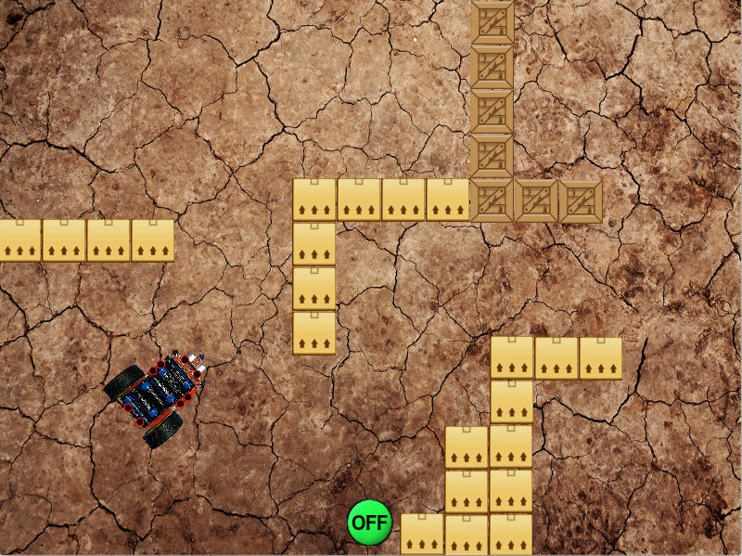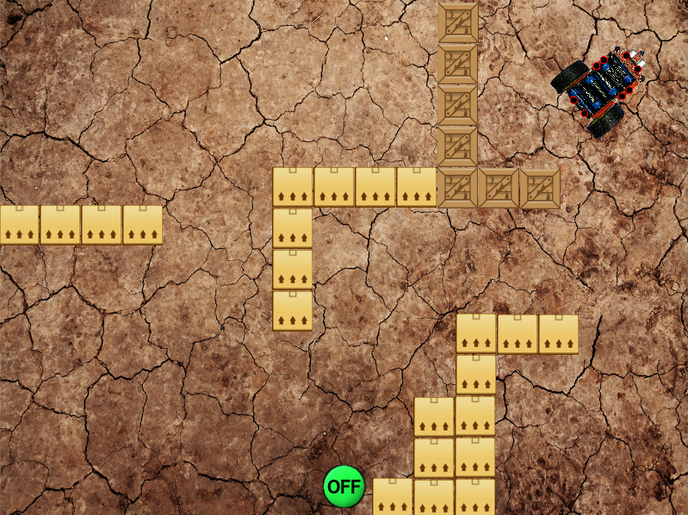

Move the robot from the position on the left to the position on the right.



University of Liverpool, 2019

This work is licensed under a [Creative Commons Attribution-NonCommercial-ShareAlike 4.0 International License](https://creativecommons.org/licenses/by-nc-sa/4.0/).