Installing the Simulator

**AIM:** After following this worksheet you should have a working version of the Python RoboticsSimulator. This worksheet assumes you have a working version of Python 3 including the numpy library installed on your machine.

**Download** the file pirover_simulator.zip From http://www.csc.liv.ac.uk/~lad/pyrobots and unzip it into the location of your choice.

In the pirover_simulator folder you should find two files pysim.py and pysimosx.py. The first is for use on Windows and Linux machines and the second for use on Macs.

You can run the simulator either from the *command line* or from a Python development environment such as IDLE.

**From the command line:** Type python3 pysim.py (pysimosx.py on Macs) in the pirover_simulator folder then press return.

**From IDLE:** Start IDLE. A window should open and you should see something like:

Python 3.7.2 (v3.7.2:9a3ffc0492, Dec 24 2018, 02:44:43)

[Clang 6.0 (clang-600.0.57)] on darwin

Type "help", "copyright", "credits" or "license()" for more information.

>>>

Open pysim.py (pysimosx.py on Macs) from the File Menu. A file will open in Idle (ignore this) and a new menu item **Run** should appear. From **Run** select **Run Module.**

You should see:

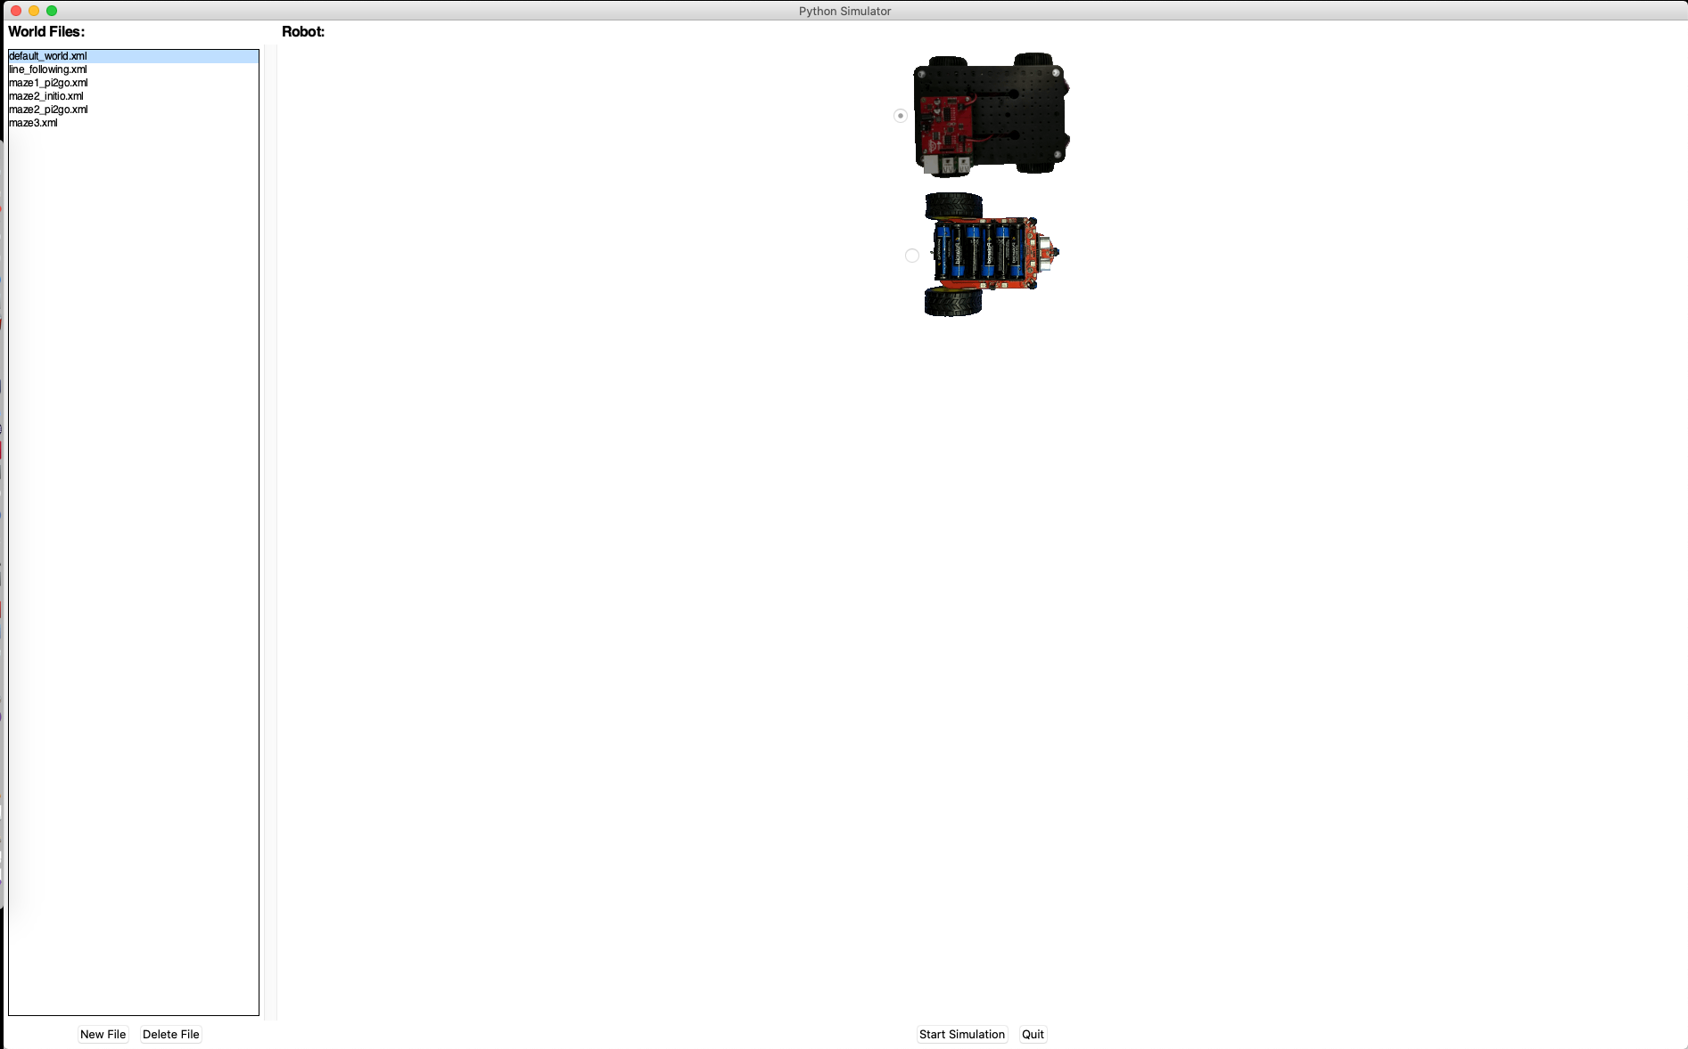

From here you can start a simulation for either the Initio robot (click on the top image then select start simulation) or the Pi2Go robot (click on the bottom image then select start simulation) in a number of settings (the “World Files” on the left).

Once the simulation has started you can stop it by pressing Q or Quit.



University of Liverpool, 2019

This work is licensed under a [Creative Commons Attribution-NonCommercial-ShareAlike 4.0 International License](https://creativecommons.org/licenses/by-nc-sa/4.0/).