Start PHP Server

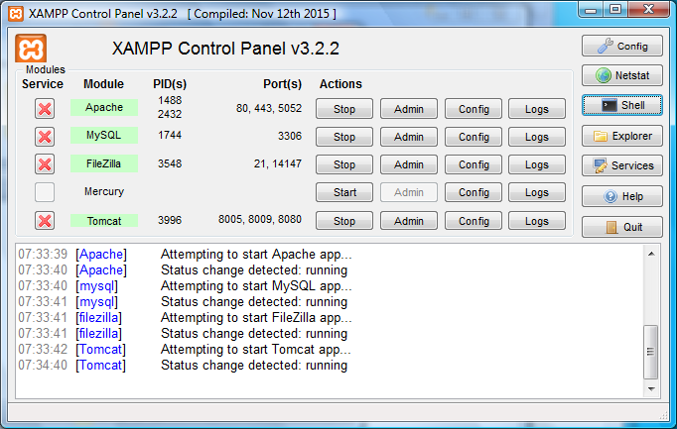

Click “Shell”

Enter command “php –q C:\xampp\htdocs\chat_server.php” <RTN>

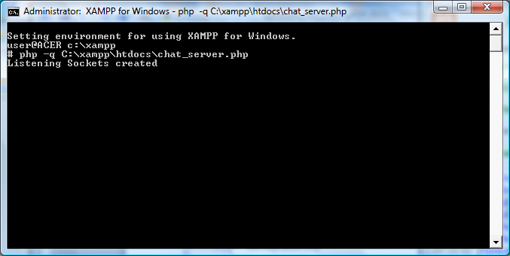

# Start Manager Webpage

Start Web browser

Visit “localhost/manager.php” NOTE: this tab will be referred to as the Manager Tab

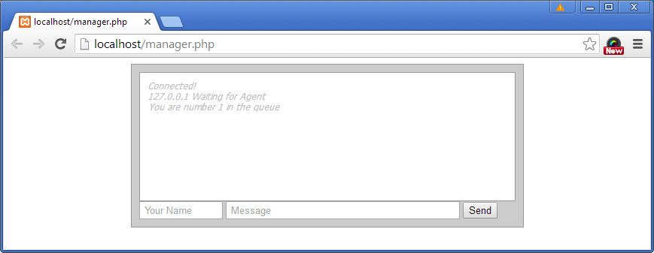

Start first client

Web browser -> open new tab

Visit “localhost” NOTE: this loads index.php. This will be referred to as Customer 1 Tab

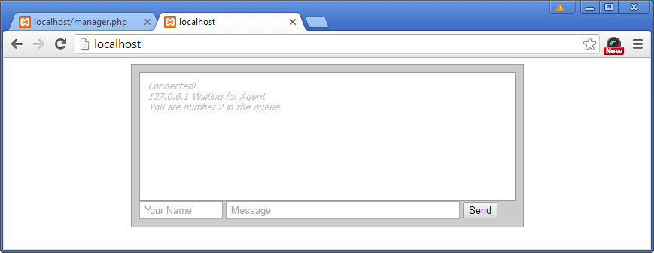

Start second client

Web browser -> open new tab

Visit “localhost” NOTE: this loads index.php. This will be referred to as Customer 2 Tab

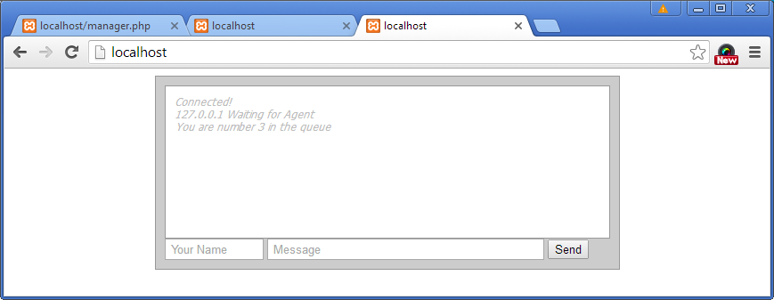

Start ManagerChat

Web browser Manager tab -> Name=Mgr, Message=Hello, Click Send

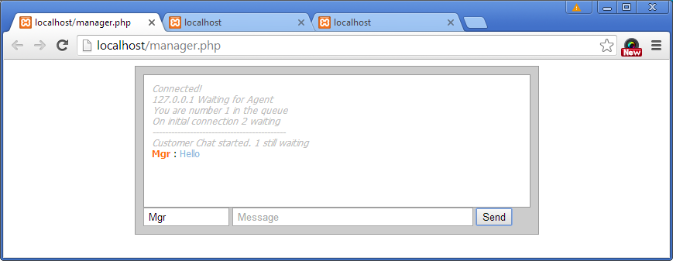

Check Customer 1 Tab indicates chat in progress and the Manager message

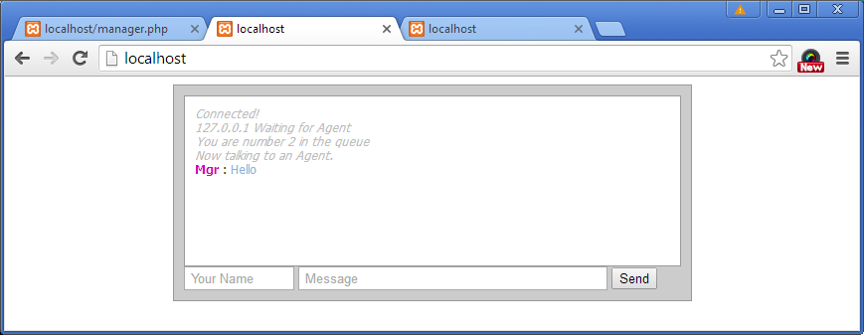

Check Customer 2 Tab indicates they are now first in the queue

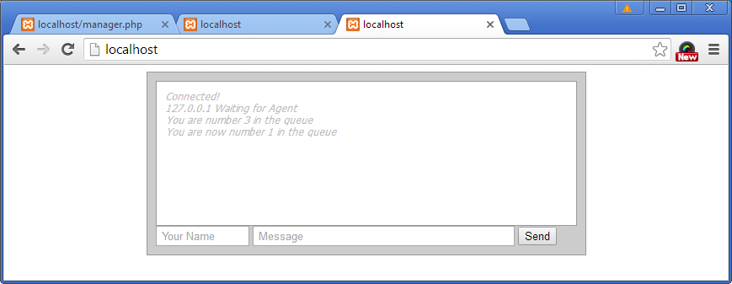

Customer 2 Impatient

When Customer 2 types a message they receive a message indicating where they are in the queue.

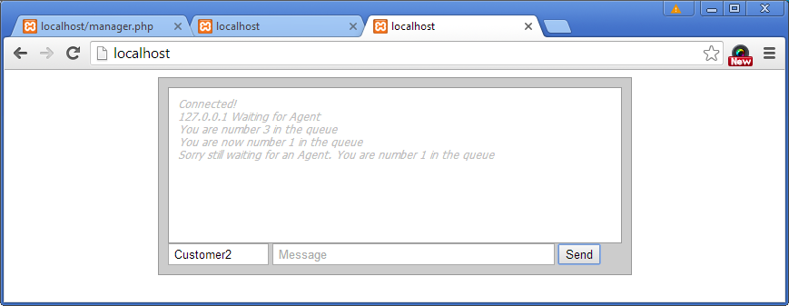

Customer 3 Connects

Web browser -> open new tab

Visit “localhost” NOTE: this loads index.php. This will be referred to as Customer 3 Tab

Check that the customer is told they are second in the queue, one chat in progress, two waiting.

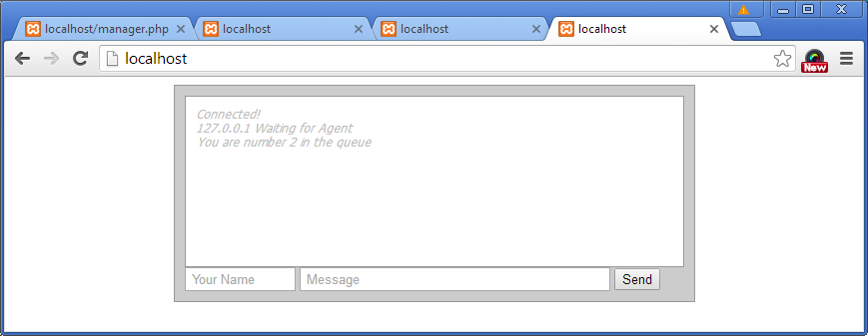

Check that the manager is told that another customer has joined the queue

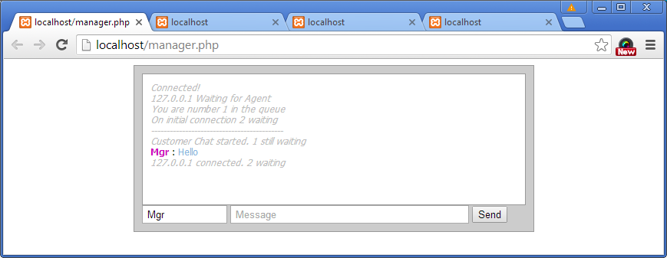

Check that Customer 1 and Customer 2 have no messages.

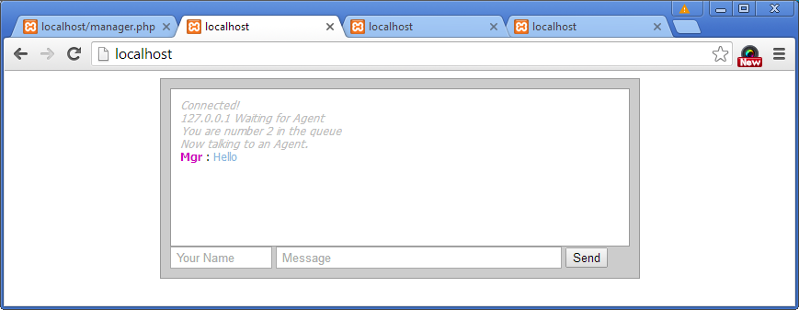

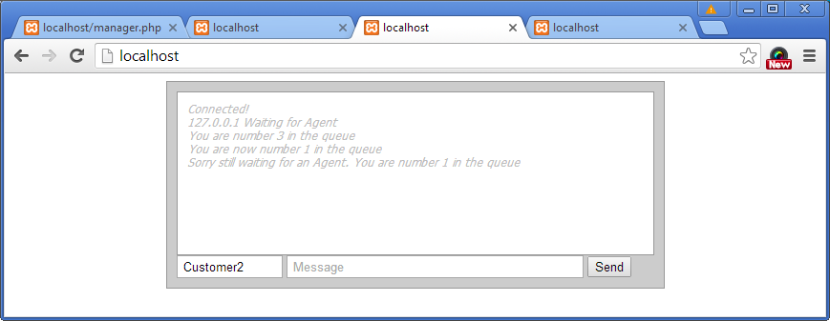

Customer 1 Replies

Customer 1 Tab -> Name=Customer1, Message=Hello from Customer 1, Click Send.

Check that the message is shown on the Customer 1 Tab and Manager Tab.

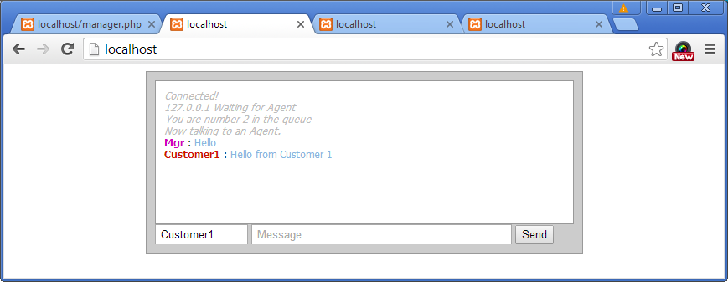

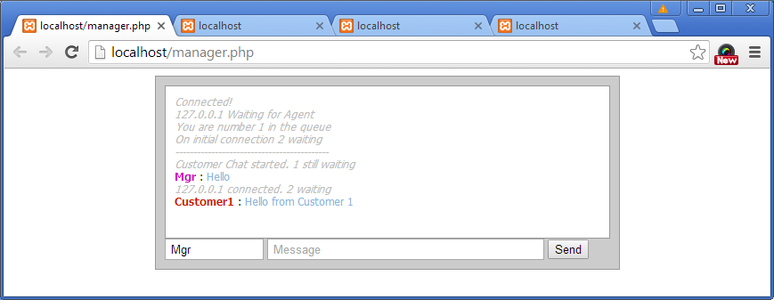

Check that the message is not shown on the Customer 2 Tab and Customer 3 Tab

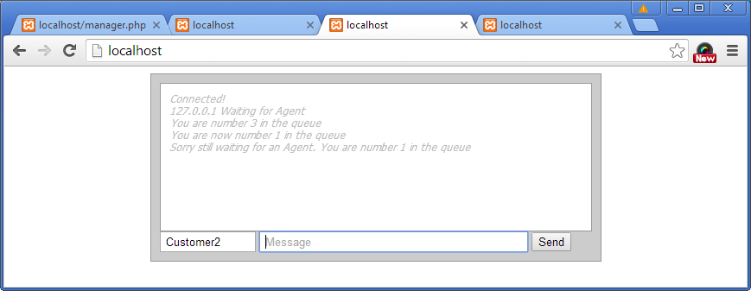

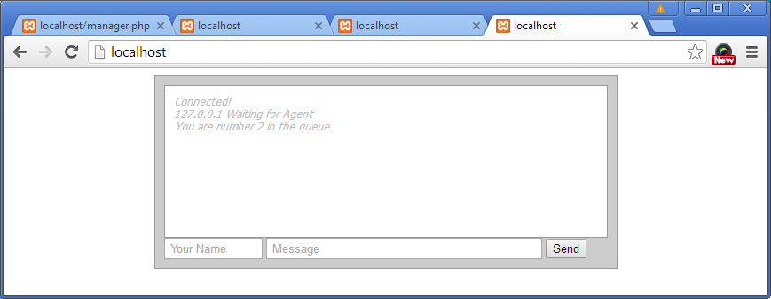

Customer 1 ends the Chat

Web browser close Customer 1 Tab

Check that the Manager Tab indicates the chat was disconnected and the number of customers still waiting.

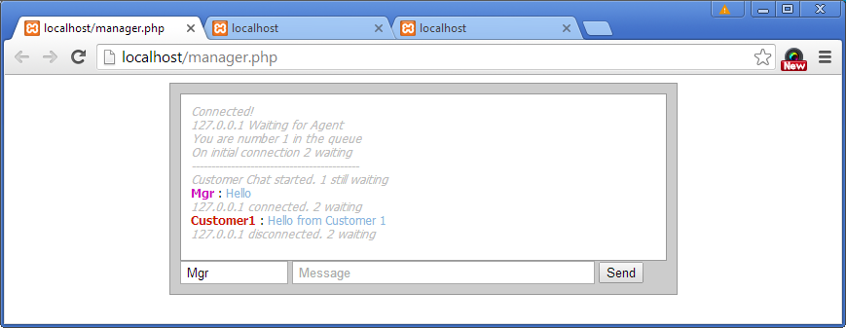

Check that the Customer 2 Tab and Customer 3 Tab do not change.

Manager starts a new chat

Manager Tab -> Message=Hello again, Click Send.

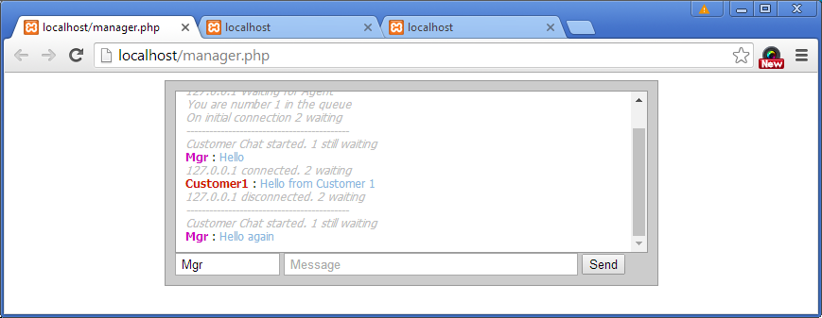

Check Customer 2 Tab indicates chat in progress and the Manager message

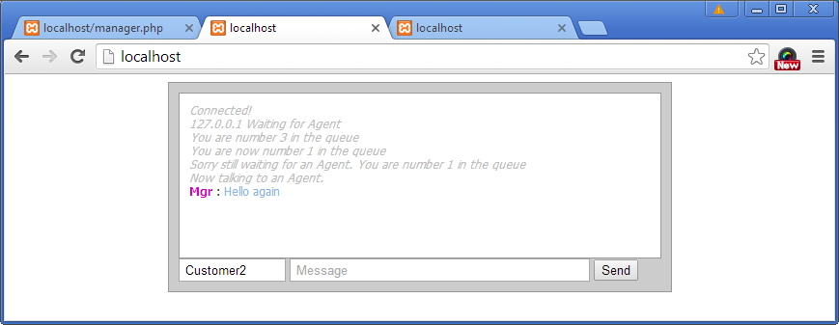

Check that Customer 3 Tab indicates that they have moved up in the queue.

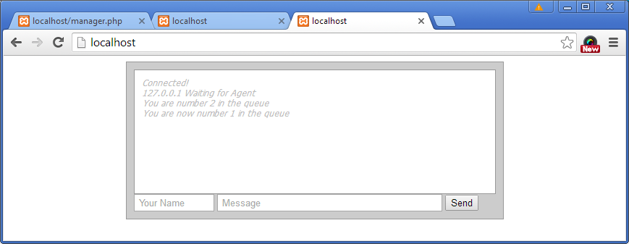

Customer 2 Replies

Customer 2 Tab -> Name=Customer1, Message=Hello from Customer 1, Click Send.

Check that the message is shown on the Customer 2 Tab and Manager Tab.

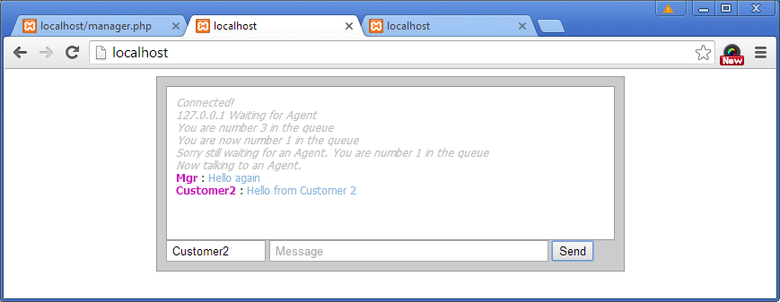

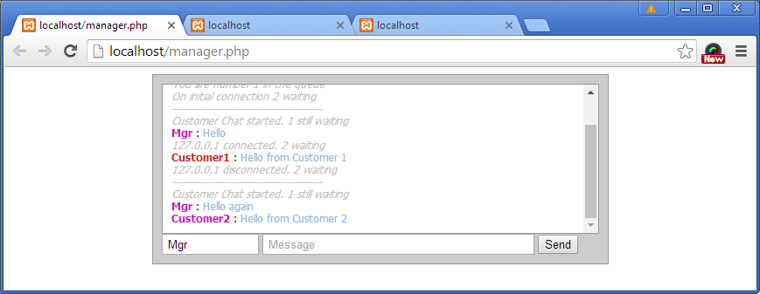

Check that the Customer 3 Tab is unchanged.



Manager disconnects

Web browser-> close Manager Tab

Check that the Customer 2 Tab indicates waiting for agent.

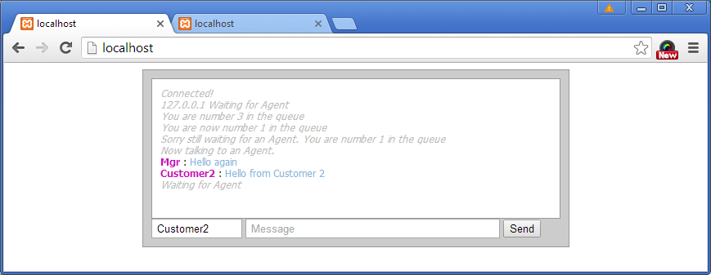

Check that Customer 3 Tab is indicates waiting for agent and their position in the queue

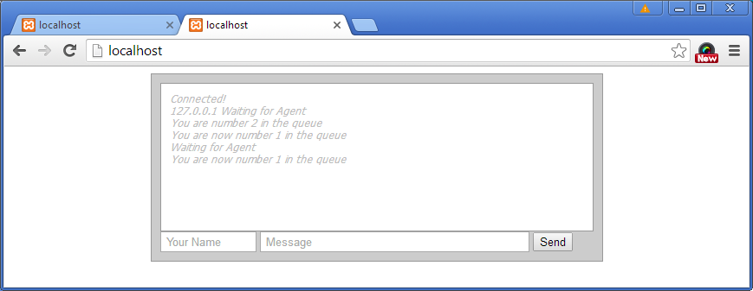

NOTE: The Customer with Chat in progress should have a different message indicating that they need to open a new tab to restart the chat.

NOTE: CODE IMPROVEMENT NEEDED. The customer whose chat is ended should be able to refresh the page to join the queue again. Generally the reaction of the software on web page refresh needs to be improved.

e.g. When the Customer 2 Tab is refreshed no messages are received…

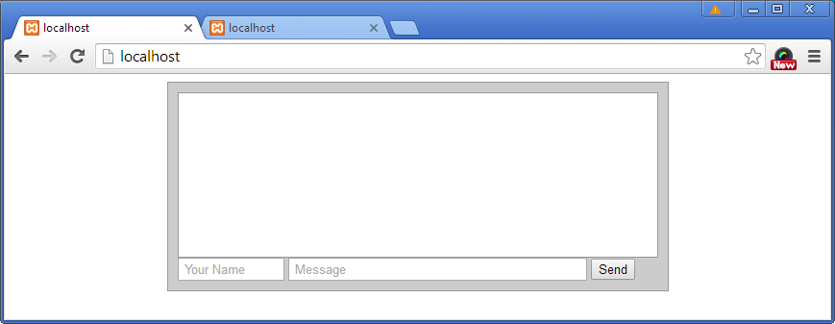

A new manager starts a session.

Web browser-> open a new tab

Visit “localhost/manager.php” NOTE: this tab will be referred to as the Manager 2 Tab

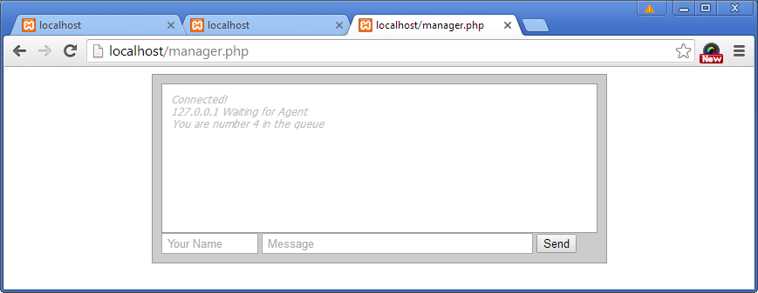

NOTE: that the manager is told they are number 4 in the queue. Customer 2, Customer 3 and Manager, plus one other yet to be determined client.

Check that Customer 2 Tab indicates they are now second in the queue, behind Customer 3.

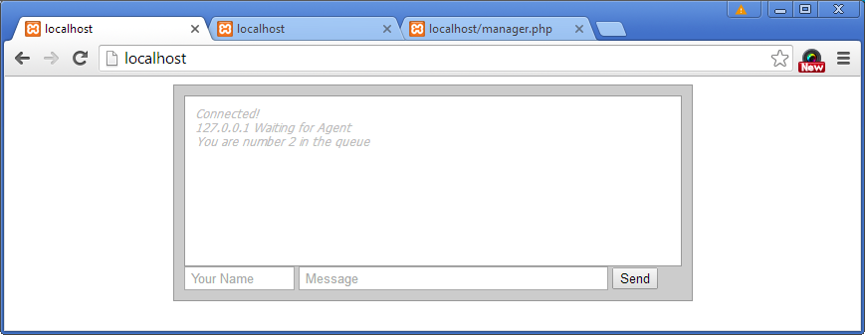

Check that Customer 3 Tab indicates that they are first in the queue.

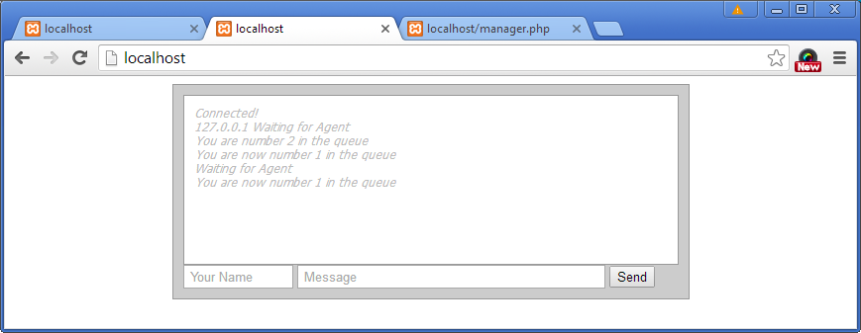

Manager 2 Starts a Chat

Manager 2 Tab-> Name=Mgr2, Message=Hello from Manager 2, Click Send.

Check that Manager 2 Tab indicates that a chat has been started and one customer, which is Customer 2, is still waiting.

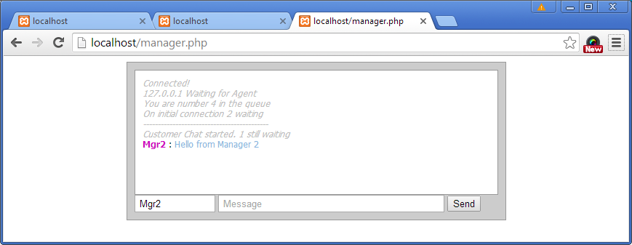

Check that Customer 3 Tab indicates a chat is in progress and displays the Manager 2 message.

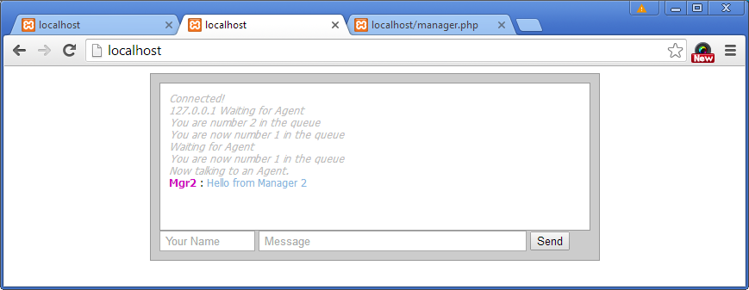

Check that the Customer 2 Tab indicates they are first in the queue.

