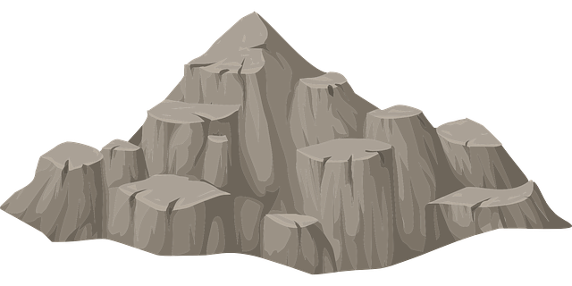
The New Stone Times
Want a REAL tomb?  Kickstart it! https://stn.st/egypttombs |  | VISIT ORKNEY  No boat needed! Just pay us! Phone: (123) 4567-890 | Join us!  https://greece.math.com

HOMES FOR SALE
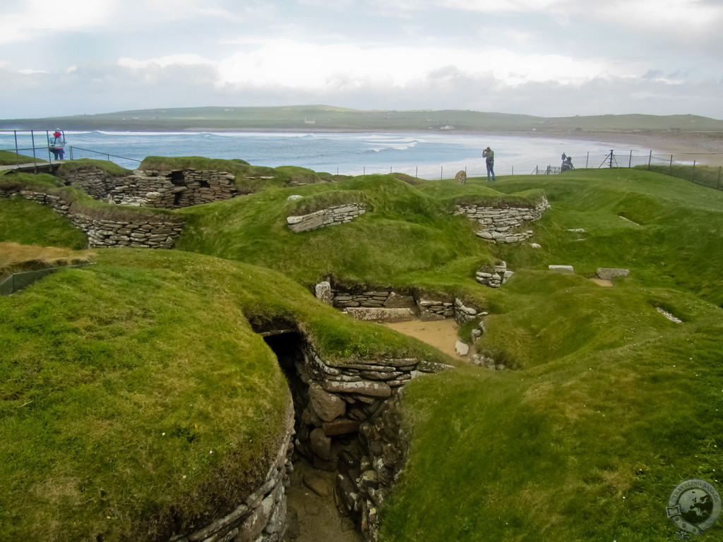
Orkney, Skara Brae | $1,010-10,100

Skara Brae is an awesome place to live these days. Sadly, most places where you can live at Orkney, are too expensive to live or private. Looks like no way to live on Orkney. But now, some owners decided o leave, giving you the opportunity to get your dream house today. The village hopefully is located next to many touristic places, which are amazing once you understand their purpose.

What are they built from?
The homes are built from stone, with the tops going into the inside, creating a cozy roof feeling.

Still not recovered from
STONE AGE?
ICE AGE?
We can help! Call STONE-AGE-500 or ICE-AGE-100 for help.

Continued over page….

What are you waiting for? Let’s take a tour!
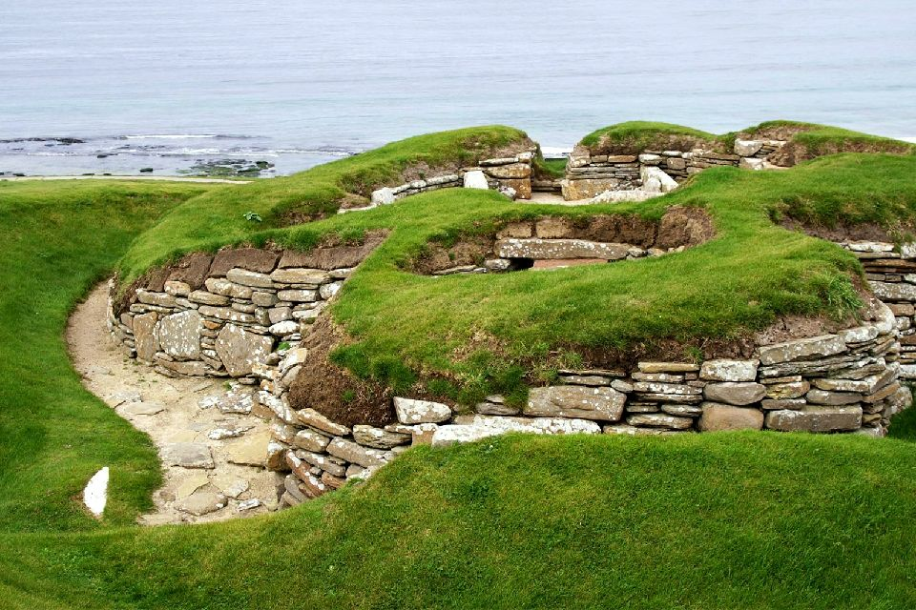
We chose the most coziest house in the whole village, house #8 In this house we have extra storage in the back, and a dresser, to put your stuff into in the front. We got there three cozy luxury beds for you, and your kids and wife. To the left there is a storage space too! But this time it is private. Oh, and on rainy days you can go to your neighbors through the underground passages! Speaking about rainy days and cold days, we got a warm hearth for you in the middle of the house! Doesn’t sound that bad, huh? The houses are priced from $1,010 to $10,010, not so much for a luxury heaven, right? If all that doesn’t look right, let me show you some pictures of it.
