##### Your #1 Mesopotamia magazine!

# New Building Types and The Ziggurat project

The king has chosen to make a new invention, and invented the pyramids. Well, the pyramids should be invented a bit later, so he decided not to invent them. Instead, he decided to call his invention a Ziggurat, giving the same name to the project that will build those across the world.

[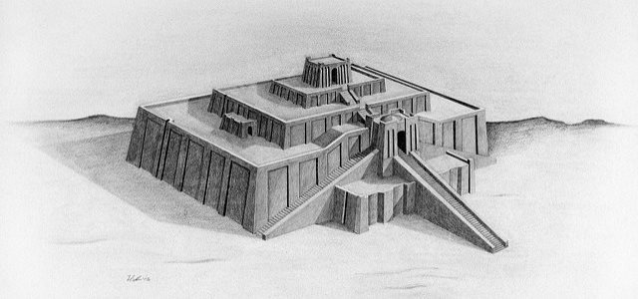](https://www.infocuriosity.com/all-you-need-to-know-about-ziggurat/) <The Ziggurat concept

The top part will be the room dedicated to the god of the city. The middle rooms will be used for the city’s ruler’s quarters and other things.

The lower parts will be for rent, so people can rent a place there to sell their goods. The staircases are going to be designed by the best designers in the whole Sumer. Additionaly, there is going to be a park on the blank spaces, where everyone will be able to relax. [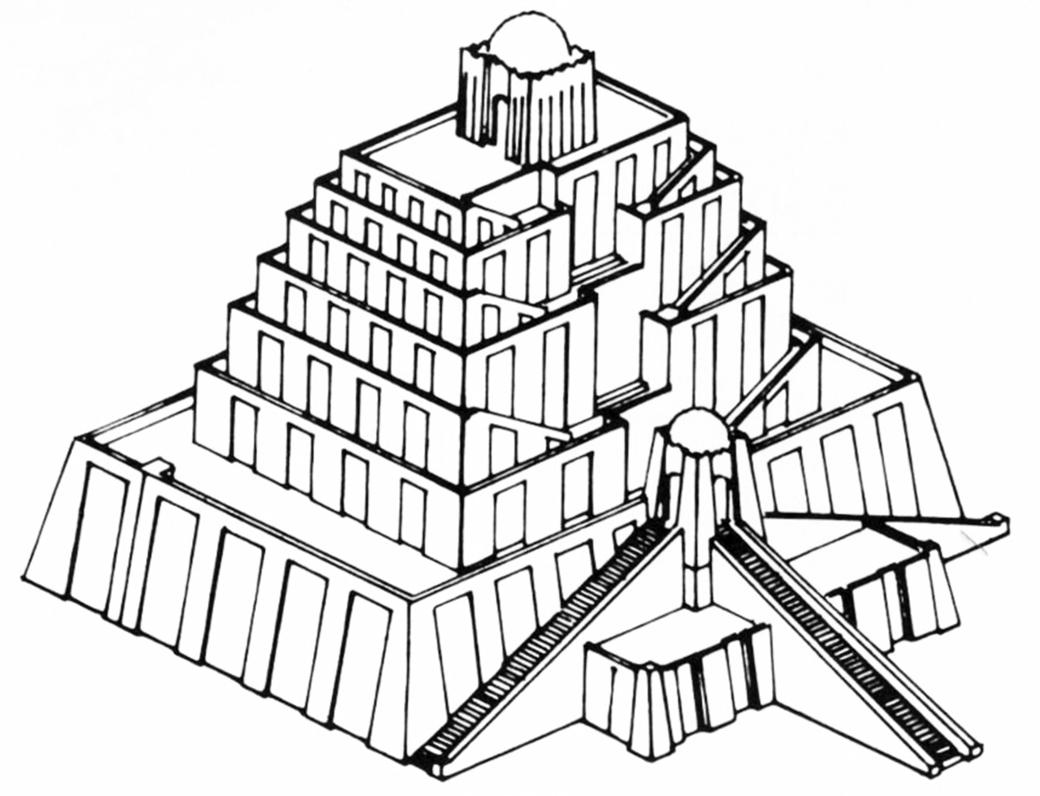](https://24.media.tumblr.com/tumblr_m4x8fqx2Z31qe0nlvo1_1280.jpg)Another concept art shows the higher version of the ziggurat, that might work but is expected to break, until it is going to be planned fully. In this concept there will be more places to rent and maybe some places to rent and live, so get ready for a rush.

The prices are going to start from $200 which is a cheap price for something incredibly new. So what do you think? If you like this idea please kindly support the project on https://mesop.ot/am/ziggurat

The first one is already starting to get built in Ur, but it might take some moths to complete the build. We will let you know when there are cheap places available. Craftsmen will get 25% off. Priests will get 50% off. The King’s men will get 75-99% off depending on the cost and the size.