

**International School**

**Team projects**

**SRS DOCUMENT**

*Date: September, 2024*

**CMU-SE 214 ACIS**

**Online Clothing Retail application**

**Posted by**

**Nguyen Phan Vinh  
Le Tien Danh  
Tran Anh Quang  
Huynh Tan An  
Thai Thanh Cong  
Le Hai Dang**

**Approved by**

*Nguyen Trung Thuan*

|  |  |  |  |
| --- | --- | --- | --- |
|  | **PROJECT INFORMATION** | |  |
| **Project**  **Abbreviate** | Clothers App | |  |
| **Project Name** | Clothers management app | |  |
| **Start date** | 10/09/2024 | |  |
| **End date:** | 15/10/2024 | |  |
| **Main organizations** | International School, Duy Tan University | |  |
| **Project Advisor** | M.Sc Thuan, Nguyen Trung | |  |
| **Scrum Master** | Le Hai Dang | hd1732005@gmail.com | 29219042977 |
| **Team members** | Le Tien Danh | letiendanh123@gmail.com | 29219020567 |
| Tran Anh Quang | Xuhexxit1@gmail.com | 29214227220 |
| Nguyen Phan Vinh | woasoaicaphanvinh@gmail.com | 29219024755 |
| Thai Thanh Cong | doem579@gmail.com | 29211141385 |
|  | Huynh Tan An | huynhtanan2@gmail.com | 29219054529 |

Contents

**1.** **Introduce** 4

**1.1.** **Document purpose** 4

**1.2.** **Scope** 4

**1.3.** **Project Proposal** 4

**1.4.** **Bibliography** 5

**2.** **Overall Description** 5

**2.1.** **System Environment** 5

**2.2.** **Functional Requirements Specification** 5

**2.2.1.** **Register users Use Case** 5

**2.2.2.** **User Use Case** 6

**2.2.3.** **Use Case** 7

**2.2.4.** **Help ER Diagram** 9

**2.2.5.** **System Work Data Flow Diagram** 9

**2.3.** **Functional Requirements** 10

**2.4.** **Non-Functional Requirements** 10

**3.** **System Design** 11

**3.1.** **Description of procedures and function** 11

**4.** **Implementation and Testing** 11

**4.1.** **Introduction** 11

**4.2.** **Layout** 12

**4.2.1.** **Login** 12

**4.2.2.** **Register a new account** 12

**4.3.** **Layouts report** 14

**4.3.1.** **Register layout** 14

**4.3.2.** **Login layout** 15

1. **Introduce**
   1. **Document purpose**

Online Clothing Retail application. It will explain the purpose and characteristics of the system, its interfaces, the functions the system will perform, the constraints it must adhere to, and how the system will react to external stimuli. This application aims to create a convenient, fast, and secure shopping experience for users while connecting consumers with fashion brands through an online platform.

* 1. **Scope**

This online clothing retail application is designed to serve a diverse audience and functions, creating a wide range of options:

* Customers and Users: The application primarily targets individuals who are interested in fashion and shopping online. However, it can also cater to a broad audience, including various age groups and fashion preferences.
* Range of Products: The application offers a wide variety of clothing items, including apparel for men, women, and children, as well as accessories. This ensures that users can find suitable options for themselves and their loved ones.
* Accessibility: The application is accessible from anywhere with an internet connection (3G, 4G, 5G, Wi-Fi), making it easy and convenient for users to shop from personal computers, mobile phones, or tablets.
  1. **Project Proposal**

Technology today is one of the most important resources and can be applied in all areas of life, from science, education, engineering, and communication to entertainment, shopping, and many other fields. Therefore, the idea is to create an online clothing retail application to help people easily access fashion and shopping. The online clothing retail application is a software system designed to support fashion shopping activities. This application simplifies the shopping process, increases accuracy and efficiency, and improves the user experience. The online clothing retail system includes features such as browsing and searching for products, order tracking, promotional notifications, product reviews, and flexible payment integration. The application also allows users to store their account information and shopping history. Thus, the Online Clothing Retail Application is a great solution that helps users save time and effort in shopping while meeting their fashion needs quickly and conveniently.

* 1. **Bibliography**

[SRS Example (mu.edu.sa)](https://m.mu.edu.sa/sites/default/files/content/2019/10/Final%20report.pdf)

[Software Requirements Specification document with example - Krazytech](https://krazytech.com/projects/sample-software-requirements-specificationsrs-report-airline-database)

[Example Software Requirements Specification (SRS) | ReqView](https://www.reqview.com/doc/iso-iec-ieee-29148-srs-example/)

1. **Overall Description**
   1. **Use Case Diagram**

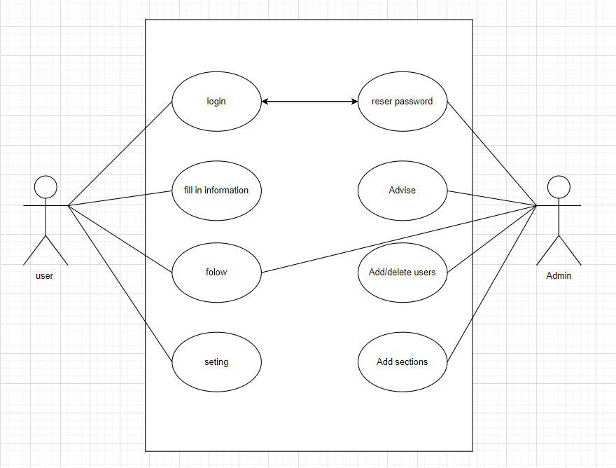

* 1. **Functional Requirements Specification**

This section outlines the use cases for each of the activities in the program.

* + 1. **Register users Use Case**

***Use case***: Account Create

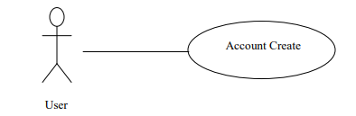

***Brief Description***

If the user wants to use the program, he must register within it to benefit from it.

***Initial Step-By-Step Description***

Before this use case can be initiated, the user already has the program.

1. The user will be creating an account.

2. The system requires the activation of the account.

3. The user needs to reset the password.

4. User access the system.

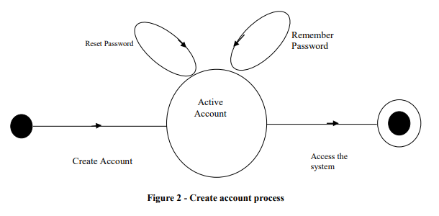

* + 1. **User Use Case**

The User after registering has the following:

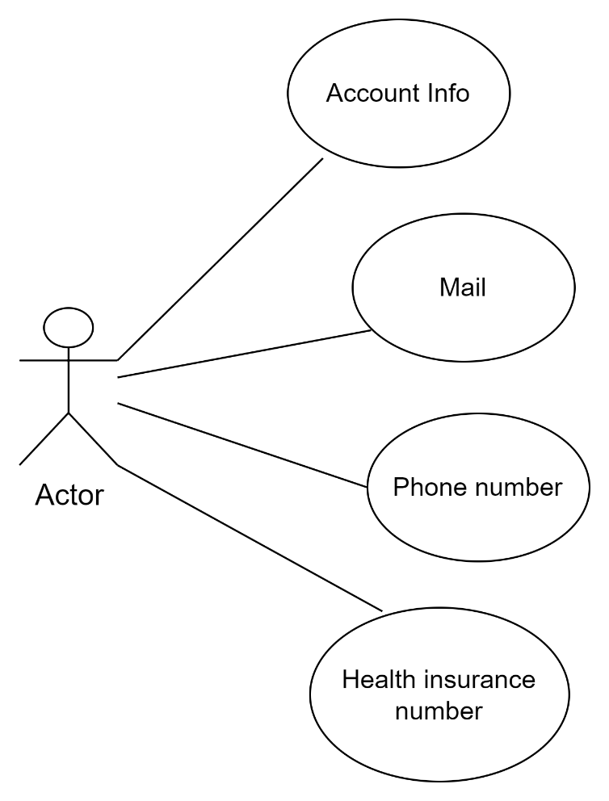

* + 1. **Use Case**

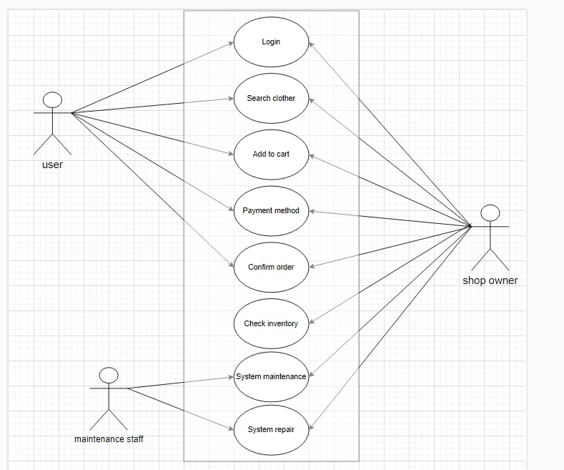

* + 1. **Help ER Diagram**

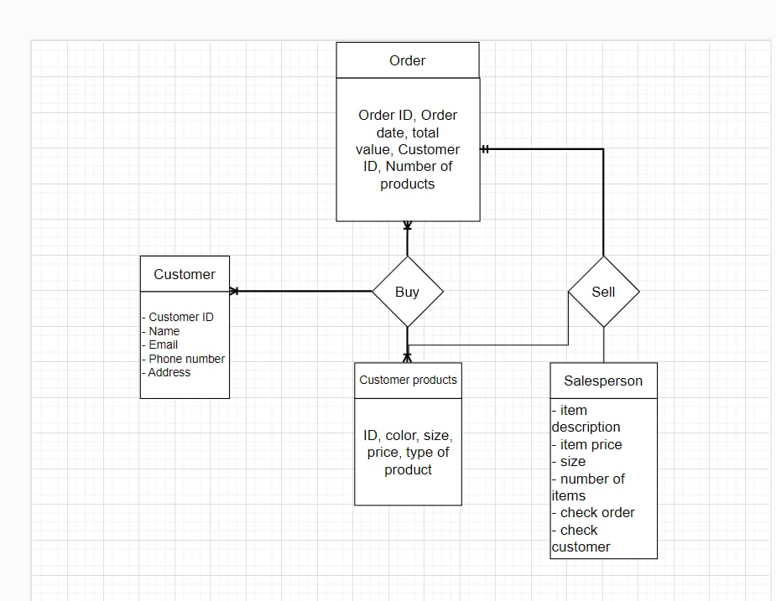

* + 1. **System Work Data Flow Diagram**

**2.3. Functional Requirements for a Clothing Store:**

1. Product Browsing and Search

2. Product Detail Page

3. User Registration and Login

4. Shopping Cart Management

5. Checkout Process

6. Order Tracking

7. Inventory Management

8. Product Reviews and Ratings

9. Shipping Options

10. Mobile Responsive

11. Secure Payment Gateway

12. Social Media Integration

**2.4. Non-functional requirements for a clothing store application:**

1. Efficiency

o When a customer places an order or performs an action, the system should respond quickly and process it efficiently.

2. Usability

o The interface should be user-friendly, easy to use, and clear, providing a smooth shopping experience for customers.

3. Get help

o Provide users with instructions or support contact information when needed.

4. Scalability

o The application should be scalable and upgradeable to support additional products, services, or users without sacrificing performance.

5. Interoperability

o The application should be able to integrate with other systems such as payment gateways, inventory management software, and social media platforms.

6. Reliability

o The application operates stably and ensures no errors during use and product approval.

7. Maintainability

o The application can be easily maintained and updated when problems or changes are encountered.

8. Confidentiality

o The application is secured from cyber attacks, ensuring the safety of customers' personal information and payment data.

9. Regulation

o The application operates stably, without incidents or errors that disrupt the user experience.

10. Manageability

o There is an administrator responsible for managing and monitoring the application's operations, ensuring the system operates smoothly.

**3. System Design**

3.1. Process and Function Description

The system is deployed and simulated on Figma, with main functions built to work on all three platforms iOS, Android, and web. The application will be compatible with:

• iOS operating system: Version 11.0 or higher.

• Android operating system: Version 8.0 or higher.

• Web app: Compatible with popular browsers such as Chrome, Firefox, Safari.

3.2. Main components of the system

1. Frontend (User Interface):

o Design intuitive, easy-to-use user interface with interface development technologies:

▪ iOS: Using Swift and SwiftUI.

▪ Android: Using Kotlin or Java.

▪ Web: Using React.js or Vue.js.

o Main functions:

▪ Browse products: Users can browse fashion products by category (shirts, pants, shoes, accessories) and by filter criteria (price, color, size).

▪ Search: Allows users to search for products by keyword.

▪ Add products to cart: Users can select products and add them to cart.

▪ Manage user accounts: Update personal information, view purchase history.

▪ Online payment: Integrate with online payment gateways to process order payments.

2. Backend (Business processing):

▪ API: The system will use RESTful or GraphQL API to communicate between devices and servers.

▪ Backend functions:

▪ Product management: The system can add new, update, and delete products from the admin dashboard.

▪ Order Management: Manage order information, payment status, and delivery status.

▪ User Management: Supports registration, login, authentication, and user account management.

▪ Payment: Integrate payment gateways such as Stripe, PayPal, Google Pay, or Apple Pay to process transactions.

▪ • Database:

▪ SQL Database: Use MySQL or PostgreSQL to store product, user, and order data.

▪ NoSQL Database: Use MongoDB or Firebase to store unstructured data such as user product browsing history information.

▪ Main tables:

▪ Product table: Contains product information such as name, price, description, quantity.

▪ User table: Contains customer information, including name, email, address, and purchase history.

▪ Orders table: Contains information about orders, including status, quantity, and order value.

1. Database:

o SQL Database: Use MySQL or PostgreSQL to store product, user, and order data.

o NoSQL Database: Use MongoDB or Firebase to store unstructured data such as information about users' product browsing history.

o Main tables:

▪ Product table: Contains product information such as name, price, description, quantity.

▪ User table: Contains customer information, including name, email, address, and purchase history.

▪ Orders table: Contains information about orders, including status, quantity, and order value.

2. System architecture:

o Client-Server architecture: The system operates according to the client-server model, where the user interface (client) communicates with the server via API to retrieve and send data.

o API layer: Ensures that data between the frontend and backend is transmitted securely and quickly.

o Security: The system uses SSL to encrypt information between the client and the server. At the same time, sensitive data such as passwords and payment information will be encrypted in the database.

3. Advanced features:

o Push Notifications: Notifications about promotions, discounts or order information via push notifications on both Android and iOS.

o Machine Learning (Optional): Can use machine learning algorithms to suggest products that match the user's shopping behavior.

o Warehouse management: The system can connect to warehouse management software to update inventory quantities in real time.

3.3. System Requirements

• Software Requirements:

o Frontend: iOS 11+, Android 8.0+, web browser supporting HTML5 and JavaScript.

o Backend: Server with Node.js, Python (Django), or Java (Spring) to handle logic and business.

o Database: MySQL/PostgreSQL for structured data, MongoDB or Firebase for unstructured data.

• Hardware Requirements:

o Server must be scalable to accommodate a large number of users, with the ability to handle multiple requests simultaneously.

o Storage: Large enough capacity to store product information, orders, and user data.

3.4. External Integration

• Payment: The system can integrate payment gateways such as Stripe, PayPal, Google Pay, Apple Pay to process order payments.

• Shipping Services: Integrate with delivery partners such as VNPost, GHN, GHTK to provide delivery services directly from the application.

• User authentication: Integrate OAuth to support login via Google, Facebook, or Apple ID to optimize the login experience for users.

3.5. Development and deployment process

• Design phase: Design user interface (UI) and user experience (UX) on Figma, create prototypes and get feedback from potential users.

• Development phase: Develop both frontend and backend, integrate with external services such as

1. **Implementation and Testing**
   1. **Introduction**

The application consists of three basic interfaces:

New account registration interface:

Users can create a new account by filling in information such as name, email, password and confirm password.

There is a "Register" button to register after filling in all the information.

Login interface:

Users can log in with the registered email and password.

The "Login" button is to authenticate and enter their account.

Can include a password recovery option if the user forgets it.

Home page interface:

Display personalized welcome information (e.g. "Hi, [Username]").

Featured product categories, such as new clothes of the month.

Integrate a "Buy Now" button for selected products.

Bottom navigation bar with icons such as:

Home

Cart

Favorites

Profile

Notifications

Home screen dialog:

Displays notifications about new products, promotions, or information related to orders and shipping.

Users can view information and details about products or services on the home page.

Add new user dialog:

Appears after a user successfully registers an account, confirming that an account has been created.

May ask the user to add details, such as a shipping address or update a personal profile.

Add comment/review dialog:

After making a purchase, the user can leave a review for the product.

This dialog allows the user to rate the product (e.g. 1-5 stars) and write a review about their experience.

User Database:

Stores information about all users who have registered an account on the application, including:

Username

Email address

Password (encrypted)

Shipping address (can store multiple addresses)

Purchase history

Information about user login time and activity.

Product Information Database:

Stores detailed information about products currently available in the store, including:

Product ID

Product name

Detailed product description

Price

Size, color, and other options

Inventory quantity

Product image

Promotion information (if any).

Comments Database:

Stores user comments and reviews on products, including:

Comment ID

Product ID

User ID who left the review

Review (star rating from 1-5)

Detailed comment content

Date and time the review was submitted.

* 1. **Layout**
     1. **About page**

* + 1. **login page**

* + 1. **registration page**

* + 1. **Home page**

* + 1. **Bar page**

* + 1. **Information page**

* + 1. **Announcement page**

* + 1. **Short neck shirt list page**

* + 1. **Jeans List Page**

* + 1. **shirt buying site**

* + 1. **shopping cart page**

* + 1. **shipping address page**

* + 1. **delivery method selection page**

* + 1. **order in transit page**

* + 1. **successful order page**

* + 1. **payment method selection page**

* + 1. **order confirmation page**

* 1. **Layouts report** 
     1. **Register layout**

* + 1. **Login layout**

