1. To support “float” with sprintf() function for STM32:

+STM32Cube IDE:

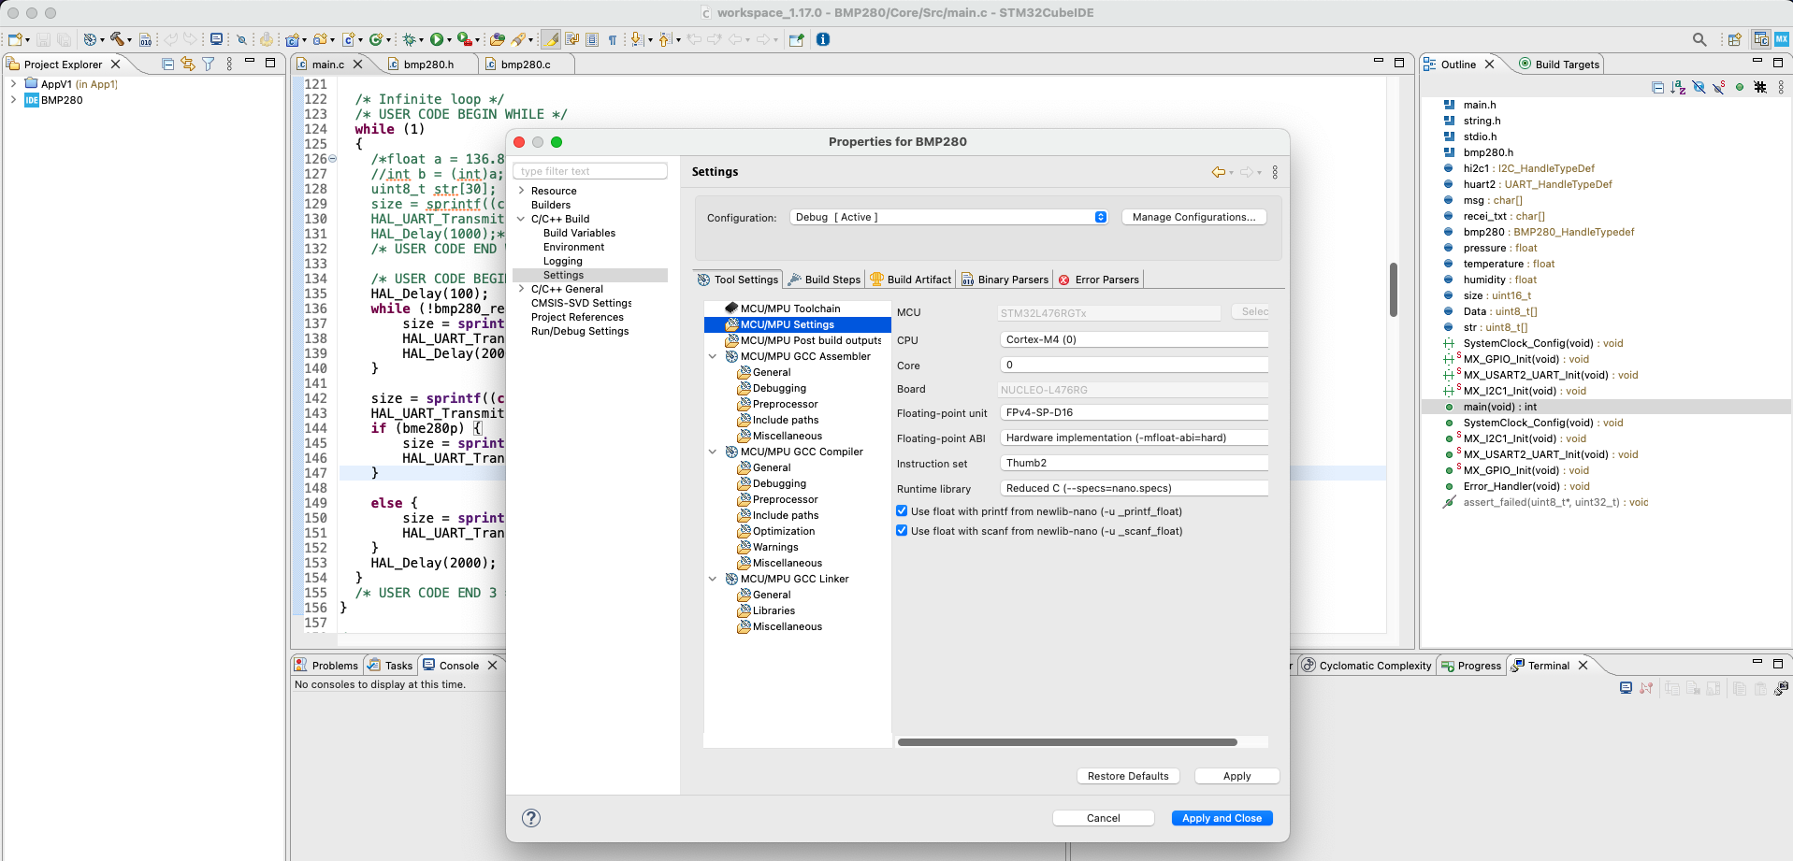

+ VScode:

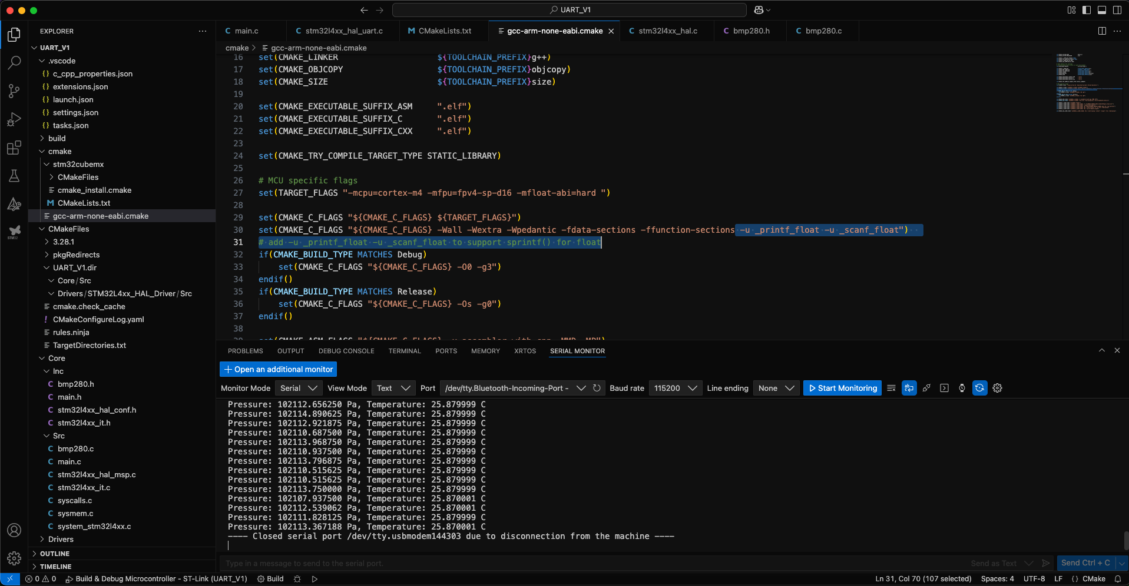

<https://stackoverflow.com/questions/54534700/enabling-floating-point-emulation-in-gcc-arm-none-eabi>

CFLAGS = -W -Wall -O0 --std=gnu99 -fgnu89-inline -mcpu=cortex-m3 -mthumb -msoft-float

CFLAGS += -ffunction-sections -fdata-sections -mfloat-abi=soft -u _printf_float -u _scanf_float

LDFLAGS = -nostartfiles -specs=rdimon.specs -specs=nano.specs -lc -lrdimon -u _printf_float -u _scanf_float

2. Adding library files path

VScode:

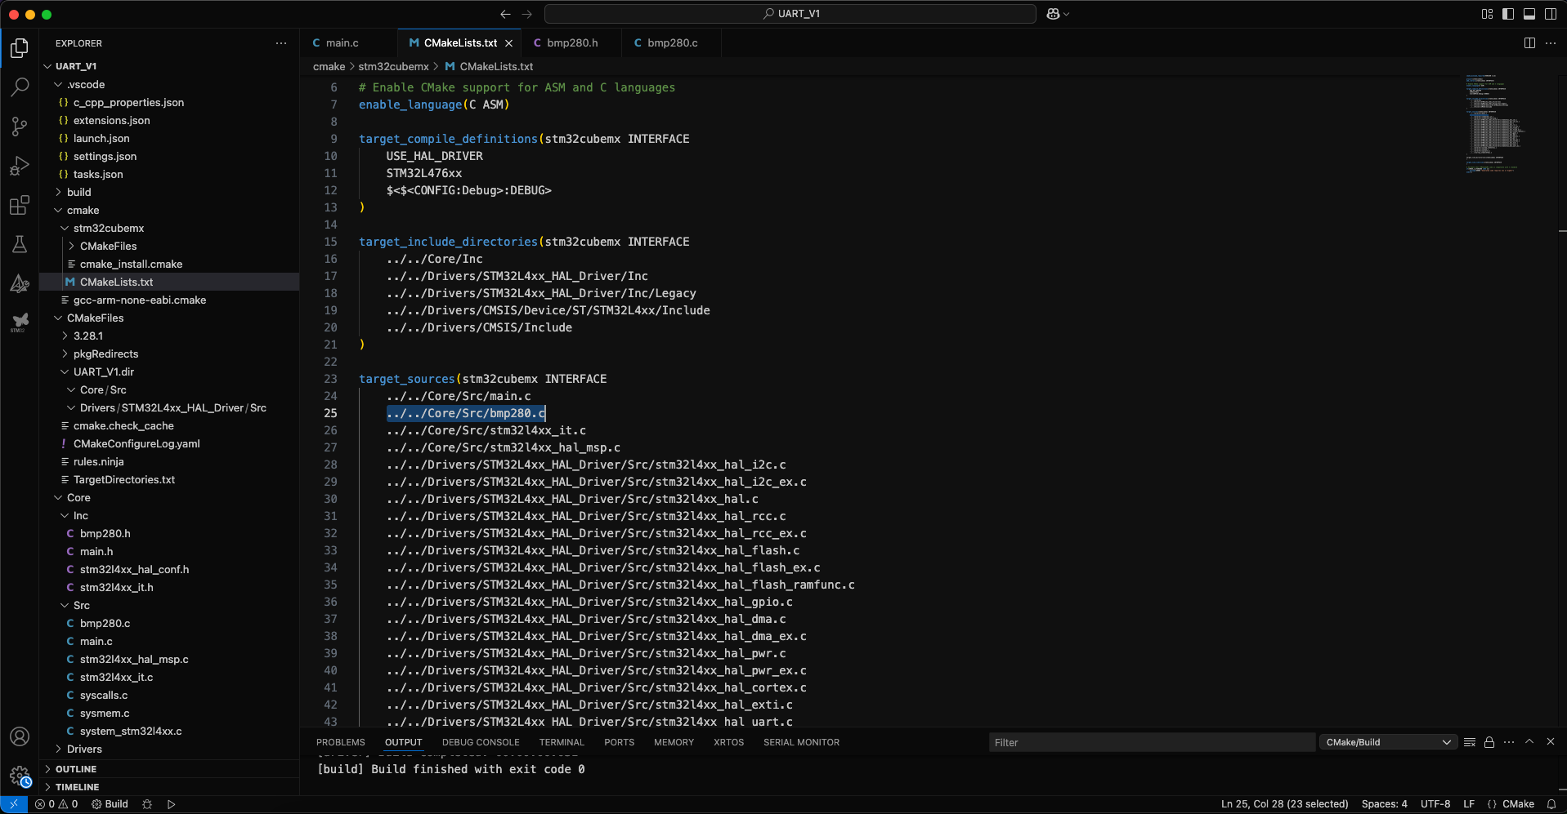

STM32CubeIDE:

Only “Inc” folder:

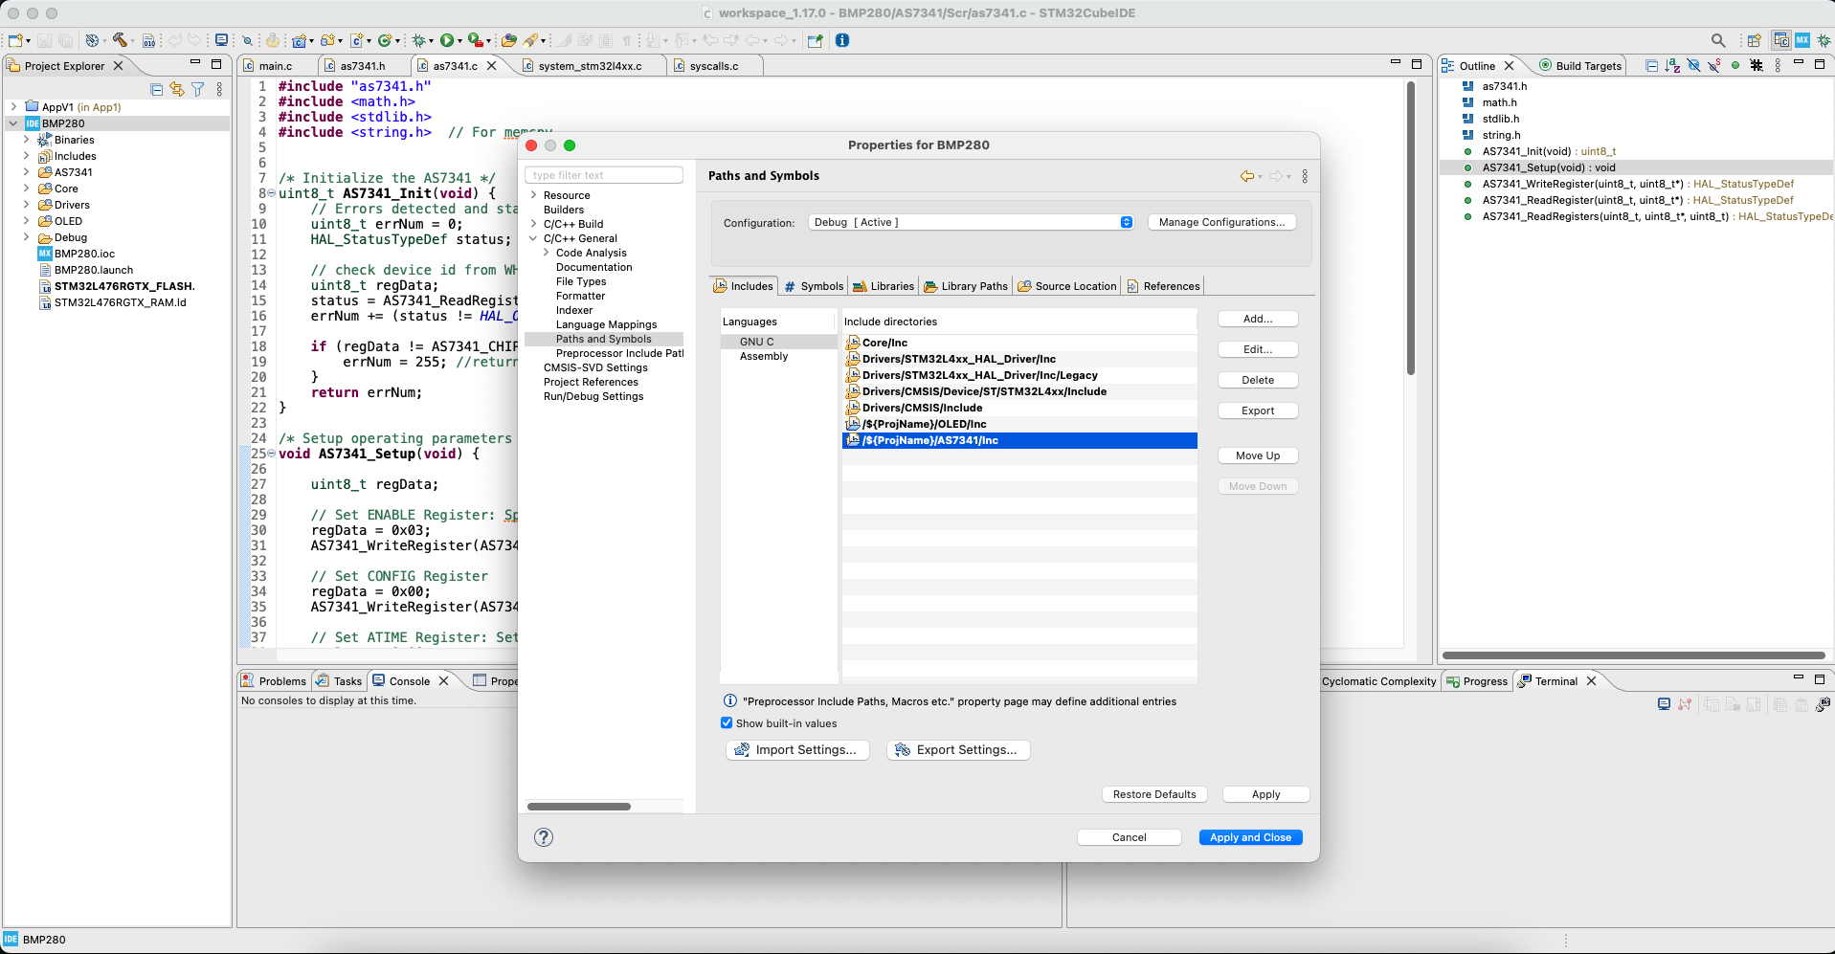

Library folder (both Scr and Inc)

