Challenge 1.

1. Show that F ∨ G ∨ G’ ∨ H is not valid.

For domain D = food that taste good by itself, and P means “eat together and taste good”

is always false, as all foods in domain taste good by itself.

is false, if x, and y combine good, and y and z combine good, doesn’t imply x and z combines good.

is false, if x, and y combine good, and y and z combine good, doesn’t imply x and z combines doesn’t taste good.

is also false, if x and y combines taste good, y and x combine is the same which is also good. This implies not good.

Under this interpretation ,

For domain D = , and P means “less than”

( will be true)

Under this interpretation ,

Therefore, S = F ∨ G ∨ G’ ∨ H, it’s not valid

1. Show that F ∧ G’ ∧ H is satisfiable.

For domain , and P means “is not a mother of”

Under this interpretation ,

For domain , and P means “is mother of”

Under this interpretation ,

Therefore, F ∧ G’ ∧ H is satisfiable

c. Show that (F ∧G)⇒H is valid.

Negate S:

(1). makes true only if for all which

**makes false**

(2). true only if for all

(3). makes true requires makes true and makes true, according to the (2), this means () is true, which is a contradiction to (1).

So, , and S is valid

Challenge 2

a.

S1:

S2:

S3:

S4:

b.

S1:

S2:

S3: (

c.

S4:

d.

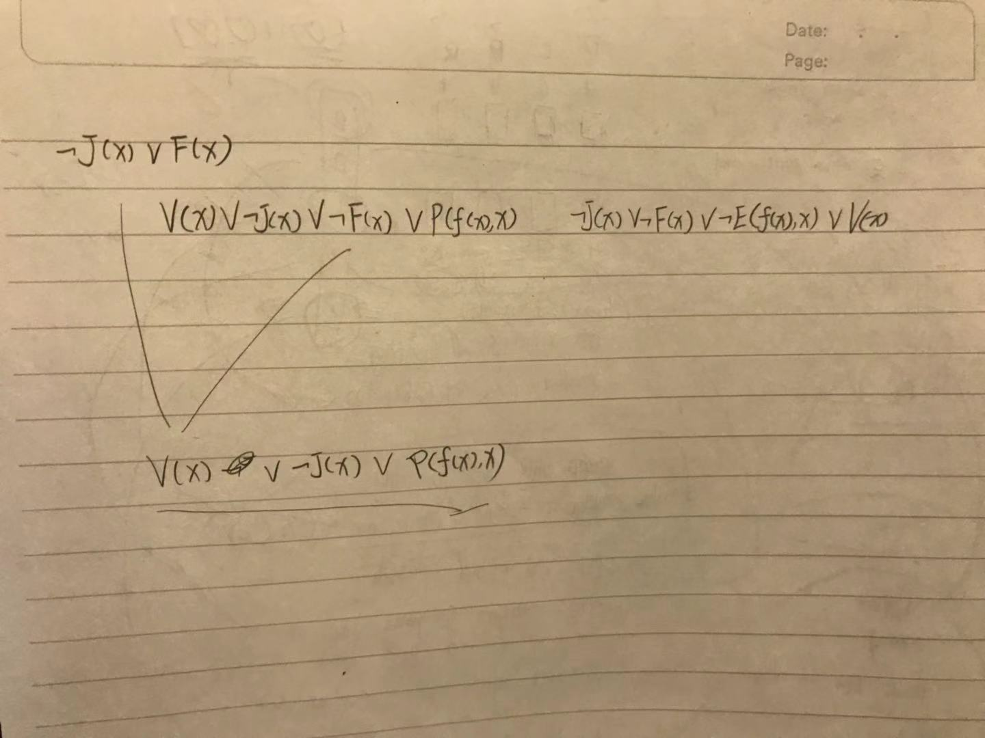



S4:

Proof by resolution

Challenge 3

For every input there is a different output, so

For these two inputs there is a same output, so

For every input there is a different output, so

1. For a n-dimensional Boolean vector function, which both number of inputs and outputs are n.

So, there will be number of inputs, and for the output, there will be of combinations if we only have 1 output, as for the number of inputs, it produce 1 output which has two possibilities (0, or 1).

Therefore, for a number output of n, there will be combinations . In other words, there will be distinct n-dimensional Boolean vector functions.

In terms of reversible functions, this means that the outputs of the function must be distinct for each distinct input. In this case, it would be the same number of inputs, which is . However, the order of these distinct output doesn’t necessary to be fixed. So, this is a problem of permutation. We have elements, and we have “rows” to permutate with. So, the number will be or

So, the formula of fraction of reversible functions to the total number of distinct functions, will be