1. **Data**

**Data 1:** Neighborhood has a total of 5 boroughs and 306 neighborhoods. In order to segment the neighborhoods and explore them, we will essentially need a dataset that contains the 5 boroughs and the neighborhoods that exist in each borough as well as the latitude and longitude coordinates of each neighborhood. This dataset exists for free on the web. Link to the dataset is: https://geo.nyu.edu/catalog/nyu_2451_34572

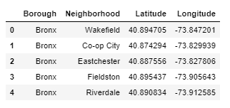

**Data2:** New York city geographical coordinates data will be utilized as input for the Foursquare API, that will be leveraged to provision venues information for each neighborhood. We will use the Foursquare API to explore neighborhoods in New York City.

Moreover, Vietnamese restaurant category Id 4bf58dd8d48988d14a941735 is used for retrieving data from Foursquare API.