**The Battle of the Neighborhoods – Report**

1. **Introduction & Business Problem:**

Vietnam is known for its centuries-old architecture and a rich culture with Southeast Asian, Chinese and French influences. At its heart is the chaotic Old Quarter, where the narrow streets are roughly arranged by trade. Food street is one of unique features that make Vietnam becomes a attractive travel destination in Asian. Vietnamese food is highly recommended by tourists around the world.

The City of New York, is the most famous city in the United State. It provides lot of business opportunities and also friendly business environment. There are places with diverse in ethnic cultures as you can see people come from around the world living there. A diverse in cultures bring an opportunity to start your own business with an exotic product that may attract a lot of customers.

Therefore, it is a good idea to start your own Vietnamese restaurants which serves an exotic food – Vietnamese food in New York city. But how can we start and know where we should open Vietnamese restaurant. This analysis will give the insights of the business environment which can help in strategically targeting the market and reducing risk.

## **Business problem**

In New York city, there are a lot of international cuisines restaurant from around the world like Turkish, Japanese, Chinese restaurants. Vietnamese is one of exotic food and have become popular in United State. Therefore, it is a good idea to start your own Vietnamese restaurants which serves an exotic Vietnamese food in New York city. But how can we start and know where we should open Vietnamese restaurant. This analysis will give the insights of the business environment which can help in strategically targeting the market and reducing risk.

Clearly that, we should open a restaurant in an area that inadequate neighborhood so the restaurants can attract more customers. Moreover, around this location, there are only fewer pho restaurants, so the business environment is not really competitive for us to enter.

My client wants to open his business in Manhatta area, so I focus on that borough during my analysis. We define potential neighborhood based on the number of Vietnamese restaurants which are operating right in each neighborhood.

1. **Data**

**Data 1:** Neighborhood has a total of 5 boroughs and 306 neighborhoods. In order to segment the neighborhoods and explore them, we will essentially need a dataset that contains the 5 boroughs and the neighborhoods that exist in each borough as well as the latitude and longitude coordinates of each neighborhood. This dataset exists for free on the web. Link to the dataset is: https://geo.nyu.edu/catalog/nyu_2451_34572

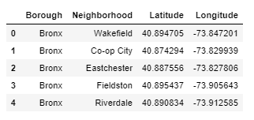

**Data2:** New York city geographical coordinates data will be utilized as input for the Foursquare API, that will be leveraged to provision venues information for each neighborhood. We will use the Foursquare API to explore neighborhoods in New York City.

Moreover, Vietnamese restaurant category Id 4bf58dd8d48988d14a941735 is used for retrieving data from Foursquare API.

1. **Methodology**

In this project, I will use the basic methodology as taught in Week 3 lab.

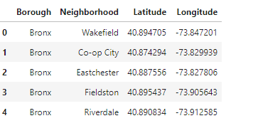

First, I convert addresses into their equivalent latitude and longitude values. Then using Foursquare API to explore neighborhoods in Manhattan, New York. Finally, explore function to get Vietnamese restaurant categories in each neighborhood.

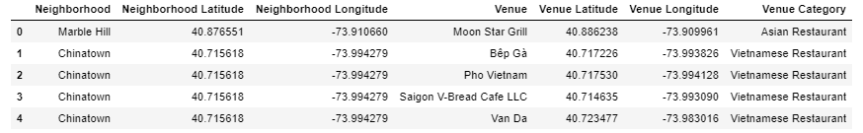

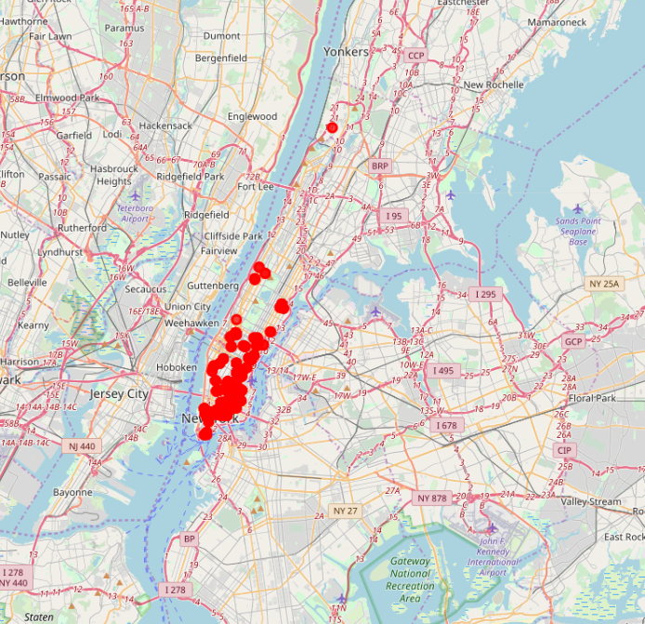

Vietnamese restaurants in Manhattan

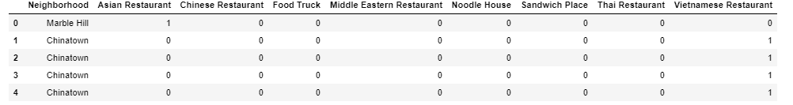

Group the neighborhoods into clusters K-means clustering algorithm 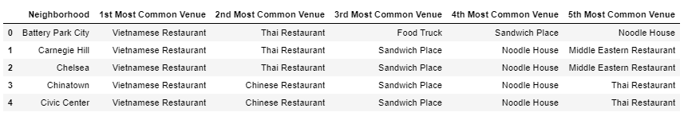

1. **Results**

**K-mean Cluster** Using K-mean to clustering data area with less number of sushi bars

**Cluster 0**

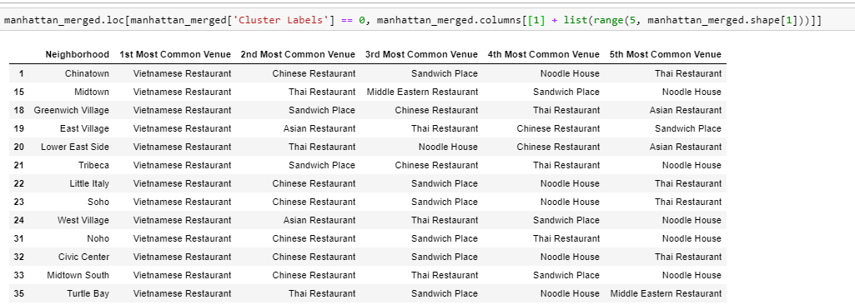

**Cluster 1**

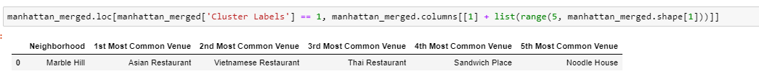

**Cluster 2**

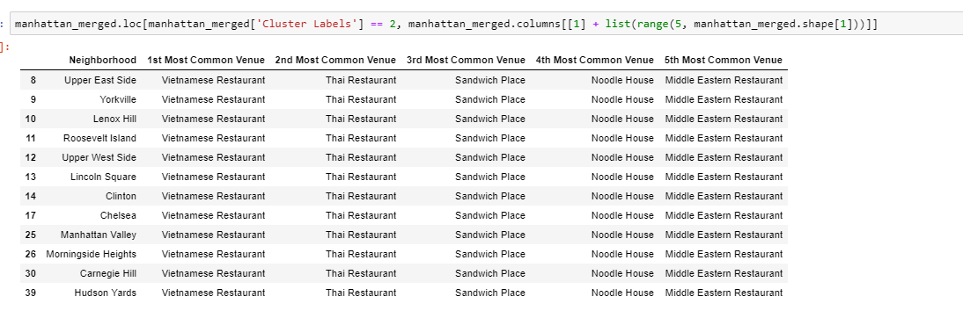

**Cluster 3**

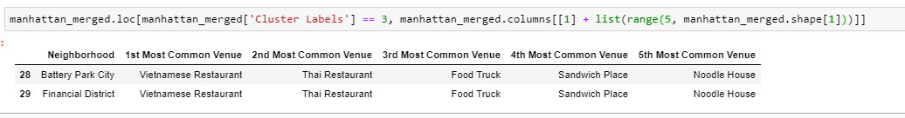

**Cluster 4**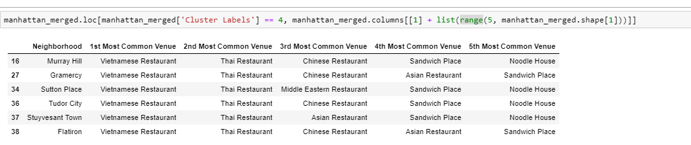

Based on dataframe analysis above Cluster 1 (Marble Hill) areas is the best places to open a new Vietnamese restaurant business.

1. **Discussion**

In this section, I would be discussing the lack of data. Due to the limit of data, this analysis may be right or wrong. If there are more data available, I believe that the result will be much better.

1. **Conclusion**

In conclusion, the best areas for open Vietnamese restaurant is Marble Hill. The result of project may be right or not because of data lacking. There is definitely the room for further improvement. However, we met the object of the project.