Smart Fleet Intelligence for Route Optimization and
Profit Per Trip Enhancement

DESIGN DOCUMENT

1.Introduction
This design document presents the technical blueprint for the Smart Fleet Analytics Platform, an Azure-based data engineering solution designed to analyze fleet operations and optimize profit per trip. The platform integrates data from multiple fleet-related sources such as trip records, vehicle and driver master data, GPS tracking, fuel consumption, and traffic information.
The objective of this document is to describe how the system is designed, including the architecture, data ingestion strategy, storage layers, processing logic, data model, and analytics components. It follows standard Software Development Life Cycle (SDLC) principles to ensure the solution is scalable, maintainable, and aligned with enterprise best practices.
The platform is implemented as a batch-oriented analytics solution, where data is periodically ingested, cleaned, transformed, and analyzed. This approach is well-suited for operational reporting and KPI-driven decision-making in logistics environments, where near-real-time insights are sufficient and system stability is critical.
This document serves as a reference for developers, architects, analysts, and stakeholders to understand the technical design and implementation approach of the system before development and deployment

2. Business Problem Statement
Logistics and fleet management organizations generate large volumes of operational data from vehicles, drivers, and routes on a daily basis. However, this data is often stored in disconnected systems or raw files, making it difficult to gain meaningful insights into operational efficiency and profitability.
Key challenges faced by the business include:
- High fuel costs due to inefficient routing and excessive idling
- Delays caused by traffic congestion and unplanned route deviations
- Limited visibility into driver performance and behavior
- Manual and delayed analysis of trip costs after trip completion
- Absence of a centralized system to measure and monitor profit per trip
Due to these challenges, management teams lack timely and accurate insights to identify cost leakages, optimize routes, and improve overall fleet performance. Decisions are often reactive rather than data-driven, leading to increased operational expenses and reduced margins.
The Smart Fleet Analytics Platform addresses these issues by consolidating fleet data into a unified analytics system. By applying structured data processing, business rules, and KPI calculations, the platform enables proactive monitoring of fleet operations and supports informed decision-making aimed at improving profitability and operational efficiency.

3.Project Objectives
The primary objective of the Smart Fleet Analytics Platform is to build a centralized, scalable analytics solution that transforms raw fleet data into meaningful business insights. The key objectives of the project are as follows:
- Centralize fleet data across multiple sources
Consolidate driver, vehicle, route, trip, GPS, fuel, and traffic data into a single analytics platform to eliminate data silos and ensure a unified view of fleet operations.
- Enable accurate profit per trip calculation
Compute profit per trip by combining fuel costs, delays, idle time, and operational metrics, allowing management to assess trip-level profitability.
- Improve route efficiency and compliance monitoring
Analyze planned versus actual routes to identify deviations, unnecessary detours, and inefficient routing patterns that increase fuel usage and delays.
- Monitor and reduce fuel consumption and idle time
Track fuel usage and engine idle periods to identify wastage and operational inefficiencies, supporting cost reduction initiatives.
- Evaluate driver performance and efficiency
Calculate driver efficiency scores based on driving behavior, fuel usage, idle time, and route adherence to encourage responsible driving practices.
- Provide actionable KPIs and insights to stakeholders
Deliver clear, business-ready KPIs and dashboards that enable operations teams and management to make informed, data-driven decisions.

4. Scope of the Project
This section defines the functional and technical boundaries of the Smart Fleet Analytics Platform to ensure clarity on what is included and excluded in the implementation.
In Scope
- Batch ingestion of fleet-related data
Ingest structured and semi-structured data such as CSV, Excel, and JSON files using Azure Data Factory on a scheduled basis.
- Data cleaning, validation, and transformation
Perform structural cleaning, data quality checks, and business rule enforcement using Azure Databricks to ensure reliable analytics.
- Layered data storage architecture
Implement raw, cleaned, and curated data layers in Azure Data Lake Storage Gen2 to support traceability and reprocessing.
- Relational data modeling
Design and populate a relational data model consisting of 13 interrelated tables with Trip as the central entity.
- KPI calculation and analytics
Calculate operational and financial KPIs such as fuel cost per trip, idle time, delay minutes, driver efficiency score, and profit per trip.
- Dashboard and reporting development
Develop Power BI dashboards to visualize fleet performance, profitability, and operational trends.
- Monitoring and alerting
Implement monitoring and alerts for pipeline failures, data freshness issues, and operational anomalies.

Out of Scope
- Real-time streaming data ingestion
Continuous ingestion using Event Hubs or IoT Hub is not included in the current phase.
- Machine learning and predictive analytics
Advanced ML-based route optimization and demand forecasting are considered future enhancements.
- Vehicle control or navigation systems
The platform does not provide real-time navigation or vehicle command capabilities.

5. Stakeholders & RACI Matrix
Key Stakeholders
- Business Sponsor (Logistics Head)
- Product Owner (Fleet Operations Manager)
- Data Engineering Team
- BI & Analytics Team
- Fleet Supervisors
- Management & Finance Teams

RACI Matrix
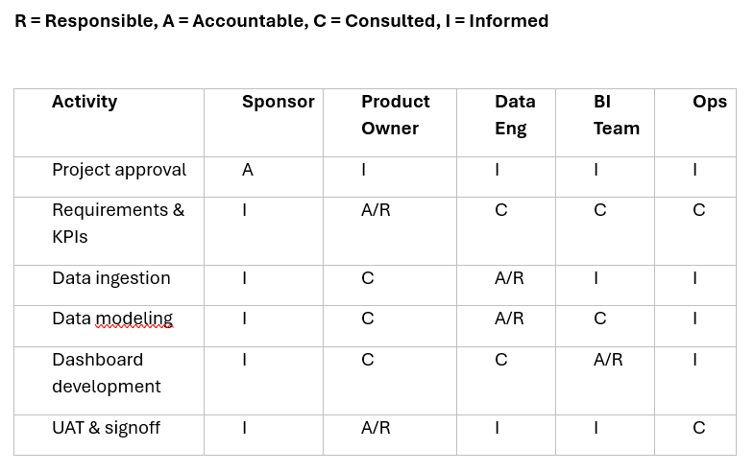

6.High Level Solution Overview
The Smart Fleet Analytics Platform is designed as a batch-oriented data analytics solution that consolidates fleet operational data from multiple sources into a centralized Azure-based platform. The solution enables end-to-end visibility into fleet performance by integrating ingestion, storage, processing, and visualization layers.
At a high level, data from fleet systems such as GPS tracking devices, fuel monitoring systems, trip records, driver information, vehicle details, and traffic data is ingested using Azure Data Factory. The ingested data is stored in Azure Data Lake Storage Gen2 in its raw form to preserve data lineage and support reprocessing.
The raw data is then processed using Azure Databricks, where data cleaning, validation, and transformation logic is applied. Business rules such as idle time calculation, route deviation detection, fuel consumption analysis, and trip cost computation are implemented during this stage. The processed data is converted into structured, analytics-ready datasets.
Finally, the curated datasets are consumed by Power BI to generate dashboards and reports that provide actionable insights to business users. Monitoring and alerting are implemented using Azure Monitor to ensure reliability, operational visibility, and timely issue resolution.
7.Target Architecture
The target architecture for the Smart Fleet Analytics Platform is designed to support batch-based analytics, scalability, and clear separation of concerns across ingestion, storage, processing, and visualization layers.
The architecture follows a layered data design where raw data is ingested without modification, processed through a centralized transformation engine, and stored in analytics-ready formats. Azure-native services are used to ensure reliability, security, and ease of maintenance.
Key architectural principles include:
- Batch-oriented processing using scheduled pipelines
- Separation of raw, cleaned, and curated data to support reprocessing and traceability
- Centralized transformation logic using Azure Databricks
- Decoupling of storage and compute for scalability
- Visualization layer isolated from processing logic
This architecture ensures that new data sources or KPIs can be added with minimal impact on existing components and supports future enhancements such as real-time ingestion.
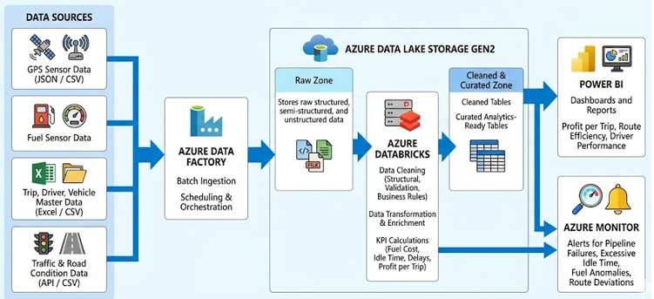

8.Data Sources & Data Classification
The Smart Fleet Analytics Platform integrates data from multiple sources that vary in structure and format. These data sources are classified based on their structure to determine ingestion and processing strategies.
Structured Data Sources include CSV and Excel files containing driver, vehicle, route, and trip master data. These datasets have predefined schemas and can be directly mapped to relational tables.
Semi-Structured Data Sources include JSON-based GPS tracking data and traffic information. These datasets contain nested or flexible structures and require parsing and flattening before analysis.
All incoming data is first stored in the Raw zone of Azure Data Lake Storage Gen2 without transformation. This approach preserves data lineage, enables reprocessing, and supports audit requirements.
The classification helps determine:
- Ingestion method in Azure Data Factory
- Transformation logic in Databricks
- Validation and quality checks required

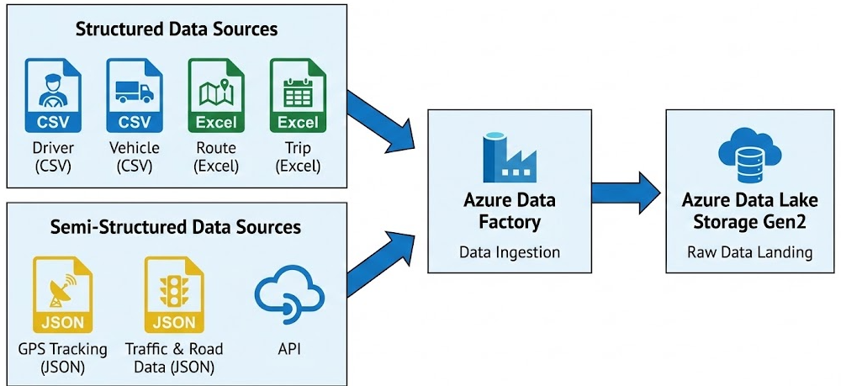

9.Data Ingestion Design
Azure Data Factory (ADF) is used as the primary orchestration and ingestion tool for the Smart Fleet Analytics Platform. The ingestion process is fully batch-driven and operates on scheduled intervals.
ADF pipelines are designed to:
- Ingest data from multiple source formats (CSV, Excel, JSON)
- Load data into the Raw zone of ADLS Gen2
- Maintain schema consistency
- Handle failures using retry and logging mechanisms
Each data source has a dedicated ingestion pipeline or parameterized pipeline to support scalability. The ingestion layer performs no transformations, ensuring that raw data is preserved exactly as received from the source.
Scheduling ensures that data is ingested in a predictable and controlled manner, enabling downstream processing jobs in Databricks to execute reliably
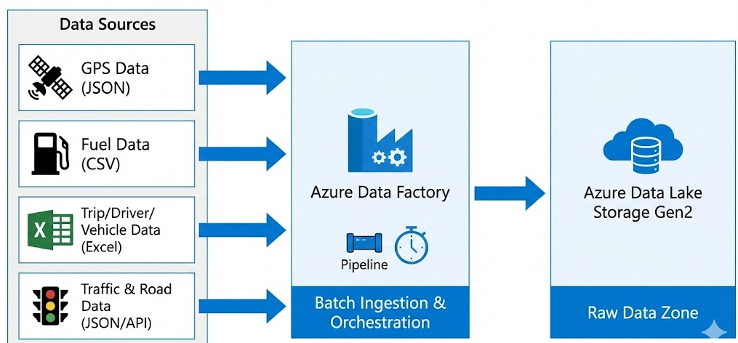

10. Data Storage Design
The platform uses Azure Data Lake Storage Gen2 (ADLS Gen2) as the centralized storage layer. Data is logically separated into multiple zones to ensure traceability, data quality, and reprocessing capability.
Key aspects:
- Raw zone stores ingested data without modification
- Cleaned zone stores validated and standardized data
- Curated zone stores analytics-ready datasets
- Logical separation is used within the same ADLS account
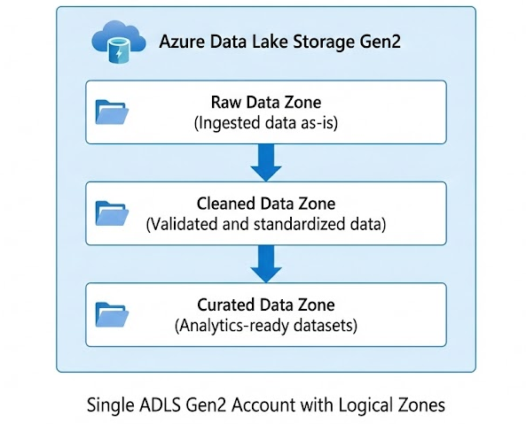

11. Data Processing & Transformation Design
Azure Databricks is used as the primary data processing engine. It transforms raw data into structured, reliable datasets by applying data cleaning and business logic.
Processing includes:
- Structural cleaning (schema alignment, JSON flattening)
- Data validation (null checks, datatype checks)
- Business rule implementation (idle, deviation, fuel usage)
- Writing cleaned and curated outputs to ADLS
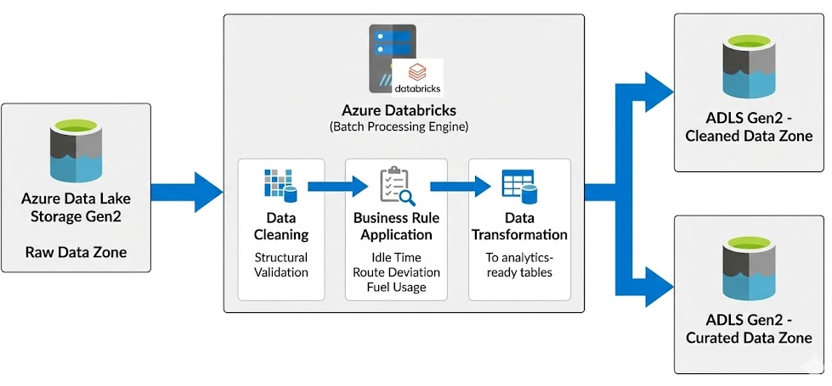

12. Data Model Design
The data model follows a relational design with clearly defined primary and foreign key relationships. The Trip table acts as the central fact table, connecting master and transactional data.
Key characteristics:
- 13 normalized tables
- Strong referential integrity
- Supports KPI and dashboard requirements
- Designed for analytical querying

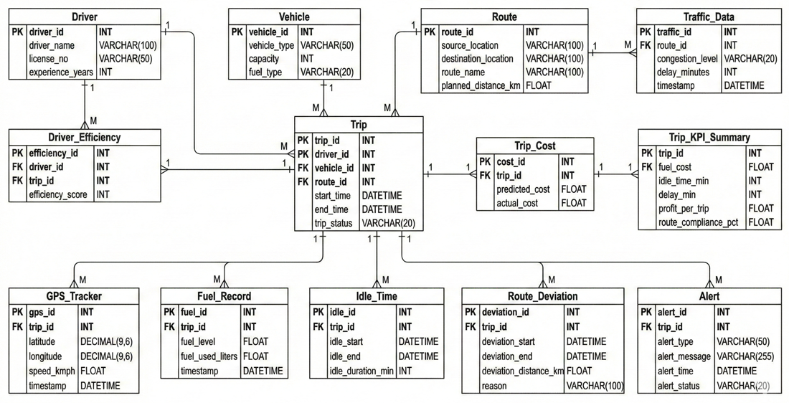

13. Business Logic & KPI Design
Business logic is implemented to convert operational data into meaningful KPIs. These KPIs help measure efficiency, cost, and profitability at trip and driver levels.
Key KPIs include:
- Profit per trip
- Fuel cost and consumption
- Idle time and delay minutes
- Driver efficiency score
- Route compliance percentage

14 . Analytics & Visualization Design
Power BI is used to visualize curated data and present insights to stakeholders. Dashboards are designed for both operational and management users.

Dashboards provide:
- Profit per trip analysis
- Route efficiency insights
- Driver performance trends
- Fuel and idle time analysis

15. Orchestration, Scheduling & Monitoring
Azure Data Factory orchestrates the execution of batch pipelines and Databricks jobs. Monitoring ensures pipeline reliability and timely issue detection.
Includes:
- Scheduled pipeline execution
- Dependency-based orchestration
- Pipeline and job monitoring
- Alerting on failures and delays

16.Security & Access Control Design
Security is implemented using Azure-native access control mechanisms to protect sensitive data.
Key measures:
- Role-based access control (RBAC)
- Restricted access to driver and cost data
- Controlled access to storage and compute resources

17.Error Handling & Data Quality Strategy
The system includes mechanisms to handle failures and ensure data quality throughout the pipeline.
Strategies include:
- Retry logic in ingestion pipelines
- Logging and error tracking
- Data validation checks
- Isolation of bad or incomplete records

18. SDLC & DevOps Strategy
The project follows SDLC best practices with DevOps integration to support reliable development and deployment.
Approach includes:
- Version control using Git
- CI/CD pipelines for deployment
- Environment separation (Dev, Test, Prod)
- Controlled releases and rollback support
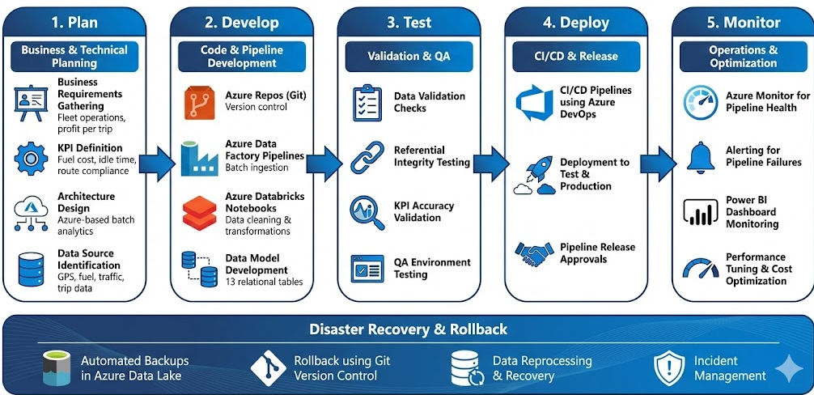

19. Deployment Strategy
The solution is deployed incrementally across environments to reduce risk and ensure stability.
Deployment includes:
- Configuration-based deployments
- Approval gates for production
- Post-deployment validation
- Rollback mechanisms if issues occur

20.Modules & Timeline
Weeks 1–2: Project Foundations & Planning
- Business requirement analysis for fleet operations
- Identification of KPIs (profit per trip, fuel cost, idle time, route compliance)
- Data source identification (GPS, fuel, trip, driver, vehicle, traffic)
- High-level Azure architecture design
- Data model design (13 relational tables)

Weeks 3–5: Data Generation & Batch Ingestion (Raw Layer)
- Synthetic data generation using Python for all source tables
- Preparation of CSV / Excel / JSON input files
- Azure Data Factory pipeline development
- Batch ingestion of data into ADLS Gen2 (Raw zone)
- Scheduling, retries, and monitoring setup in ADF

Weeks 6–8: Data Cleaning & Transformation (Databricks Processing)
- Structural cleaning of raw data
- Validation of schema, datatypes, and null values
- Business rule implementation (idle detection, route deviation logic)
- Transformation of semi-structured data into structured tables
- Creation of cleaned datasets in ADLS Gen2

Weeks 9–11: Curated Layer & KPI Logic
- Creation of curated, analytics-ready tables
- Calculation of KPIs:
  - Fuel cost per trip
  - Idle time and delay minutes
  - Driver efficiency score
  - Profit per trip
  - Route compliance percentage
- Data aggregation and optimization for reporting
- Validation of KPI accuracy

Weeks 12–14: Analytics, Dashboards & UAT
- Power BI data model creation
- Development of dashboards:
  - Profit per Trip Analysis
  - Route Efficiency Insights
  - Driver Performance Trends
- User Acceptance Testing (UAT)
- Feedback incorporation and refinements

Weeks 15–16: Go-Live, Monitoring & Knowledge Transfer
- Production deployment of pipelines and dashboards
- Azure Monitor configuration for pipeline and job monitoring
- Alert setup for failures and anomalies
- Performance tuning and cost optimization
- Documentation and knowledge transfer
- User training and project handover

21. Risks, Assumptions & Dependencies
This section identifies potential project risks and underlying assumptions.
Risks:
- Incomplete or delayed source data
- Data quality issues
Assumptions:
- Batch data availability
- Stable source schemas

22.Future Enhancements
The architecture is designed to support future extensions without major redesign.
Future scope includes:
- Real-time streaming ingestion
- Advanced analytics and ML models
- Predictive route optimization
- Near-real-time alerting

24.Conclusion
The Smart Fleet Analytics Platform provides a comprehensive, scalable, and industry-aligned solution for analyzing fleet operations and improving profitability in logistics environments. By integrating data from multiple sources such as GPS tracking, fuel consumption, trip records, driver information, vehicle details, and traffic data, the platform establishes a single source of truth for fleet analytics.
The solution is built using Azure-native data engineering services and follows a batch-based architecture that emphasizes reliability, traceability, and maintainability. Azure Data Factory enables controlled and scheduled ingestion of data, while Azure Data Lake Storage Gen2 ensures organized and secure storage through logical raw, cleaned, and curated layers. Azure Databricks plays a central role in transforming raw data into high-quality, analytics-ready datasets by applying data cleaning, validation, and business logic.
Through structured KPI calculations and well-defined business rules, the platform delivers actionable insights such as profit per trip, fuel efficiency, idle time analysis, route compliance, and driver performance. These insights are presented through intuitive Power BI dashboards, empowering operations teams and management to make informed, data-driven decisions that reduce costs and improve operational efficiency.
Overall, this project demonstrates a strong understanding of end-to-end data engineering concepts, SDLC practices, and Azure ecosystem capabilities. The design is flexible enough to accommodate future enhancements such as real-time streaming, advanced analytics, and machine learning, making it a robust foundation for enterprise-scale fleet analytics solutions.

