Smart Fleet Intelligence for Route Optimization and
Profit Per Trip Enhancement

Project Understanding Document

Table of Contents
- Executive Summary
- Project Overview
2.1 Problem Statement
2.2 Objectives
2.3 Key Stakeholders
- Stakeholder RACI
- Primary Use Cases
- Scope
- Target Architecture
- Tools & Technologies
- Data Sources & Ingestion
- Data Model
- Pipelines & Orchestration
- Dashboards & KPIs
- Data Governance & Security
- SDLC & DevOps
- Data Population & Backfill
- Risks, Assumptions & Dependencies
- Success Metrics
- Glossary

1.Executive Summary
This project builds a centralized Smart Fleet Analytics Platform to optimize profit per trip for logistics operations.Currently, fleet data such as GPS tracking, fuel usage, idle time, traffic conditions, and trip costs are fragmented across devices and files, making it difficult to monitor inefficiencies and control operational costs.
The proposed Azure-based data engineering solution ingests, cleans, and integrates fleet data into a scalable analytics platform. It enables route efficiency analysis, fuel optimization, driver performance tracking, and real-time alerts. The platform provides business-ready KPIs through dashboards, allowing operations teams and management to make data-driven decisions that improve profitability and reduce wastage.

2. Project Overview
2.1 Problem Statement
Logistics operations suffer from:
- High fuel consumption due to inefficient routes and idling
- Delays caused by traffic congestion and route deviations
- Lack of visibility into driver performance
- Manual cost analysis after trips are completed
- No centralized system to measure profit per trip
These issues lead to increased operational costs and reduced margins.

2.2 Objectives
- Create a single source of truth for fleet and trip data
- Automate profit-per-trip calculation
- Track route compliance and deviations
- Monitor fuel usage, idle time, and delays
- Evaluate driver efficiency per trip
- Provide KPI dashboards for operations and management
- Enable alerting for abnormal events (idle, fuel, deviation)
2.3 Key Stakeholders
- Business Sponsor (Logistics Head)
- Product Owner (Fleet Operations Manager)
- Data Engineering Team
- BI & Analytics Team
- Fleet Supervisors
- Management & Finance Teams

3. Stakeholder RACI
R = Responsible, A = Accountable, C = Consulted, I = Informed

Activity | Sponsor | Product Owner | Data Eng | BI Team | Ops
Project approval | A | I | I | I | I
Requirements & KPIs | I | A/R | C | C | C
Data ingestion | I | C | A/R | I | I
Data modeling | I | C | A/R | C | I
Dashboard development | I | C | C | A/R | I
UAT & signoff | I | A/R | I | I | C

4. Primary Use Cases
- Analyze route deviations to reduce extra distance and fuel cost
- Monitor idle time to improve fuel efficiency
- Compare predicted vs actual trip cost
- Evaluate driver efficiency scores
- Identify high-delay routes due to traffic
- Generate alerts for abnormal trip behavior
5. Scope
In Scope
- Batch ingestion of fleet data
- Raw, cleaned, and curated data layers
- Relational data model with 13 tables
- KPI calculation and dashboards
- Alerts for idle, fuel, and deviation
Out of Scope
- Real-time streaming (future enhancement)
- ML-based route prediction (future phase)

6. Target Architecture
Data flows from fleet data sources into Azure Data Factory, stored in Azure Data Lake Gen2 (raw). Azure Databricks performs data cleaning, validation, and business logic. Cleaned and curated data is stored back in ADLS and consumed by Power BI for dashboards and KPI reporting.
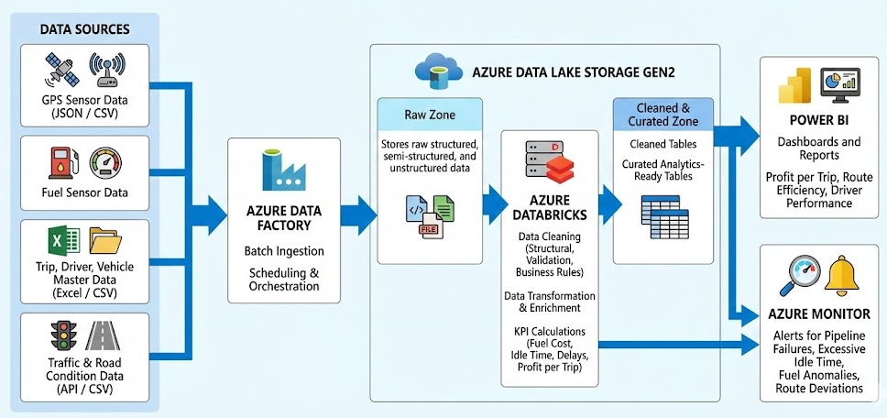

7. Tools & Technologies
- Azure Data Factory
- Azure Data Lake Storage Gen2
- Azure Databricks
- Power BI
- Azure Monitor & Alerts
- Azure Syanpse(Optional)

8. Data Sources & Ingestion

Source | Format | Frequency
GPS Tracking | JSON | Batch
Fuel Records | CSV / Excel | Batch
Trip Details | Excel | Batch
Driver Data | Excel | Batch
Traffic & Road Data | API / CSV | Batch

9. Data Model
Core Tables (13)
- Driver
- Vehicle
- Route
- Trip (central table)
- GPS_Tracker
- Fuel_Record
- Idle_Time
- Route_Deviation
- Traffic_Data
- Driver_Efficiency
- Trip_Cost
- Alert
- Trip_KPI_Summary

10. Pipelines & Orchestration
- ADF handles ingestion, scheduling, retries, and monitoring
- Databricks performs:
  - Structural cleaning
  - Data validation
  - Business rules
  - KPI calculations
- Dependency-based pipeline execution

11. Dashboards & KPIs
Dashboards
- Profit per Trip Dashboard
- Route Efficiency Dashboard
- Driver Performance Dashboard
- Fuel & Idle Analysis
Key KPIs
- Profit per Trip
- Fuel Cost per Trip
- Idle Time (minutes)
- Route Compliance %
- Delay Minutes/Hours

12. Data Governance & Security
- Role-based access control
- Secure storage in ADLS
- Restricted access to driver information
- Audit logs and pipeline monitoring

13. SDLC & DevOps
- Dev / Test / Prod environments
- Git-based version control
- CI/CD for ADF and Databricks notebooks
- Rollback and reprocessing support
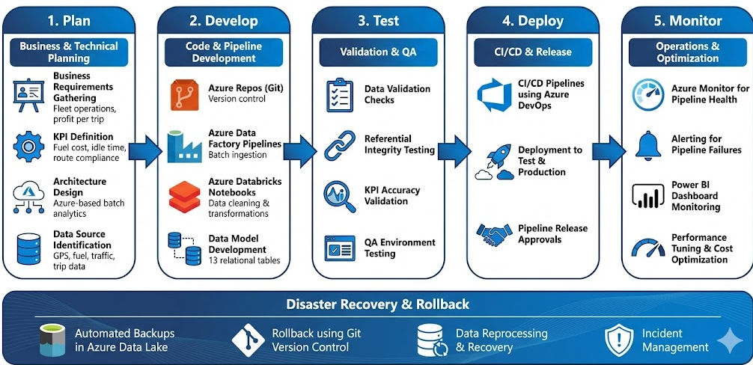

14. Data Population & Backfill
- Synthetic data generation using Python
- Historical backfill for trips
- Incremental loads for new trips

15. Risks, Assumptions & Dependencies
Risks
- Incomplete sensor data
- Delayed source files
Assumptions
- Consistent trip IDs across systems
- Batch data availability
Dependencies
- Fleet device data availability
- API access for traffic data

16. Success Metrics
- Reduction in fuel cost per trip
- Reduced idle time
- Improved route compliance
- Faster KPI availability
- Better driver performance visibility

17. Glossary
- KPI – Key Performance Indicator
- ADLS – Azure Data Lake Storage
- ADF – Azure Data Factory
- ETL – Extract Transform Load

