

|  |
| --- |
|  |

ETL System Specification

ETL- Contract Creation Life

Document Version: 0.1

Contents

1. Document Revision History 5

2. BACKGROUND 7

2.1 IFRS17 Background 8

2.2 Overall Solution Design 9

3. SCOPE 9

3.1 In-Scope 10

3.2 Out-of-Scope 11

3.3 Assumptions & Limitations 12

3.4 2.4 Dependencies & Pre-requisites 13

4. OVERVIEW 14

4.1 ETL Dataflow (Functional) 15

4.2 ETL Dataflow (Technical) 16

4.3 System Descriptions 17

5. IMPLEMENTATION DETAILS 18

5.1 Transformation – Get FRS117 Coverage Updates 19

5.1.1 Source Data Objects 19

5.1.2 Transform 19

5.1.3 Target Data Objects 21

5.2 Transformation – Get Contract Modifications 22

5.2.1 Source Data Objects 22

5.2.2 Transform 22

5.2.3 Target Data Objects 23

5.3 Transformation – Separate or Combine Coverages (LI) 24

5.3.1 Source Data Objects 24

5.3.2 Transform 24

5.3.3 Target Data Objects 26

5.4 Assign FRS117 Contract per Coverage 28

5.4.1 Source Data Objects 28

5.4.2 Transform 28

5.4.3 Target Data Objects 31

5.5 Transformation – Assign Cohort LI 32

5.5.1 Source Data Objects 32

5.5.2 Transform 32

5.5.3 Target Data Objects 32

5.6 Transformation – Assign Measurement Model LI 34

5.6.1 Source Data Objects 34

5.6.2 Transform 34

5.6.3 Target Data Objects 35

5.7 Transformation – Assign Portfolio 36

5.7.1 Source Data Objects 36

5.7.2 Transform 36

5.7.3 Target Data Objects 36

5.8 Transformation – Set Initial Recognition Date (LI) 38

5.8.1 Source Data Objects 38

5.8.2 Transform 38

5.8.3 Target Data Objects 38

5.9 Transformation – Set Contract Boundary Type 40

5.9.1 Source Data Objects 40

5.9.2 Transform 40

5.9.3 Target Data Objects 40

5.10 Transformation – Set Contract Boundary Date 42

5.10.1 Source Data Objects 42

5.10.2 Transform 42

5.10.3 Target Data Objects 43

5.11 Transformation – Set Contract Derecognition Date 44

5.11.1 Source Data Objects 44

5.11.2 Transform 44

5.11.3 Target Data Objects 44

5.12 Transformation – Persist Data 45

5.12.1 Source Data Objects 45

5.12.2 Transform 45

5.12.3 Target Data Objects 45

6. ADDITIONAL DETAILS 47

6.1 Audit Controls 48

6.2 Error Handling 49

6.3 Scheduling 50

6.4 Monitoring 51

7. APPENDIX 51

7.1 Acronyms 52

7.2 References 53

Table of Figures

Table of Tables

Table 1: Document Revision History 6

Table 2: “Contract Coverage Assignment” Mapping 30

Table 3: “FRS117 Contract” Mapping 31

Table 4: “Contract Coverage Assignment” Mapping 31

# Document Revision History

Table 1: Document Revision History

|  |  |  |  |
| --- | --- | --- | --- |
| Ver | Description | Author | Date |
| 0.1 | Initial Draft | Deloitte | 31 July 2020 |

# BACKGROUND

## IFRS17 Background

## Overall Solution Design

# SCOPE

## In-Scope

## Out-of-Scope

## Assumptions & Limitations

## 2.4 Dependencies & Pre-requisites

# OVERVIEW

This System Specification details the Blueprint chapter “5.2.3.1 LI Contract Create / Update” and its subchapters.

This is the main process to manage FRS117 Contract lifecycle for LI business:

* Create new FRS117 contracts and assign GBM coverages for new business/renewed business/converted business
* Identify existing FRS117 contracts and assign new GBM coverages when late additions need to be combined

For more details on FRS117 Contracts please also refer to Blueprint Chapter “5.2.3.1.1 General concept of contract creation”

## ETL Dataflow (Functional)

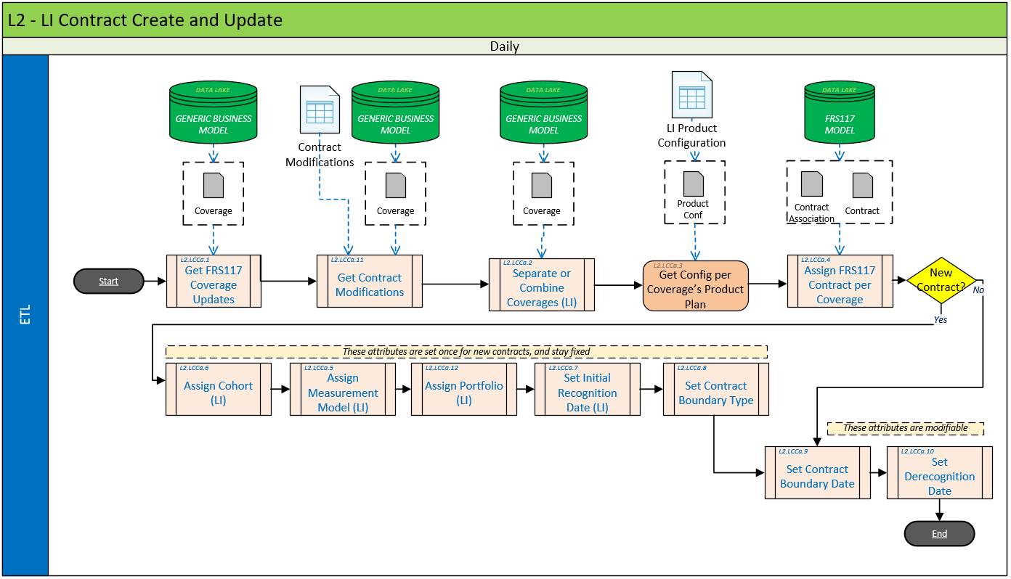

## ETL Dataflow (Technical)

## System Descriptions

# IMPLEMENTATION DETAILS

[5.A] Any system specification document requires adherence to the ETL Foundation Specifications. This includes but is not limited to:

* Following naming conventions for Informatica & Cloudera artefacts
* Following framework for logging & error handling
* Following framework for ETL configurations

[5.B] This system specification covers the entire process to create new FRS117 contracts, or update existing FRS117 contracts which gets triggered by source system changes to underlying master data.

[5.C] The following chapters detail each step in below diagram.



## Transformation – Get FRS117 Coverage Updates

[5.1.A] This process identifies all new or changed relevant coverages in the Data Models > Generic Business Model (Logical) on or after a specified timestamp.[1]

[5.1.B] Note that this process must remove coverages that are not relevant for the FRS117 process.

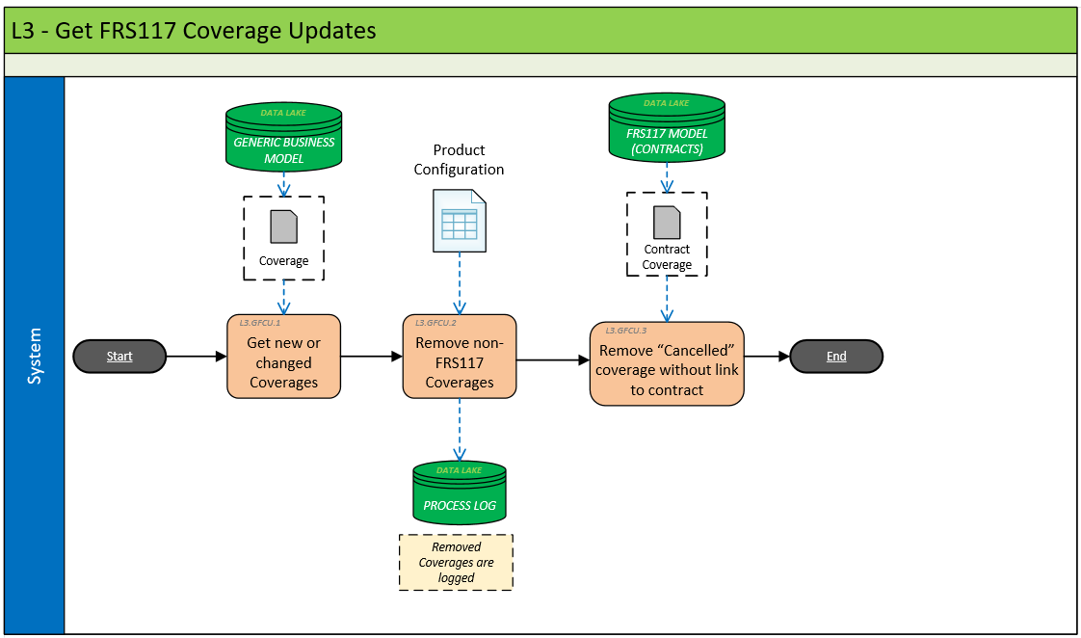

### Source Data Objects

#### Extract Details/Source Details

|  |  |
| --- | --- |
| DATA OBJECT | REFERENCE |
| Policy Agreement | Data Models > Generic Business Model (Logical) |
| Policy Plan | Data Models > Generic Business Model (Logical) |
| Coverage | Data Models > Generic Business Model (Logical) |
| Product Configuration | Data Models > Data Models > FRS117 Model (Logical) (Logical) |

### Transform

#### Get new or changed Coverages[2]

[5.1.2.1.A] Determine the timestamp on or after which changed coverages must be identified. This timestamp should default to the timestamp when the job was last run (refer to ETL Foundation Specifications).

[5.1.2.1.B] An alternative timestamp can be supplied as a runtime parameter for rerun, and testing purposes.

[5.1.2.1.C] Create a new dataset DS_NEW_COVERAGES by selecting all Life business “Coverage” records that have been uploaded to the Data Models > Generic Business Model (Logical) after the determined timestamp.

[5.1.2.1.D] Join the coverage records with their corresponding Policy Plan, and Policy Agreement records. Such joined data has to be available going forward, so for a given coverage its plan, and policy agreement data is readily available in DS_NEW_COVERAGES.

[5.1.2.1.E] In order to filter on Life business, check on the Policy Business Type of the Policy Agreement.

#### Get Config per Coverage’s Product Plan

[5.1.2.2.A] For each coverage, retrieve its applicable config entry from the Product Configuration matching the policy agreements’ “App Source Code”, the policy plan’s “Plan Code”, and the coverage’s “Cover Type Code”. Note, the configurations’ “Risk Category” is not applicable for Life products.

[5.1.2.2.B] Ensure that the found unique configuration record for any given coverage is readily available going forward (i.e. appended to the coverage record same as above for Policy Plan, and Policy Agreement) in the DS_NEW_COVERAGES

[5.1.2.2.C] If none, or multiple config records are found for a given coverage, log an error.

Configuration tables can contain wildcards, please see relevant Foundation Spec.

#### Remove non-FRS117 Coverages[3]

[5.1.2.3.A] For each coverage, identify. Determine the config entry’s “FRS Type” using the policy agreement’s App Source Code, and the Policy Plan’s Plan Code.

[5.1.2.3.B] Remove coverages from DS_NEW_COVERAGES which “FRS Type” is not set to “FRS117”.

[5.1.2.3.C] Log the removed coverages.

#### Remove Cancelled coverage without link to contract[4]

[5.1.2.4.A] Remove coverages from DS_NEW_COVERAGES whose related “Policy Status Code REF” is not “In Force”.

[5.1.2.4.B] Log the removed coverages.

#### Data Quality Checks (if any)

#### Transformation Technical Details

Please insert documentation of Informatica build artefacts

### Target Data Objects

|  |  |
| --- | --- |
| DATA OBJECT | REFERENCE |
| DS_NEW_COVERAGES | Chapter "5.1.2 - Transform" |

#### <Individual Output Details>

Please insert documentation of Informatica build artefacts

|  |  |  |  |  |  |
| --- | --- | --- | --- | --- | --- |
| Col1 | Col2 | … | … | .. | . |
| [9.1.3.4] | And another | Text | In | Cells | somewhere |

## Transformation – Get Contract Modifications[5]

[5.2.A] This process identifies policy coverages who have been modified under their FRS117 scope. For these coverages, the assigned FRS117 contracts must be terminated[6].

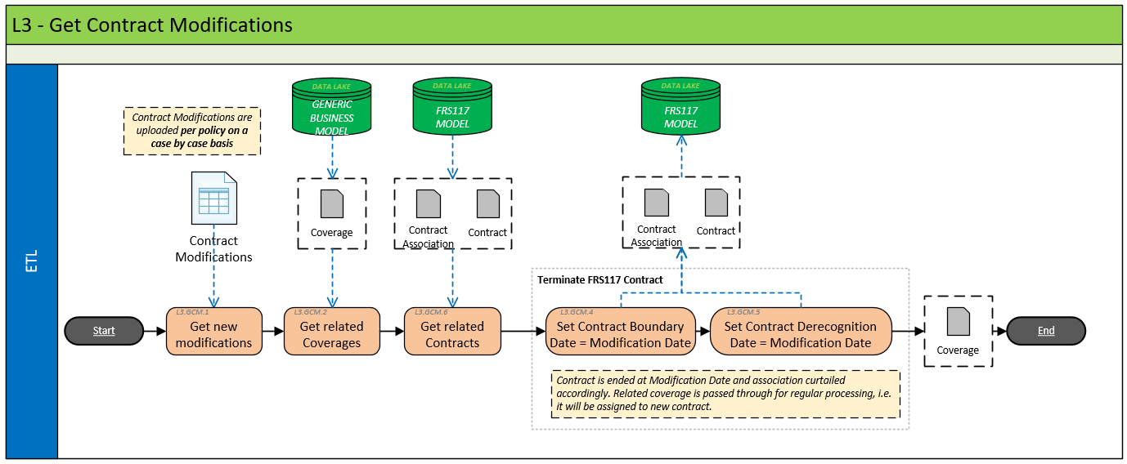

### Source Data Objects

#### Extract Details/Source Details

|  |  |
| --- | --- |
| DATA OBJECT | REFERENCE |
| DS_NEW_COVERAGES | Chapter “5.1.3 - Target Data Objects” |
| Contract Modification | Data Models > FRS117 Model (Logical) |
| FRS117 Contract | Data Models > FRS117 Model (Logical) |

### Transform

[5.2.2.A] Read the contract modification configuration fetching all records where the config entry’s “Modification Date” falls into the current process period.[7]

ToDo: current processing period has to be available to all transformations

[5.2.2.B] Create a new dataset DS_MOD_COVERAGES retrieving the joined Policy Agreement, Policy Plan, and Coverage data for each “Source Application Code” & “Source Policy ID” pair found in the modification configuration.

[5.2.2.C] For each coverage in the DS_MOD_COVERAGES dataset retrieve its related Contract Coverage Associations, and FRS117 Contract data (FRS117 Model).[8]

[5.2.2.D] For each “Contract Coverage” link, set the “Valid To” date to the corresponding “Modification Date” of the config entry.

Note: “Valid To” refers to the general validity fields in the Foundation Specs applying to any configuration table

[5.2.2.E] For each FRS117 contract, set both its “Contract Boundary Date” and “Derecognition Date” to the corresponding “Modification Date” of the config entry.[9]

#### Get Config per Coverage’s Product Plan

[5.2.2.1.A] For each coverage in , retrieve its applicable config entry from the Product Configuration matching the policy agreements’ “App Source Code”, the policy plan’s “Plan Code”, and the coverage’s “Cover Type Code”. Note, the configurations’ “Risk Category” is not applicable for Life products.

[5.2.2.1.B] Ensure that the found unique configuration record for any given coverage is readily available going forward (i.e. appended to the coverage record same as above for Policy Plan, and Policy Agreement)

[5.2.2.1.C] If none, or multiple config records are found for a given coverage, log an error.

Configuration tables can contain wildcards, please see relevant Foundation Spec.

[5.2.2.1.D] Combine the datasets DS_NEW_COVERAGES and DS_MOD_COVERAGES into the DS_NEW_MOD_COVERAGES dataset[10].

#### Data Quality Checks (if any)

#### Transformation Technical Details

Please insert documentation of Informatica build artefacts

### Target Data Objects

|  |  |
| --- | --- |
| DATA OBJECT | REFERENCE |
| DS_NEW_MOD_COVERAGES | Chapter "5.2.2 - Transform" |

#### <Individual Output Details>

Please insert documentation of Informatica build artefacts

1. BLP: 5.2.3.1.2
2. BLP: [5.2.3.1.2.B]
3. BLP: [5.2.3.1.2.C]
4. BLP: [5.2.3.1.2.D]
5. BLP: [5.2.3.1.3]
6. BLP: [5.2.3.1]
7. BLP: [5.2.3.1.3.B]
8. BLP: [5.2.3.1.3.C], [5.2.3.1.3.D]
9. BLP: [5.2.3.1.3.E], [5.2.3.1.3.F]
10. BLP: [5.2.3.1.4.C]