R.Markdown

Hieu T. Le

2023-11-14

## R Markdown

### Smaller

#### Even Smaller

Bold Text with double asterisks **Bold UP** Italicize with single asterisks *Italicize*

# SAT Math and Reading Scores by State

We are analyzing a dataset that has math and reading SAT scores in three states. There are 150 observations in our data. We are interested in whether there are differences between states in the avg math and reading scores on SAT. To test for these diff we ran a one-way ANOVA on reading scores with state (Minnesota, Maryland, and Texas) as the independent variable. This anova yielded a sig effect of state on reading scores, *F*(2, 147) = 31.54, *p* < 0.001, 2 = 0.3.

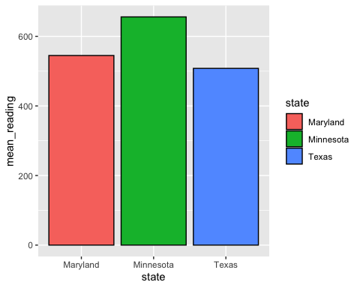

This is an R Markdown document. Markdown is a simple formatting syntax for authoring HTML, PDF, and MS Word documents. For more details on using R Markdown see <http://rmarkdown.rstudio.com>.

When you click the **Knit** button a document will be generated that includes both content as well as the output of any embedded R code chunks within the document. You can embed an R code chunk like this:

summary(cars)

## speed dist   
## Min. : 4.0 Min. : 2.00   
## 1st Qu.:12.0 1st Qu.: 26.00   
## Median :15.0 Median : 36.00   
## Mean :15.4 Mean : 42.98   
## 3rd Qu.:19.0 3rd Qu.: 56.00   
## Max. :25.0 Max. :120.00

## Including Plots

You can also embed plots, for example:

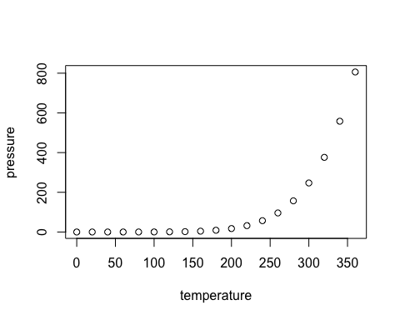

Note that the echo = FALSE parameter was added to the code chunk to prevent printing of the R code that generated the plot.