4802 Write Up Draft
2025-11-20

R Markdown

Question 1: Compare the underlying deaths from lung cancer and the underlying deaths not from lung cancer. Then see if lung cancer occurs more than expected/chance
library(tidyverse)
## ── Attaching core tidyverse packages ──────────────────────── tidyverse 2.0.0 ──
## ✔ dplyr 1.1.4 ✔ readr 2.1.5
## ✔ forcats 1.0.0 ✔ stringr 1.5.1
## ✔ ggplot2 4.0.0 ✔ tibble 3.2.1
## ✔ lubridate 1.9.4 ✔ tidyr 1.3.1
## ✔ purrr 1.0.4
## ── Conflicts ────────────────────────────────────────── tidyverse_conflicts() ──
## ✖ dplyr::filter() masks stats::filter()
## ✖ dplyr::lag() masks stats::lag()
## ℹ Use the conflicted package (<http://conflicted.r-lib.org/>) to force all conflicts to become errors
LongDat<- pivot_longer(da37237.0001, cols = c("MULTICOD_1_ICD10", "MULTICOD_2_ICD10", "MULTICOD_3_ICD10", "MULTICOD_3_ICD10", "MULTICOD_4_ICD10", "MULTICOD_5_ICD10", "MULTICOD_6_ICD10", "MULTICOD_7_ICD10", "MULTICOD_8_ICD10", "MULTICOD_9_ICD10", "MULTICOD_10_ICD10", "MULTICOD_11_ICD10", "MULTICOD_12_ICD10"), names_to = "MULTICOD_ICD10", values_to = "Scores", values_drop_na = TRUE)
chisq.test(c(157,2164), p= c(.05,.95))
##
## Chi-squared test for given probabilities
##
## data: c(157, 2164)
## X-squared = 15.21, df = 1, p-value = 9.618e-05
LongDat$LungCancer<- NA
LongDat$LungCancer<- ifelse(LongDat$Scores=="C349 ", 1, 0)
DataFrame1<- data.frame(
group = c("Lung Cancer", "Other"),
value = c(172, 2164)
)
ggplot(DataFrame1,aes(group, value))+geom_bar(stat = "identity", color = "black", fill = "grey") + xlab("Cause of Death") + ylab("Frequency") + ggtitle("Frequency of Lung Cancer as Cause of Death") + theme_classic()
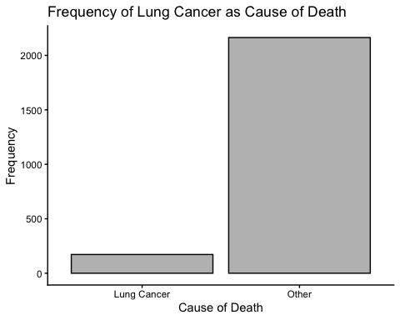
##Question 2: What are the top five underlying causes of death?
library(modeest)
sort(table(LongDat$UNDERCOD_ICD10))
##
## A084 A415 A481 A490 A499
## 12 12 12 12 12
## B199 B207 B208 B238 B24
## 12 12 12 12 12
## B342 B91 B948 C01 C07
## 12 12 12 12 12
## C109 C119 C140 C181 C187
## 12 12 12 12 12
## C19 C253 C329 C37 C383
## 12 12 12 12 12
## C399 C419 C437 C446 C449
## 12 12 12 12 12
## C482 C491 C494 C66 C712
## 12 12 12 12 12
## C716 C780 C786 C793 C841
## 12 12 12 12 12
## C850 C851 C910 C921 C925
## 12 12 12 12 12
## C950 D374 D377 D429 D472
## 12 12 12 12 12
## D571 D649 D70 D752 E039
## 12 12 12 12 12
## E105 E107 E111 E114 E115
## 12 12 12 12 12
## E117 E141 E144 E146 E147
## 12 12 12 12 12
## E162 E271 E440 E45 E854
## 12 12 12 12 12
## E859 F059 F069 F191 F339
## 12 12 12 12 12
## G049 G10 G310 G510 G700
## 12 12 12 12 12
## G710 G808 G903 G909 G919
## 12 12 12 12 12
## G92 G939 G961 I071 I080
## 12 12 12 12 12
## I082 I099 I131 I139 I248
## 12 12 12 12 12
## I249 I258 I312 I313 I359
## 12 12 12 12 12
## I361 I425 I442 I607 I609
## 12 12 12 12 12
## I613 I614 I615 I632 I671
## 12 12 12 12 12
## I711 I712 I776 J101 J152
## 12 12 12 12 12
## J159 J181 J42 J448 J61
## 12 12 12 12 12
## J960 J988 J989 K112 K210
## 12 12 12 12 12
## K222 K225 K274 K315 K358
## 12 12 12 12 12
## K449 K519 K551 K559 K579
## 12 12 12 12 12
## K638 K661 K720 K729 K760
## 12 12 12 12 12
## K805 K810 K830 L989 M348
## 12 12 12 12 12
## M349 M625 M726 M793 M844
## 12 12 12 12 12
## M869 N039 N049 N135 N184
## 12 12 12 12 12
## N288 R068 R092 R568 R570
## 12 12 12 12 12
## R628 V031 V194 V234 V295
## 12 12 12 12 12
## V445 V584 V594 V599 V800
## 12 12 12 12 12
## W06 W40 W70 X01 X31
## 12 12 12 12 12
## X59 X590 X62 X65 X67
## 12 12 12 12 12
## X69 X93 X95 Y02 Y08
## 12 12 12 12 12
## Y11 Y14 Y34 Y484 Y608
## 12 12 12 12 12
## Y834 Y839 Y848 C069 C221
## 12 12 12 24 24
## C240 C269 C319 C444 C519
## 24 24 24 24 24
## C579 C830 C959 D619 D65
## 24 24 24 24 24
## E109 E43 G35 G409 G934
## 24 24 24 24 24
## I132 I340 I38 I516 I610
## 24 24 24 24 24
## I633 I634 I691 I714 J100
## 24 24 24 24 24
## J150 J441 J82 J969 K550
## 24 24 24 24 24
## K578 K631 K743 K802 K819
## 24 24 24 24 24
## K861 R02 R54 V274 V535
## 24 24 24 24 24
## V877 W79 X47 X599 X72
## 24 24 24 24 24
## X94 B182 C029 C160 C459
## 24 36 36 36 36
## C833 D432 D689 E780 E86
## 36 36 36 36 36
## F102 G301 I420 I461 I490
## 36 36 36 36 36
## I678 I709 J110 J90 K769
## 36 36 36 36 36
## N179 V892 W80 X00 Y86
## 36 36 36 36 36
## A099 C169 C499 C73 D471
## 48 48 48 48 48
## E145 E46 E669 G319 G931
## 48 48 48 48 48
## I519 I620 I639 I672 I694
## 48 48 48 48 48
## I713 I802 R688 W10 A047
## 48 48 48 48 60
## C20 C911 F101 J984 K703
## 60 60 60 60 60
## K922 N180 N189 C229 C55
## 60 60 60 72 72
## C798 C97 E112 I350 J961
## 72 72 72 72 72
## K566 D469 E668 F019 G122
## 72 84 84 84 84
## I214 I679 J849 N19 R99
## 84 84 84 84 84
## X74 C439 E119 E785 G318
## 84 96 96 96 96
## I120 I259 I499 I629 I698
## 96 96 96 96 96
## C541 G311 I739 C159 C220
## 108 108 108 120 120
## C920 I269 I509 N390 J690
## 120 120 120 120 132
## W18 X42 X44 C900 I272
## 132 132 132 144 144
## K746 N185 I10 I110 J841
## 144 144 156 156 156
## C679 C859 W19 C64 C719
## 168 168 168 180 180
## E142 I255 I469 I619 J440
## 180 180 180 180 180
## I429 I119 J439 C56 J189
## 192 204 204 240 252
## I48 A419 C61 C80 E149
## 300 324 336 336 372
## G20 C189 U071 C509 C259
## 372 420 540 564 612
## I500 I64 I250 F03 -8
## 660 696 708 840 876
## G309 I219 -9 J449 I251
## 960 1056 1584 1644 1776
## C349
## 1884
#The five top causes of death: Lung Cancer, Pancreas Cancer, Colon Cancer, Liver Cancer and Esophagus Cancer
dataFrame2<- data.frame(
group = c("Lung Cancer", "Pancreas Cancer", "Colon Cancer", "Liver Cancer", "Esophagus Cancer"),
value = c(157, 51, 35, 27, 16)
)
ggplot(dataFrame2, aes(group, value))+ geom_bar(stat = "identity", color = "black", fill = "grey") + xlab("Cause of Death") + ylab("Frequency") + ggtitle("The Five Most Frequent Causes of Death") + theme_classic()
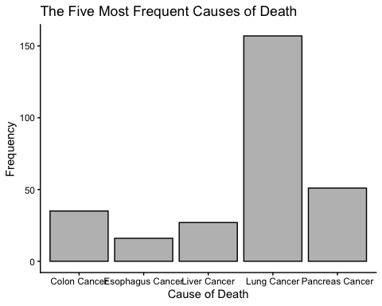
##Question 3: lung cancer disease; is it associated with other causes of death?
–> use logistic regression outcome: heart disease 0/1 predictors: other causes of death –> how do I note this in my code?, can I just choose other things? #Would using scatter plots be an acceptable way to visualize this infomration? What is the right way to graph this information
lcdat<- subset(LongDat, LungCancer== 1)
#Lung cancer is comorbid with Unspecified Residual Disease (URD) (161 counts), Chronic Lower Respiratory Disease (CLRD) (25 counts) and Diabetes (8)
#For Unspecified Risidual Disease
chisq.test(c(161, 11), p =c(.21, .79))
##
## Chi-squared test for given probabilities
##
## data: c(161, 11)
## X-squared = 546.53, df = 1, p-value < 2.2e-16
#For Chronic Lower Respiratory Disease
chisq.test(c(25, 147), p =c(.064, .936))
##
## Chi-squared test for given probabilities
##
## data: c(25, 147)
## X-squared = 19.001, df = 1, p-value = 1.307e-05
#For Diabetes
chisq.test(c(8, 164), p = c(.116, .884))
##
## Chi-squared test for given probabilities
##
## data: c(8, 164)
## X-squared = 8.0992, df = 1, p-value = 0.004428
dataFrame3<- data.frame(
group = c("Unspecifed Residual Disease", "Chronic Lower Resipiratory Disease", "Diabetes"),
value = c(161, 25, 8)
)
ggplot(dataFrame3, aes(group, value))+ geom_bar(stat = "identity", color = "black", fill = "lightblue") + xlab("Comorbidty") + ylab("Frequency") + ggtitle("Causes of Death Comorbid with Lung Cancer") + theme_classic()
