VietLedgr

Use-Case Specification

Version <1.0>

Revision History
Date | Version | Description | Author
<06/11/2025> | <1.0> | Creation of Use-Case Specification | Lê Minh Nghĩa

Table of Contents
1. Use-case Model 4
2. Use-case Specifications 4
2.1 Use-case: Add a product to cart 4
2.2 Use-case: Create a new account 5

Use-case Model
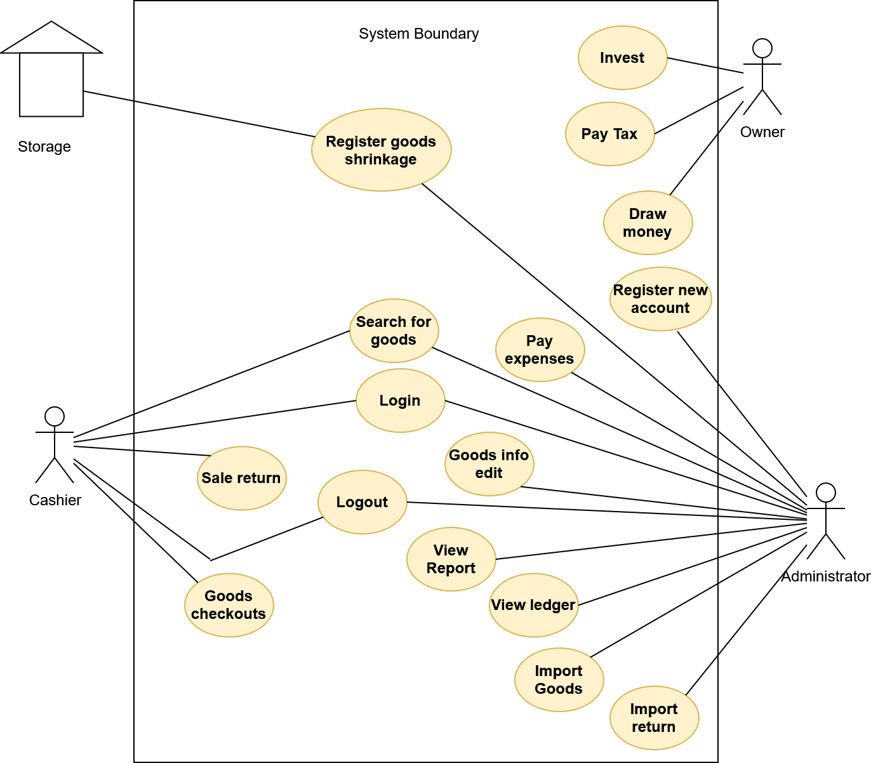

Use-case Specifications

Use-case: Import Goods
Use case Name | Import goods to the stock.
Brief description | This use case describes how the Administrator can record imported goods into the system.
Actors | Administrator
Basic Flow | - At the homepage, the user switch into the “Inventory” tab  - User clicks on ‘New Item’ button  - System open a menu (form) for batch input  - User type in the info of the products, batch size,….  - System adds a new batch into the “Inventory” of the warehouse  - System add entries into the ledger and update the accounts
Alternative Flows | Alternative flow 1: Advanced user willing to provide more detail of the goods  - Follow up to step #3 of the basic flow  - User clicks on “Advance”  - System provide detailed form for the user to input.  - Follow step #5 and #6 of the basic flow.
Pre-conditions | Administrator must be logged in and on the main dashboard page.
Post-conditions | The user successfully adds new item to the “inventory” and register the transaction into the ledger.

Use-case: Admin Search for Product (Dashboard)
Use case Name | Search for Product from Main Dashboard
Brief description | This use case describes how the Administrator finds a specific product from the main admin dashboard.
Actors | Administrator
Basic Flow | - Administrator is on the main dashboard.  - Administrator types the product's name or SKU into the global search bar.  - Administrator presses the 'Enter' key or clicks the search icon.  - System provides a list of Items (Batch) that fit the prompt.  - Administrator click on an item.  - System navigates to the "Product Details" page for that item.
Alternative Flows | Alternative flow 1: No product found  - Follow steps 1-3 of the basic flow.  - The system finds no product matching the query.  - System displays a "No results found" message on the dashboard.
Pre-conditions | Administrator must be logged in and on the main dashboard page.
Post-conditions | The Administrator has successfully navigated to the desired product's detail page or is viewing a list of relevant results.

Use-case: Cashier Search for Product (POS)
Use case Name | Search for Product from POS Screen
Brief description | This use case describes how the Cashier finds a product to add to a customer's transaction.
Actors | Cashier
Basic Flow | - At the POS screen, the Cashier clicks on the "Search Product" input field.  - Cashier types the product's name or SKU.  - System displays a real-time list of matching products below the search bar.  - Cashier clicks on the correct product from the list.  - System adds the product to the current sales transaction list (cart).
Alternative Flows | Alternative flow 1: Using barcode scanner  - The cursor is active in the "Search Product" input field.  - Cashier scans the product's barcode.  - The system automatically inputs the barcode (SKU) into the field and searches.  - System finds the exact product match.  - System adds the product to the current sales transaction list.  Alternative flow 2: Product not found  - Follow steps 1-3 of the basic flow.  - The system finds no product matching the query.  - System displays a "Product not found" message.
Pre-conditions | Cashier must be logged in and on the main POS (Point of Sale) screen with an active or new transaction.
Post-conditions | The desired product is added to the sales transaction list, or the Cashier is notified that the product is not in the system.

Use-case: User Login
Use case Name | User Login
Brief description | This use case describes how an Administrator or Cashier logs into the system.
Actors | Administrator, Cashier, Owner
Basic Flow | - User navigates to the system's login page.  - User enters their email or username into the "Username" field.  - User enters their password into the "Password" field.  - User clicks the "Login" button.  - System validates the credentials.  - System logs the user in and redirects them to their respective start page (Admin Dashboard for Administrator, POS Screen for Cashier).
Alternative Flows | Alternative flow 1: Invalid credentials  - Follow steps 1-4 of the basic flow.  - System fails to validate the credentials (wrong username or password).  - System displays an "Invalid username or password" error message.  - User remains on the login page.  Alternative flow 2: User forgot password  - At step 1, the user clicks the "Forgot Password?" link.  - This initiates the "Password Reset" use case (documented separately).
Pre-conditions | User has a valid account and is currently not logged in. User is on the login page [website.VietLedger.com]/login.
Post-conditions | The user is successfully authenticated and has an active session in the system.

Use-case: User Logout
Use case Name | User Logout
Brief description | This use case describes how a logged-in user securely ends their session.
Actors | Administrator, Cashier, Owner
Basic Flow | - User clicks on their profile icon or name (usually in the navigation bar).  - System displays a user menu.  - User clicks the "Logout" button.  - System terminates the user's session.  - System redirects the user to the login page.
Alternative Flows | Alternative flow 1: Automatic session timeout  - The user has been inactive for a pre-defined period (e.g., 60 minutes).  - System automatically terminates the session for security.  - When the user next attempts an action, the system redirects them to the login page, often with a message like "Your session has expired."
Pre-conditions | The user is currently logged into the system.
Post-conditions | The user's session is terminated, and they are no longer authenticated.

Use-case: Cashier Checkout Goods
Use case Name | Cashier Checkout Goods
Brief description | This use case describes how the Cashier finalizes a sale, accepts payment, and completes a transaction.
Actors | Cashier
Basic Flow | - The POS screen has one or more items in the current transaction list (cart).  - Cashier clicks the "Checkout" button.  - System displays the total amount due (including taxes).  - Cashier asks for and selects the payment method (e.g., "Cash", "Card").  - Cashier enters the amount received.  - System calculates and displays the change due.  - Cashier confirms the transaction.  - System records the sale, and the inventory level for the sold items is reduced.  - System adds entries to the ledger (e.g., Debit Cash, Credit Sales Revenue; Debit COGS, Credit Inventory).  - System generates a receipt, which the Cashier can print.
Alternative Flows | None
Pre-conditions | Cashier is logged in at the POS screen, and there is at least one item in the cart.
Post-conditions | The sale is recorded, inventory is updated, payment is registered, and a receipt is generated.

Use-case: Cashier Receive Sale Return
Use case Name | Cashier Checkout Goods
Brief description | This use case describes how the Cashier processes a customer's return of a previously purchased item.
Actors | Cashier
Basic Flow | - From the POS screen, Cashier navigates to the "Return" mode.  - Cashier enters the original transaction ID from the customer's receipt.  - System retrieves and displays the original transaction items.  - Cashier selects the item(s) and quantity being returned.  - Cashier clicks "Process Return".  - System calculates the refund amount.  - System issues the refund to the original payment method (or as store credit).  - System updates inventory (increases stock for the returned item).  - System adds reversal entries to the ledger (Debit Sales Returns, Credit Cash; Debit Inventory, Credit COGS).  - System generates a return receipt.
Alternative Flows | None
Pre-conditions | Cashier is logged in at the POS screen.
Post-conditions | The return is processed, inventory is restocked, the customer is refunded, and the ledger is updated.

Use-case: Register Good Shrinkage
Use case Name | Register Good Shrinkage
Brief description | This use case describes how an Administrator records inventory losses not due to sales (damaged, expired, or stolen goods).
Actors | Administrator, Owner
Basic Flow | - Administrator navigates to the "Inventory" tab.  - Administrator searches for and selects the product to adjust.  - Administrator clicks on "Record Shrinkage".  - System displays an adjustment form.  - Administrator enters the quantity to be removed (e.g., "-2").  - Administrator selects a reason (e.g., "Damaged", "Expired").  - Administrator confirms the adjustment.  - System reduces the inventory quantity for that item.  - System adds entries to the ledger (Debit Shrinkage Expense, Credit Inventory).
Alternative Flows | None
Pre-conditions | Administrator is logged in and has permission to manage inventory.
Post-conditions | The inventory level for the item is corrected, and the loss is financially recorded in the ledger.

Use-case: Admin Return Imported Good
Use case Name | Admin Return Imported Good
Brief description | This use case describes how the Admin records the return of goods to a supplier
Actors | Administrator
Basic Flow | - Administrator navigates to the "Inventory" or "Suppliers" tab.  - Administrator locates the original purchase order or bill associated with the goods.  - Administrator clicks "Create Purchase Return" or "Supplier Credit Note".  - System displays a return form, pre-filled with items from the original purchase.  - Administrator enters the quantity of the item(s) being returned.  - Administrator confirms the return.  - System reduces the "Inventory" quantity for the returned items.  - System creates a credit note, reducing the amount owed to the supplier (Accounts Payable).  - System adds entries to the ledger (Debit Accounts Payable, Credit Inventory).
Alternative Flows | None
Pre-conditions | Administrator is logged in and has permission to manage inventory.
Post-conditions | The inventory level for the item is corrected, and the loss is financially recorded in the ledger.

Use-case: View General Ledger
Use case Name | View General Ledger
Brief description | This use case describes how the Admin views the detailed log of all double-entry accounting transactions.
Actors | Administrator
Basic Flow | - Administrator navigates to the "Accounting" or "Reports" tab.  - Administrator clicks on "General Ledger".  - System displays a chronological list of all journal entries (showing date, accounts, debit, and credit).
Alternative Flows | Alternative flow 1: Filter by date  - Follow step 3 of the basic flow.  - Administrator enters a "Start Date" and "End Date" in the filter fields.  - System refreshes the list to show only entries within that date range.  Alternative flow 2: Filter by account  - Follow step 3 of the basic flow.  - Administrator selects a specific account (ex: "Cash") from a dropdown.  - System refreshes the list to show only entries that affect the "Cash" account.
Pre-conditions | Administrator is logged in and has accounting permissions.
Post-conditions | The Administrator has reviewed the financial transactions.

Use-case: Admin View Report
Use case Name | View Financial Report
Brief description | This use case describes how the Administrator generates and views key financial reports.
Actors | Administrator
Basic Flow | - Administrator navigates to the "Reports" tab.  - System displays a list of available reports ("Profit & Loss", "Balance Sheet", "Sales by Item").  - Administrator clicks on "Profit & Loss".  - System prompts for a date range.  - Administrator selects the range and clicks "Generate Report".  - System displays the Profit & Loss statement for the selected period.
Alternative Flows | Alternative flow 1: Export report  - Follow step 6 of the basic flow.  - Administrator clicks the "Export" button.  - System generates a PDF or CSV file of the report.
Pre-conditions | Administrator is logged in. There is financial data in the system.
Post-conditions | The Administrator has viewed or exported a financial report.

Use-case: Admin Pay Expense
Use case Name | Admin Pay Expense
Brief description | This use case describes how the Admin records a payment for a general business expense such as rent, utilities.
Actors | Administrator
Basic Flow | - Administrator navigates to the "Expenses" tab.  - Administrator clicks "New Expense".  - System displays a form.  - Administrator enters the payment date, amount, and payee (e.g., "Power Company").  - Administrator selects the Expense Account (e.g., "Utilities Expense").  - Administrator selects the Payment Account (e.g., "Main Bank Account").  - Administrator clicks "Save".  - System adds entries to the ledger (e.g., Debit Utilities Expense, Credit Main Bank Account).
Alternative Flows | none
Pre-conditions | Administrator is logged in. The Chart of Accounts (including expense accounts) is set up.
Post-conditions | The expense is recorded, and the ledger is updated.

Use-case: Admin Edit Goods (Batch) Info
Use case Name | Admin Edit Goods (Batch) Info
Brief description | This use case describes how the Admin updates information for an existing product or a specific batch.
Actors | Administrator
Basic Flow | - Administrator navigates to the "Inventory" tab.  - Administrator searches for and clicks on the product to edit.  - System displays the "Product Details" page.  - Administrator clicks the "Edit" button.  - System makes the fields (like "Name", "Sale Price", "SKU") editable.  - Administrator updates the "Sale Price".  - Administrator clicks "Save".  - System updates the product information for all future transactions.
Alternative Flows | Alternative flow 1: Edit specific batch info  - Follow up to step #3 of the basic flow.  - Administrator scrolls to the "Batches" section on the Product Details page.  - Administrator clicks "Edit" on a specific batch.  - Administrator updates the "Expiry Date" for that batch.  - Administrator clicks "Save".  - System updates the info for only that specific batch.
Pre-conditions | Administrator is logged in. The product or batch exists in the system.
Post-conditions | The information for the product or batch is updated.

Use-case: Admin Register New Account for Other Roles
Use case Name | Admin Register New Account for Other Roles
Brief description | This use case describes how the Administrator creates a new user account (such as for a new Cashier).
Actors | Administrator, Owner
Basic Flow | - Administrator navigates to "Settings" -> "User Management".  - Administrator clicks "Add New User".  - System displays a user creation form.  - Administrator enters the new user's name, email, and a temporary password.  - Administrator selects a "Role" from a dropdown list (e.g., "Cashier").  - Administrator clicks "Create User".  - System creates the new account with permissions limited to the "Cashier" role.
Alternative Flows | None
Pre-conditions | Administrator is logged in and has administrative privileges.
Post-conditions | A new user account is created with the specified role.

Use-case: Owner Invest Money
Use case Name | Owner Invest Money
Brief description | This use case describes how the Owner records a new capital investment into the business.
Actors | Owner
Basic Flow | - Owner navigates to the "Accounting" or "Banking" tab.  - Owner clicks "Record Transaction" -> "Owner's Investment".  - System displays a form.  - Owner types in the info of the money invested.  - Owner enters the date and the amount invested.  - Owner clicks "Record".  - System adds entries to the ledger (Debit Main Bank Account, Credit Owner's Equity).
Alternative Flows | None
Pre-conditions | Owner is logged in. The Chart of Accounts is set up.
Post-conditions | The business's cash and equity are increased, and the transaction is recorded.

Use-case: Owner Pay Tax
Use case Name | Calculate and pay tax
Brief description | This use case describes how the Owner could use the system to calculate the tax amount of the store, and records a payment made to a tax authority
Actors | Owner
Basic Flow | - Owner navigate to the "Accounting" tab.  - Owner click on “Tax detail”  - The system navigates to a special tab for tax expense, which contain tax detail of the shop (VAT,…).  - Owner clicks "Record Payment".  - System displays a form.  - Owner enters the payment date, and amount.  - Owner selects the correct tax account ("VAT Payable" or " Income Tax Expense").  - Owner selects the payment account ("Main Bank Account").  - Owner clicks "Save".  - System adds entries to the ledger (Debit VAT Payable, Credit Main Bank Account).
Alternative Flows | None
Pre-conditions | Owner is logged in. The Chart of Accounts is set up.
Post-conditions | The tax payment is recorded, and the corresponding liability or expense account is updated.

Use-case: Owner Draw Money
Use case Name | Owner Draw Money
Brief description | This use case describes how the Owner records a withdrawal of funds from the business for personal use.
Actors | Owner
Basic Flow | - Owner navigates to the "Accounting" or "Banking" tab.  - Owner clicks "Record Transaction" -> "Owner's Draw".  - System displays a form.  - Owner selects the bank account the money was withdrawn from ("Main Bank Account").  - Owner enters the date and the amount withdrawn.  - Owner clicks "Record".  - System adds entries to the ledger ( Debit Owner's Draw, Credit Main Bank Account).
Alternative Flows | None
Pre-conditions | Owner is logged in. The Chart of Accounts is set up.
Post-conditions | The business's cash is reduced, and the withdrawal is recorded in the Owner's Draw equity account.

