VietLedgr

Software Development Plan

Version 1.0

Revision History
Date | Version | Description | Author
26/10/2025 | 1.0 | Initial plan | Lê Hoàng Ân

Table of Contents
1. Introduction 4
2. Project Overview 4
2.1 Project Purpose, Scope, and Objectives 4
2.2 Assumptions and Constraints 4
2.3 Project Deliverables 4
3. Project Organization 4
3.1 Organizational Structure 4
3.2 Roles and Responsibilities 4
4. Management Process 4
4.1 Project Estimates 4
4.2 Project Plan 4
4.2.1 Phase and Iteration Plan 5
4.2.2 Releases 5
4.2.3 Project Schedule 5
4.2.4 Project Resourcing 5
4.3 Project Monitoring and Control 5
4.3.1 Reporting 5
4.3.2 Risk Management 5
4.3.3 Configuration Management 6

Software Development Plan

Introduction
The VietLedgr software development plan outline the strategy, structures and processes for building a demo of concept Point-of-Sale and inventory management app tailored for small and medium sized business in Vietnam. The document serves as the roadmap to guide the team throughout the course of development: outlining the stages of work, organization structure communication methods and risks involved.

Project Overview

Project Purpose, Scope, and Objectives
Purpose: The purpose of the VietLedgr project is to create an accessible POS system for small and medium sized business. It will help the business owner/manager manage sales transactions, monitor stock levels and generate reports.
Scope: Build a demo web app that uses local host. It will have basic inventory management features and an intuitive and accessible experience. We focus on a secure and immutable inventory system; along with a straightforward and convenient calculating system to automatically produce financial reports and tax calculation.
Objectives:
- Develop a functional POS and Inventory management system web app within 8 weeks.
- Design a simple, intuitive and accessible interface that make it easy to navigate.
- Basic financial reporting, VAT tax calculation.
- Low stock and expiry warnings.
- Deploy on local machine.

Assumptions and Constraints
- Project has a fixed schedule of 8 weeks.
- Maximum operating budget must be within 500,000 VNĐ, there will be no pay for team members.
- Project has 5 people, there will be no more people added during the project, some people will need to fill multiple roles.
- Everyone must have a laptop with GitHub desktop, VS Code and NodeJS installed; a smartphone with Messenger and Discord installed.
- The app will be written in JavaScript, using React library for frontend work.
- Weekly meetings will be held for a maximum of 1 hour every Wednesday to report progress and plan next steps.
- Documentation will be in English, but the app must have Vietnamese as the default language.

Project Deliverables

Database design:
- A schema of the database
- A local running database and the APIs for using that database.
- A spreadsheet for API usage instruction.
- A report on design decision and how the database should be used.
- Target delivery: Sprint 2.

User interface design:
- A Figma page containing the intuitive and accessible UI design.
- A report about the UI elements used in the program.
- Target delivery: Sprint 3.

Success metrics, user study and feedback:
- A simple user study on the app to make sure the app is simple and accessible; is the AI feature potentially useful; and to rule out obvious issues.
- A report on metrics used to evaluate the success of app.
- Target delivery: Sprint 4.

Final product and demonstration:
- A video advertisement/demo of the application.
- A report on how the app works and instructions on how it should be used, along common questions.
- A final build for the project on GitHub.
- Target delivery: Sprint 5.

Project Organization

Organizational Structure

Roles and Responsibilities
Person | Role | Responsibilities
Lê Hoàng Ân | Project Manager, Evaluator | Oversee the project progress, coordinate meetings. Plan and assign tasks. Conduct user study and evaluate based on user feedback.
Lê Minh Nghĩa | Business Analyst | Define business requirement, ensure the project’s feature aligns with the requirements and consult on documentations.
Hồ Nguyễn Đăng Khoa | Techlead, Database Designer, Tester | Lead the technical decision-making process. Ensure the code works properly and oversees integration of different elements.
Cao Hoàng Nguyên | (API implementation) Developer | Implement backend APIs, provide documentations and instructions for database usage.
Bùi Lê Hoàng | (UI Implementation) Developer, UI Designer | Create user interface using Figma and implement them using React, work closely with BA to ensure accessibility.

Management Process

Project Estimates
The project will last 10 weeks, divided into 5 sprints. Each sprint will last 10 days, focusing on delivering project deliverables.
The maximum budget is 500,000 VNĐ, allocated for server and other services cost, including conducting the user study. All team members are working unpaid.
Project effort is estimated based on each member working 7 hours per week. Total effort capacity is: 5 x 8 x 7 = 280 team-hours. Actual working team hours maybe less since team members are inexperience and more effort may be needed for learning new skills.

Project Plan

Phase and Iteration Plan
There will be 5 sprints, each lasting 10 days.
Sprint 1: Project Initialization & Core Setup
Objectives:
- Set up project repository and basic folder structure
- Install required dependencies and development environment
- Define database schema and establish connection
- Prepare initial documentation
Deliverables:
- GitHub repository initialized
- Running local project skeleton
- Draft of the database schema
- Setup report
Sprint 2: Database and Backend Development

Objectives:
- Finalize database schema and implement core CRUD APIs
- Integrate database with backend logic
- Ensure API security and data validation
- Write initial API usage guide
Deliverables:
- Working local database
- Functional API endpoints
- Spreadsheet for API usage instruction
- Report on design decisions

- Sprint 3: User Interface Design and Frontend Integration
Objectives:
- Design and prototype the UI in Figma
- Implement core UI features (dashboard, inventory pages, forms)
- Ensure UI accessibility and responsiveness
- Connect frontend with backend APIs
Deliverables:
- Figma prototype and design report
- Implemented frontend components
- Working local build for UI + API integration
Sprint 4: User Study and Success Evaluation
Objectives:
- Conduct user study with selected testers
- Gather feedback on usability, accessibility, and overall experience
- Analyze data and refine based on user feedback
- Define and apply success metrics
Deliverables:
- User study plan and results
- Report on success metrics
- Updated build after refinements

Sprint 5: Final Product, Demonstration, and Documentation

Objectives:
- Finalize all functionalities and fix remaining bugs
- Prepare demo video and final documentation
- Upload final build to GitHub repository
- Present project to stakeholders
Deliverables:
- Final GitHub release build
- Video advertisement/demo
- User manual and FAQ section
- Project summary report

Releases
There will be a demo release, which will run localhost. There must also be a video demo/advertisement on overall features of the app.

Project Schedule
Sprint | Name | Duration | Start | End | Key deliverables
1 | Project Initialization | 10 days | 16 Oct | 20 Oct | Project setup, initial schema
2 | Backend and Frontend development | 10 days | 21 Oct | 31 Oct | APIs report, UI report
3 | UI and database integration | 10 days | 1 Nov | 10 Nov | Full integration of UI and Database
4 | User study and evaluation | 10 days | 11 Nov | 21 Nov | Functional app, user study report
5 | Final demo | 10 days | 22 Nov | 1 Dec | Final build and video demo

Project Monitoring and Control

Reporting
- There will be a meeting on Wednesday afternoon, which will last no longer than 1 hour.
- Members will discuss continuously offline during class breaks, Discord and Messenger about progress and adjustment.

Risk Management
ID | Description | Probability (1-5) | Impact (1-5) | Exposure | Mitigation plan
1 | Member absence or illness | 3 | 4 | 12 | Assign backup roles
2 | Library/framework failing (nextJS, React) | 4 | 3 | 12 | Use stable versions
3 | Git control merge failure | 3 | 3 | 9 | Use Git workflow
4 | User study time underestimation | 4 | 2 | 8 | Prepare the list of volunteers early
5 | Platform incompatibility | 3 | 2 | 6 | Check on macOS and windows after each iteration

Configuration Management
- Moodle: used for posting and submitting assignments.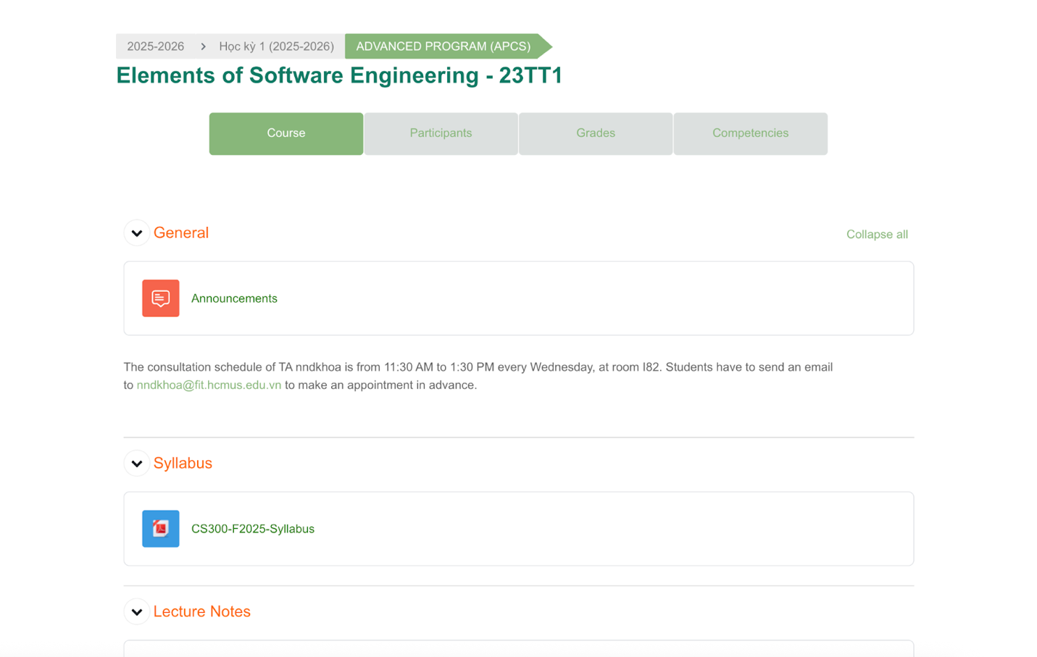
- Discord: detailed communication and meeting space.
There are channels for each activity. There is also a voice channel for meetings. There is a fixed schedule for meetings every week (on Wednesday), the meeting must take no longer than 1 hour.
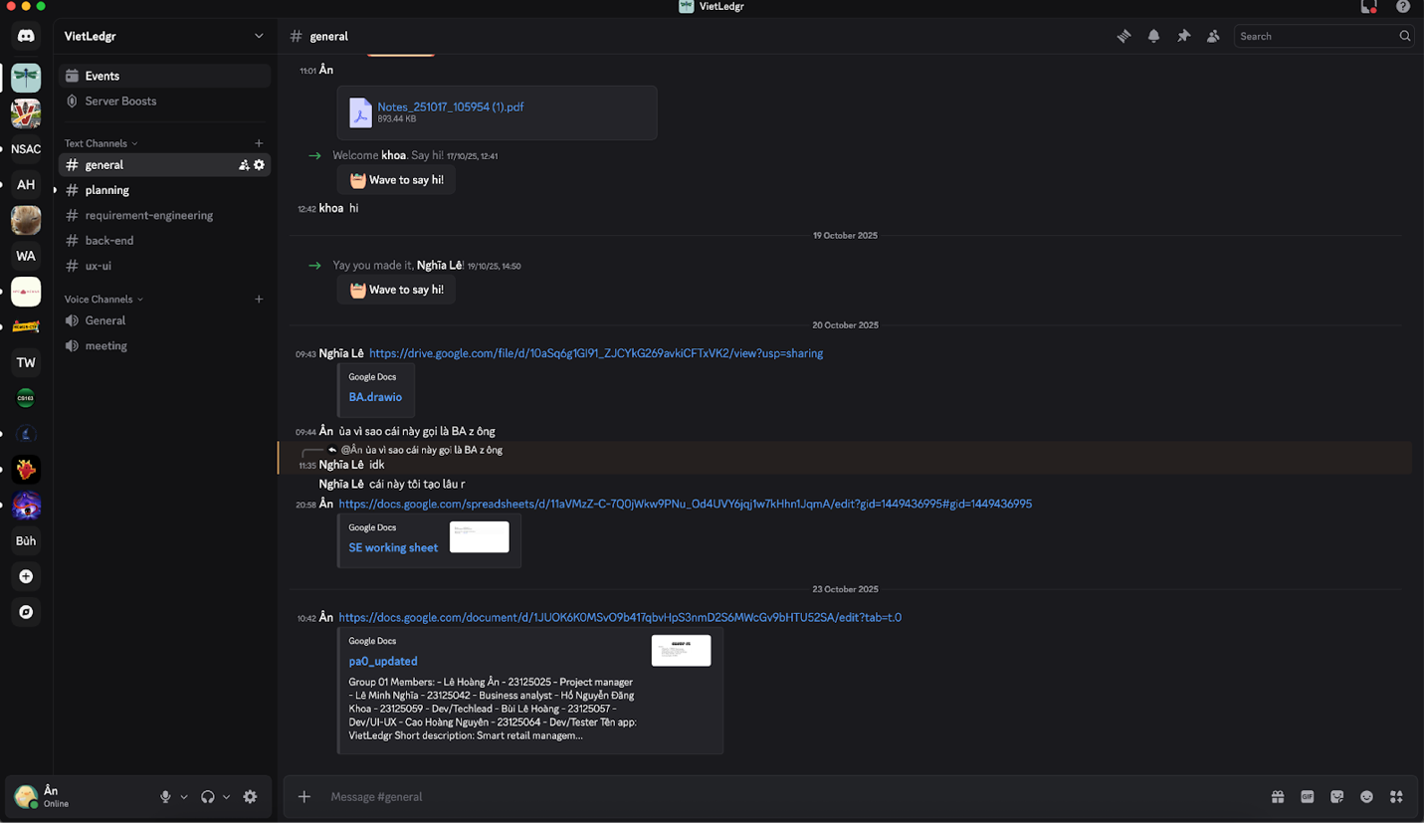
- Jira:
Jira is used to manage tasks. We group activities into sprints, following the Scrum framework.
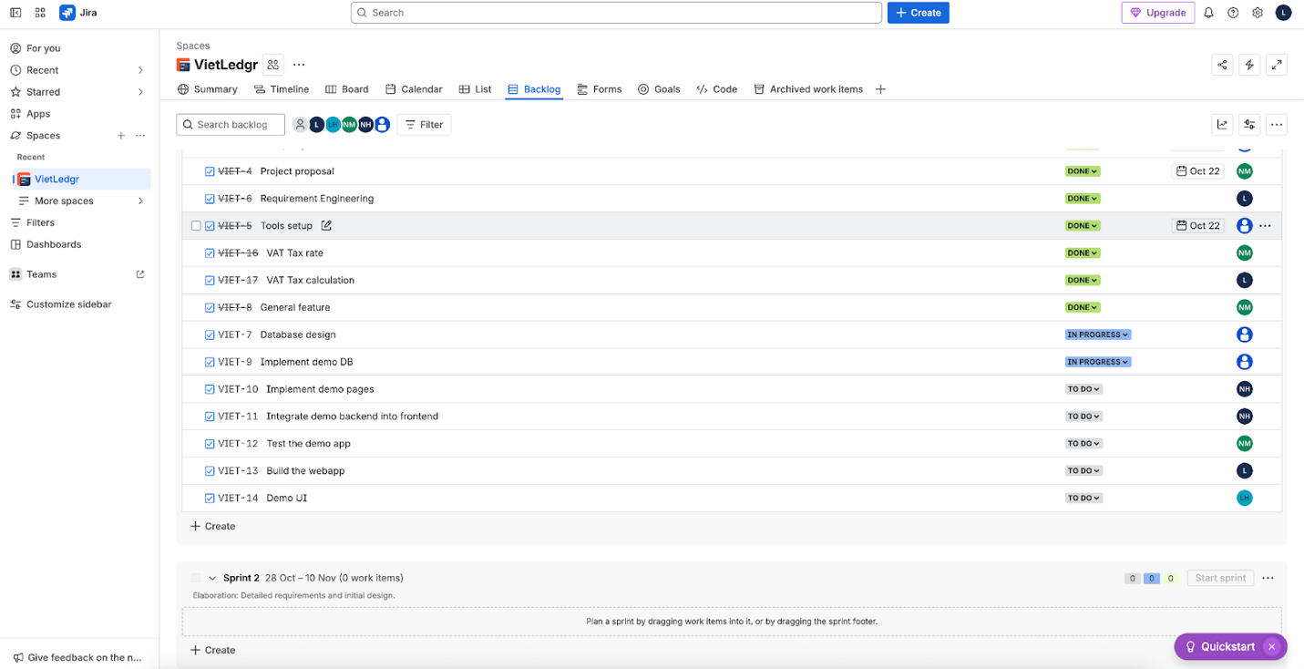
- (Facebook) Messenger:
We use Messenger for general notifications, since every member frequently uses Messenger.
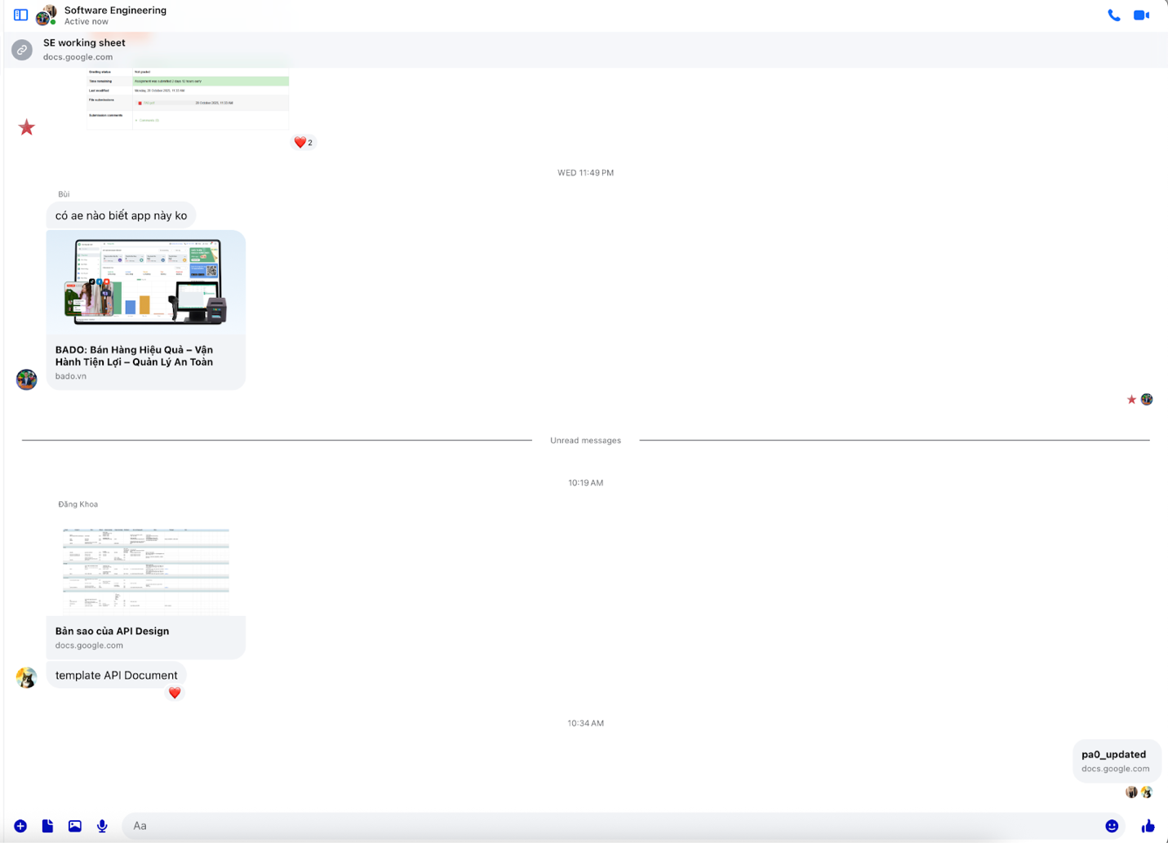
- Github:
We use the Git workflow to do version control. The code on the main branch must be fit for release. Each dev must have a branch for a specific feature, he/she needs to create a pull request to merge into dev. The Techlead (Khoa) needs to approve and resolve merge conflicts. After each iteration, code on the dev branch is merged into the main branch.
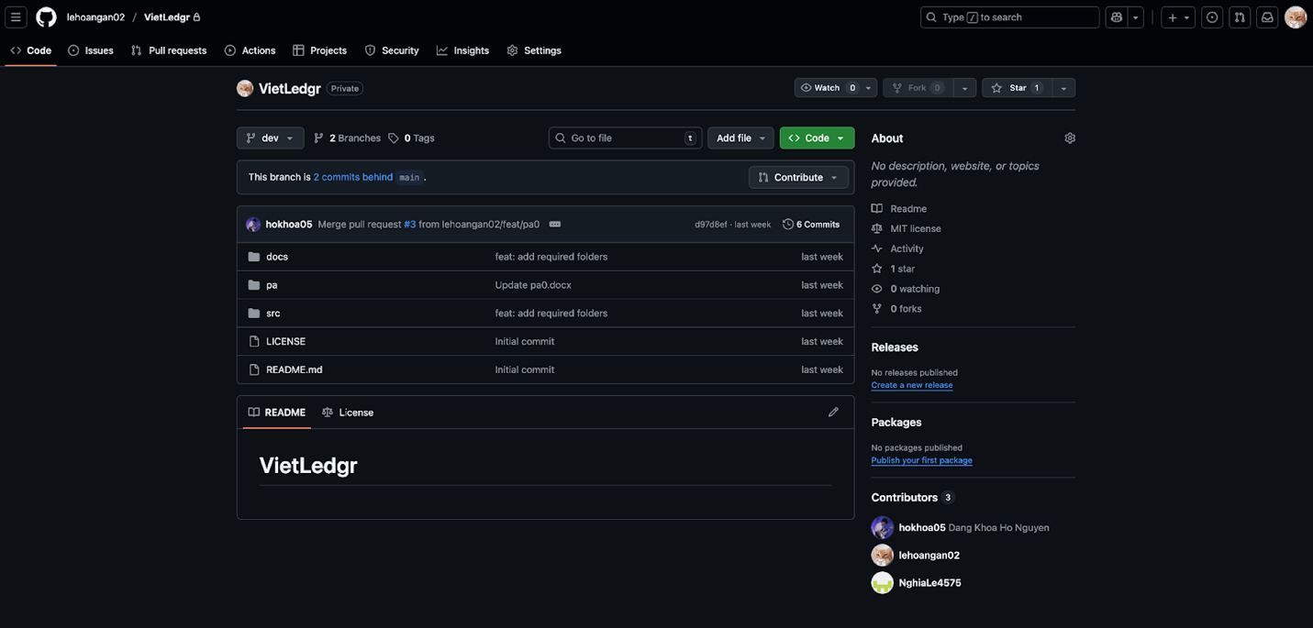
- Google sheet: we create a sheet to share documents.
https://docs.google.com/spreadsheets/d/11aVMzZ-C-7Q0jWkw9PNu_Od4UVY6jqj1w7kHhn1JqmA/edit?gid=0#gid=0

