1. Login page, enter username and password. Then click Sign In button to enter and go to another page.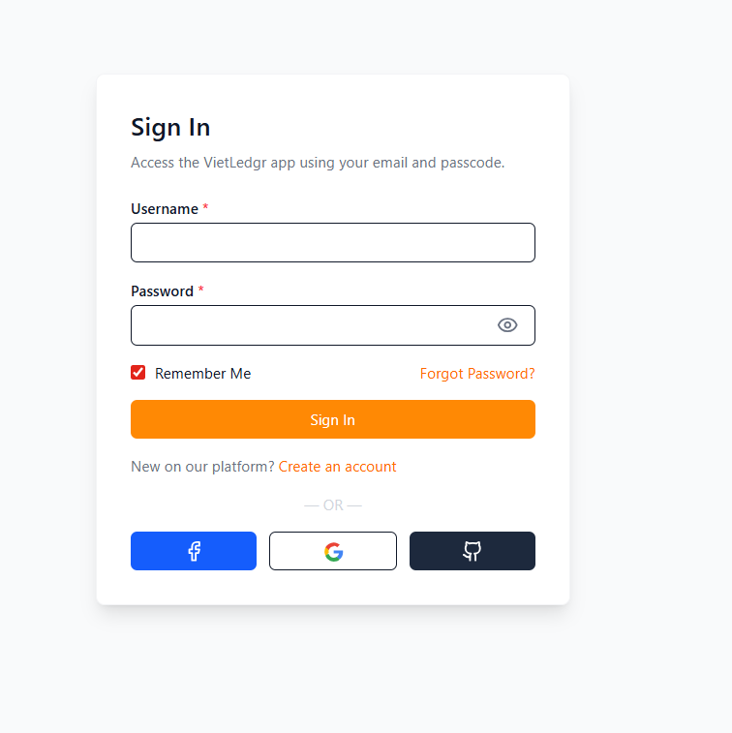
2. After entering the main screen, go to the Inventory – Products page to see all available products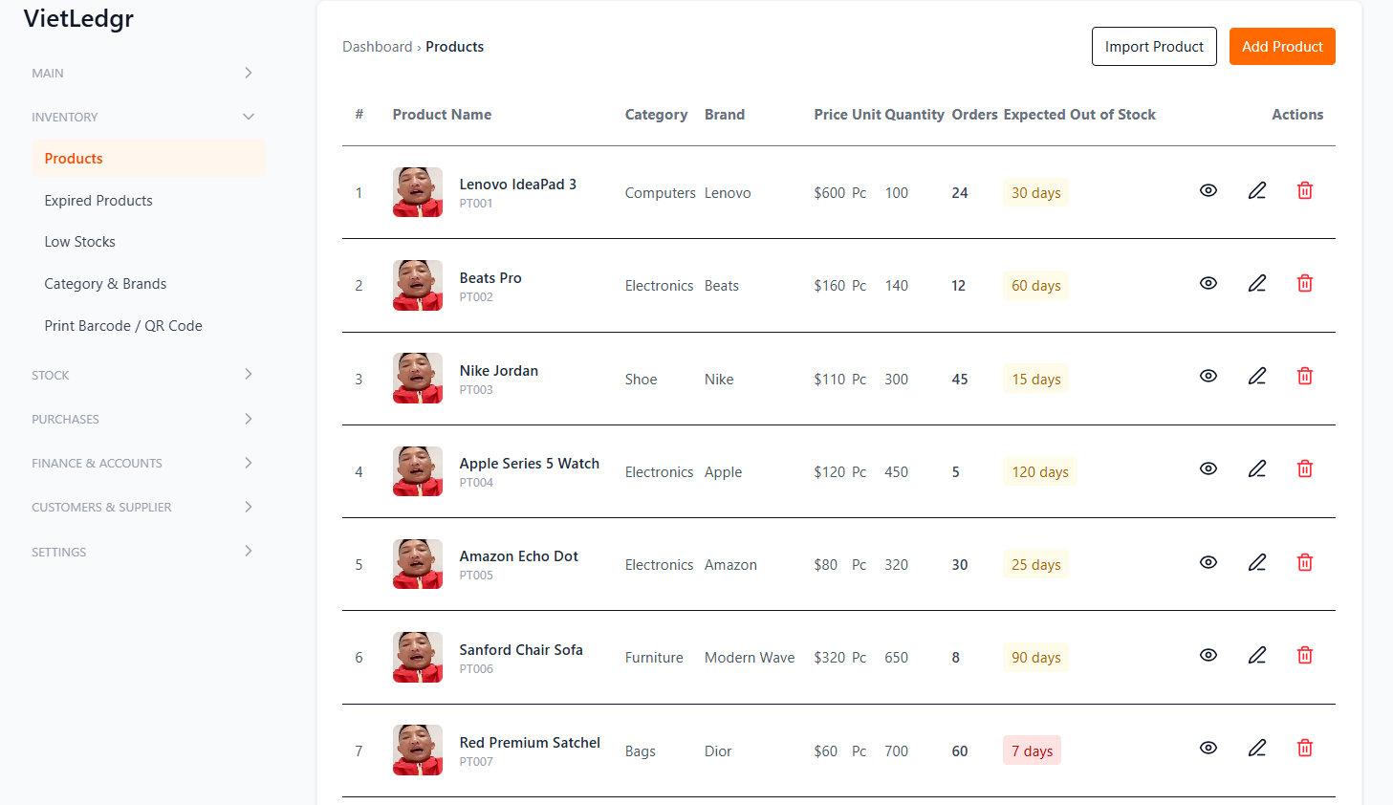
3. Click the Add Product button to create a new product form.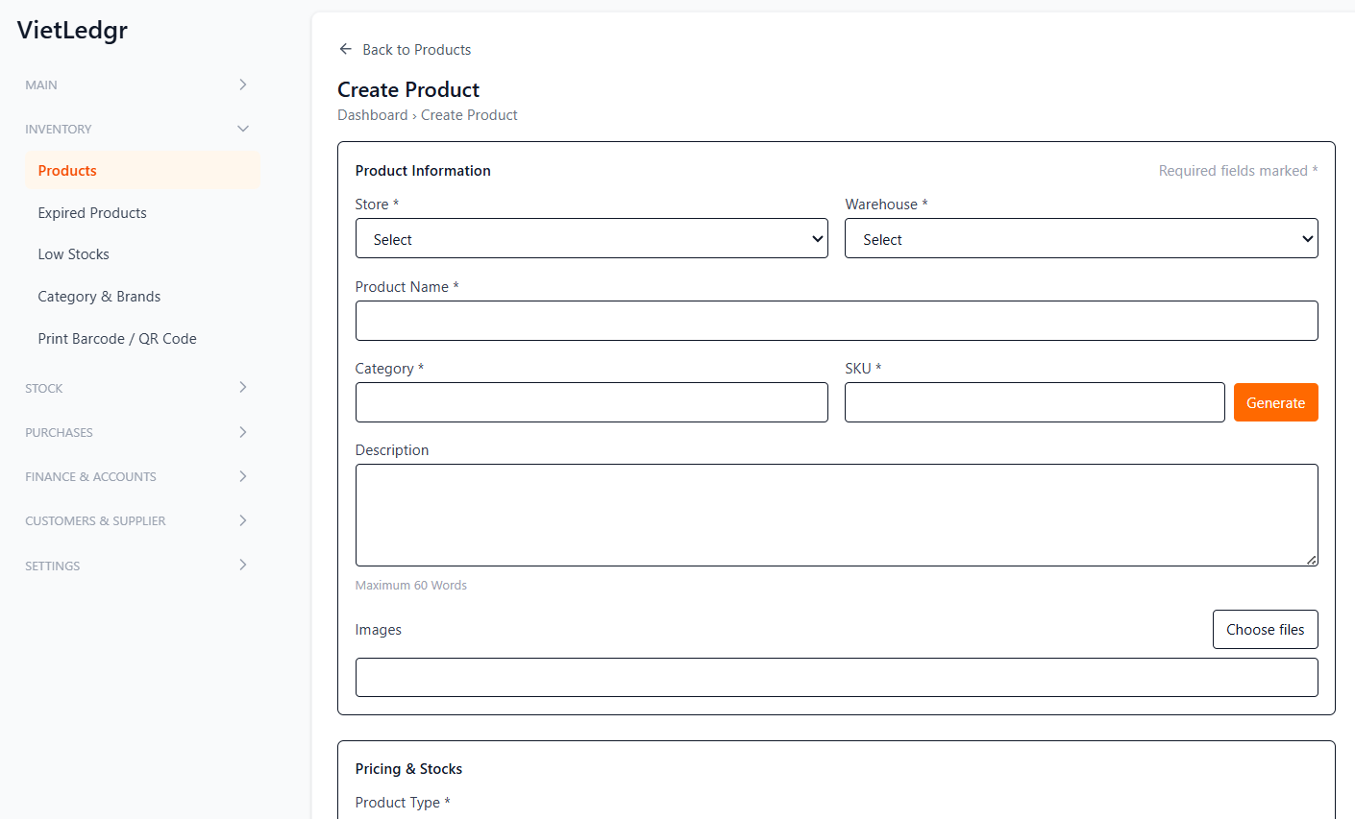

4. If you log in with the Staff role, the main screen will be the POS page like this.