VietLedgr

Software Architecture Document

Version 1.0

Revision History
Date | Version | Description | Author
04/Dec/25 | 1.0 | Creation of Software Architecture Document | Cao Hoang Nguyen, Le Minh Nghia, Ho Nguyen Dang Khoa, Le Hoang An, Bui Le Hoang

Table of Contents
1. Introduction 3
2. Architectural Goals and Constraints 4
3. Use-Case Model 5
4. Logical View 6
4.1 Component: Authentication
4.2 Transaction (Ledger & Handler)
4.3 Dashboard (Analytics & UI)
4.4 Component: POS
4.5 Component: API Client (Front-end API wrappers & Routers)
4.6 Component: API Service (Backend aggregate module)
4.7 Component: Business Logic & Schemas
4.8 Component: Models (Data Layer)
4.9 Component: Database (Postgres)

5. Deployment 13
6. Implementation View 14

Software Architecture Document

Introduction
Purpose.
This Software Architecture Document (SAD) describes the architecture of VietLedgr — a smart retail management platform. It documents the key architectural decisions, component structure, responsibilities, communication mechanisms, and constraints needed by developers, architects, QA, and operations to build, maintain and evolve the system.
Scope.
Covers high-level architecture and detailed component descriptions for the web application (React front-end), backend services (FastAPI), data layer (Postgres), and integrations (supplier APIs, optional mobile front ends). It focuses on the logical view, component responsibilities, key classes/interfaces, communication protocols, non-functional requirements, and deployment considerations.
Definitions / Acronyms.
- API: Application Programming Interface
- POS: Point of Sale
- DB / Postgres: PostgreSQL database
- JWT: JSON Web Token
- UI: User Interface
- UX: User Experience
References.
- Vision / Requirements document (functional and non-functional requirements)
- Use-case specification document and diagrams.
- RESTful API design guidelines.

Architectural Goals and Constraints
Primary architectural goals.
- Reliability / Auditability: Immutable transaction ledger; no destructive deletes — only reversals. Complete audit trails for financial and inventory operations.
- Consistency: Strong consistency for inventory and ledger operations within a user session. Single source of truth in Postgres.
- Performance: Sub-second response for POS critical flows (add item, calculate totals). Scales to many concurrent cashiers (horizontal scaling of API).
- Security & Privacy: Role based access control (RBAC), encrypted credentials in transit (HTTPS/TLS), JWT session tokens with short TTL, field-level protection for sensitive data.
- Extensibility & Integration: API-first design enabling third-party integrations (suppliers, accounting software) and potential mobile apps (React Native).
- Observability: Centralized logging, structured events for transactions, metrics, tracing for latency investigation.
Constraints.
- Technology choices: Frontend: React (web) (+ possible React Native); Backend: FastAPI (Python); Database: PostgreSQL. Team familiarity with these stacks required.
- Deployment environment: Cloud (containerized), CI/CD pipeline required; assume Linux containers (Docker/K8s).
- Regulatory: Must support VAT/GST calculations and audit export formats for local tax authorities.
- Data retention / storage: Immutable ledger implies growth of DB; need retention/archival policy and partitioning.
- Team & Schedule: Modular design to allow parallel work by frontend, backend and data engineers.

Use-Case Model
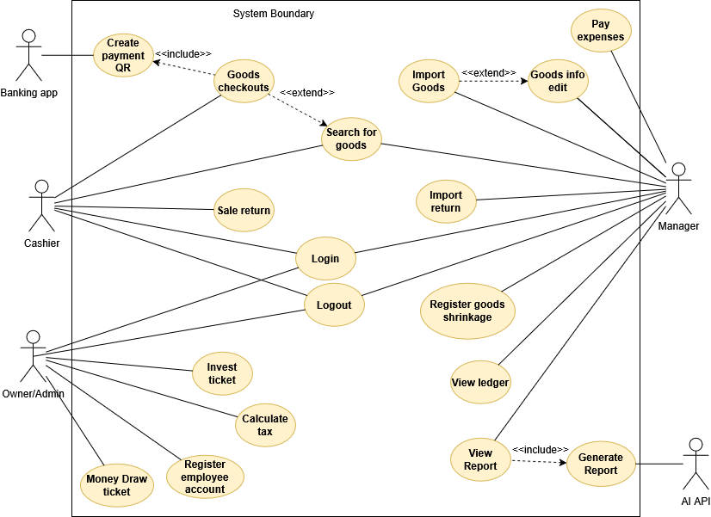

Logical View
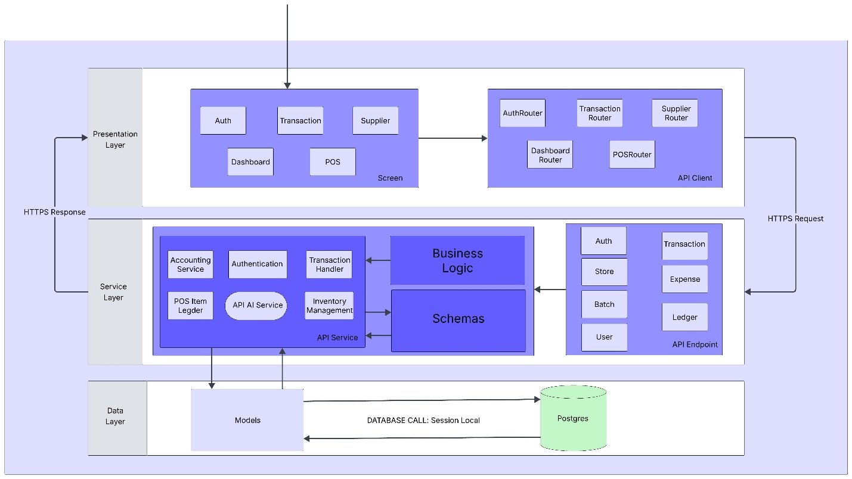
This section describes the componentization and relationships, communications, and responsibilities. The application is organized into three logical layers:
- Presentation Layer (Client): React web app (POS, Dashboard, Admin screens), API client/routers.
- Service Layer (Backend API): FastAPI services, business logic, API endpoints, background jobs.
- Data Layer: Models (ORM SQLAchelmy) & repository, PostgreSQL.
Communication between front-end and API uses HTTPS/JSON. The backend communicates with Postgres over the DB driver (psycopg / asyncpg), and with external suppliers via HTTPS REST or optionally message broker for async flows.
Below we list components and then detail each using the template: responsibilities, key classes (UML-like), and interfaces.

Component: Authentication
Responsibilities
- Authenticate users and devices (support username/password and device binding).
- Issue and validate JWT tokens (access + refresh patterns) or session tokens.
- Provide RBAC (roles: Cashier, Manager, Accountant, Admin).
- Support SSO / external identity providers (optional).
- Record login events for audit trails and device IDs for each transaction.
Services / Interfaces
- /auth/login (POST) — credentials, returns JWT
- /auth/refresh (POST) — refresh token
- /auth/logout (POST) — revoke refresh token / device
- /auth/users (GET/POST/PUT) — Admin user management (RBAC controls)
Key classes / types (conceptual UML)
- AuthService : verify_credentials(), issue_jwt(), revoke_token()
- UserRepository : get_user_by_id(), create_user(), list_users()
- JWTManager : encode(payload), decode(token), is_revoked(token)
- PasswordHasher : hash(), verify()
- AuthController (FastAPI router) : endpoints exposures
Communications
- Frontend ↔ Backend: HTTPS/JSON
- Auth backend ↔ DB: SQL queries via ORM (session local)
- Token revocation metadata stored in DB / Redis (short TTL) if needed.
Non-functional
- TLS mandatory, enforce secure cookies for refresh tokens (if using cookies), rate limiting on login, MFA optional.
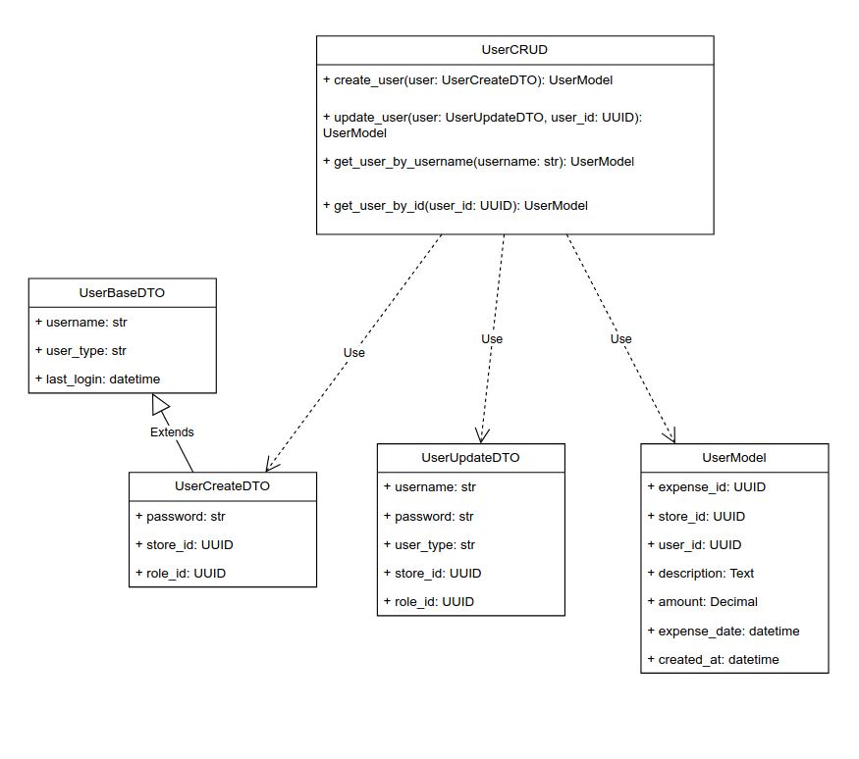

Transaction (Ledger & Handler)
Responsibilities
- Record immutable transaction ledger entries for all financial events (sales, returns, adjustments, expenses).
- Accept transaction requests from POS and API endpoints; validate, persist, and emit domain events.
- Provide reversal operation that creates a compensating transaction (never delete).
- Ensure atomic updates: ledger entries linked to inventory movements must both succeed or both roll back (DB transaction).
- Expose query API for reports and audit (with filters, paging).
Services / Interfaces
- /transactions/create (POST)
- /transactions/rupdate (POST)
- /transactions/{id} (GET)
- /transactions/transaction_list (GET) — time/range/filters
Key classes
- TransactionHandler : create_transaction(), reverse_transaction(), validate()
- LedgerEntry (DB model) : id, type, amount, user_id, timestamp, device_id, reference_id, metadata
- TransactionRepository : persist_entry(), query_entries()
- TransactionService : coordinates between InventoryService and Ledger
Communication
- Synchronous: API -> TransactionHandler -> DB (Postgres), within DB session to maintain ACID.
- Emits domain events (in-process events or to message broker) for async tasks (reporting, analytics).
Design notes
- Use DB constraints and append-only tables for ledger.
- Store device_id and session metadata for audit traceability.
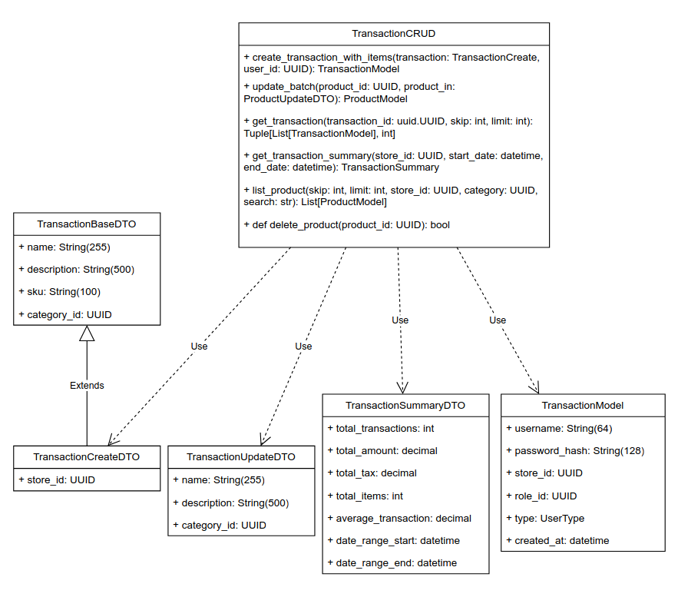
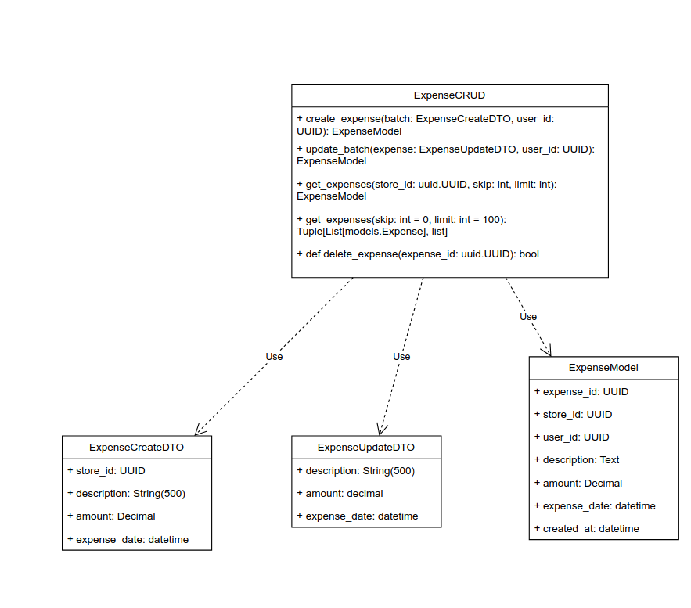
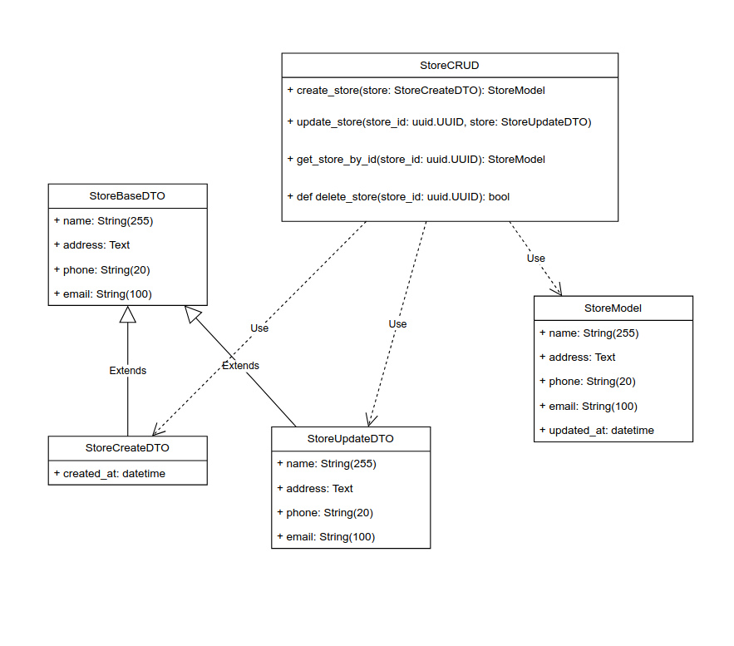
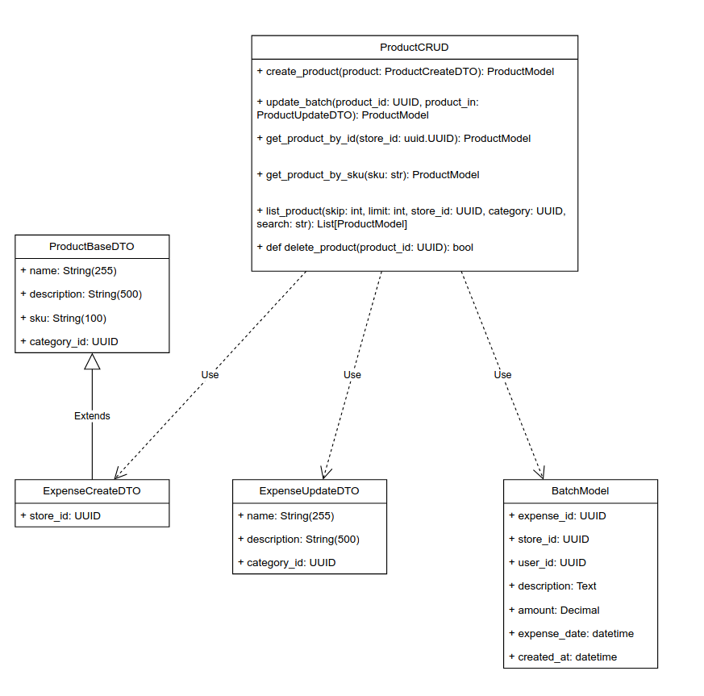
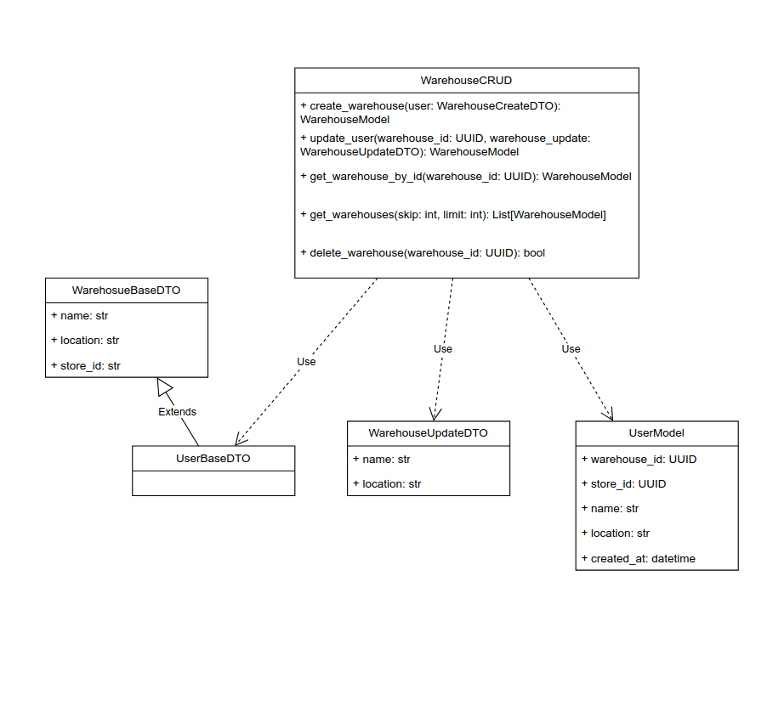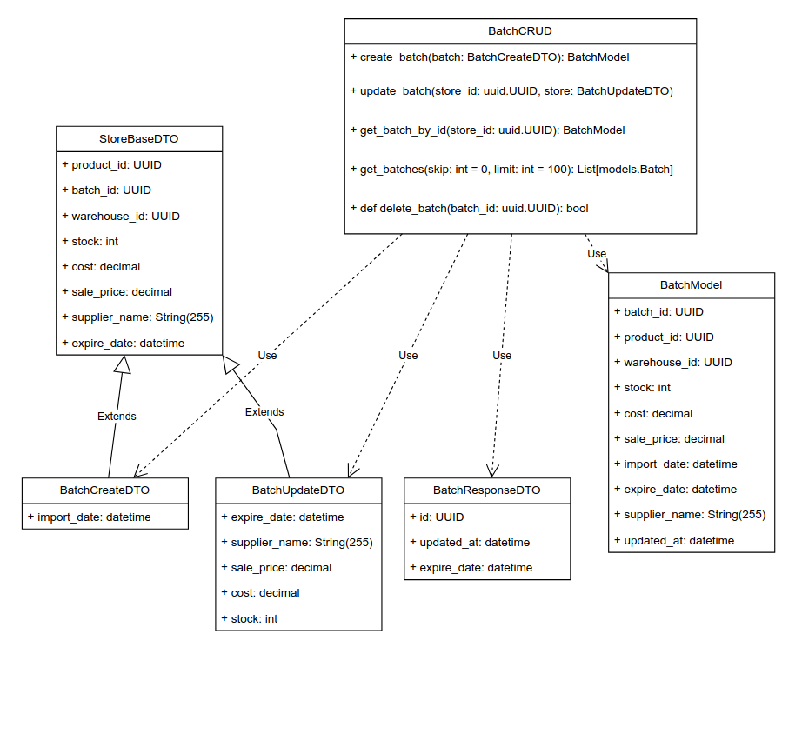

Dashboard (Analytics & UI)
Responsibilities
- Aggregate KPIs and time series for UI dashboards (sales today, top items, low stock).
- Provide role-specific dashboards (manager vs cashier).
- Allow drill-downs into transactions and inventory details.
- Serve as entry point for AI insights (calls to API AI Service for suggestions).
Key classes
- DashboardService : fetch_kpis(), fetch_trends()
- KPIRepository : precomputed aggregates (cached)
- DashboardRouter : API endpoints consumed by frontend
Communication
- Frontend ↔ Dashboard Router: HTTPS.
- Backend ↔ DB: Queries and precomputed aggregates.
- Optional: use a cache (Redis) for frequently requested dashboards

Component: POS
Responsibilities
- Fast, minimal click checkout flow; manage cart, apply discounts, taxes.
- Communicate with Transaction component to finalize sale and with Inventory to decrement stock.
- Support barcode scanning input and quick product search.
- Offline mode (optional) with eventual sync: queue transactions locally and replay upon connection.
Key classes
- POSScreen (frontend)
- POSRouter (client-side route handlers)
- PosService (backend) : add_to_cart(), checkout()
Communication
- Frontend → Backend: HTTPS for checkout. For offline mode, front-end caches locally and syncs when connected.

Component: API Client (Front-end API wrappers & Routers)
Responsibilities
- Centralize API calls from the frontend; implement retry logic, error handling, JWT token refresh.
- Provide typed API client modules (e.g., authClient, transactionClient, supplierClient) to UI components.
Key classes / modules
- ApiClient : base HTTP client (handles headers, auth refresh)
- AuthRouter, TransactionRouter, SupplierRouter, DashboardRouter, POSRouter : thin wrappers with endpoints
Communication
- Frontend -> Backend via HTTPS/JSON with JWT in Authorization header.

Component: API Service (Backend aggregate module):
This is the host module that contains domain services exposed by FastAPI.
Responsibilities
- Expose REST endpoints for all domain operations.
- Coordinate business logic and schema validation.
- Provide background job scheduling interface (for AI tasks, supplier sync, reports).
Subcomponents
- API Endpoint groups (Auth, Transaction, Inventory, User, Ledger, Reports).
- API AI Service — wrapper for AI features (insights, anomaly detection).
- Accounting Service — for financial exports and mapping to external accounting formats.
Key classes
- APIRouter modules (FastAPI routers) grouped by domain.
- ServiceLayer classes (TransactionService, InventoryService, ReportingService).
- Schema (Pydantic models) for request/response validation.
Communication
- Receives HTTPS requests from client; interacts with DB (Postgres) and other internal services synchronously/async.

Component: Business Logic & Schemas
These are core backend components that implement domain rules.
Business Logic responsibilities
- Implement transactional rules: matching inventory change with ledger entry, tax calculation rules, discount application.
- Enforce role permissions and audit rules.
- Implement AI/forecast orchestration (delegate to API AI Service).
Schemas responsibilities
- Define canonical Pydantic schemas for all external interfaces and internal DTOs (e.g., ProductSchema, TransactionCreateSchema, LedgerEntrySchema).
- Ensure stability and backwards compatibility for API versions.
Key artifacts
- schemas/ (pydantic): ProductCreate, TransactionCreate, UserOut, ReportRequest
- services/ : InventoryManager, LedgerManager, PricingEngine

Component: Models (Data Layer)
Responsibilities
- Define ORM models and repository patterns (SQLAlchemy / async ORM) for persistence.
- Provide atomic DB sessions for service operations.
- Implement migrations (Alembic).
Primary Models
- Product : id, name, barcode, category, unit, price, tax_code, expiration_date, variants
- InventoryItem : product_id, quantity, batch_no, location, expiry_date
- LedgerEntry : id, txn_type, amount, currency, timestamp, user_id, device_id, reference
- User : id, username, role, hashed_password, created_at
- Supplier : id, name, lead_time, API meta
- PurchaseOrder, StockReceipt
DB Access
- Repository classes per aggregate (ProductRepository, InventoryRepository, TransactionRepository)
- DB transactions used to ensure atomicity: e.g., on checkout update inventory and insert ledger entry in same DB transaction.

Component: Database (Postgres)
Responsibilities
- Store canonical data, append-only ledger, and indices for query performance.
- Support transactional integrity and constraints (FK, unique constraints).
- Partitioning or table sharding strategies for ledger table if scale demands (time-based partitions).
- Backups, replication and read replicas for reporting.
Design considerations
- Ledger uses append-only model; expose materialized views for reporting.
- Indexes for frequently queried fields (product_id, timestamp).
- Use JSONB for flexible metadata on ledger entries and products (for extensibility).
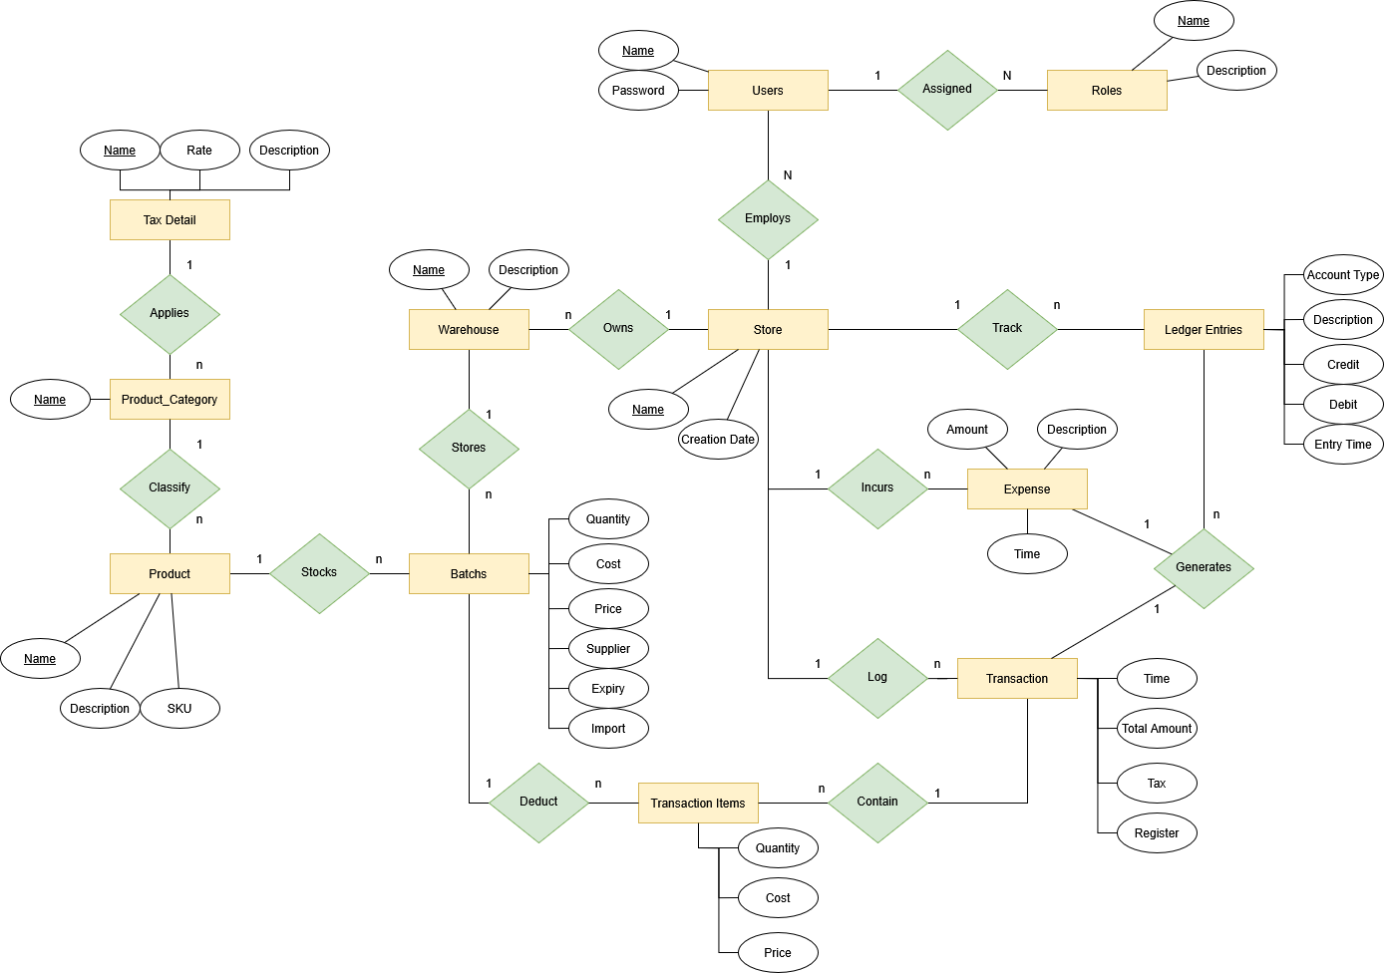

Deployment
[Leave this section blank for PA4 if you are writing this document for PA3.
In this section, describe how the system is deployed by mapping the components in Section 4 to machines running them. For example, your mobile app is running on a mobile device (Android, iOS, etc), your server runs all components on the server side including the database]

Implementation View
[Leave this section blank for PA4 if you are writing this document for PA3.
In this section, provide folder structures for your code for all components described in Section 4. ]

