Youtube: https://drive.google.com/file/d/1iCm6pJBabTk24bHBjeWN575eYT8KfDRE/view?fbclid=IwZXh0bgNhZW0CMTEAc3J0YwZhcHBfaWQPNDM3NjI2MzE2OTczNzg4AAEeyRJ0KAs5ziivjq0dmbPR7AnqT-1W9I5-1gm0LVkPtyebzKJfjOM20a3jv7Q_aem_L-e5_LViIgm8zlO4Rc89V

1. Login page, enter username and password. Then click Sign In button to enter and go to another page.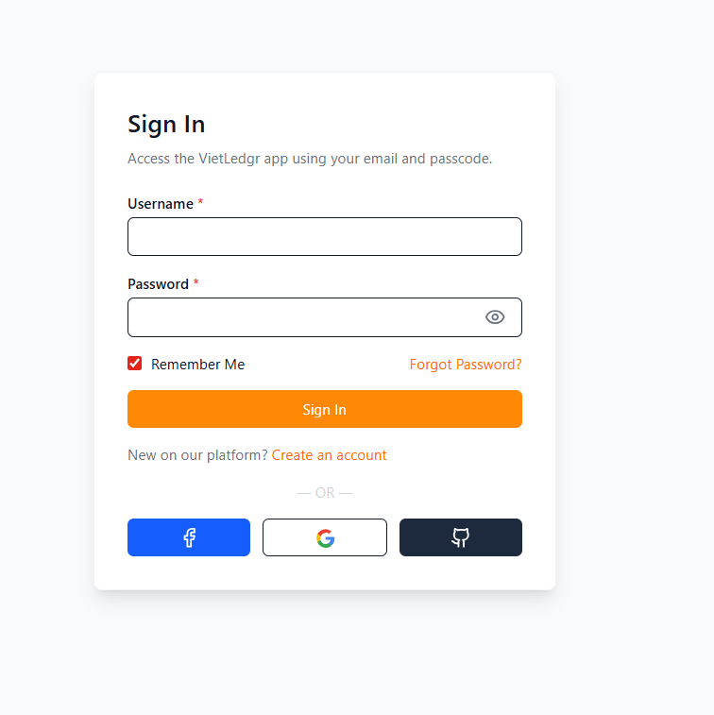
2. After entering the main screen, go to the Inventory – Products page to see all available products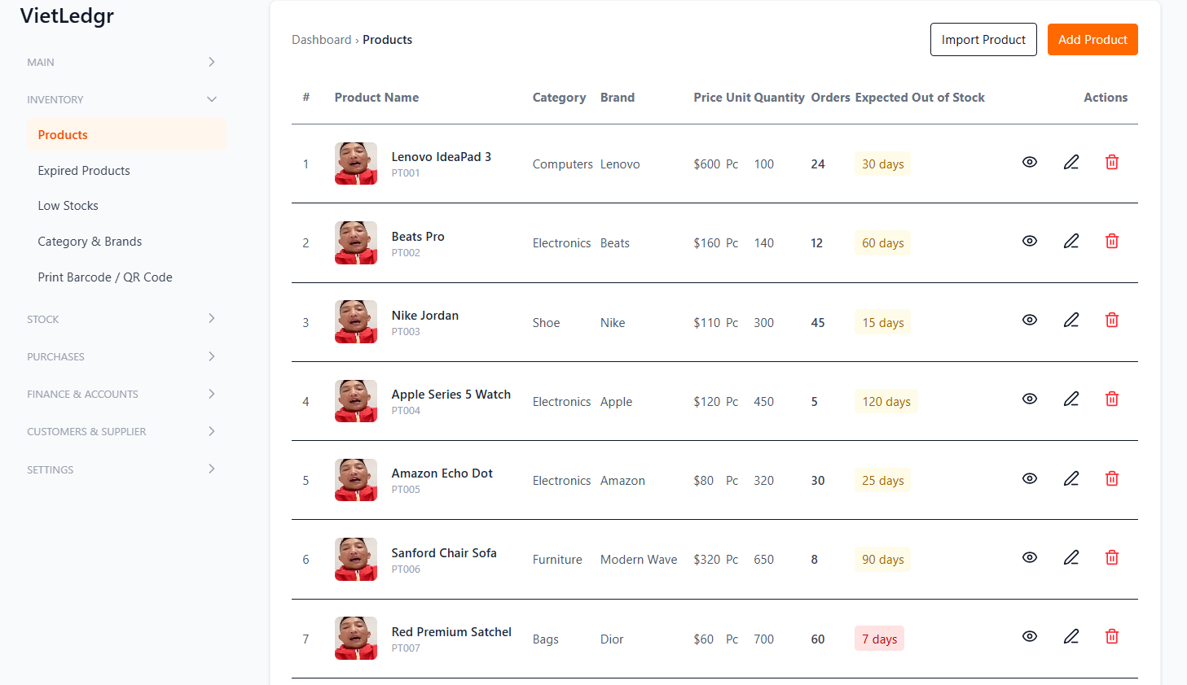
3. Click the Add Product button to create a new product form.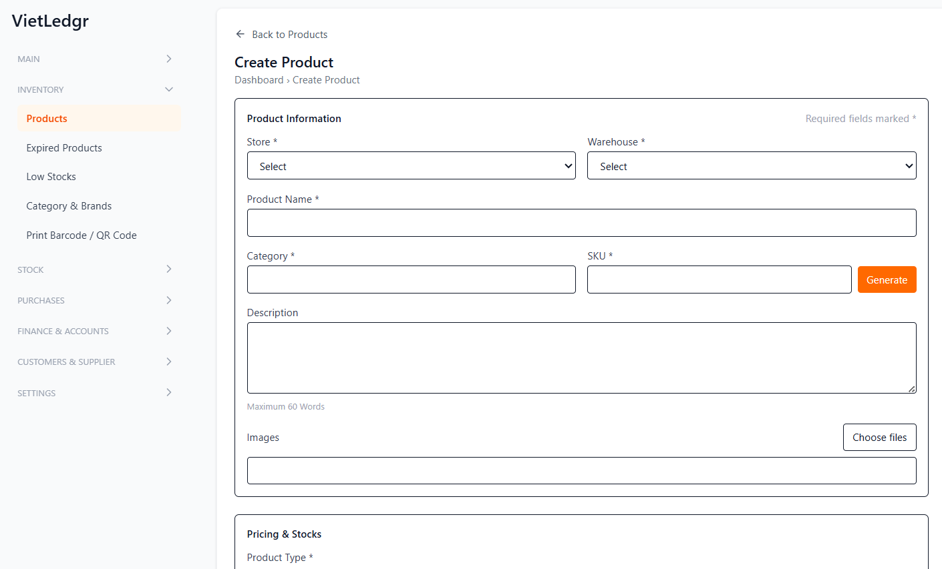

4. If you log in with the Staff role, the main screen will be the POS page like this.