OUR TRIPS | YOUR OWN TRIPS

OUR TRIPS
- Foody tour
Price: 45$
Time: 4 hours
- Nhu Lan Bread ( 50 Ham Nghi, Ben Nghe, district 1) 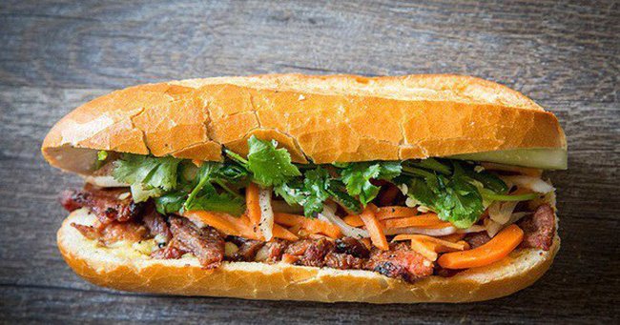
“So far, nearly 50 years, only from a mobile propeller to sell bread near Gia Long (now known as Nguyen Thi Minh Khai), then transferred to a small shop on Ham Nghi Street, Saigon Old Market, then Nowadays, Nhu Lan bread brand has become so familiar to everyone, all families are familiar with eating rice,
Not only the Vietnamese, but quite a large number of Western tourists also love hamburgers, hamburgers, kebab ...... of Nhu Lan, a brand selling noodles with culinary characteristics of Saigon far and away today “
- Moc broken rice (85 Ly Tu Trong, Ben Thanh, district 1) 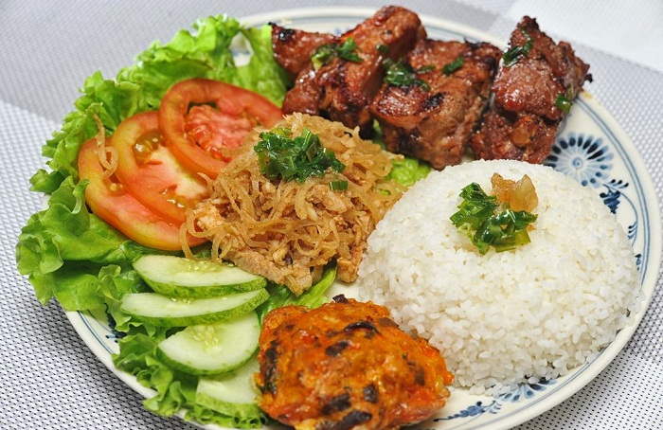
“ Cơm tấm, or broken rice, is a Vietnamese dish made from rice with fractured rice grains. Tấm refers to the broken rice grains, while cơm refers to cooked rice. Although there are varied names like cơm tấm Sài Gòn (Saigon-style broken rice), particularly for Saigon,^{[1]} the main ingredients remain the same for most cases. It is usually served with grilled pork (either ribs or shredded) plus the Vietnamese dish bì (thinly shredded pork mixed with cooked and thinly shredded pork skin) over broken rice. The rice and meat are served with various greens and pickled vegetables, along with a prawn paste cake, trứng hấp (steamed egg), and grilled prawns. Typically, restaurants will serve this popular combination rice plate with a small bowl of nước mắm, as well as a small bowl of soup broth (canh) with garlic chives (to cleanse the throat). The dish cơm tấm bì comes with a chả trứng egg meatloaf, which nowadays may be substituted with an omelette”

- Sugarcane juice ( 122 Pasture, Ben Nghe, district 1) 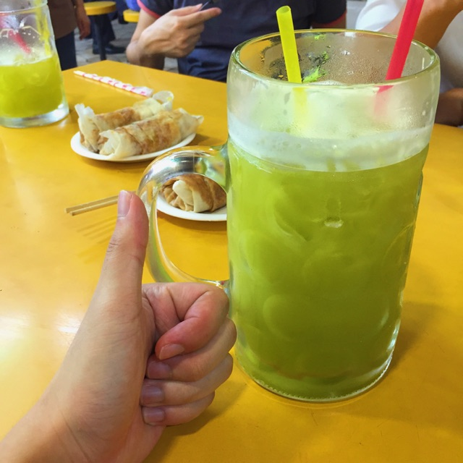
“Sugarcane juice is the syrup extracted from pressed sugarcane. "Juice" is misleading as this is not a fruit or vegetable juice.^{[1]} It is consumed as a beverage in many places, especially where sugarcane is commercially grown such as Southeast Asia, the Indian Subcontinent, Egypt, and Latin America. Evaporated cane juice, as an ingredient in prepared food, is a misleading way of saying "sugar".
Sugarcane juice is obtained by crushing peeled sugar cane in a mill and is one of the main precursors of rum.”
- Thin Pho ( 170 Nguyen Dinh Chieu, district 3) 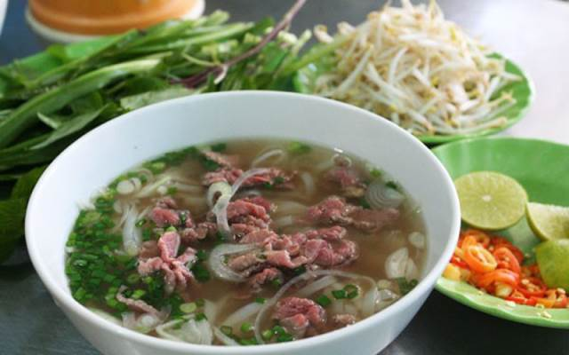
“Phở or pho is a Vietnamese soup consisting of broth, rice noodles called bánh phở, a few herbs, and meat, primarily made with either beef (phở bò) or chicken (phở gà).Pho is a popular street food in Vietnam and the specialty of a number of restaurant chains around the world. Pho originated in the early 20th century in northern Vietnam, and was popularized throughout the rest of the world by refugees after the Vietnam War. Because pho's origins are poorly documented, there is significant disagreement over the cultural influences that led to its development in Vietnam, as well as the etymology of the word itself. The Hanoi and Saigon styles of pho differ by noodle width, sweetness of broth, and choice of herbs. A related noodle soup, bún bò Huế, which is a spicy beef noodle soup, is associated with Huế in central Vietnam”
- Coconut juice ( 254 Pasture, district 3) 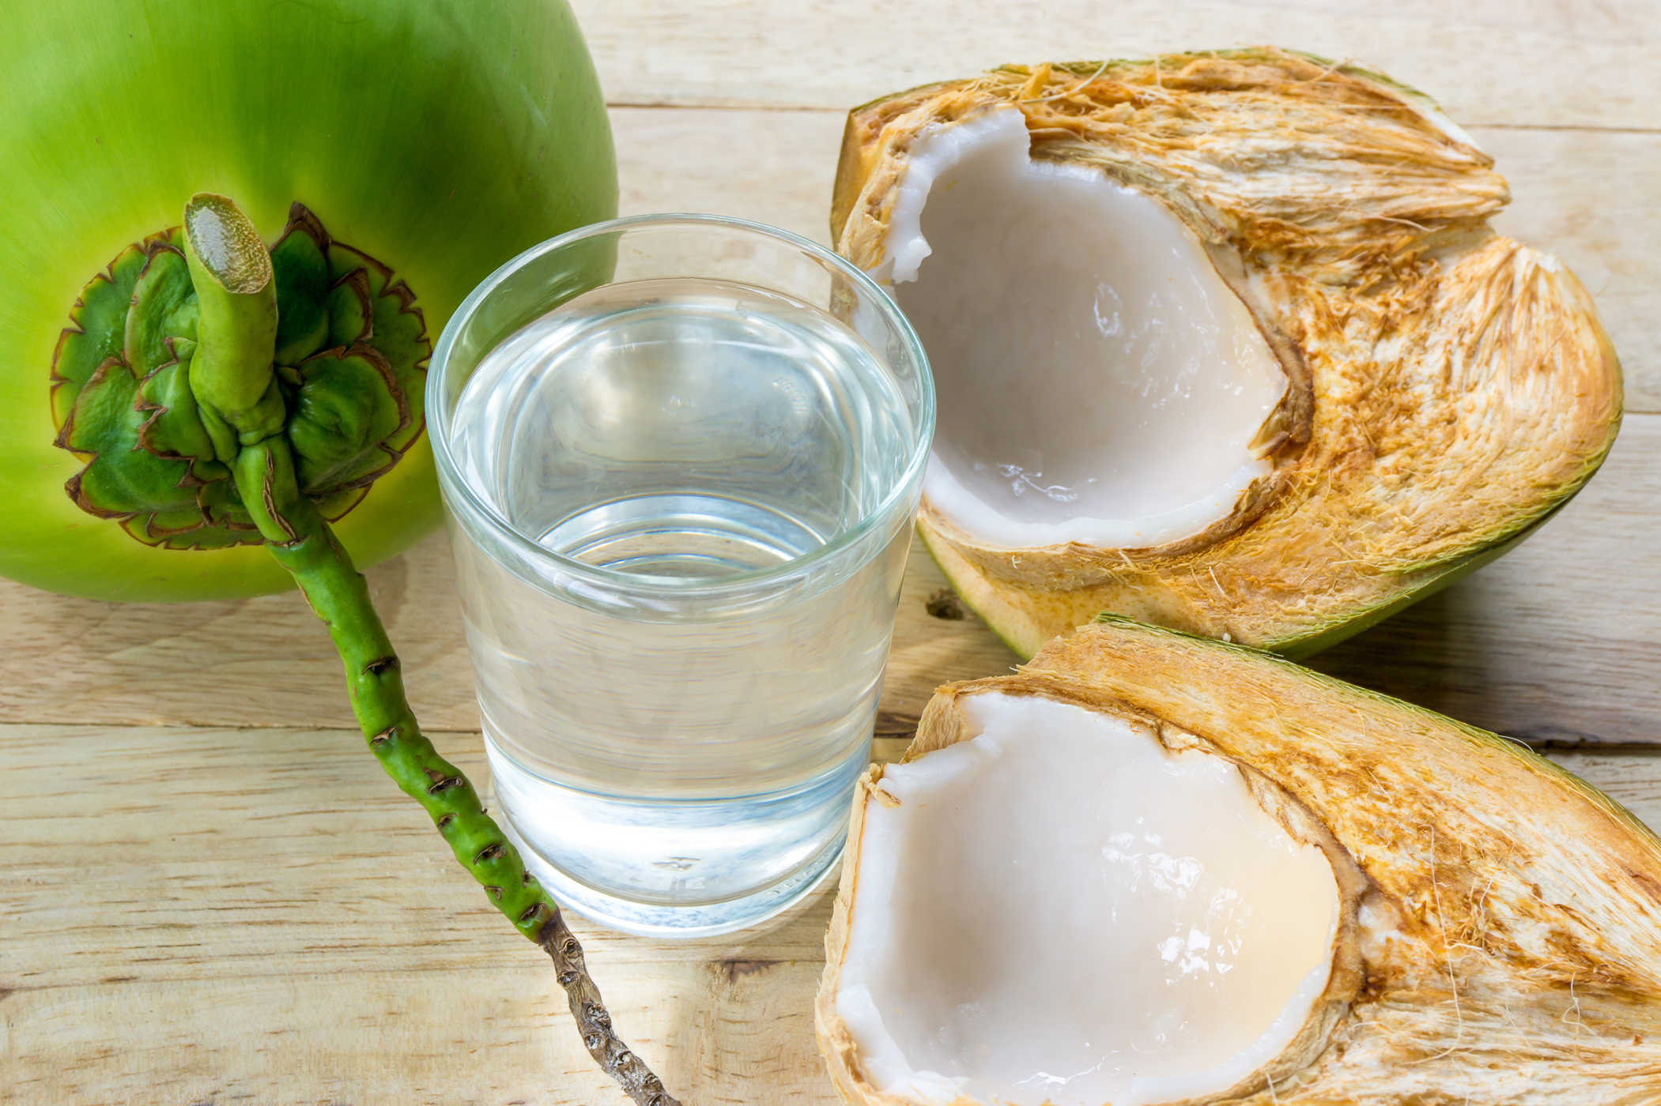
“Coconut juice is the beverage trend of the world and Vietnam, because consumers increasingly choose the product of natural origin, not preserved. Markets placed coconut water in the healthy drink category, outperforming conventional beverages.”
- Ganh Bun bo ( 110 Ly Chinh Thang, district 3) 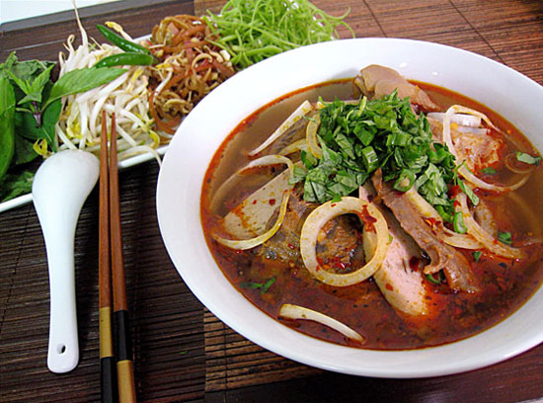
“Bún bò Huế or bún bò is a popular Vietnamese soup containing rice vermicelli (bún) and beef (bò). Huế is a city in central Vietnam associated with the cooking style of the former royal court. The dish is greatly admired for its balance of spicy, sour, salty and umami flavors. The predominant flavor is that of lemon grass. Compared to phở or bún riêu, the noodles are thicker and more cylindrical.
- Vy Coffee ( Le Thanh Ton- Le Anh Xuan, district 1) 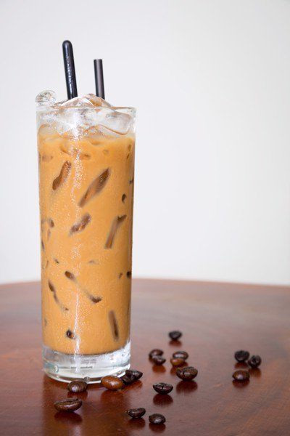
“Vietnamese iced coffee, also known as cà phê đá or cafe da (Vietnamese: cà phê đá, literally "ice coffee") is a traditional Vietnamesecoffee recipe.
At its simplest, cà phê đá is made using medium to coarse ground dark roast Vietnamese-grown coffee with a small metal Vietnamese drip filter (phin cà phê). After the hot water is added, the drip filter releases drops of hot coffee slowly into a cup. This finished cup of hot coffee is then quickly poured into a glass full of ice making the finished Vietnamese iced coffee.
A popular way to drink Vietnamese coffee is cà phê sữa đá, which is Vietnamese iced coffee with sweetened condensed milk. This is done by filling up the coffee cup with 2-3 tablespoons or more of sweetened condensed milk prior to the drip filter process

- Thao snails ( 169 Vinh Khanh, district 4) 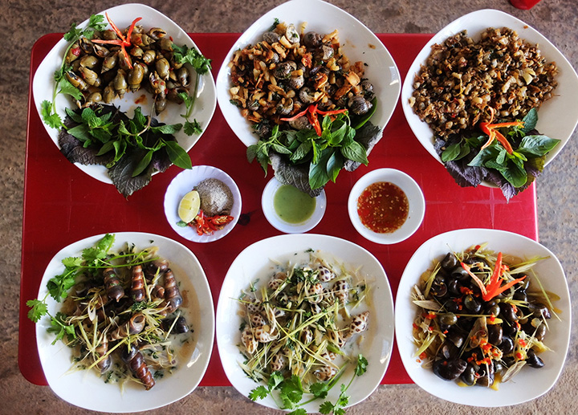
“Saigon people sometimes do not see snails as snacks, eat that can eat instead of lunch, dinner. Often, the pubs are served around midnight until late at night. When the street lights up, people end their busy day, when they call each other to familiar goods to gather, shade the story. From the popular push-carts with a small kitchen for processing to the restaurant with many types of snails waiting for the customers name all, all created a culture of gastronomy for Saigon at night. .”

- Sightseeing tour
    - Price: 35$
    - Time: 4 hours
- Ben Thanh market 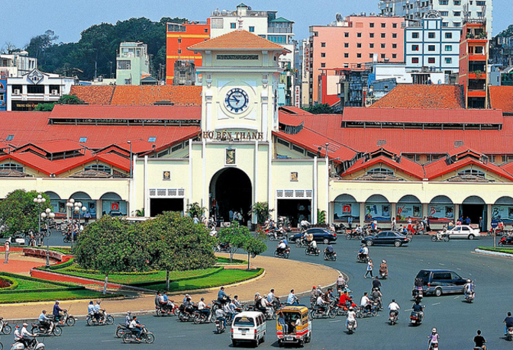
“Bến Thành Market (Vietnamese: Chợ Bến Thành) is a large marketplace in central Hồ Chí Minh City, Vietnam in District 1. The market is one of the earliest surviving structures in Saigon and an important symbol of Hồ Chí Minh City, popular with tourists seeking local handicrafts, textiles, áo dài and souvenirs, as well as local cuisine.”

- Duc Ba Church 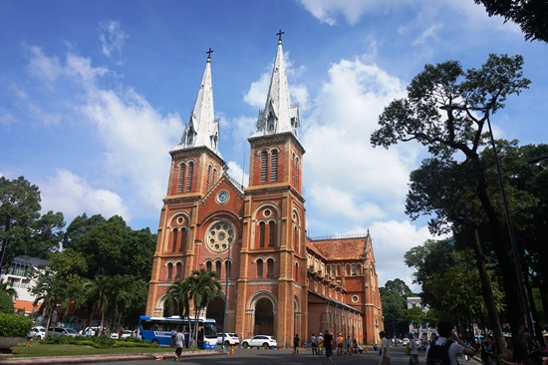
“Notre-Dame Cathedral Basilica of Saigon (Vietnamese: Vương cung thánh đường Chính tòa Đức Bà Sài Gòn or Nhà thờ Đức Bà Sài Gòn; French: Basilique-Cathédrale Notre-Dame de Saigon), officially Cathedral Basilica of Our Lady of The Immaculate Conception (Vietnamese: Vương cung thánh đường Chính tòa Đức Mẹ Vô nhiễm Nguyên tội; French: Basilique-Cathédrale Notre-Dame de l'Immaculée Conception) is a cathedral located in the downtown of Ho Chi Minh City, Vietnam. Established by French colonists who initially named it Cathédrale Notre-Dame de Saïgon, the cathedral was constructed between 1863 and 1880. It has two bell towers, reaching a height of 58 meters (190 feet)

- Saigon Opera House 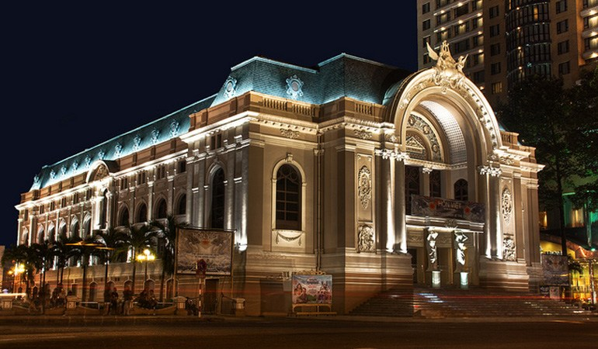
“The Municipal Theatre of Ho Chi Minh City, also known as Saigon Opera House (Vietnamese: Nhà hát lớn Thành phố Hồ Chí Minh; French: Opėra de Saigon), is an opera house in Ho Chi Minh City, Vietnam. It is an example of French Colonial architecture in Vietnam.”
- Bui Vien walking street 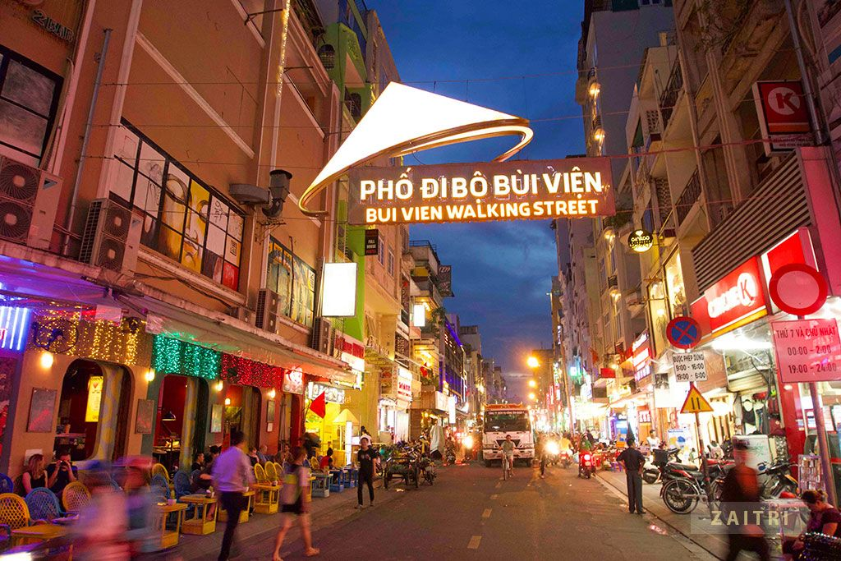
“Bui Vien Street is the main street of the so called ‘backpackers area’ of Ho Chi Minh City. Here you find a wide variety of inexpensive restaurants, bars, souvenir shops and hotels/hostels. While being seated at one of the places you can soak up the local lifestyle and culture. You can shop, dine and party on Bui Vien Street.”
- Independence Palace 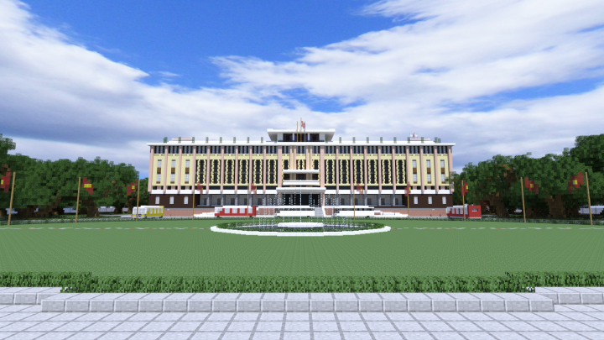
“Independence Palace (Dinh Độc Lập), also known as Reunification Palace (Vietnamese: Dinh Thống Nhất), built on the site of the former Norodom Palace, is a landmark in Ho Chi Minh City, Vietnam. It was designed by architect Ngô Viết Thụ and was the home and workplace of the President of South Vietnam during the Vietnam War. It was the site of the end of the Vietnam War during the Fall of Saigon on 30 April 1975, when a North Vietnamese Army tank crashed through its gates.”
- Floating Market 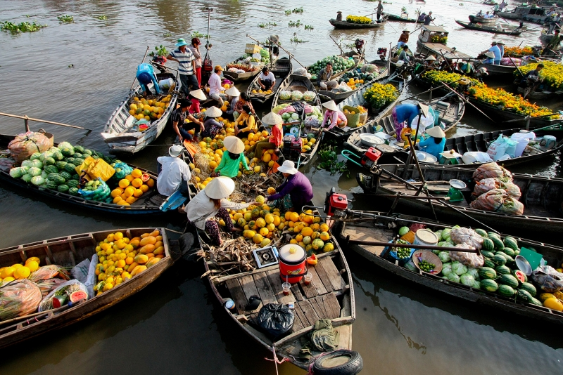
“Floating market is a type of market often appear in the river area is considered the main traffic. Where both sellers and buyers use boats for transportation and transportation. The floating market in the river is not too wide nor too narrow. River must be relatively wide, not too dry nor too deep. If the river is too deep, too big, it can not anchor the boat easily and very dangerous.”
- Nuoc dua ( 254 Pasture, district 3)
“Coconut juice is the beverage trend of the world and Vietnam, because consumers increasingly choose the product of natural origin, not preserved. Markets placed coconut water in the healthy drink category, outperforming conventional beverages.”

- Mix tour
  - Price: 47$
  - Time: 4 hours
- Nuoc dua ( 254 Pasture, district 3)
“Coconut juice is the beverage trend of the world and Vietnam, because consumers increasingly choose the product of natural origin, not preserved. Markets placed coconut water in the healthy drink category, outperforming conventional beverages.”

- Ganh Bun bo ( 110 Ly Chinh Thang, district 3)
“Bún bò Huế or bún bò is a popular Vietnamese soup containing rice vermicelli (bún) and beef (bò). Huế is a city in central Vietnam associated with the cooking style of the former royal court. The dish is greatly admired for its balance of spicy, sour, salty and umami flavors. The predominant flavor is that of lemon grass. Compared to phở or bún riêu, the noodles are thicker and more cylindrical.”
- Vy Coffee ( 277E Le Thanh Ton district 1)
“Vietnamese iced coffee, also known as cà phê đá or cafe da (Vietnamese: cà phê đá, literally "ice coffee") is a traditional Vietnamesecoffee recipe.
At its simplest, cà phê đá is made using medium to coarse ground dark roast Vietnamese-grown coffee with a small metal Vietnamese drip filter (phin cà phê). After the hot water is added, the drip filter releases drops of hot coffee slowly into a cup. This finished cup of hot coffee is then quickly poured into a glass full of ice making the finished Vietnamese iced coffee.
A popular way to drink Vietnamese coffee is cà phê sữa đá, which is Vietnamese iced coffee with sweetened condensed milk. This is done by filling up the coffee cup with 2-3 tablespoons or more of sweetened condensed milk prior to the drip filter process”
- Floating Market
“Floating market is a type of market often appear in the river area is considered the main traffic. Where both sellers and buyers use boats for transportation and transportation. The floating market in the river is not too wide nor too narrow. River must be relatively wide, not too dry nor too deep. If the river is too deep, too big, it can not anchor the boat easily and very dangerous.”
- Ben Thanh market
““Bến Thành Market (Vietnamese: Chợ Bến Thành) is a large marketplace in central Hồ Chí Minh City, Vietnam in District 1. The market is one of the earliest surviving structures in Saigon and an important symbol of Hồ Chí Minh City, popular with tourists seeking local handicrafts, textiles, áo dài and souvenirs, as well as local cuisine.

- Independence Palace
“Independence Palace (Dinh Độc Lập), also known as Reunification Palace (Vietnamese: Dinh Thống Nhất), built on the site of the former Norodom Palace, is a landmark in Ho Chi Minh City, Vietnam. It was designed by architect Ngô Viết Thụ and was the home and workplace of the President of South Vietnam during the Vietnam War. It was the site of the end of the Vietnam War during the Fall of Saigon on 30 April 1975, when a North Vietnamese Army tank crashed through its gates.”

YOUR OWN TRIP ( trên map khi click vào địa điễm chỉ cần hiện ra tên, hình ảnh, giá )
(NOTE: thông tin về địa điểm copy như trên)

- Nhu Lan Bread ( 50 Ham Nghi, Ben Nghe, district 1) 10.771256, 106.703952
Price: 8$
- Moc Broken rice (85 Ly Tu Trong, Ben Thanh, district 1) 10.774502, 106.697973
Price: 12$
- Sugarcane juice ( 122 Pasteur , Ben Nghe, district 1) 10.773827, 106.701395
Price: 3$
- Thin Pho ( 170 Nguyen Dinh Chieu, district 3) 10.781146, 106.692417
Price:15$
- Coconut juice ( 254 Pasteur, district 3) 10.786340, 106.689502
Price: 5$
- Ganh Bun bo ( 110 Ly Chinh Thang, district 3) 10.789086, 106.685260
Price: 15$
- Vy Coffee ( 277E Le Thanh Ton, district 1) 10.771646, 106.695356
Price: 5$
- Thao snails ( 169 Vinh Khanh, district 4) 10.760787, 106.703350
Price: 20$
- Ben Thanh market 10.772479, 106.698347
Price: 8$
- Duc Ba Church 10.779808, 106.699026
Price: 8$
- Saigon Opera House 10.776667, 106.703112
Price: 10$
- Bui Vien walking street 10.766736, 106.692151
Price: 7$
- Independence Palace 10.777190, 106.695501
Price: 8$
- Floating Market 10.760800, 106.699490
Price: 8$
PAYMENT
KHÁCH HÀNG điển info và chọn hinh thức thanh toán
Trang payment có total price và hiện các địa điểm đã chọn ( nếu là tour có sẵn chỉ hiện tên tour : Food tour hay sightseeing tour , mix tour)

