Requirement Analysis

Group ICT1.K62.20201-09

* Hoàng Tuấn Anh Văn
* …

# Use case diagram

## General use case diagram

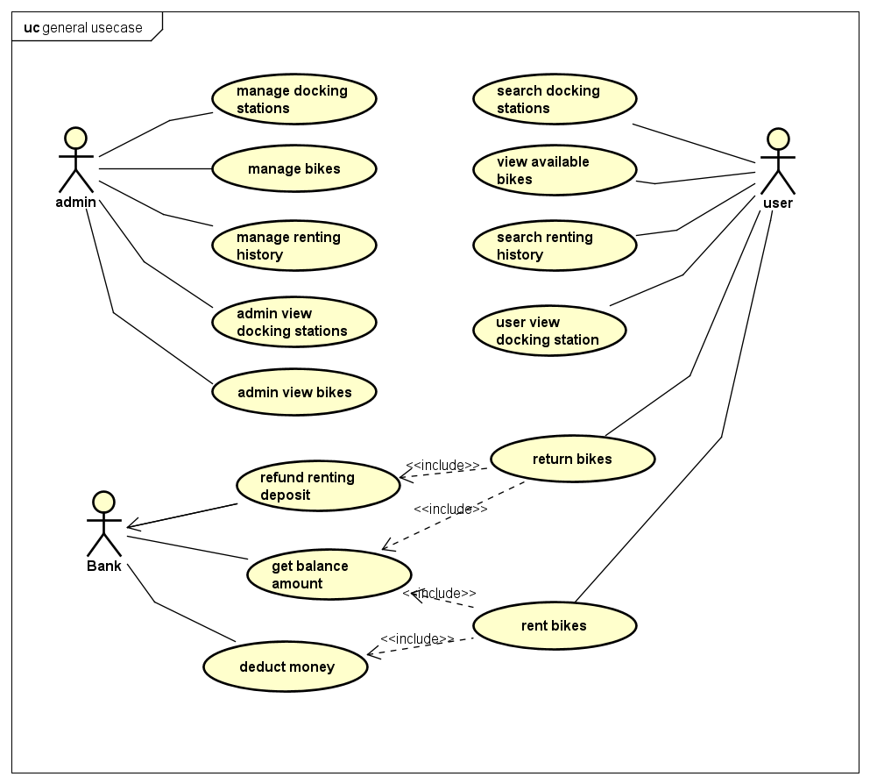

# Use case specification

## Use case “Search docking stations”

|  |  |  |  |
| --- | --- | --- | --- |
| UC Code | UC002 | Use case name | User Search Docking Stations |
| Actor | User | | |
| Description | The “user search docking stations” use case is initiated when user press the search bar in the docking stations list page. Subsequently, a new page with title “Search Docking Station” appears containing a bar for user to enter search keyword. User then can enter some keyword which is contained in the address or name of target docking station. System then display a list of station matched the input keyword. | | |
| Precondition | Admin successful Login | | |
| Main flow of event (success) | | # | Doer | Action | | --- | --- | --- | |  | User | Choose search bar in Docking Station List Page | |  | Software | Displays Search Station screen | |  | User | Enter search keyword | |  | User | Enter search button | |  | Software | Search for stations that match the keyword | |  | Software | Display list of matched station | | | |
| Alternative flow of event | |  |  |  | | --- | --- | --- | | # | Doer | Action | |  | User | Cancels search page at any time | | 4a | User | Choose cancel button | | 5b | Software | Display “No matching station” | | | |
| Post-condition | None | | |

|  |  |  |  |  |  |
| --- | --- | --- | --- | --- | --- |
| No. |  | Mô tả | Bắt buộc? | Điều kiện hợp lệ | Ví dụ |
| 1. | Search Keyword |  | Yes | Characters and digits, no special characters | 90 Nguyen Van Cu Street  Tran Duy Hung |