UNIVERSITY OF BUEA

FACULTY OF ENGINEERING AND TECHNOLOGY

DEPARTMENT OF COMPUTER ENGINEERING

CEF 672 – MultiAgent Systems

NETLOGO SIMULATION PLATFORM

REPORT

LENYA HOPE NEMBI

FE19P030

06th May, 2021

INTRODUCTION
NetLogo is a programmable modeling environment for simulating natural and social phenomena. It is particularly well suited for modeling complex systems developing over time. Instructions can be given to thousands of “agents” all operating independently. This makes it possible to explore the connection between the individual behavior of agents as well as the interaction between each other.
It is authoring environment which lets users create their own models and it also permits students run open simulations and explore their behaviors under different conditions.
NetLogo runs on the Java Virtual Machine so it is supported on all major operating systems including Mac, Windows and Linus. It is run as a desktop app but also supports command line operations.

NETLOGO FEATURES
NetLogo is a free and open source which come with a variety of features making it suitable for a wide range of applications ranging from simple simulation projects to complex systems. Some of these features include:

Multiple Agent Categories
It comprises of mobile agents known as Turtles which move over a grid of stationary agents known as Patches. In addition, there are also Link Agents that connect turtles to make networks, graphs and aggregates.

Programming:
The platform is fully programmable with a high level and easy to use syntax. It uses the same dialect as Logo programming language extended to support agents. The language supports large built-in language primitives, double precision floating point math and first-class function values.

System:
The platform is free and open-source and it has a large community of over 50 maintainers on GitHub. The system is cross-platform; running on Mac, Windows and Linux and it also has support for international characters.

Environment:
The application has a user friendly environment with a command center for on-the-fly interaction. The interface contains a builder with buttons, sliders, switches, choosers, monitor, text-boxes, notes and open areas. The application also provides Agent monitors for controlling and inspecting agents. It also provides:
- Export and Import features for users to export data, save and restore state of models.
- HubNet, participatory simulation using network devices.
- System Dynamics Modelers.
- Support for 3D modeling of 3D worlds.
- Headless mode to interact using the command line.

INSTALLATION AND SETUP
To install NetLogo, visit the official website and click on the Download tab on the sidebar to open the download page as shown below.
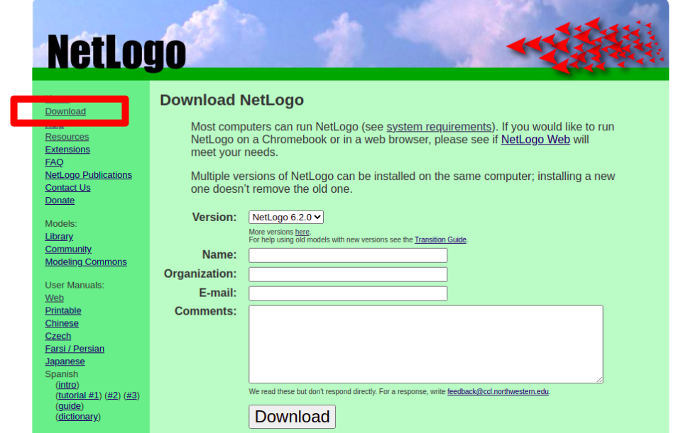
Figure 1: NetLogo Doanload Page
From the download page, you cane select the version of NetLogo to be download and then provide additional information in the form which is not required. After that, click on the Download button which redirects you to another page which shows the different options for different operating systems as shown below.
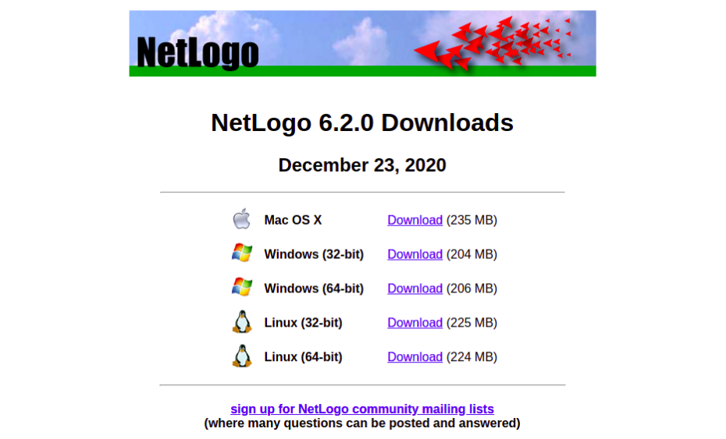
Figure 2: NetLogo Download Option Page
The Linux (64-bit) option was downloaded and installed on Ubuntu 18.04. After installing and running, the application was launched.
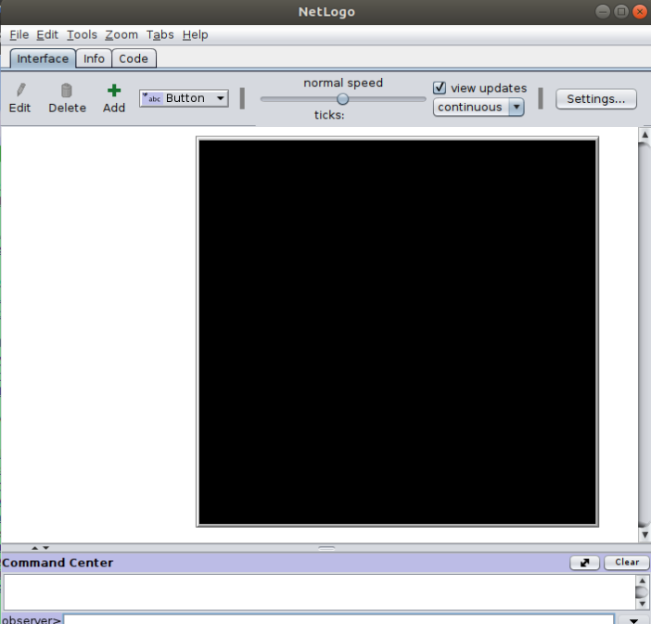Figure 3: NetLogo Welcome Screen

SAMPLE SIMULATION
NetLogo comes with a variety of sample simulations in their model library spanning across multiple fields of study.
A sample simulation; Bacteria Food Hunt which simulates the behavior of single cell bacteria in a biotic environment and how the distribution of resources affects the outcome of natural selection. The simulation was ran and it showed how cells that get more resources end up replicating into other cells while those with lack of resources end up denaturing. The running simulation is shown below:
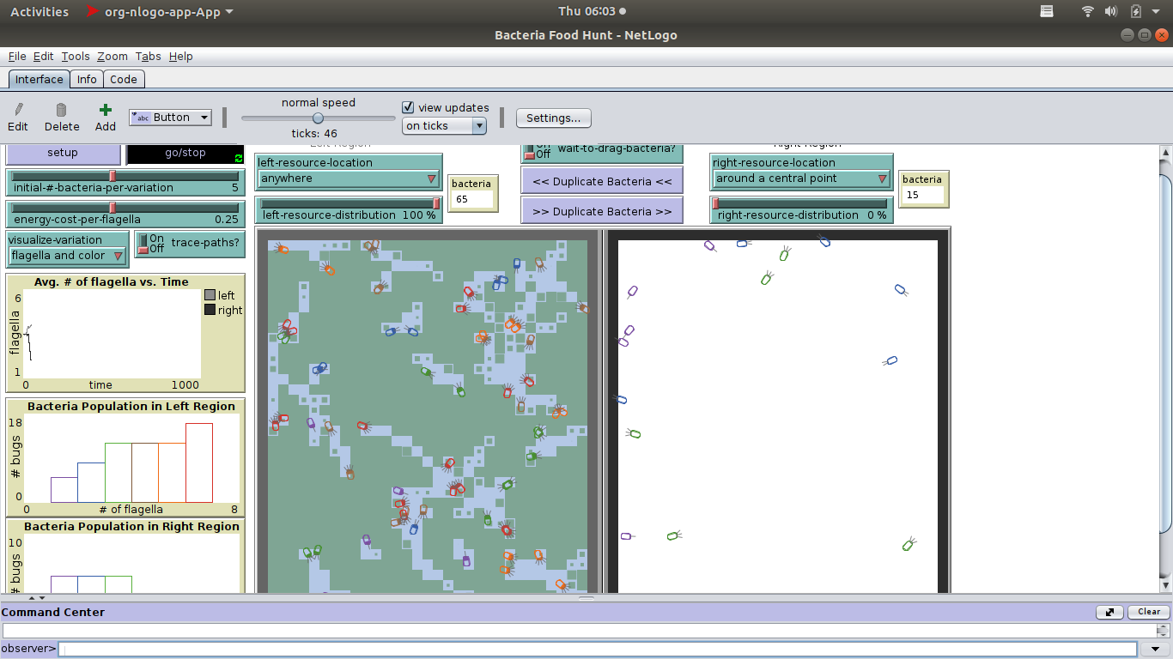Figure 4: Bacteria Food Hunt Simulation in NetLogo

