UNIVERSITY OF BUEA
FACULTY OF ENGINEERING AND TECHNOLOGY
DEPARTMENT OF COMPUTER ENGINEERING

CEF 691 - ADVANCED OOP

DESIGN AND IMPLEMENTATION OF ATTENDANCE MANAGEMENT SYSTEM

LENYA HOPE NEMBI
FE19P030

27th January, 2021

Class Diagram Implementation
The attendance management system consists of three main users; Administrator, Instructor and Students. Administrators are responsible of managing courses and course schedules(timetable). Instructors on the other hand can lecture in one or more courses while a student enrolls in one or more courses. Each course has a schedule which specifies the time of the lecture, the location and the course being scheduled. Each schedule has a list of students who attended and the instructor can generate an attendance report from this. The attendance report is generated from the list of students enrolled in a course and the list of students who attended the lecture. This is described in the class diagram below
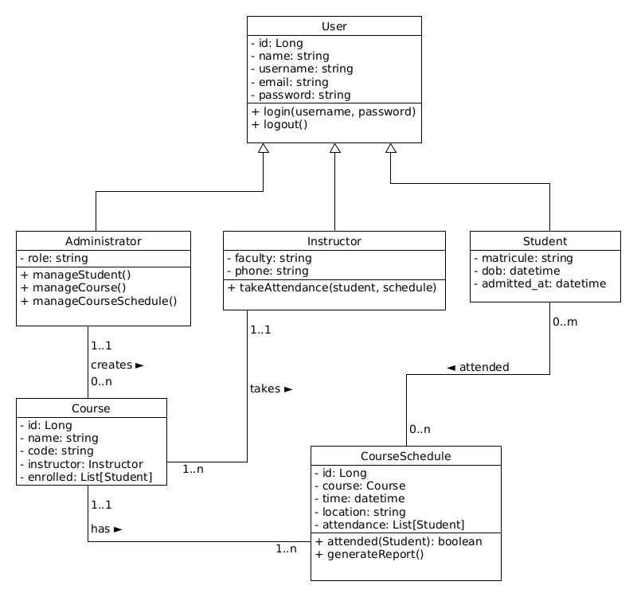Figure 1: Class Diagram of Attendance Management System

Implementation in Java
Below are code spinets of the class diagram in Figure 1 above implemented in Java:
public class User {
private String name, username, email, password;
public User(String name) { this.name = name; }
}
public class Student extends User {
private String matricule; private Date dob;
public Student(String name) { super(name); }
}
public class Instructor extends User {
private String phone;
public Instructor(String name) { super(name); }
public void takeAttendance(Student student, CourseSchedule schedule) { }
}
public class Course {
private String name, code; private Instructor instructor;
private ArrayList<CourseSchedule> schedules;
private ArrayList<Student> enrolledStudents;
public Course(String name, String code, Instructor instructor) { }
}
public class CourseSchedule {
private Course course;
private Date date;
private String location;
private ArrayList<Student> students; // students who were present for the course
public CourseSchedule(Course course, Date date, String location) { }
public boolean attended(Student student) { // check if student attended this class }
public void generateReport() { // shows students who we present and absent }
}

