**Week 2, Cao lab group R session**

Hi everyone!

I know at the end of our first R session we had discussed some topics to cover in the future. I’m working on developing a session for regression analyses in spatial stream networks (SSN). There is a lot of material and code for that topic about how to import data, prepare and format these data, compile data to generate an SSN object, and then finally get to the actual analyses themselves. I want to make sure I provide you with substantial and working code that will require only slight modifications for you to use this analytic framework, but I did not feel I would be able to do so by this week’s session. Sorry for the delay - I will continue to work on this and present it during one of our future sessions!

As an alternative to the regression/SSN session, I’ve developed a session that focuses on species distribution modeling using Maxent. This session will require a little setup on your part that entails installing some new R packages and Maxent itself. The following is a guide for preparing for this week’s session. Reference materials can be found in the UofI Box under the “Week 2 Materials” folder.

**Step 1: Install the appropriate packages**

For this week, you’ll need to install the following R packages in either R GUI or R Studio:

install.packages(c("rnaturalearth","rnaturalearthdata",”spocc”,”dismo”,”scrubr”))

**Step 2: Install Maxent into the “dismo” folder**

Once the needed packages have been installed, we’ll need to install Maxent so that it can be opened and used remotely by R.

Maxent download: <https://biodiversityinformatics.amnh.org/open_source/maxent/>

Once Maxent has been downloaded, you will need to copy files into the “dismo” library. In my case, this was done by following the directory provided when installing ‘dismo’.

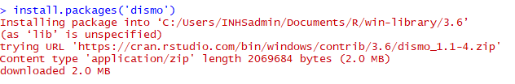

Once you’ve arrived at this specific directory, you’ll want to copy, paste, and extract the zipped Maxent folder into the “java” folder

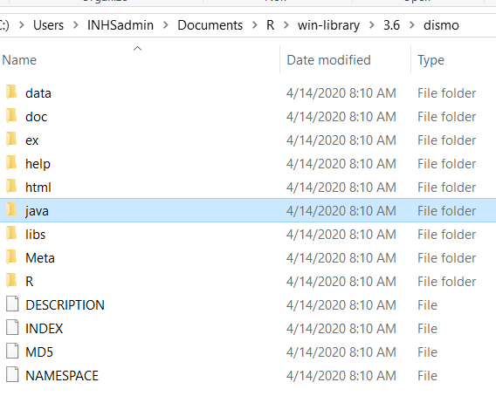

Once the Maxent folder has been extracted, you’ll want to copy the .jar executable file into the main ‘java’ folder:

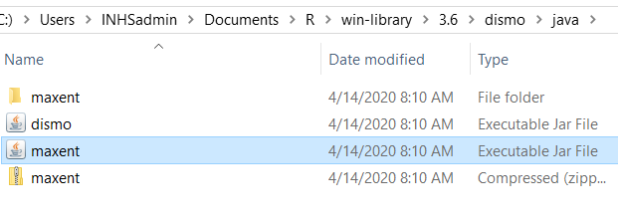

That process should complete the necessary setup to prepare you to use Maxent remotely in R!