SE LAB GROUP ASSIGNMENT 1 REPORT TEMPLATE
Software Engineering | Smart Ticketing System (Ticket Vendor Machine) | Sem 1_2627 | Template for the file [YourID]_[YourStudentName].docx
Marking of this report
No. | Task | Marks | Section in this report
1 | Clarification Q&A (Excel) | 5 | 2.1
2 | Requirements Specification | 15 | 2.2
3 | Use Case Modeling | 10 | 3.1
4 | Activity Diagrams | 10 | 3.2
5 | Detailed System Modeling: "Buy a Ticket" | 15 | 3.3
6 | UI/UX Design | 5 | 4.1
7 | Architectural Design | 10 | 4.2, 4.3
8 | Visual Studio Engineering (Model-to-Code) | 10 | 5.1
9 | GitHub & AI Tooling (Copilot) | 10 | 5.2
10 | Demo Application (C# and MSSQL) | 10 | 5.3
Total |  | 100 | Weight: 20% of QT2 (plus 1 bonus point towards the Final Project for exceptional work)

How to use this template
- Keep all titles and numbering. Replace every blue [bracketed placeholder] with your own content, and delete all grey "Guidance" paragraphs, unused figure frames and this instruction page before you submit.
- Keep the headings as real Word headings (the navigation pane must work). Update the table of contents before submitting (right-click, Update Field).
- Group of 3 to 5 students. Section 7 must list the % contribution of each member (total 100%) and must match your readme.txt.
- Submit [YourID]_[YourStudentName].docx, readme.txt (GitHub link and other links such as Figma and database script instructions) and the % contribution of each member. All final artifacts are also uploaded to the shared GitHub repository.
- The report must also address the content of "LabGroupAssignment1.pdf". Use the checklist in section 6 to show where each item is covered.
- Keep your diagrams consistent with each other: the rubric rewards diagrams that are syntactically correct, logically sound and aligned. Use the consistency table in section 3.4.
- The workbook A1_Team_Workbook (Q&A, requirements, prompt log, commit log, progress log) is your working record and the source for several tables here.

Smart Ticketing System
Ticket Vendor Machine (TVM)
Software Engineering Lab Group Assignment 1 – Sem 1_2627
Group [NLH]
1. 524H0051 : Nguyễn Lê Hùng
2. 524H0184 : Nguyễn Ngọc Quý
3. 524H0181 : Lê Quang Phúc
4. 524H0139 : Phan Hoài An
5. 524H0187 : Võ Huỳnh Duy Tân

GitHub repository | Figma / other link | Date submitted
https://github.com/lehung1521/Assignment1 | https://www.figma.com/design/uvulsznsp4j2dX43Mp4Oao/Untitled?node-id=0-1&t=xNLMiauqwCYEVyQE-1 | [date]

Table of Contents
Table of Contents 4
1. Introduction 6
1.1 Purpose and Scope 6
1.2 Problem Statement in Our Own Words 6
1.3 Team and Roles 6
2. Phase 1: Requirements Engineering (20 marks) 7
2.1 Clarification Q&A (5 marks) 7
2.2 Requirements Specification (15 marks) 7
2.2.1 Functional Requirements 7
2.2.2 Non-Functional Requirements 7
2.2.3 Domain Requirements 8
3. Phase 2: UML Modeling & System Design (35 marks) 9
3.1 Use Case Modeling (10 marks) 9
3.1.1 Use Case Diagram 9
3.1.2 Actors and Use Case List 9
3.1.3 Use Case Descriptions 9
3.2 Activity Diagrams (10 marks) 10
3.2.1 Passenger Buys a Ticket at the TVM 10
3.2.2 Communication with External Payment Gateways 10
3.3 Detailed System Modeling: Main Use Case "Buy a Ticket" (15 marks) 10
3.3.1 Sequence Diagram 10
3.3.2 State Chart Diagram 10
3.3.3 Class Diagram (Domain Model) 10
3.4 Model Consistency Check 10
4. Phase 3: UI/UX & Architecture (15 marks) 12
4.1 UI/UX Design (5 marks) 12
4.2 Architectural Design (10 marks) 12
4.2.1 Architecture Diagram 12
4.2.2 Deployment Diagram 12
5. Phase 4: Implementation, Tooling & Demo (30 marks) 13
5.1 Visual Studio Engineering: Model-to-Code (10 marks) 13
5.1.1 Forward Engineering (Model to Code) 13
5.1.2 Backward Engineering (Code to Model) 13
5.1.3 Code Map 13
5.2 GitHub & AI Tooling (10 marks) 13
5.2.1 Source Control 13
5.2.2 AI Assistance: Copilot Prompt Documentation 14
5.2.3 Reflection on AI Use 14
5.3 Demo Application (10 marks) 14
6. Checklist for "LabGroupAssignment1.pdf" 16
7. Contribution of Each Member 16
8. Conclusion and Lessons Learnt 16
References 16
Appendix 17
Appendix A: readme.txt 17
Appendix B: Full-size Diagrams 17

1. Introduction

1.1 Purpose and Scope
The purpose of this report is to analyze, design, and develop a Smart Ticketing System focusing on the Ticket Vendor Machine (TVM) for public transportation. The system allows passengers to select available Bus or MRT routes, review ticket fares, complete payments using Credit Cards, QR Codes, or Digital Wallets, and receive printed tickets with unique barcodes. The project covers requirements engineering, UML modeling, UI/UX design, system architecture, and prototype implementation, while excluding online ticket booking, cash payments, and multi-journey ticket services.

1.2 Problem Statement in Our Own Words
Traditional ticket purchasing methods may require passengers to wait in queues and depend on ticket counter staff, reducing convenience and efficiency. To address these limitations, the Smart Ticketing System introduces an automated Ticket Vendor Machine (TVM) that allows passengers to purchase single-journey Bus and MRT tickets independently.
Passengers can select their preferred transportation mode, destination, and available route before reviewing the ticket fare. The system supports Credit Card and QR-based payments, including bank-linked QR Codes and Digital Wallets such as MoMo, VNPay, and ZaloPay. After successful payment verification, the TVM generates and prints a paper ticket containing a unique barcode.
However, several requirements must be clarified to ensure the system operates reliably and securely. These include payment timeouts, transaction failures, duplicate payment prevention, QR Code expiration, printer errors, network unavailability, and purchase cancellation. Therefore, the system must be designed to handle both successful transactions and exceptional situations while maintaining transaction accuracy, security, and user convenience.

1.3 Team and Roles
No. | Name | Student ID | Main responsibilities
1
2 | Name | Student ID | Role / main responsibility
3 | Nguyễn Lê Hùng | 524H0051 | Implementation & Tooling
4 | Nguyễn Ngọc Quý | 524H0184 | Requirements & Documentation
5 | Lê Quang Phúc | 524H0181 | UI/UX & Architecture

2. Phase 1: Requirements Engineering (20 marks)

2.1 Clarification Q&A (5 marks)
ID | Question to the stakeholder | Assumed answer | Why it matters | Requirement ID
Q ID | Clarifying question to the stakeholder | Assumed answer (logical) | Rationale and impact on the design | Requirement ID
Q01 | Which functions belong to the TVM, and must the system also support purchases via a website or mobile app? | TVM handles on-machine route selection, fare display, payment initiation/confirmation and printed ticket issuance; fleet operations and web/app sales are excluded. A phone is used only to complete a QR payment. | Defines the system boundary for use cases, architecture and deployment; prevents unsupported booking-app use cases. | FR-01, FR-02
Q02 | Which transport modes are supported in the first release? | The prototype supports Bus and MRT only. | Limits route catalogue, fare tables and UI screens. | DR-01
Q03 | Which languages and accessibility features must the TVM screens provide? | Vietnamese and English with a language switch on every screen; large high-contrast text and touch targets, with controls reachable from a wheelchair. | Affects wireframes, screen text and the usability limit. | FR-21, NFR-15
Q04 | How does the TVM determine the origin of the trip? | Each TVM is configured with a fixed origin/boarding station. | Required input for route selection and fare calculation. | FR-03
Q05 | Does the passenger select a destination only, or a specific route as well? | Passengers first select a supported transport mode and destination; the TVM displays any matching routes for selection. | Defines screen order and Buy Ticket activity flow. | FR-04
Q06 | Which ticket types must the TVM sell? | Only single-journey tickets are supported for this assignment prototype. | Controls domain model and prevents assuming passes/return tickets. | FR-05
Q07 | Can a passenger buy more than one ticket at a time? | One ticket per transaction in the initial prototype. | Simplifies quantities, totals, printing and transaction states. | FR-06
Q08 | How is the fare determined and when is it displayed? | Fare is read from a configured route-based fare table and displayed before the passenger confirms payment. | Requires fare data, price display and confirmation step. | FR-07, FR-23, NFR-16
Q09 | What happens if a destination or route is unavailable? | Unavailable destinations/routes are hidden or disabled; no payment can start for them. | Defines validation and alternative UI paths. | FR-08
Q10 | Which payment options appear on screen and how is each started? | The user selects Card or QR Payment; QR Payment allows an available bank-linked QR or supported wallet via gateway. | Aligns UI payment choice with external payment gateway modeling. | FR-09
Q11 | Which cards are accepted and who authorizes card charges? | The prototype simulates tap/insert credit-card input; the payment gateway returns approved or declined status; no card details are stored. | Defines external gateway boundary and safe demo behavior. | FR-10, DR-03
Q12 | What does the QR represent, and how is successful QR payment confirmed? | The TVM requests a transaction-specific QR from the gateway and accepts success only after a trusted gateway confirmation. | Requires transaction IDs, callback/polling behavior and avoids trusting a phone screenshot. | FR-11, DR-04
Q13 | How long is a payment QR code valid? | A QR expires 120 seconds after generation; an expired QR cannot complete the current purchase. | Adds timeout transitions, expiration UI and retry path. | FR-12
Q14 | What should the TVM do when the gateway explicitly reports that a card or QR payment is declined or failed? | For an explicit decline/failure, show a clear error, issue no ticket, and allow one fresh payment attempt or cancellation. A timeout with an unknown outcome is handled separately under Q24. | Defines the known-failure path and keeps it distinct from an uncertain payment outcome, preventing unsafe retries or ticket issuance. | FR-13, NFR-10
Q15 | How are duplicate charges and duplicate tickets prevented? | Each purchase uses a unique transaction ID; repeated gateway confirmations cannot produce another charge or ticket. | Needs idempotent transaction updates and test cases. | FR-14, NFR-05
Q16 | Until what point can a passenger cancel a purchase, and what happens if payment has already been confirmed? | Cancellation is allowed before payment confirmation. After confirmation, the TVM does not treat the purchase as cancelled; it records the transaction for reconciliation/support instead. | Defines valid cancellation transitions and prevents a paid transaction from being incorrectly marked as cancelled. Refund decisions are outside the TVM prototype unless separately specified. | FR-15, FR-24
Q17 | Does QR/wallet payment also print a paper ticket, and which hardware must the TVM have and monitor? | All successful payment methods issue the same paper ticket. The TVM has a touchscreen, card reader (chip and contactless), thermal printer and UPS; sensors report paper low (below 10%), printer faults and reader faults to the maintenance team. | Ensures one consistent issuance use case and defines the hardware context for architecture and deployment. | FR-16, FR-22
Q18 | What information must be printed and encoded on the ticket? | Print ticket ID, mode, origin, destination, fare, purchase timestamp and barcode encoding a unique ticket ID. | Defines Ticket data model, print template and scanner integration. | FR-17, DR-02
Q19 | What happens if payment succeeds but the paper ticket cannot be printed? | Record the paid/unfulfilled transaction and show a support reference; block further purchases if printer is unavailable. | Avoids lost transactions and specifies recovery workflow. | FR-18, NFR-13
Q20 | When does an inactive TVM session end? | After 60 seconds without input before payment initiation, the session resets to the welcome screen. | Adds an idle timer and reset transition. | FR-19
Q21 | Can the TVM process payments if the gateway or network is unavailable? | No; temporarily disable purchases and show 'Payment service unavailable' until restored. Transaction records are buffered locally and synchronised when the network returns. | Establishes safe failure mode and external service dependency. | FR-20, NFR-14
Q22 | What maximum response times are acceptable for normal on-screen actions and for each payment and ticket step? | At least 95% of local UI actions finish within 2 seconds. Step limits: destination menu within 2 s of Start (95%); QR code shown within 3 s (95%); card result within 5 s (95%); ticket printing starts within 2 s and finishes within 5 s of payment confirmation (99%). | Provides verifiable response-time NFRs and timing acceptance tests for each step of the main flow. | NFR-01, NFR-06, NFR-07, NFR-08, NFR-09
Q23 | What availability and reliability levels are expected, including after a power loss? | Monthly availability of at least 99.5% excluding planned maintenance; at most 1 TVM-caused failed transaction per 1,000; after a power cut the TVM restarts within 60 s and never marks an unconfirmed payment as successful. | Specifies measurable reliability targets for architecture, recovery design and tests. | NFR-02, NFR-11, NFR-12
Q24 | How long may the TVM wait for a final gateway response, and what should happen if no final response arrives? | The TVM shows a processing state immediately. If no final response arrives within 30 seconds, it marks the transaction Pending/Reconciliation and checks the final gateway status before allowing retry or issuing a ticket. | Makes timeout distinct from an explicit decline; prevents duplicate charging and ensures no ticket is issued without confirmed payment. | NFR-03, NFR-07
Hidden complexities we uncovered
- Payment Timeout and Uncertain Transaction Status: A payment may remain unconfirmed when the Payment Gateway does not respond within 30 seconds. Instead of automatically treating the transaction as successful or failed, the TVM must mark it as PENDING and perform reconciliation before allowing another payment attempt or issuing a ticket.
- Duplicate Payment and Ticket Prevention: Payment Gateways may send repeated notifications for the same transaction. The TVM must verify transaction identifiers and process payment confirmations idempotently to ensure that one successful purchase produces only one ticket.
- QR Code Expiration and Payment Retry: Each payment QR Code is valid for 120 seconds. If the QR Code expires or a payment explicitly fails, the system must prevent ticket issuance and allow only one fresh payment attempt with a new transaction ID.
- Printer Failure After Successful Payment: A payment may be successfully confirmed even when the ticket printer is unavailable or encounters an error. In this situation, the system must record the transaction as PAID_UNFULFILLED, provide a support reference, and prevent further ticket purchases until the printer is restored.
- Network Unavailability and Transaction Recovery: A network failure may interrupt communication between the TVM and the Payment Gateway. The system must temporarily disable new purchases, preserve transaction records locally, and reconcile pending transactions when the connection is restored to prevent data loss and incorrect payment processing.

2.2 Requirements Specification (15 marks)
This section defines the requirements of the Smart Ticketing System based on the identified business needs and stakeholder clarification questions. The requirements are classified into Functional Requirements (FR), Non-Functional Requirements (NFR), and Domain Requirements (DR). Each requirement is assigned a unique identifier to support traceability, implementation, and testing. Particular attention is given to payment security, transaction reliability, system availability, response time, and error recovery.

2.2.1 Functional Requirements
ID | Requirement ("The system shall…") | Priority | Use case | Source (Q&A)
FR-01 | The TVM shall allow on-machine destination/route selection, display the applicable fare, initiate and confirm payment, and issue a paper ticket only after confirmed payment. | High | UC01, UC03, UC04, UC10 | Q01
FR-02 | Ticket purchases shall be initiated at the physical TVM; a passenger phone shall only be used externally to complete an on-screen QR payment. | High | UC01 | Q01
FR-03 | The TVM shall load a configured origin station or boarding point for its installed location and use it in available-route queries. | High | UC02 | Q04
FR-04 | The TVM shall show available transport modes, destinations, and matching routes; the passenger shall be able to select one supported route. | High | UC02, UC03 | Q05
FR-05 | The prototype shall sell single-journey tickets only; return, subscription and multi-day products are excluded from this prototype. | High | UC03 | Q06
FR-06 | The TVM shall permit exactly one ticket per purchase transaction in the initial prototype. | High | UC03 | Q07
FR-07 | The TVM shall retrieve the fare from its configured origin/route fare table and display the final ticket price before payment selection. | High | UC03 | Q08
FR-08 | The TVM shall hide or disable unavailable routes/destinations and prevent payment initiation for an unavailable selection. | High | UC02, UC03 | Q09
FR-09 | The TVM shall offer Credit Card and QR-based payment; the QR path shall support the configured bank-linked QR or digital-wallet gateway. | High | UC04, UC06 | Q10
FR-10 | For credit-card payment the prototype shall accept a simulated card tap/insert event, request authorization, and continue only if approved by the gateway. | High | UC05 | Q11
FR-11 | For QR payment the TVM shall display a transaction-specific QR generated by a configured gateway, and shall treat payment as successful only after gateway confirmation. | High | UC06, UC07 | Q12
FR-12 | A generated payment QR code shall expire after 120 seconds; after expiry it shall no longer be accepted for the current purchase. | High | UC06, UC09 | Q13
FR-13 | After a declined or failed payment the TVM shall show a clear error, issue no ticket, and offer one fresh payment attempt or cancellation. | High | UC08 | Q14
FR-14 | Each purchase shall have a unique transaction ID; duplicate gateway confirmations shall never result in duplicate ticket issuance. | High | UC07, UC10 | Q15
FR-15 | The passenger shall be able to cancel before payment confirmation; after confirmation the TVM shall follow a recorded reconciliation/support procedure instead of immediate cancellation. | High | UC09 | Q16
FR-16 | After confirmed successful payment by card or QR, the TVM shall print a paper ticket containing a machine-readable barcode. | High | UC10 | Q17
FR-17 | Each printed ticket shall include ticket ID, transport mode, origin, destination, fare, purchase time and a barcode encoding the unique ticket ID. | High | UC10 | Q18
FR-18 | If printing fails after confirmed payment, the TVM shall store a paid-but-unfulfilled transaction, show a support reference and block new sales while the printer is unavailable. | High | UC11 | Q19
FR-19 | Before payment initiation the TVM shall clear an inactive session after 60 seconds and return to the welcome screen, removing the previous selection. | High | UC01, UC09 | Q20
FR-20 | When the payment network is unavailable the TVM shall disable new purchases, explain service unavailability, and resume only after connectivity returns. | High | UC12 | Q21
FR-21 | The passenger shall be able to switch the TVM screens between Vietnamese and English at any time before payment. | Medium | UC01 | Q03
FR-22 | The TVM shall notify the maintenance team when paper is low (below 10%), the printer fails or the card reader fails. | Medium | UC11 | Q17
FR-23 | Authorised staff shall be able to update the fare table and the destination/route list centrally, without visiting the TVM. | Medium | UC02, UC03 | Q08
FR-24 | The TVM shall record every transaction (ID, time, route, fare, payment method, final status) with no card data, so paid-but-unfulfilled and pending cases can be reconciled. | High | UC07, UC10, UC11 | Q16

2.2.2 Non-Functional Requirements

ID | Category | Measurable requirement | Measurement method | Related FR
NFR-01 | Response time | At least 95% of local screen interactions complete within 2 seconds; no interaction takes longer than 3 seconds. | Time >=100 representative actions; calculate p95 response time. | UC01, UC02, UC03, UC04
NFR-02 | Availability | At least 99.5% monthly uptime, excluding scheduled maintenance. | Calculate (available minutes / scheduled operational minutes)*100 from uptime logs. | UC01, UC12
NFR-03 | Response time | Display processing state immediately; after 30 seconds without final response enter pending/reconciliation state, not success. | Simulate slow/no callback; time cutoff and verify no ticket before confirmation. | UC05, UC06, UC07
NFR-04 | Security | All payment-gateway requests use TLS; 0 full card-number or CVV values persisted in TVM application storage/logs. | Inspect TLS settings and search test DB/logs for prohibited sensitive fields. | UC05, UC06
NFR-05 | Reliability | 100% of 100 duplicate payment notifications for the same transaction produce no second ticket. | Replay duplicate callbacks in integration tests; query issued-ticket count. | UC07, UC10
NFR-06 | Response time | At least 95% of sessions show the destination menu within 2 seconds of pressing Start; maximum 3 seconds. | Timestamp log from Start press to menu rendered over 100 sessions; calculate p95. | UC02
NFR-07 | Response time | At least 95% of card payment results are displayed within 5 seconds of the card being read; after 30 seconds the transaction becomes Pending (see NFR-03). | Run 100 mock card authorisations; measure request-to-result time; p95. | UC05
NFR-08 | Response time | At least 95% of QR codes are displayed within 3 seconds of choosing QR payment; maximum 5 seconds. | Timestamp log from QR choice to QR displayed over 100 requests; p95. | UC06
NFR-09 | Response time | Printing starts within 2 seconds and finishes within 5 seconds of payment confirmation for at least 99% of purchases. | Timestamp confirmation, print start and print end over 100 end-to-end purchases. | UC10
NFR-10 | Response time | The error message is displayed within 2 seconds of the gateway result in at least 95% of cases; 0 tickets are issued for declined payments. | Simulate 50 declines; measure time from gateway result to error screen; count tickets issued. | UC08
NFR-11 | Reliability | At most 1 TVM-caused failed transaction per 1,000 (probability of failure on demand <= 0.001), declines by the gateway excluded. | Run 1,000 simulated purchases (mock gateway); count failures caused by TVM software or hardware. | UC05, UC06, UC07, UC10
NFR-12 | Reliability | The TVM restarts within 60 seconds; 0 transactions in progress are marked successful without gateway confirmation; 0 committed transaction records are lost. | Kill the process and cut power during payment and printing (20 repetitions each); inspect state and database. | UC07, UC12
NFR-13 | Reliability | At least 99.9% of paid tickets print on the first attempt; 100% of print failures are stored as paid-but-unfulfilled with a support reference. | Count printed vs. paid tickets over 1,000 purchases; inject 20 printer failures and inspect records. | UC10, UC11
NFR-14 | Reliability | Network loss is detected within 10 seconds and new sales are disabled; at least 1,000 records are buffered and synchronised within 5 minutes of reconnection with 0 records lost. | Disconnect the network; time the detection; create 100 records offline; reconnect and compare counts. | UC12
NFR-15 | Usability | At least 90% of 10 first-time users buy a ticket without help in 3 minutes or less and 6 touches or fewer; text is at least 18 pt. | Usability test with 10 first-time users; observation sheet and stopwatch. | UC01, UC02, UC03, UC04
NFR-16 | Maintainability | 100% of online TVMs show an updated fare table within 15 minutes of publication. | Update a fare on the server; measure the time until 10 test TVMs show it. | UC02, UC03

2.2.3 Domain Requirements

ID | Domain requirement | Domain / source | Related FR / NFR
DR-01 | The assignment prototype shall offer Bus and MRT only; additional transport modes require a future catalogue extension. | Ticket and fares (Q02) | UC02
DR-02 | A successfully issued ticket shall have a unique identifier whose barcode represents the same identifier. | Ticket and fares (Q18) | UC10
DR-03 | Card payments shall follow the EMV and PCI DSS standards (assumed for the prototype). | Payment (Q11) | UC05
DR-04 | Bank-linked QR payments shall follow the VietQR (NAPAS) standard and wallet payments the provider's API (assumed for the prototype). | Payment (Q12) | UC06

3. Phase 2: UML Modeling & System Design (35 marks)

3.1 Use Case Modeling (10 marks)

3.1.1 Use Case Diagram

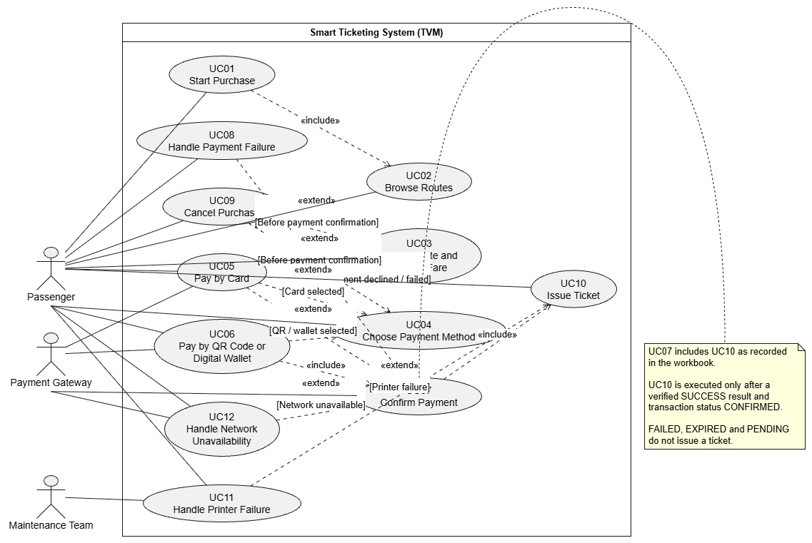
Figure 3.1. Use Case Diagram (editable source: uc.drawio).

3.1.2 Actors and Use Case List
ID | Use case | Primary actor | Short description
UC01 | [ ] | [ ] | [ ]
UC02 | [ ] | [ ] | [ ]
UC03 | [ ] | [ ] | [ ]
UC04 | [ ] | [ ] | [ ]
UC05 | [ ] | [ ] | [ ]

3.1.3 Use Case Descriptions

UC01 – Start Purchase
Use Case ID | UC01
Use Case Name | Start Purchase
Primary Actor | Passenger
Secondary Actor | None
Priority | High
Relationships | <<include>> UC02 Browse Routes
Description | The Passenger starts a new purchase session at the physical TVM by pressing Start. The TVM checks that it is ready to sell and then shows the transport modes.
Trigger | The Passenger presses the "Start" button on the welcome screen.
Preconditions | - The TVM is powered on and the welcome screen is displayed.  - No purchase session is active.  - The printer is ready with paper and the payment network is available.
Postconditions – success | A new purchase session is open with a 60 s idle timer; the transport modes are displayed in the selected language.
Postconditions – failure | No session is created; the TVM stays on the welcome screen or shows an out-of-service notice.
Main Flow | 1. The Passenger presses "Start".  2. The TVM checks the printer status, paper level and payment network availability.  3. The TVM creates a purchase session with a unique session ID and starts the 60 s idle timer.  4. The TVM displays the screen in Vietnamese (default language).  5. The TVM includes UC02 Browse Routes.
Alternative Flows | A1 – Change language (step 4): the Passenger switches between Vietnamese and English; the TVM relabels the screen and keeps the session.
Exception Flows | E1 – Printer unavailable or no paper (step 2): the TVM shows "Out of service" and creates no session (see UC11).  E2 – Payment network unavailable (step 2): the TVM shows "Payment service unavailable" and creates no session (see UC12).  E3 – No input for 60 s: the session is closed and the TVM returns to the welcome screen (see UC09).
Business Rules | - Only one purchase session can be active at a time.  - The language can be switched on every screen before payment.
Related Requirements | FR-01, FR-02, FR-19, NFR-01, NFR-02, FR-21, NFR-15

UC02 – Browse Routes
Use Case ID | UC02
Use Case Name | Browse Routes
Primary Actor | Passenger
Secondary Actor | None
Priority | High
Relationships | Included by UC01
Description | The Passenger views the supported transport modes (Bus, MRT), the destinations and the routes available from the origin station configured for this TVM.
Trigger | UC01 has opened a purchase session.
Preconditions | - A purchase session is open.  - Route, destination and fare data are loaded on the TVM.
Postconditions – success | A list of available routes for the chosen destination is displayed and the Passenger can select one.
Postconditions – failure | No route is displayed; the Passenger returns to the previous list or the session ends.
Main Flow | 1. The TVM displays the transport modes (Bus, MRT).  2. The Passenger selects a transport mode.  3. The TVM displays the destinations of that mode, grouped by line, with paging and a search box.  4. The Passenger selects a destination.  5. The TVM loads the matching routes from its configured origin station and displays them; unavailable routes are hidden or disabled.
Alternative Flows | A1 – Search (step 3): the Passenger types text; the TVM filters the destination list.  A2 – Back (any step): the Passenger presses Back and returns to the previous screen.
Exception Flows | E1 – No available route for the destination (step 5): the TVM shows "No route available" and returns to the destination list.  E2 – Route data cannot be loaded: the TVM shows an out-of-service message.  E3 – No input for 60 s: the session is cleared (see UC09).
Business Rules | - Only Bus and MRT are offered.  - The origin is fixed per TVM.  - Payment cannot start for an unavailable route.
Related Requirements | DR-01, FR-03, FR-04, FR-08, NFR-01, FR-23, NFR-06, NFR-15, NFR-16

UC03 – Select Route and Review Fare
Use Case ID | UC03
Use Case Name | Select Route and Review Fare
Primary Actor | Passenger
Secondary Actor | None
Priority | High
Relationships | Extended by UC09 Cancel Purchase
Description | The Passenger selects one available route and reviews the single-journey ticket details and the fare in VND before paying. One ticket is sold per transaction.
Trigger | The Passenger selects a route from the list shown by UC02.
Preconditions | - Routes are displayed (UC02).  - The fare table is available.
Postconditions – success | A ticket order (mode, origin, destination, route, fare) is confirmed and the payment options are shown (UC04).
Postconditions – failure | No ticket order is confirmed; the Passenger returns to the route list or the session ends.
Main Flow | 1. The Passenger selects one route.  2. The TVM reads the fare from the configured origin–destination fare table.  3. The TVM displays a summary: mode, origin, destination, route, ticket type "Single journey", quantity 1 and fare in VND (VAT included).  4. The Passenger presses "Confirm".  5. The TVM continues with UC04 Choose Payment Method.
Alternative Flows | A1 – Back (step 3): the Passenger returns to UC02 to choose another route.
Exception Flows | E1 – The route becomes unavailable (step 1–2): the TVM shows a message and returns to the route list.  E2 – No fare found for the route (step 2): the TVM shows "This ticket cannot be sold", logs the error and returns to the route list.  E3 – Cancel pressed or 60 s inactivity: UC09 Cancel Purchase extends this use case.
Business Rules | - Only single-journey tickets are sold; quantity is always 1.  - The fare comes from the fare table and is shown before payment.
Related Requirements | FR-01, FR-04, FR-05, FR-06, FR-07, FR-08, NFR-01, FR-23, NFR-15, NFR-16

UC04 – Choose Payment Method
Use Case ID | UC04
Use Case Name | Choose Payment Method
Primary Actor | Passenger
Secondary Actor | None
Priority | High
Relationships | Extended by UC05, UC06 and UC09
Description | The Passenger chooses how to pay: Credit Card, or QR-based payment (bank-linked QR code or digital wallet such as MoMo, VNPay or ZaloPay).
Trigger | The Passenger confirms the fare in UC03.
Preconditions | - A ticket order is confirmed.  - The payment network is available.
Postconditions – success | The chosen payment method is stored in a new transaction (status CREATED) and UC05 or UC06 starts.
Postconditions – failure | No transaction is started; the Passenger returns to fare review or the session ends.
Main Flow | 1. The TVM creates a transaction with a unique transaction ID, the amount and status CREATED.  2. The TVM displays the payment options "Credit Card" and "QR Code / Digital Wallet" with the amount to pay.  3. The Passenger selects one option.  4. The TVM starts UC05 Pay by Card or UC06 Pay by QR Code or Digital Wallet.
Alternative Flows | A1 – Back (step 3): the Passenger returns to UC03; the unused transaction is discarded.  A2 – Fresh attempt after a failure (see UC08): the TVM shows this screen again and creates a new transaction ID for the new attempt.
Exception Flows | E1 – Payment network unavailable: the TVM applies UC12.  E2 – Cancel pressed or 60 s inactivity: UC09 Cancel Purchase extends this use case.
Business Rules | - Cash is not accepted.  - Exactly two payment options are shown: Credit Card and QR Code / Digital Wallet.
Related Requirements | FR-01, FR-09, NFR-01, NFR-15

UC05 – Pay by Card
Use Case ID | UC05
Use Case Name | Pay by Card
Primary Actor | Passenger
Secondary Actor | Payment Gateway
Priority | High
Relationships | Extends UC04; <<include>> UC07
Description | The Passenger inserts or taps a credit card. The TVM reads the card, asks the Payment Gateway for authorisation and continues only if the payment is approved.
Trigger | The Passenger selects "Credit Card" in UC04.
Preconditions | - The transaction has status CREATED.  - The card reader works and the network is available.
Postconditions – success | The gateway returns APPROVED and UC07 confirms the payment; or the result is DECLINED (UC08) or unknown (PENDING).
Postconditions – failure | No ticket is issued and no card data is stored.
Main Flow | 1. The TVM displays "Insert or tap your card" and activates the card reader.  2. The Passenger inserts the card (chip) or taps it (contactless).  3. The TVM reads the card through the EMV reader; for an inserted card the Passenger enters the PIN.  4. The TVM sends an authorisation request (transaction ID, amount, currency, signature) to the Payment Gateway over TLS and shows "Processing".  5. The Payment Gateway sends the request to the acquirer/issuer and returns APPROVED or DECLINED.  6. The TVM includes UC07 Confirm Payment.
Alternative Flows | A1 – Contactless (step 2): the card is tapped and no PIN is required for ticket amounts below the contactless limit.
Exception Flows | E1 – Card cannot be read (step 3): the TVM shows "Cannot read card" and offers to try again or to choose another method (UC04).  E2 – Payment declined (step 5): the TVM applies UC08.  E3 – No final answer within 30 s: the transaction becomes PENDING (see UC07).  E4 – Network lost during the request: the TVM applies UC12.  E5 – Cancel pressed before the request is sent: UC09.
Business Rules | - Card numbers, PINs and CVV are never stored (NFR-04).  - In the prototype the card insert/tap event is simulated and the gateway is a mock service.
Related Requirements | FR-10, NFR-03, NFR-04, NFR-07, NFR-11, DR-03

UC06 – Pay by QR Code or Digital Wallet
Use Case ID | UC06
Use Case Name | Pay by QR Code or Digital Wallet
Primary Actor | Passenger
Secondary Actor | Payment Gateway
Priority | High
Relationships | Extends UC04; <<include>> UC07
Description | The TVM shows a transaction-specific QR code. The Passenger scans it with a banking or wallet app (MoMo, VNPay, ZaloPay or a bank app) and pays; the Payment Gateway confirms the result.
Trigger | The Passenger selects "QR Code / Digital Wallet" in UC04.
Preconditions | - The transaction has status CREATED.  - The network is available.
Postconditions – success | The gateway confirms the payment and UC07 records it as CONFIRMED.
Postconditions – failure | The QR code expires, fails or is cancelled; no ticket is issued.
Main Flow | 1. The TVM sends a "create QR payment" request (transaction ID, amount, provider) to the Payment Gateway.  2. The Payment Gateway returns a transaction-specific QR payload and its expiry time.  3. The TVM displays the QR code with a 120 s countdown and the status "Waiting for payment".  4. The Passenger scans the QR code with a banking or wallet app and confirms the payment.  5. The provider processes the payment and notifies the Payment Gateway, which sends a signed callback to the TVM side; the TVM also polls the status every 2 s.  6. The TVM includes UC07 Confirm Payment.
Alternative Flows | A1 – New QR code: after expiry the Passenger may ask for a new QR code; this counts as the one fresh attempt (see UC08).
Exception Flows | E1 – QR code expires after 120 s (step 3–5): status EXPIRED; late payments are ignored for this purchase; the TVM applies UC08.  E2 – The gateway cannot create a QR code (step 2): the TVM shows an error and returns to UC04.  E3 – Payment fails or is rejected by the provider: the TVM applies UC08.  E4 – No final result within 30 s after the payment started: status PENDING (see UC07).  E5 – Network lost: the TVM applies UC12.
Business Rules | - Each QR code is valid for one transaction and one payment only.  - Success is accepted only from the gateway, never from a screenshot on the phone.
Related Requirements | FR-09, FR-11, FR-12, NFR-03, NFR-04, NFR-08, NFR-11, DR-04

UC07 – Confirm Payment
Use Case ID | UC07
Use Case Name | Confirm Payment
Primary Actor | Payment Gateway
Secondary Actor | None
Priority | High
Relationships | Included by UC05 and UC06; <<include>> UC10; extended by UC08 and UC12
Description | The Payment Gateway sends the final payment result. The TVM verifies it, records it idempotently and only then allows the ticket to be issued.
Trigger | The Payment Gateway sends a result (callback or authorisation response), or a status poll returns a result.
Preconditions | - A transaction exists with status WAITING / PROCESSING.  - The TVM has the gateway's signing key or secret.
Postconditions – success | The transaction is CONFIRMED and recorded, and UC10 Issue Ticket starts.
Postconditions – failure | The transaction is FAILED, EXPIRED or PENDING and no ticket is issued.
Main Flow | 1. The Payment Gateway sends the final result (or the TVM obtains it by polling every 2 s).  2. The TVM verifies the signature, the transaction ID and the amount.  3. The TVM checks that this transaction ID has not already been processed.  4. For a SUCCESS result the TVM sets the status to CONFIRMED and records the transaction.  5. The TVM includes UC10 Issue Ticket.
Alternative Flows | A1 – Duplicate result (step 3): the TVM ignores it; no second charge or ticket is created.  A2 – FAILED or DECLINED result (step 4): the TVM sets the status FAILED; UC08 extends this use case.
Exception Flows | E1 – Signature, ID or amount does not match (step 2): the TVM rejects the result, logs a security event and keeps waiting until the timeout.  E2 – No final result within 30 s: the TVM sets PENDING / reconciliation, sends a status inquiry to the gateway and issues no ticket and allows no retry until the final status is known.  E3 – A success arrives after the QR has expired: the TVM records it for reconciliation and issues no ticket.  E4 – Network unavailable: UC12 extends this use case.
Business Rules | - A ticket is issued only after a verified SUCCESS.  - A timeout (unknown outcome) is not treated as a decline or as a success.
Related Requirements | FR-11, FR-14, NFR-03, NFR-05, FR-24, NFR-11, NFR-12

UC08 – Handle Payment Failure
Use Case ID | UC08
Use Case Name | Handle Payment Failure
Primary Actor | Passenger
Secondary Actor | Payment Gateway
Priority | High
Relationships | Extends UC07
Description | The TVM shows an explicit declined, failed or expired payment result. No ticket is issued. The Passenger may make one fresh payment attempt or cancel.
Trigger | UC07 sets the transaction to FAILED, or the QR code expires.
Preconditions | - The payment result is DECLINED, FAILED or EXPIRED (not PENDING).
Postconditions – success | No ticket is issued; the Passenger starts a fresh attempt (UC04) or the purchase is cancelled.
Postconditions – failure | The purchase ends without a ticket; any amount is handled by the gateway.
Main Flow | 1. The TVM shows an error message with the reason (declined, insufficient funds, QR expired).  2. The TVM states that no ticket has been issued.  3. The TVM offers "Try again" and "Cancel".  4. The Passenger selects "Try again".  5. The TVM returns to UC04 and creates a new transaction ID for the new attempt.
Alternative Flows | A1 – Cancel (step 4): the Passenger selects "Cancel"; the TVM ends the purchase and returns to the welcome screen (see UC09).
Exception Flows | E1 – The fresh attempt fails too: the TVM offers only "Cancel".  E2 – No input for 60 s: the TVM clears the session and returns to the welcome screen.
Business Rules | - Only one fresh attempt is allowed per purchase.  - The error message appears within 2 s of the gateway result (NFR-10) and 0 tickets are issued for declined payments.
Related Requirements | FR-13, NFR-10

UC09 – Cancel Purchase
Use Case ID | UC09
Use Case Name | Cancel Purchase
Primary Actor | Passenger
Secondary Actor | None
Priority | High
Relationships | Extends UC03 and UC04
Description | The Passenger (or the idle timer) cancels the purchase before payment is confirmed. Pending payments are voided and the TVM returns to the welcome screen.
Trigger | The Passenger presses "Cancel", or there is no input for 60 s.
Preconditions | - A session is open.  - The payment is not yet CONFIRMED.
Postconditions – success | The session data is cleared, any pending payment is voided, nothing is charged and the welcome screen is shown.
Postconditions – failure | The payment is already CONFIRMED or PENDING; the purchase is not cancelled and the transaction is kept for reconciliation.
Main Flow | 1. The Passenger presses "Cancel" (available on every screen before payment is confirmed).  2. The TVM checks the transaction status.  3. If a payment request is waiting, the TVM sends a void request to the gateway and sets the status CANCELLED.  4. The TVM clears the selection and session data.  5. The TVM displays the welcome screen.
Alternative Flows | A1 – Inactivity (before payment starts): after 60 s without input the TVM resets the session without asking for confirmation.
Exception Flows | E1 – Payment already CONFIRMED or PENDING (step 2): the TVM does not cancel; it shows "Payment in progress" or a support reference and records the transaction for reconciliation.  E2 – The void request fails because of the network (step 3): the status becomes CANCEL_PENDING and is reconciled when the network returns.
Business Rules | - A confirmed payment is never silently cancelled.
Related Requirements | FR-12, FR-15, FR-19

UC10 – Issue Ticket
Use Case ID | UC10
Use Case Name | Issue Ticket
Primary Actor | Passenger
Secondary Actor | None
Priority | High
Relationships | Included by UC07; extended by UC11
Description | After the payment is confirmed, the TVM creates a unique single-journey ticket and prints it with its details and barcode.
Trigger | UC07 sets the transaction to CONFIRMED.
Preconditions | - The payment is CONFIRMED.  - The printer is ready with paper.
Postconditions – success | A ticket record with a unique ticket ID exists, the paper ticket is printed, the success screen is shown and the transaction is COMPLETED.
Postconditions – failure | The ticket is not printed; the transaction is stored as paid-but-unfulfilled (UC11).
Main Flow | 1. The TVM creates a unique ticket ID linked to the transaction.  2. The TVM sends the ticket data to the printer: ticket ID, mode, origin, destination, fare, purchase time and a barcode that encodes the ticket ID.  3. The printer prints the ticket and the TVM checks the printer status.  4. The TVM displays the success screen with the transaction reference and "Please take your ticket".  5. The Passenger takes the ticket.  6. The TVM returns to the welcome screen.
Alternative Flows | A1 – Same ticket for every method: card and QR payments produce the same paper ticket.
Exception Flows | E1 – Printing fails (step 3): UC11 Handle Printer Failure extends this use case.
Business Rules | - One confirmed payment produces exactly one ticket.  - Printing starts within 2 s and finishes within 5 s of confirmation (NFR-09).
Related Requirements | FR-01, FR-14, FR-16, FR-17, NFR-05, DR-02, FR-24, NFR-09, NFR-11, NFR-13

UC11 – Handle Printer Failure
Use Case ID | UC11
Use Case Name | Handle Printer Failure
Primary Actor | Passenger
Secondary Actor | None
Priority | High
Relationships | Extends UC10
Description | The TVM handles a print failure after a confirmed payment: it records a paid-but-unfulfilled transaction, shows a support reference and stops new sales.
Trigger | The printer reports an error (paper out, jam, head error) or does not confirm printing.
Preconditions | - The payment is CONFIRMED.  - The ticket has not been printed.
Postconditions – success | The transaction is stored as PAID_UNFULFILLED, a support reference is shown, maintenance is notified and new sales are blocked.
Postconditions – failure | The failure is not recorded (this must not happen; see NFR-13).
Main Flow | 1. The printer reports an error.  2. The TVM stops printing and stores the transaction with status PAID_UNFULFILLED.  3. The TVM displays "Ticket could not be printed" with a support reference number.  4. The TVM sends an alert (fault type, TVM ID) to the maintenance team.  5. The TVM blocks new sales and shows "Out of service" until the printer is restored.
Alternative Flows | A1 – Low paper (before a sale): when paper is below 10% the TVM alerts maintenance but continues to sell.
Exception Flows | E1 – The alert cannot be sent (network): the TVM keeps it in a queue and sends it later.  E2 – Power loss during printing: after restart the TVM finds a paid transaction without a ticket and marks it PAID_UNFULFILLED.
Business Rules | - The TVM does not refund automatically; the operator reconciles the case.  - 100% of print failures are stored with a support reference (NFR-13).
Related Requirements | FR-18, FR-22, FR-24, NFR-13

UC12 – Handle Network Unavailability
Use Case ID | UC12
Use Case Name | Handle Network Unavailability
Primary Actor | Passenger
Secondary Actor | Payment Gateway
Priority | High
Relationships | Extends UC07
Description | The TVM stops new purchases while the payment network is unavailable, protects payments in progress and resumes sales when the connection returns.
Trigger | The TVM loses the connection to the Payment Gateway or the central server, before or during a payment.
Preconditions | - The TVM is in service.
Postconditions – success | New purchases are disabled while offline; pending transactions are reconciled and sales resume after reconnection.
Postconditions – failure | The TVM stays out of service until the network is restored.
Main Flow | 1. The TVM detects the network loss within 10 s (heartbeat failure).  2. The TVM disables new purchases and shows "Payment service unavailable".  3. The TVM stores transaction records locally.  4. If a payment was in progress, the TVM sets it to PENDING.  5. When the network returns, the TVM reconnects to the gateway.  6. The TVM sends status inquiries for pending transactions and applies the final status.  7. The TVM synchronises the stored records within 5 min and enables new purchases.
Alternative Flows | A1 – The Passenger is still at the machine (step 2): the message stays on screen until the 60 s idle limit, then the TVM returns to the welcome screen.
Exception Flows | E1 – The gateway is reachable but gives no final status (step 6): the transaction stays PENDING and the inquiry is repeated.  E2 – A payment is confirmed but the Passenger has left: the transaction is recorded as PAID_UNFULFILLED for support.
Business Rules | - No offline sales: a ticket is never issued without a confirmed payment.  - The TVM stores at least 1,000 records locally (NFR-14).
Related Requirements | FR-20, NFR-02, NFR-12, NFR-14

Item | Content
Use case ID and name | [ ]
Primary actor / secondary actors | [ ]
Related requirements | [FR ] [NFR ]
Pre-conditions | [ ]
Trigger | [ ]
Main flow | [Step-by-step: actor action / system response]
Alternate flows | [ ]
Exception flows | [ ] (card declined, QR timeout, printer error, …)
Post-conditions | [ ]

3.2 Activity Diagrams (10 marks)

3.2.1 Passenger Buys a Ticket at the TVM

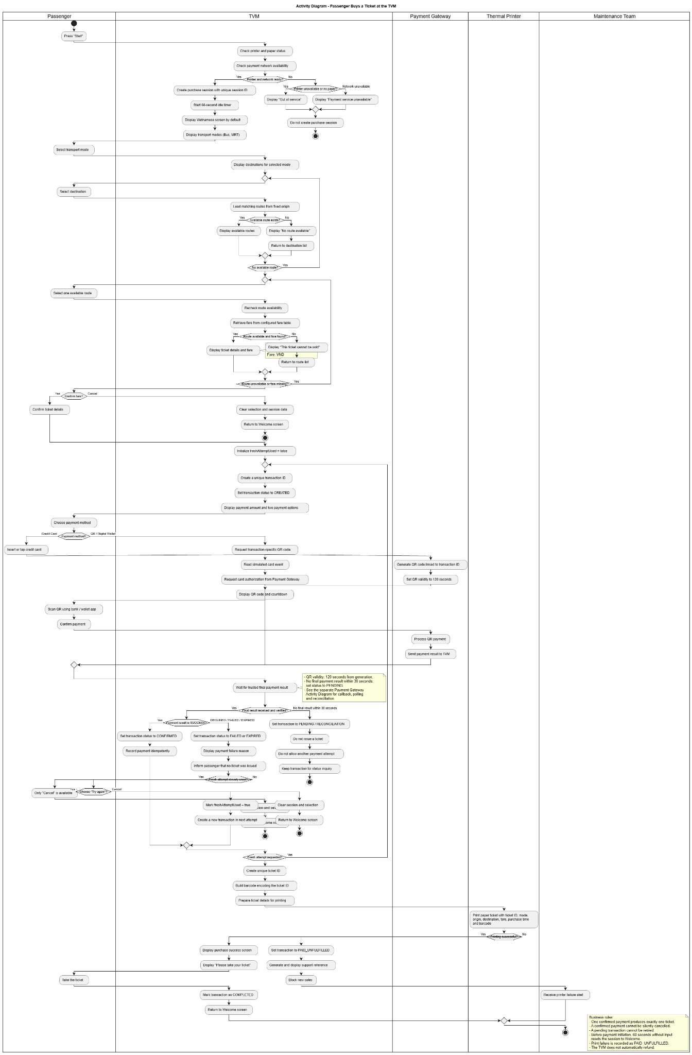
Figure 3.2. Passenger Buys a Ticket at the TVM (editable source: d1(1).drawio).

3.2.2 Communication with External Payment Gateways

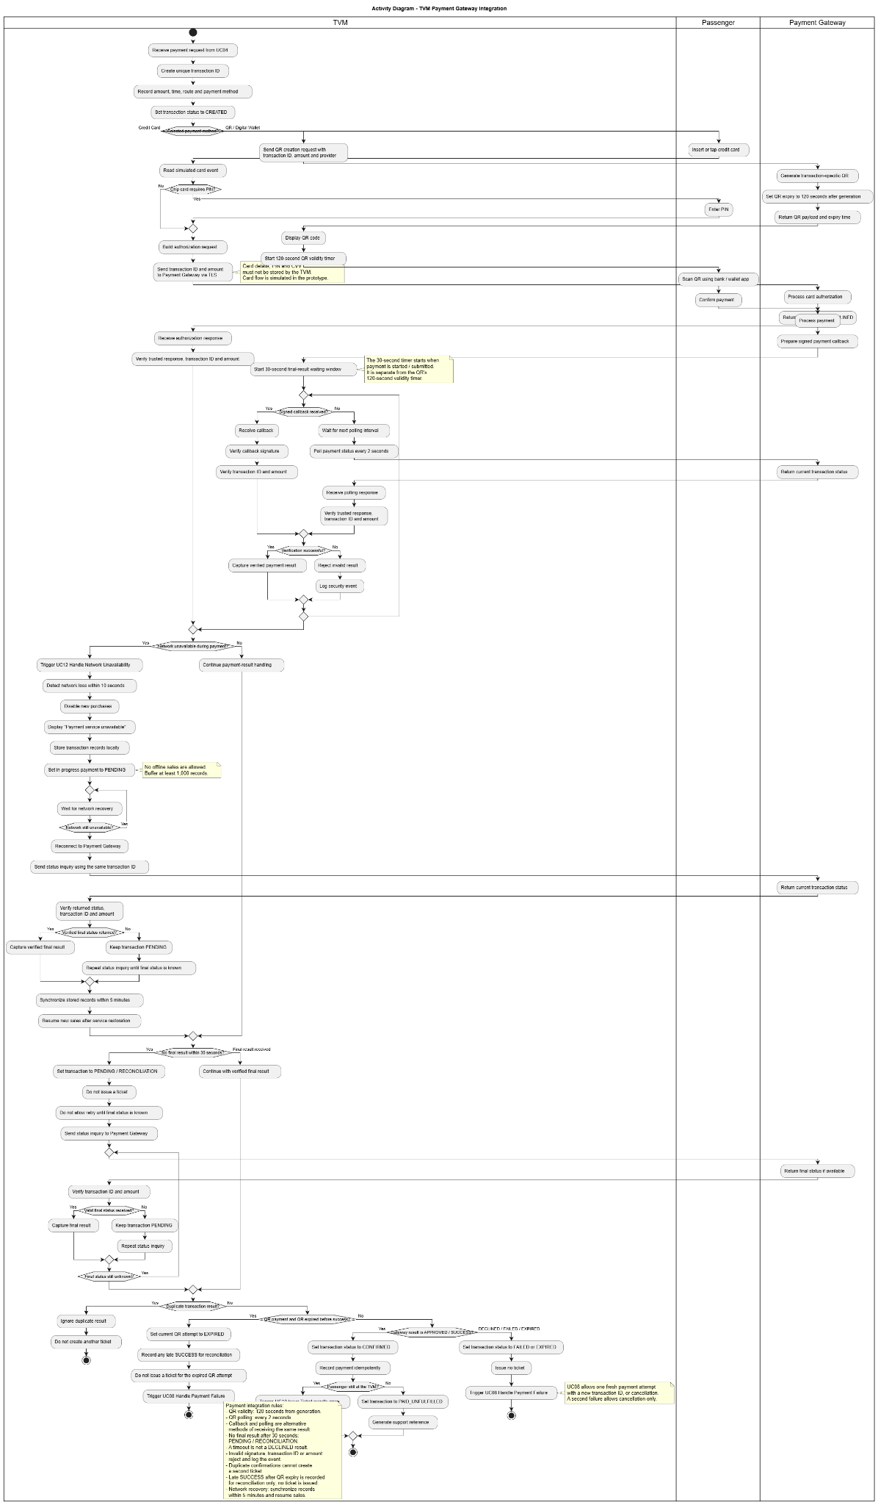
Figure 3.3. Communication with External Payment Gateways (editable source: d2(1).drawio).

3.3 Detailed System Modeling: Main Use Case "Buy a Ticket" (15 marks)

3.3.1 Sequence Diagram
The Sequence Diagram illustrates how the Passenger interacts with the TVM and how the internal system components communicate during the ticket purchasing process.
The process begins when the Passenger starts a purchase session and selects an available route. The system retrieves the corresponding fare, displays ticket information, and allows the Passenger to choose between Credit Card and QR Code / Digital Wallet payment.
The PurchaseController coordinates the purchasing process, while the TicketingRepository manages transaction records. The PaymentProcessor and GatewayAdapter handle payment requests and communication with the external payment gateway.
After the payment result is received, the system verifies the transaction before confirming the payment. Only a successfully verified payment can proceed to ticket generation and printing.
The diagram also represents alternative and exceptional flows, including payment failure, cancellation, QR expiration, network unavailability, and printer failure. A failed payment permits only one fresh payment attempt, while an uncertain payment result must be reconciled before further processing.

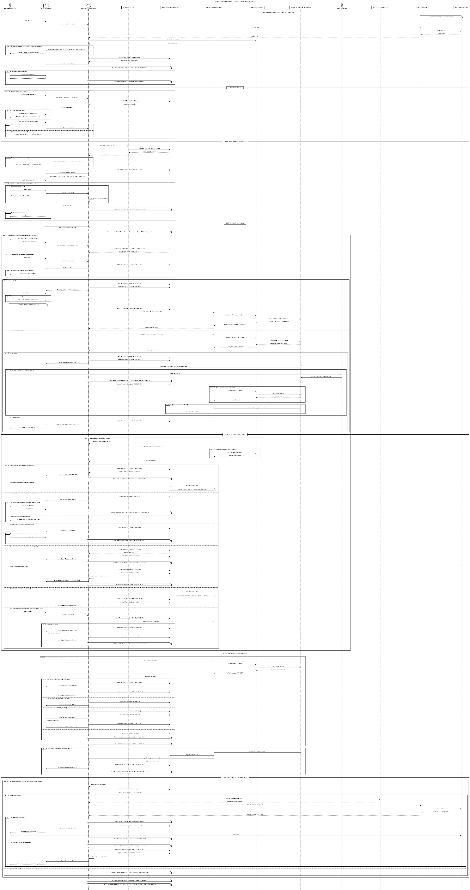

3.3.2 State Chart Diagram
The State Chart Diagram describes the different states of the TVM during the ticket purchasing process and the events that trigger transitions between those states.
The TVM initially remains in the Welcome state. After the Passenger starts a purchase, the system checks its readiness and moves through route selection, fare review, payment method selection, and payment processing.
Depending on the payment result, the system may enter the Payment Failure, Pending Reconciliation, or Payment Confirmed state. When payment is successfully verified, the TVM proceeds to Printing Ticket and Purchase Completed.
The diagram also handles exceptional situations, such as cancellation, network unavailability, and printer failure. A printer failure after confirmed payment results in a paid-but-unfulfilled transaction requiring support.
A separate transaction state machine represents payment statuses, including CREATED, WAITING, PROCESSING, CONFIRMED, FAILED, EXPIRED, PENDING, CANCELLED, CANCEL_PENDING, COMPLETED, and PAID_UNFULFILLED.
The state transitions are designed to ensure that no ticket is issued without a verified successful payment.

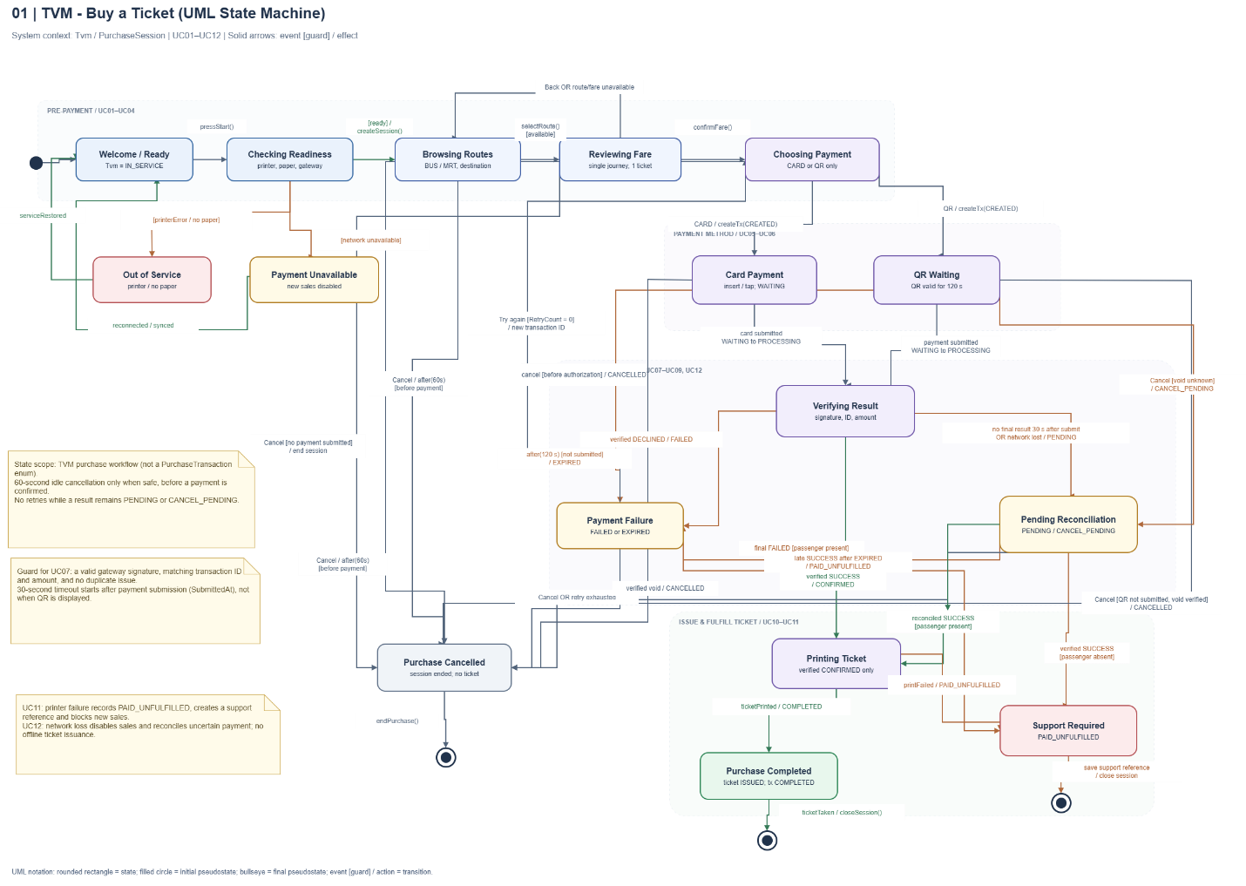

3.3.3 Class Diagram (Domain Model)
The Class Diagram defines the static structure of the Smart Ticketing System, including its classes, attributes, operations, and relationships.
The diagram contains 26 classes organized into domain entities and application/integration components.
The domain entities include Station, Tvm, Route, FareRule, PurchaseSession, PurchaseTransaction, PaymentAttempt, and Ticket, together with supporting entities for transaction history, payment callbacks, reconciliation, maintenance, and security.
Application classes such as TVMScreen, PurchaseController, TicketingRepository, PricingEngine, PaymentProcessor, GatewayAdapter, PrinterService, and BarcodeGenerator provide the operations required for the purchasing workflow.
The relationships are represented using UML associations, dependencies, and interface realizations. Multiplicities describe how many instances may participate in each association.
For example, a PurchaseSession may contain multiple purchase transactions, while each PurchaseTransaction belongs to exactly one session. A transaction can have at most one associated PaymentAttempt, and a ticket is linked to the corresponding purchase session and successful transaction.
The Class Diagram provides the structural model supporting the interactions shown in the Sequence Diagram and the state transitions shown in the State Chart Diagram

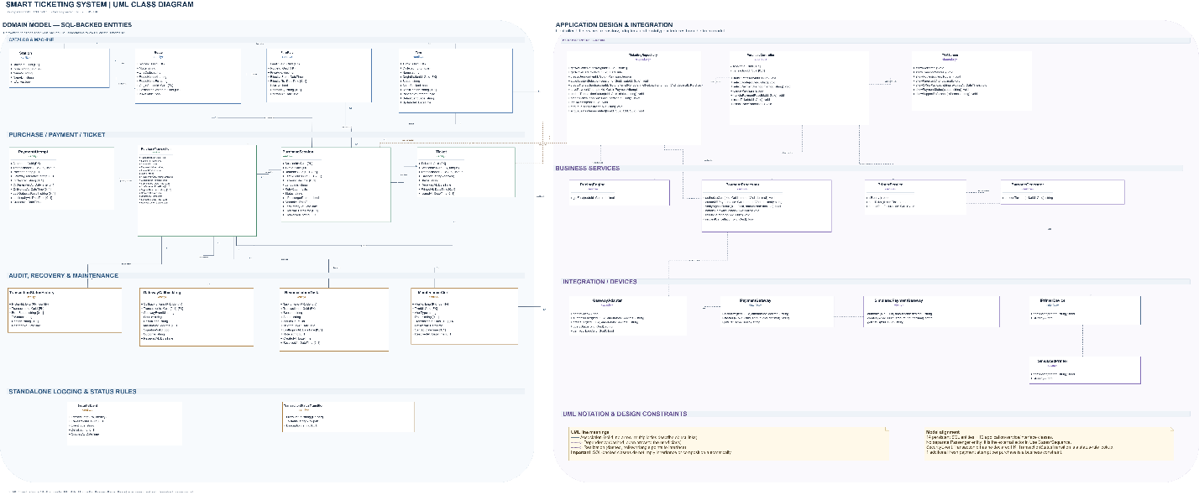
Class | Key attributes | Key methods | Relationships
Tvm | TvmId, Code, Status, OriginStationId | - | Associated with Station and PurchaseSession
Route | RouteId, Mode, OriginStationId, DestinationStationId | - | Associated with Station and FareRule
PurchaseSession | SessionId, TvmId, RouteId, RetryCount, Status | - | Associated with Tvm and PurchaseTransaction
PurchaseTransaction | TransactionId, SessionId, PaymentMethod, AmountVnd, Status | - | Associated with PurchaseSession, PaymentAttempt and Ticket
Ticket | TicketId, SessionId, TransactionId, Barcode, Status | - | Associated with PurchaseSession and PurchaseTransaction
PurchaseController | sessionId, transactionId | startPurchase(), selectRoute(), cancelPurchase(), issueTicket() | Depends on repository and payment services
PaymentProcessor | - | authorizeCard(), createQRPayment(), verifySignedResult(), reconcilePending() | Depends on GatewayAdapter
TicketingRepository | - | createSession(), createTransaction(), updateTransactionStatus(), createTicketOnce() | Provides persistence operations for domain entities

3.4 Model Consistency Check
The three UML models were designed to describe the same ticket purchasing workflow from different perspectives. The Sequence Diagram focuses on interactions between objects, the State Chart Diagram represents system behavior and payment states, and the Class Diagram defines the structural components supporting these operations.
Key business constraints are reflected across the models, including payment verification before ticket issuance, prevention of duplicate tickets, limited payment retries, and exception handling for payment and printer failures. The diagrams are reviewed for consistency in class names, operations, states, and transaction processing rules.
Consistency check | Diagrams involved | Done
Every use case in the diagram has a description, and every description is in the diagram | Use case diagram / descriptions | Done
Every step of the main flow appears in the activity diagram | Descriptions / activity | Done
Objects and messages in the sequence diagram exist as classes and methods in the class diagram | Sequence / class | Done
State names and transitions match the events in the sequence diagram | State chart / sequence | Done
Payment gateway steps match between the two activity diagrams and the sequence diagram | Activity / sequence | Done
Requirement IDs are cited in the use cases | Requirements / use cases | Done
The class diagram matches the C# code generated in 5.1 | Class / code | Done

4. Phase 3: UI/UX & Architecture (15 marks)

4.1 UI/UX Design (5 marks)
The TVM interface was designed in Figma as a touchscreen kiosk prototype. Large action buttons and clear screen transitions guide passengers from destination selection and fare review through card/QR payment to ticket issuance. The prototype also illustrates decline, pending-payment and printer-error screens. Fare values and gateway responses shown in mockups are illustrative; actual transaction processing and dynamic fares belong to the C# implementation.
Screen | Name / purpose | Linked use case step | Tool and link
S01 | Welcome / Start – Begin the ticket purchase session. | UC01 – Start purchase | Figma – project share link to be inserted
S02 | Destination Selection – Select an available destination or route. | UC01 – Select destination/route | Figma – project share link to be inserted
S03 | Review Fare – Confirm the selected journey and displayed fare. | UC01 – Review fare | Figma – project share link to be inserted
S04 | Payment Method – Choose Credit Card or QR payment. | UC01 – Select payment method | Figma – project share link to be inserted
S05 | QR Payment – Display payment QR and 120-second validity. | UC01 – QR payment | Figma – project share link to be inserted
S06 | Card Payment – Guide card tap/insert and verification. | UC01 – Card payment | Figma – project share link to be inserted
S07 | Ticket Issued – Confirm payment and successful ticket printing. | UC01 – Ticket issuance | Figma – project share link to be inserted
S08 | Payment Failed – Display decline and permitted retry/cancel options. | UC01 – Payment failure | Figma – project share link to be inserted
S09 | Payment Pending – Explain uncertain status and reconciliation. | UC01 – Pending payment | Figma – project share link to be inserted
S10 | Printer Error – Show paid-but-unfulfilled support reference. | UC01 – Printing failure | Figma – project share link to be inserted
TVM screen mockups (S01–S10):
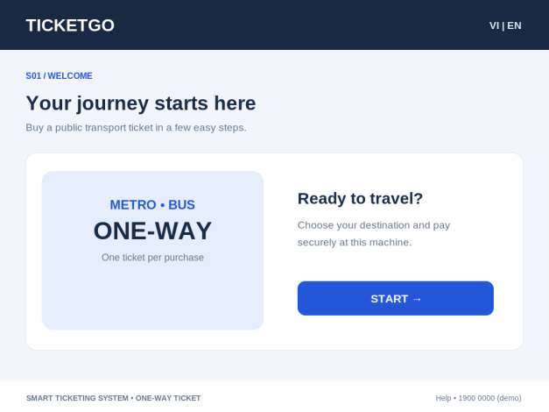 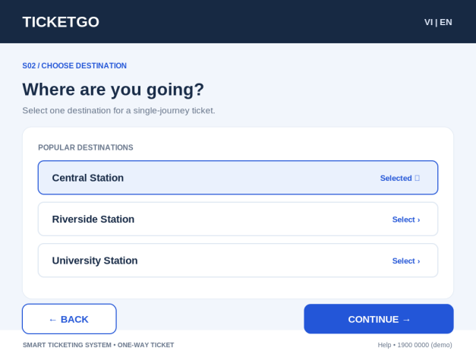
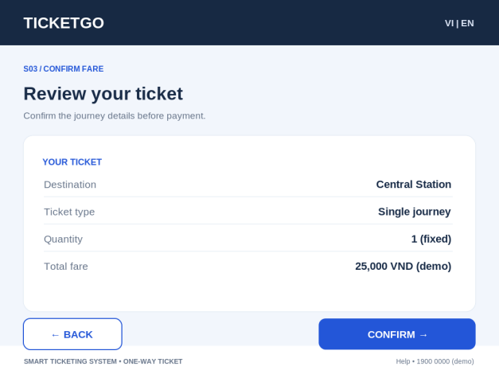 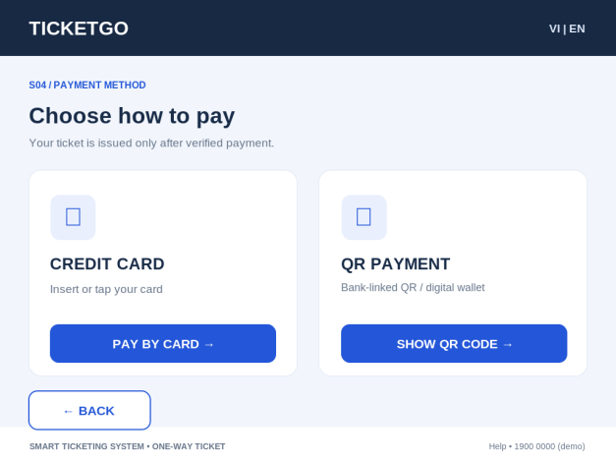
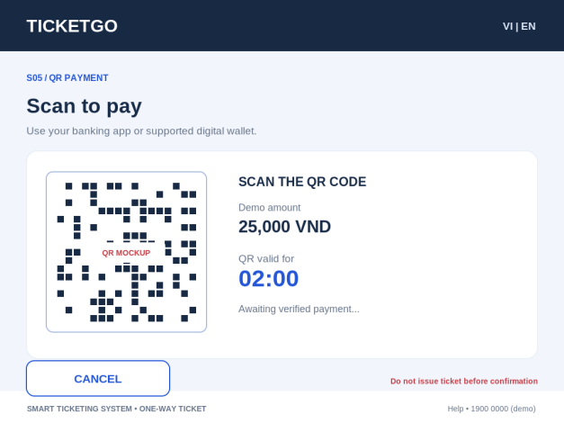 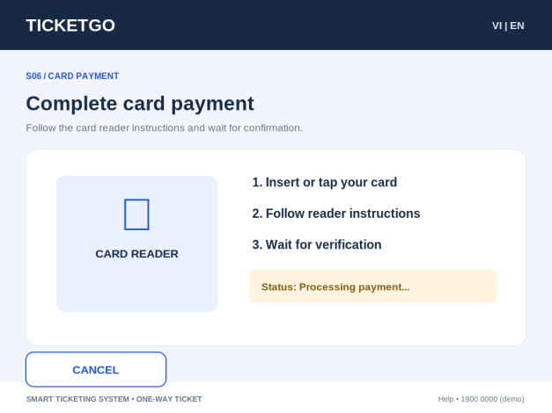
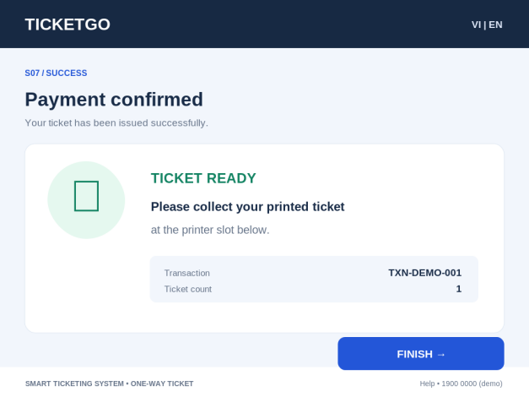 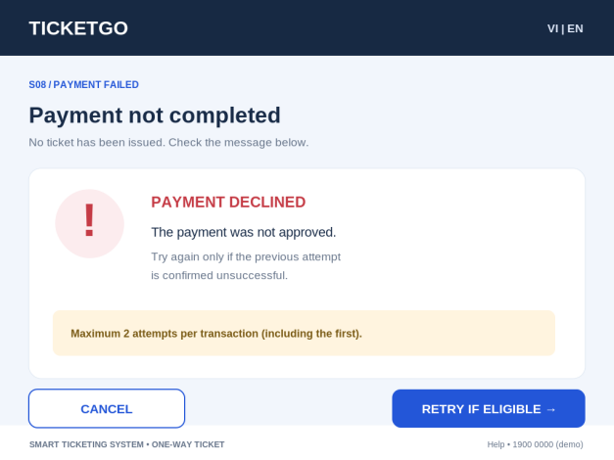
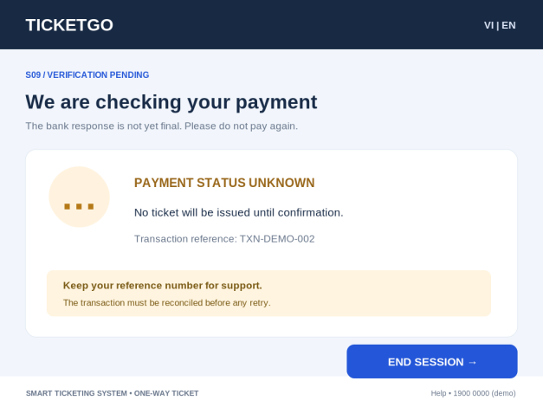 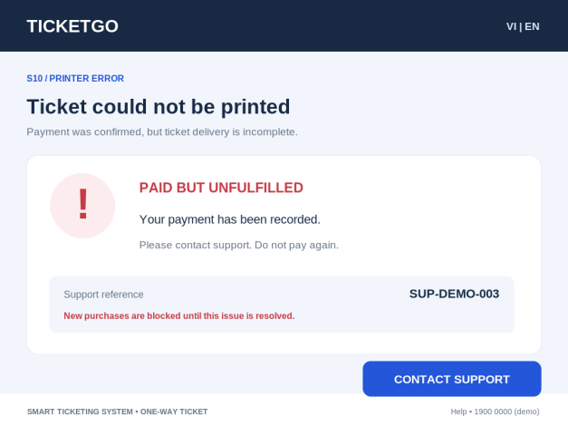

4.2 Architectural Design (10 marks)

4.2.1 Architecture Diagram
The architecture follows a layered design. The ASP.NET Core MVC presentation layer (SmartTicketing.Web) receives passenger actions through TicketController and Razor Views. It calls the application/business services in SmartTicketing.Services, including TVMController, PaymentProcessor, PricingEngine, GatewayAdapter, PrinterService and ReconciliationService. The data-access layer (SmartTicketing.Data) uses TicketingRepository and parameterized ADO.NET commands to read and update Microsoft SQL Server. SmartTicketing.Models contains the domain objects and payment-status constants shared across the workflow. Dependency injection in Program.cs registers the repository, gateway adapter, printer device and payment-processing services. The Web project uses the existing model, data and service source files through linked source files, rather than treating the legacy .NET Framework projects as runtime DLL dependencies.
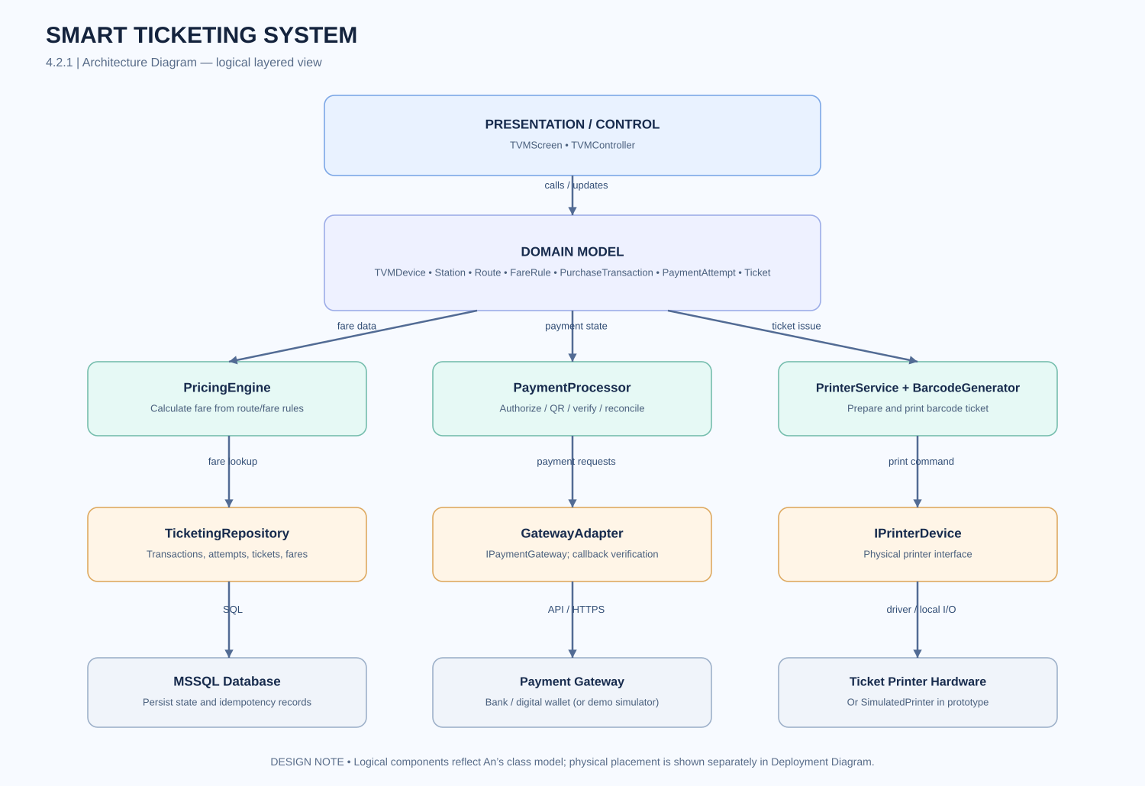
At runtime, a passenger selects a route, starts a purchase session and chooses CARD or QR. The controller stores the current SessionId and TransactionId in the ASP.NET Core session. PaymentProcessor coordinates transaction creation, the mock gateway result, confirmation, ticket reservation and printer outcome. TicketingRepository persists route, fare, session, transaction, payment-attempt, ticket and reconciliation records. A ticket is created only after a verified successful result; unresolved PENDING payments and paid-but-unfulfilled cases are retained for support/reconciliation.

4.2.2 Deployment Diagram
The target deployment separates the physical TVM kiosk, application services, SQL Server and external payment providers. In the submitted web prototype, however, the passenger interface and application logic run as one ASP.NET Core MVC web application on the local development machine, while SQL Server provides persistence. The payment gateway and printer are simulated adapters; no physical kiosk hardware or production payment endpoint is connected. The deployment description below therefore represents the intended system boundary, not proof of a production deployment.
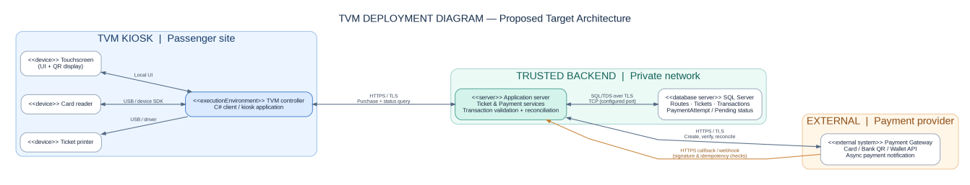
Node / component | Description | Connection (protocol, direction)
TVM hardware | Touchscreen kiosk running the C# client, card reader, QR display and ticket printer. | Touchscreen/device APIs and USB/local interfaces; TVM client → application server over HTTPS/TLS.
Application server | Processes fare, ticket and payment requests, maintains transaction state and coordinates integrations. | TVM → application server HTTPS/TLS; application server → SQL Server and ↔ payment gateway.
Database server | Microsoft SQL Server stores fare/route data, ticket IDs and payment/transaction records. | Application server → SQL Server through authenticated database protocol.
Payment gateway API | External card, bank-linked QR and digital-wallet authorization/verification services. | Application server ↔ gateway via HTTPS/TLS requests, verified callbacks and status queries.

5. Phase 4: Implementation, Tooling & Demo (30 marks)

5.1 Visual Studio Engineering: Model-to-Code (10 marks)

5.1.1 Forward Engineering (Model to Code)
The team used the UML/domain model as the design reference for the C# implementation. The model classes were represented in DomainModels.cs, while the service classes and their responsibilities were implemented in TicketingServices.cs. The supplied Visual Studio screenshots show the model-class and service-class views used during this model-to-code work. The implementation includes Route, PurchaseSession, PurchaseTransaction, PaymentAttempt, Ticket and PaymentResult, together with PricingEngine, PaymentProcessor, GatewayAdapter, PrinterService, ReconciliationService and TVMController.
Figure 5.1.1a – Model classes used as the implementation structure.
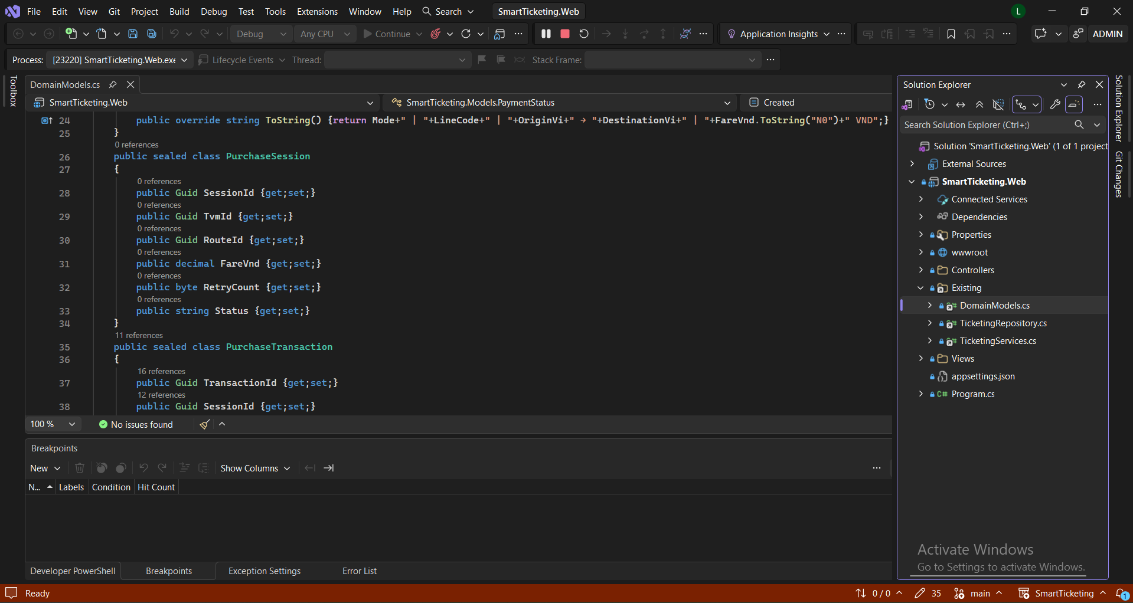
Figure 5.1.1a. Domain/model classes in the Visual Studio project.
The model layer defines the data carried through a purchase. The service layer implements the workflow and coordinates the repository, payment gateway abstraction and printer abstraction. The classes shown in the screenshots are consistent with the supplied source files in the ZIP package. The screenshots document the implementation structure; they do not by themselves prove that Visual Studio automatically generated every line of code from the UML model.
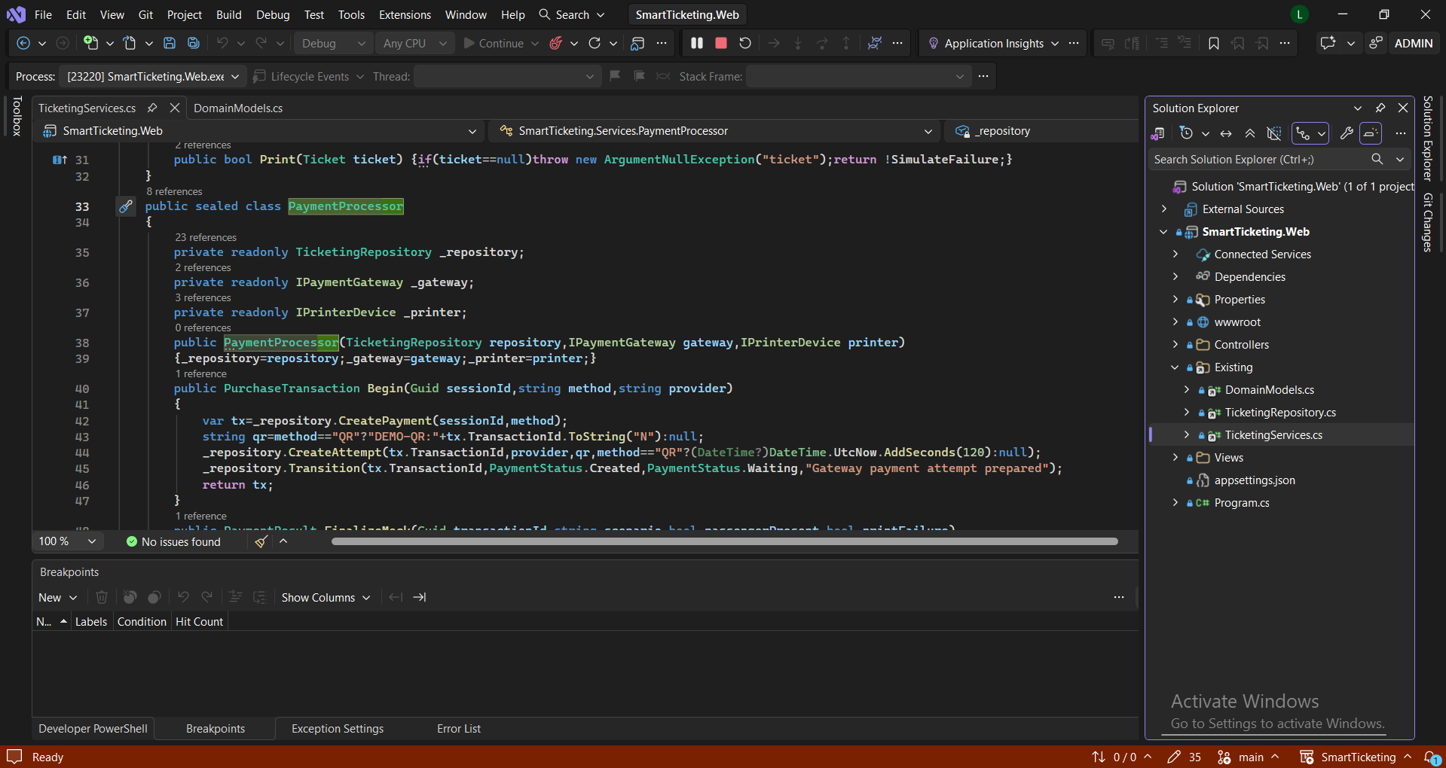
Figure 5.1.1b. Service classes and their operations.

5.1.2 Backward Engineering (Code to Model)
The implementation was reviewed against the design after the C# classes and workflow logic were added. The code contains concrete attributes, operations and state transitions that refine the initial model. Examples include unique identifiers (Guid), fare and amount values (decimal), QR expiry timestamps (DateTime?), retry counters, support references and explicit payment-status values. PaymentProcessor also implements the rules for a single fresh retry, QR expiry, pending reconciliation, late success and printer failure.
No. | Manual code change | File / class | How it was reflected in the model
1 | Added explicit payment-status constants and domain properties for transaction tracking. | DomainModels.cs – PaymentStatus, PurchaseTransaction, PaymentAttempt, Ticket, PaymentResult | The model records transaction identity, attempt number, payment method, amount, status, QR expiry and support reference.
2 | Implemented repository persistence with parameterized SQL commands and transaction/locking logic. | TicketingRepository.cs | The data model is persisted in SQL Server; serializable transactions and row locks prevent unsafe duplicate retries.
3 | Added service abstractions and orchestration for pricing, payment gateway, printing and reconciliation. | TicketingServices.cs | The service design separates business workflow from external gateway and printer implementations.
Figure 5.1.2 – Actual implementation code inspected during backward engineering.
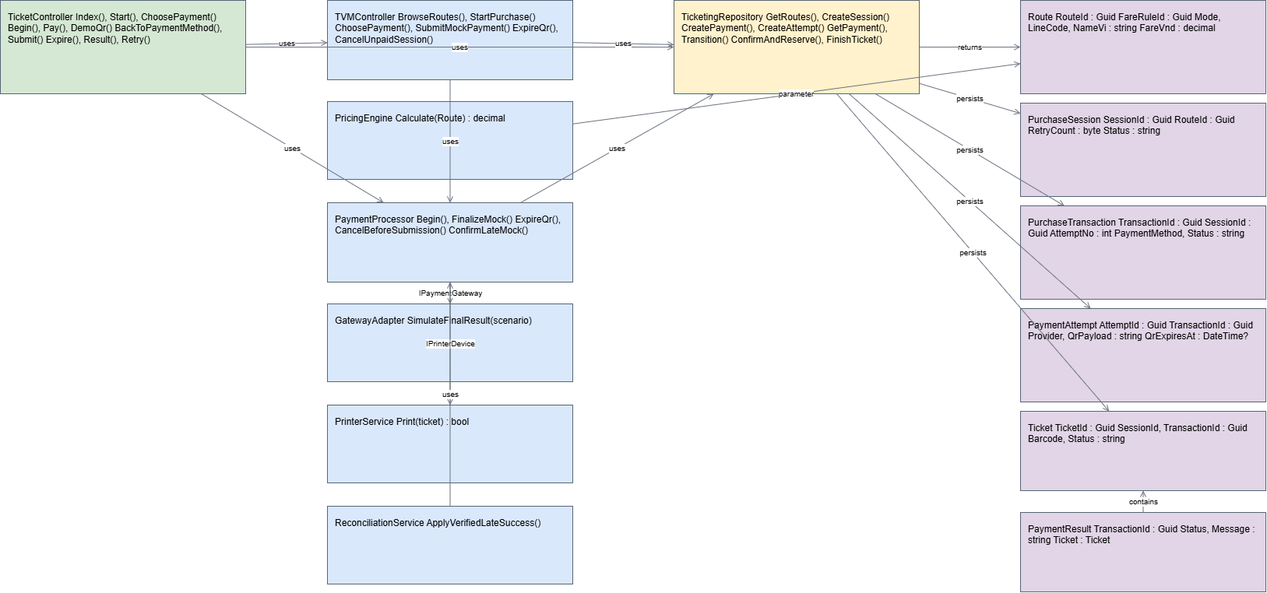
Figure 5.1.2. Actual C# implementation inspected in Visual Studio.

5.1.3 Code Map
The code-dependency views show how the presentation layer depends on service logic, how services use the repository and domain models, and how the repository connects to SQL Server. The project-dependency view complements the code map by showing the project/package structure used by the web prototype. These diagrams help identify the direction of dependencies and the main integration boundaries.
Figure 5.1.3a – Code dependency map.
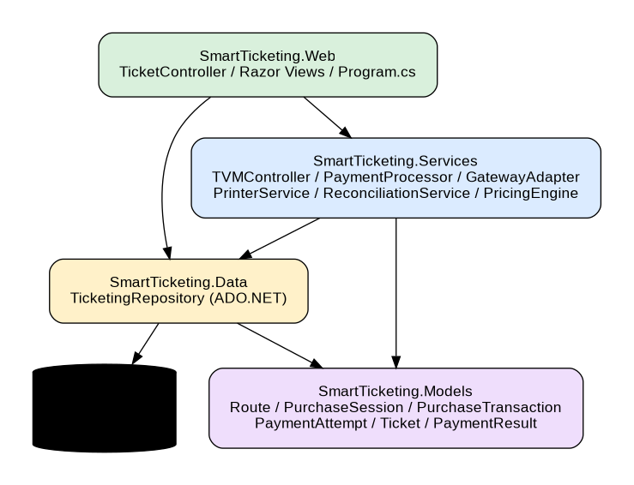
Figure 5.1.3a. Code dependency map: controllers, services, repository and model entities.
The map indicates that the controller is the entry point for the purchase flow. The service layer coordinates pricing, payment processing, gateway responses and ticket printing. The repository persists the transaction and ticket data, while the model classes carry the information between layers. The project-dependency screenshot shows the SmartTicketing.Web project and its framework/package dependencies. The actual project uses ASP.NET Core/.NET 8 and packages including QRCoder and System.Data.SqlClient. The separation makes the payment and printer integrations replaceable, although the supplied prototype currently uses mock implementations.
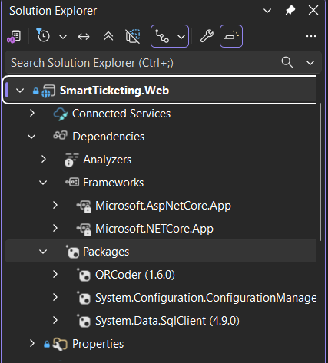
Figure 5.1.3b. Project and package dependencies shown in Visual Studio.
The supplied Visual Studio build output reports “Build: 1 succeeded, 0 failed”. It also displays CS0618 warnings for the legacy System.Data.SqlClient SqlCommand API. These are warnings rather than build errors; the project can be modernized later by migrating to Microsoft.Data.SqlClient.
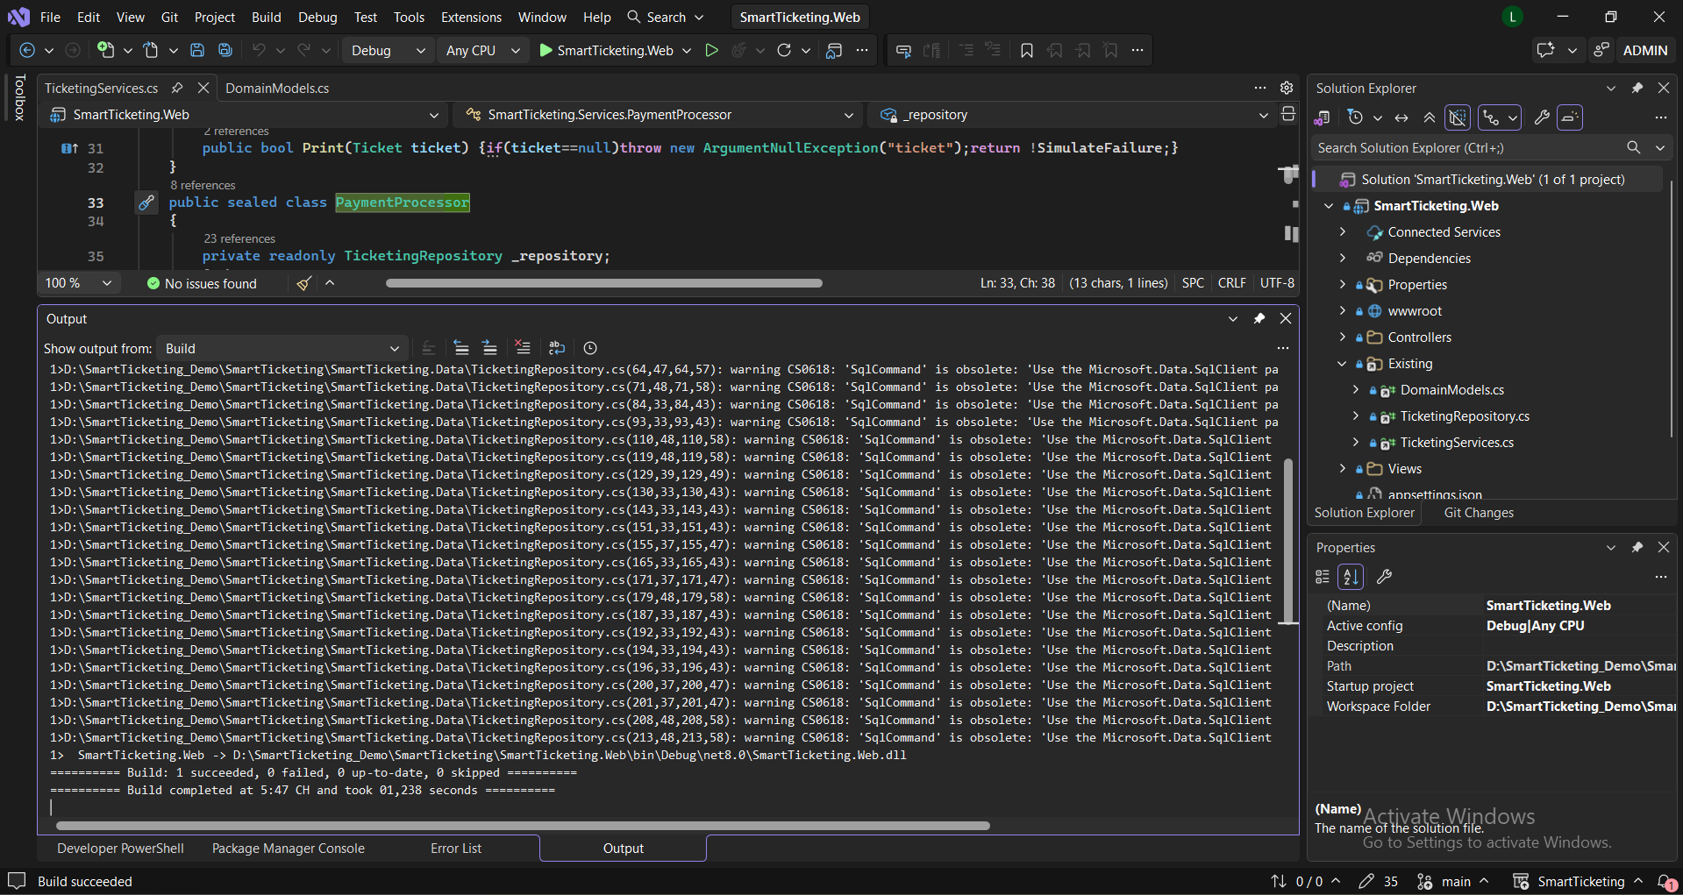
Figure 5.1.3c. Visual Studio build output: one project succeeded with no build errors.

5.2 GitHub & AI Tooling (10 marks)

5.2.1 Source Control
The report identifies the shared GitHub repository as https://github.com/lehung1521/Assignment1. The supplied Visual Studio screenshot shows the working branch named main. The current evidence does not include the repository commit history or pull-request list, so commit and pull-request counts must be copied from GitHub before submission rather than estimated.
Repository link | https://github.com/lehung1521/Assignment1
Branches (names and purpose) | main – branch visible in the supplied Visual Studio status bar. Other branches and their purposes were not evidenced in the supplied files.
Number of commits and pull requests | Not verifiable from the supplied screenshots/files. Enter the actual counts from the GitHub repository before submission.
Number of commits and pull requests | [ ]

Member | Commits | Pull requests | Main contributions
Nguyễn Lê Hùng | Not evidenced in supplied files | Not evidenced in supplied files | Implementation & Tooling
Nguyễn Ngọc Quý | Not evidenced in supplied files | Not evidenced in supplied files | Requirements & Documentation
Lê Quang Phúc | Not evidenced in supplied files | Not evidenced in supplied files | UI/UX & Architecture
Phan Hoài An | Not evidenced in supplied files | Not evidenced in supplied files | Detailed UML Modeling
Võ Huỳnh Duy Tân | Not evidenced in supplied files | Not evidenced in supplied files | Use Case & Activity Modeling

5.2.2 AI Assistance: Copilot Prompt Documentation
The submitted ZIP contains the application source code and README instructions, but it does not contain the team's AI Prompt Log. Therefore, no specific Copilot prompt, author or AI-generated code contribution can be verified from the supplied evidence. Copy the actual prompts from the workbook's “AI Prompt Log” sheet into the table below before final submission.
No. | Member | Prompt | How the AI helped | Used? (kept / changed / rejected) | How we validated it
1 | Team record required | Not included in supplied files – copy the actual prompt from the workbook. | To be completed from the team's AI Prompt Log. | Pending | Validate against the code, build output and relevant test scenarios.
2 | [ ] | [ ] | [ ] | [ ] | [ ]
…

5.2.3 Reflection on AI Use
The implementation evidence shows that the team has a working-source prototype with separated model, data-access and service responsibilities. The Visual Studio build completed successfully, although obsolete-API warnings remain and should be addressed in a later cleanup. The supplied files do not document which code was generated or modified with Copilot; the team should therefore base its final AI-use reflection on its actual prompt log and code review, not claim unverified AI contributions.

5.3 Demo Application (10 marks)
The submitted SmartTicketing.Web prototype is an ASP.NET Core MVC application using C# and Microsoft SQL Server. The browser interface demonstrates route selection, payment-method selection, QR display and result screens. The screenshots below are evidence of the local application running at localhost:54694. The application explicitly labels itself as a simulation: it does not transfer real money and does not issue a legally valid public-transport ticket.
Technology and versions | C#; ASP.NET Core MVC / .NET 8; Microsoft SQL Server; QRCoder 1.6.0; System.Data.SqlClient 4.9.0. Visual Studio version shown in screenshots: Visual Studio 2026.
Database script location and how to run it | SmartTicketing/database/. Run 01_create_schema.sql, then 02_seed_data.sql, then 03_late_success_transition.sql in SQL Server Management Studio on a fresh database. Configure the TVM connection string in SmartTicketing.Web/appsettings.json.
How to run the application | Install the ASP.NET and web development workload and .NET 8 SDK; open SmartTicketing.Web/SmartTicketing.Web.csproj; restore NuGet packages; configure the SQL Server connection string; run the database scripts; press F5. The supplied local screenshots show localhost:54694.
Video demo link (optional) | Not supplied in the uploaded files.
Video demo link (optional) | [ ]
Input form
Figure 5.3a – Route and destination selection screen.
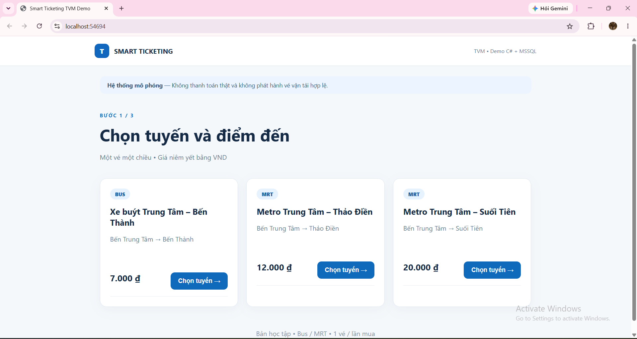
Figure 5.3a. Passenger selects one of the available Bus/MRT routes and sees the displayed fare.
Output report or success screen
Figure 5.3b – Payment-method selection and QR payment screens.
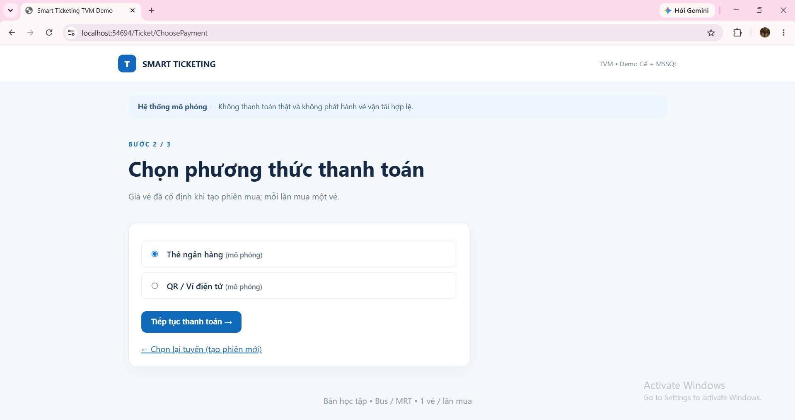
Figure 5.3b. Passenger chooses simulated card or QR/wallet payment.
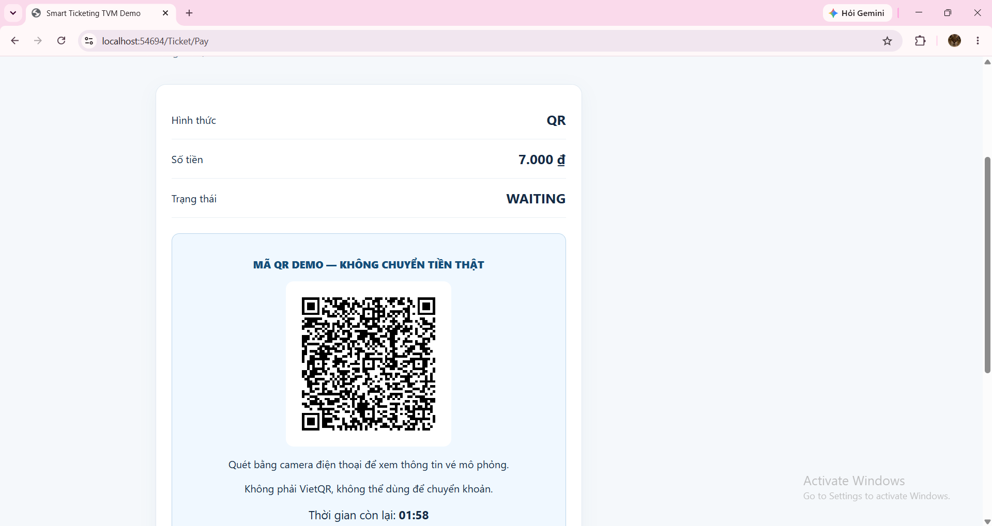
Figure 5.3c. QR payment screen with a 120-second expiry countdown.
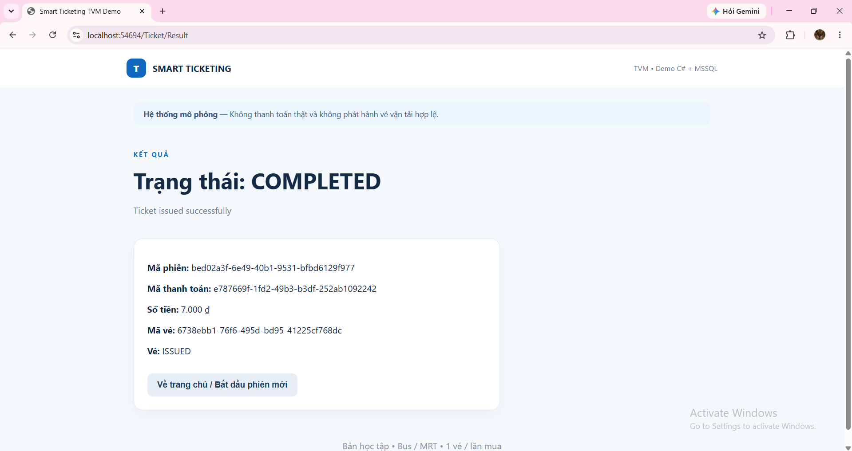
Figure 5.3d. COMPLETED result: successful simulated payment and ticket issuance.
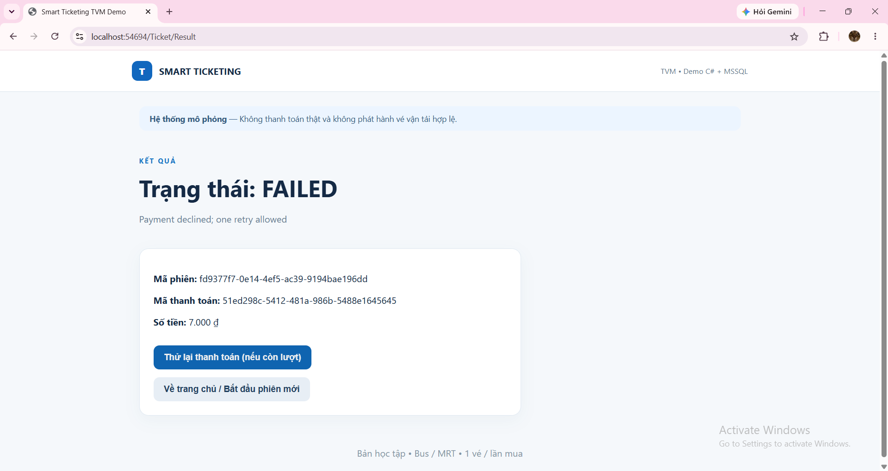
Figure 5.3e. FAILED result: declined payment; one fresh retry is offered.
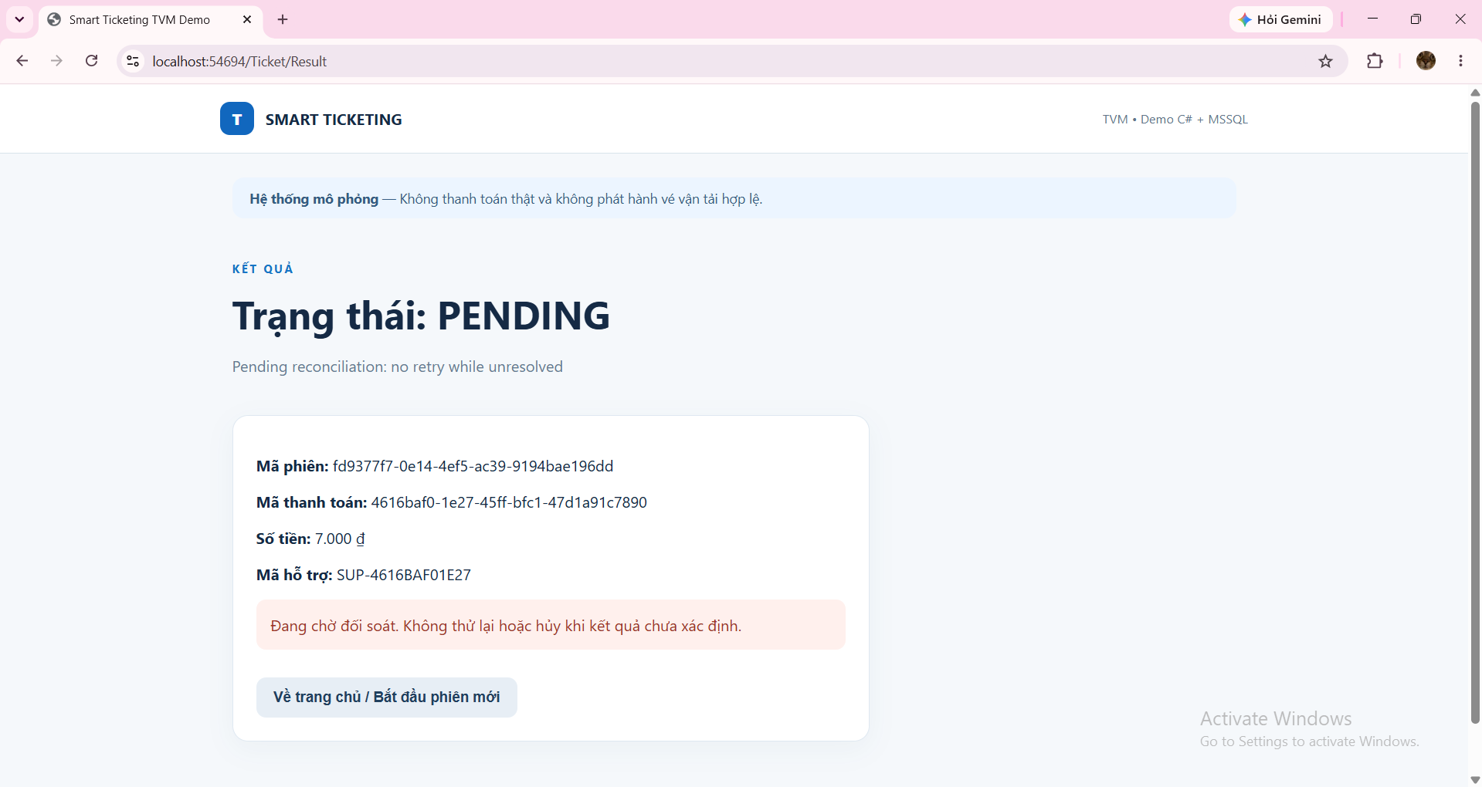
Figure 5.3f. PENDING result: reconciliation is required and retry is blocked while unresolved.
Test scenarios
1 | Successful QR purchase | Select a listed route; choose QR; simulate APPROVED. | Transaction becomes COMPLETED and one ticket is issued. | Demonstrated – COMPLETED result screenshot.
2 | Payment declined | Select a route; choose a payment method; simulate DECLINED. | Transaction becomes FAILED; no ticket is issued; one retry is available. | Demonstrated – FAILED result screenshot.
3 | No final gateway response | Select a route; choose QR/card; simulate NO_RESPONSE. | Transaction becomes PENDING; no ticket is issued and retry is blocked until reconciliation. | Demonstrated – PENDING result screenshot.
4 | QR payment display | Select QR payment for a purchase. | A demo QR is displayed with a 120-second expiry countdown; it is not a bank-transfer QR. | Demonstrated – QR screen screenshot.
5 | Build verification | Build the SmartTicketing.Web project in Visual Studio. | Build completes without errors. | Evidence supplied – 1 succeeded, 0 failed; obsolete API warnings remain.
6 | Printer failure / paid but unfulfilled | Simulate an approved payment with printer failure. | Transaction should be recorded as PAID_UNFULFILLED and a support reference shown. | Specified in source code/README; no corresponding UI screenshot supplied.
Known limitations: The gateway and payment results are mocked; no real card/bank/wallet authorization or money transfer occurs. The QR code contains a TVM-DEMO payload and is not VietQR or a bank-scannable payment request. The NO_RESPONSE option simulates the 30-second timeout without waiting in real time. QR expiry is enforced using the stored expiry timestamp, but the demo flow is not a production-grade asynchronous gateway integration. Printer output is simulated and is not sent to a physical printer. Reconciliation is a manual simulation; no background worker, verified webhook, or automatic remote status inquiry is implemented. These limitations are stated in the supplied README files.
[ ]

6. Checklist for "LabGroup_QT2_Assignment1.pdf"
Guidance (delete before submitting): The submission must address the content of LabGroupAssignment1.pdf (initial context and submission guidelines). List each item of that document, where this report covers it, and tick it.
No. | Item from LabGroupAssignment1.pdf | Where addressed in this report | Done
1 | Business context and problem statement, including the TVM purchase process and payment methods. | Sections 1.1–1.2: Purpose and Scope; Problem Statement in Our Own Words. | [✓]
2 | Clarification Q&A: identify ambiguities, ask stakeholders, and record logical assumed answers. | Section 2.1; supporting details in the Clarification Q&A sheet of the team workbook. | [✓]
3 | Requirements Specification: Functional, Non-Functional and Domain Requirements, with measurable reliability and response-time criteria. | Section 2.2; supporting FR/NFR/DR register in the Requirements sheet of the team workbook. | [✓]
4 | Use Case Modeling: Use Case Diagram and detailed Use Case Descriptions. | Section 3.1, including the Use Case Diagram and the 12 Use Case Descriptions. | [✓]
5 | Activity Diagrams: passenger buying a ticket and external payment-gateway integration. | Section 3.2: Activity Diagram – Buy a Ticket and Activity Diagram – Payment Gateway Integration. | [✓]
6 | Detailed System Modeling for Buy a Ticket: Sequence Diagram, State Chart Diagram and Class Diagram. | Section 3.3: Sequence, State Chart and Class Diagrams, with consistency discussion in Section 3.4. | [✓]
7 | Phase 3: UI/UX wireframes or mockups, Architecture Design and Deployment Diagram showing system components and external API context. | Sections 4.1–4.2: UI/UX Design and Architectural Design. Refer to the Figma and editable Draw.io artifacts in the shared repository. | [✓]
8 | Phase 4 and submission evidence: Visual Studio forward/backward engineering and Code Map; GitHub collaboration history; AI-tool prompt documentation and validation; C# and MSSQL demo with input and output; repository, README and member contribution. | Sections 5.1–5.3: Visual Studio Engineering, GitHub & AI Tooling, and Demo Application; Section 7: Contribution of Each Member; Appendix with repository and setup instructions. Supporting logs are in the team workbook. | [✓]

7. Contribution of Each Member
Guidance (delete before submitting): The % contribution of each member must total 100% and match readme.txt.
Member | Student ID | Work products and tasks | % contribution
Nguyễn Lê Hùng | 524H0051 | Implementation & Tooling: C# / MSSQL demo, Visual Studio forward and backward engineering, Code Map/dependency evidence, GitHub repository setup and technical integration. | 20%
Nguyễn Ngọc Quý | 524H0184 | Requirements & Documentation: Clarification Q&A, Functional/Non-Functional/Domain Requirements, requirements-to-use-case traceability, report coordination and documentation. | 20%
Lê Quang Phúc | 524H0181 | UI/UX & Architecture: Figma wireframes/mockups, Architecture Diagram, Deployment Diagram and coordination of the UI demo. | 20%
Phan Hoài An | 524H0139 | Detailed UML Modeling: Sequence Diagram, State Chart Diagram, Class Diagram and support for model-to-code consistency. | 20%
Võ Huỳnh Duy Tân | 524H0187 | Use Case & Activity Modeling: Use Case Diagram, Use Case Descriptions and the two Activity Diagrams (passenger ticket purchase and payment gateway integration). | 20%
Total |  |  | 100%

8. Conclusion and Lessons Learnt
The contribution percentages in Section 7 follow the team workbook and total 100%. The checklist in Section 6 maps the assignment requirements to the corresponding report sections. The team should still verify the final GitHub history, README, AI Prompt Log and all linked artifacts before uploading the submission.

References
1. SE Lab Group Assignment 1 – Smart Ticketing System (Ticket Vendor Machine), team requirements workbook and report artifacts.
2. SmartTicketing_Demo source package supplied with this report: README_BACKEND.md, README_WEB.md, C# source files and SQL scripts (01_create_schema.sql, 02_seed_data.sql, 03_late_success_transition.sql).
3. Visual Studio implementation evidence supplied by the team: Forward Engineering, Backward Engineering, Code Map, project dependencies and build output screenshots.
4. SmartTicketing.Web local demo screenshots showing route selection, payment selection, QR payment and COMPLETED / FAILED / PENDING results.

Appendix

Appendix A: readme.txt
GitHub repository: https://github.com/lehung1521/Assignment1
Figma: https://www.figma.com/design/uvulsznsp4j2dX43Mp4Oao/Untitled?node-id=0-1&t=xNLMiauqwCYEVyQE-1
Database setup: Run SmartTicketing/database/01_create_schema.sql, then 02_seed_data.sql, then 03_late_success_transition.sql in SQL Server Management Studio on a fresh database. Configure the TVM connection string in SmartTicketing.Web/appsettings.json.
Run the web demo: Install the ASP.NET and web development workload and .NET 8 SDK; open SmartTicketing.Web/SmartTicketing.Web.csproj; restore NuGet packages; configure SQL Server; run the database scripts; then start the project with F5.
The actual commit counts, pull-request counts, AI Prompt Log and member contribution percentages must be added from the team's GitHub/workbook records. They are not present in the supplied ZIP or screenshots.

Appendix B: Full-size Diagrams
The Use Case Diagram and both Activity Diagrams are included in Sections 3.1.1 and 3.2. Their editable Draw.io source files are uc.drawio, d1(1).drawio and d2(1).drawio. Additional implementation evidence included in this report comprises the Forward Engineering model/service screenshots, Backward Engineering code screenshot, Code Map and project-dependency screenshots, Visual Studio build output, and SmartTicketing.Web route/payment/result screenshots. The editable source diagrams and complete SmartTicketing_Demo project ZIP should also remain in the shared GitHub repository.

