4. Phase 3: UI/UX & Architecture (15 marks)
Smart Ticketing System — Ticket Vending Machine (TVM) | Individual contribution: UI/UX and Architecture
This section documents the proposed touchscreen interface, logical software architecture, and deployment architecture. The diagrams describe a target design; actual features and external connections must be verified against the final C# demonstration.

4.1 UI/UX Design (5 marks)
The TVM interface is designed for a touchscreen kiosk. Its primary goal is to let a passenger start a session, select a destination, review a single-journey fare for one ticket, choose card or QR payment, and receive a clear transaction outcome. The Figma mockups represent visual interaction; they are not a live banking integration.
Screen | Name / purpose | Linked use-case step | Design artifact
S01 | Welcome / Start | Initiate ticket purchase | Figma screen
S02 | Destination selection | Choose destination; Central/Riverside/University selection states | Figma screen
S03 | Review fare | Confirm destination, one ticket, fare | Figma screen
S04 | Payment method | Choose credit card or QR payment | Figma screen
S05 | QR payment | Show QR payment instructions and validity | Figma screen
S06 | Card payment | Present card instructions and pending verification | Figma screen
S07 | Ticket issued | Confirm payment and successful ticket issuance | Figma screen
S08 | Payment failed | Communicate failure and permitted retry | Figma screen
S09 | Payment pending | Show uncertain payment awaiting reconciliation | Figma screen
S10 | Printer error | Paid but ticket not delivered; provide support reference | Figma screen

4.1.1 Screen flow and interaction rules
The main flow is S01 → S02 → S03 → S04 → S05 (QR) or S06 (card). The destination selected in S02 is carried to S03 and the payment amount. On confirmed payment and successful ticket output, the flow reaches S07. A declined payment leads to S08; an unresolved payment leads to S09; a confirmed payment with printing failure leads to S10. Back and Cancel actions must be limited by the transaction state to avoid misrepresenting a submitted payment as cancelled.
Three extra S02 selection states and three corresponding S03 review states illustrate destination-dependent fares. The final C# application should calculate the amount from its data or pricing rules and populate the same payment interface dynamically. The Figma demo scenario selector, if shown, is for demonstrations only and must not appear as a passenger option in production.
Figma design and prototype link: [INSERT YOUR REAL FIGMA SHARE LINK HERE]

4.1.2 UI mockups
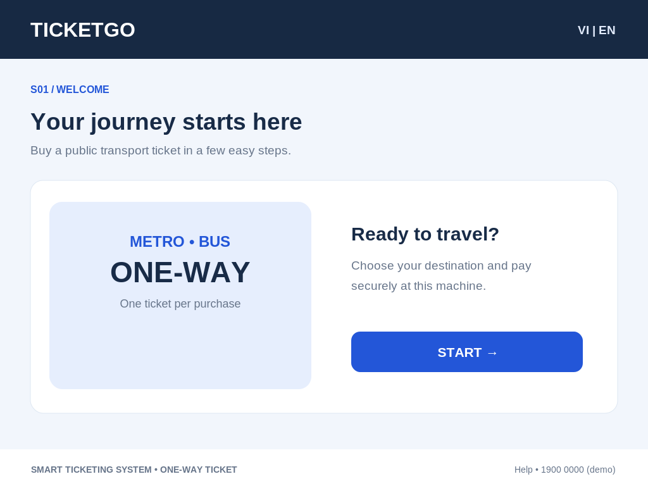 | 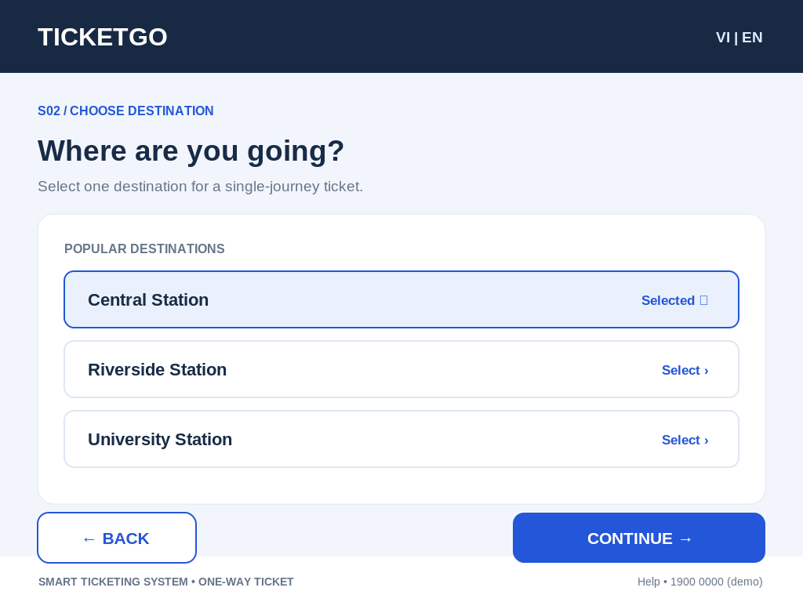
S01_Welcome | S02_Destination

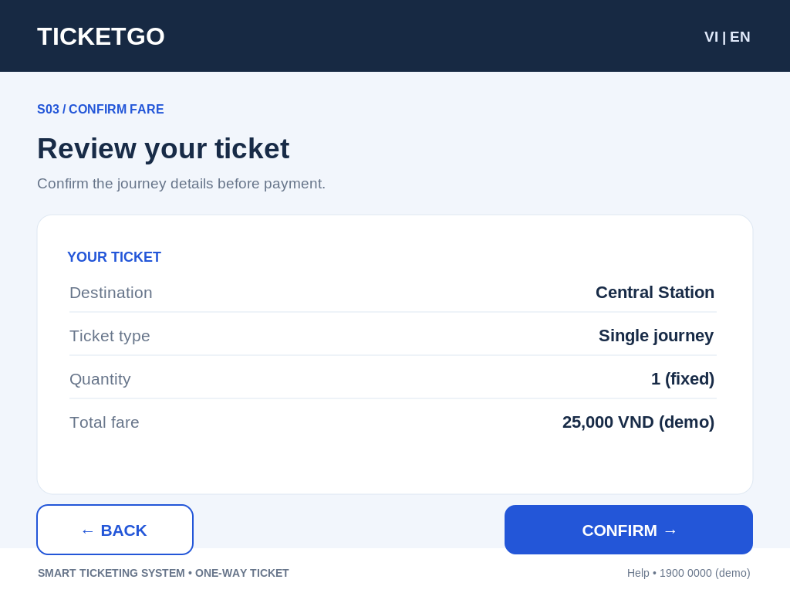 | 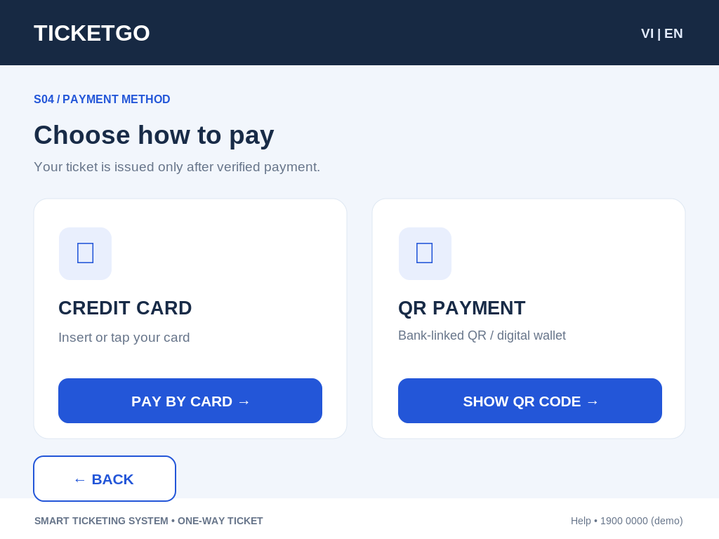
S03_Review_Fare | S04_Payment_Method

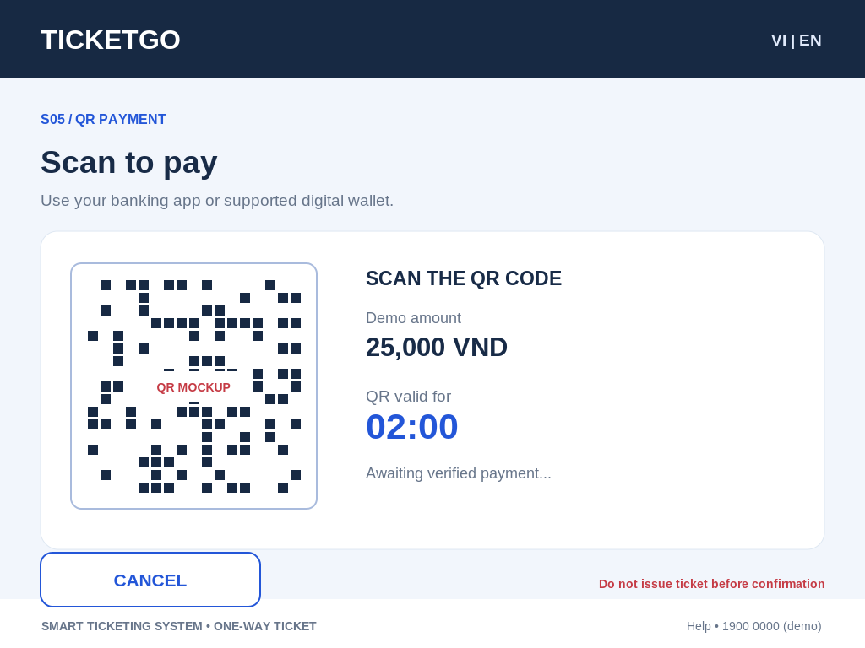 | 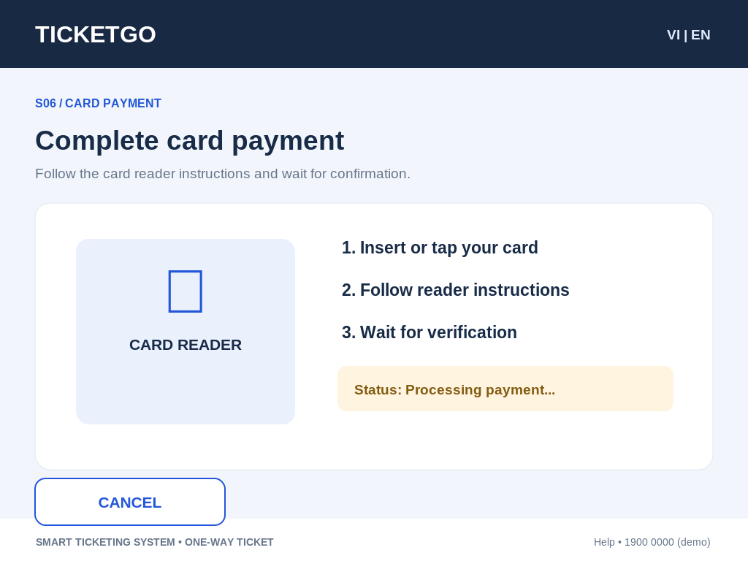
S05_QR_Payment | S06_Card_Payment

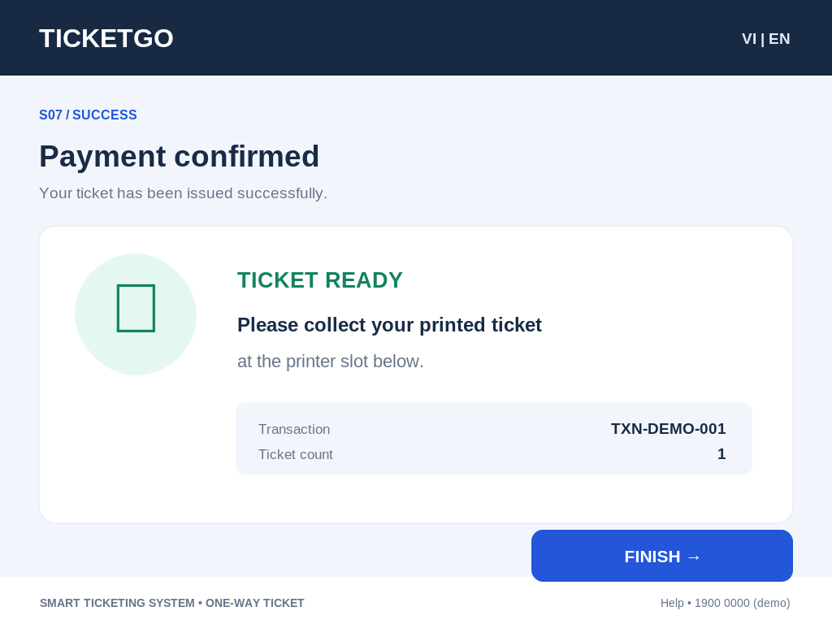 | 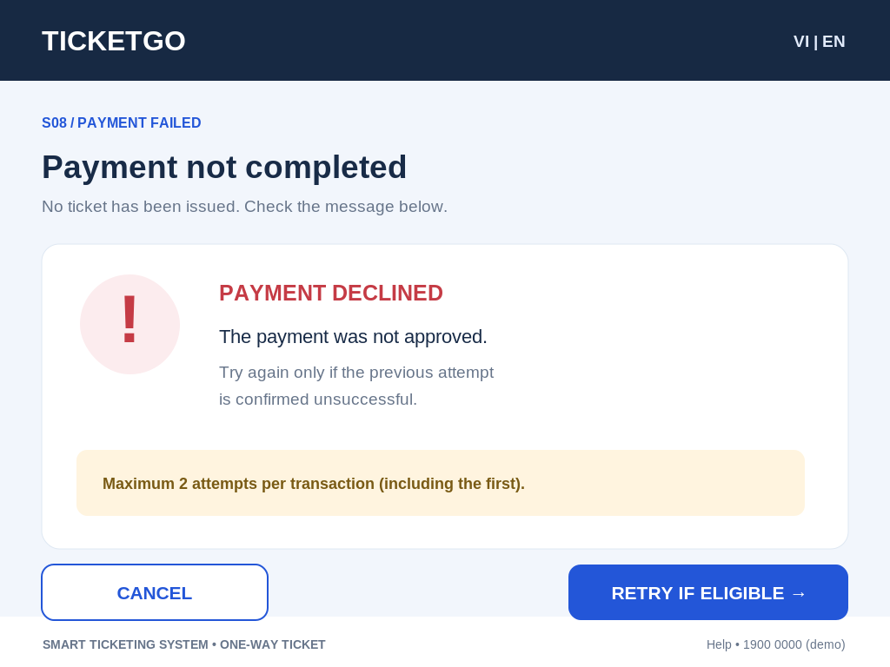
S07_Success | S08_Payment_Failed

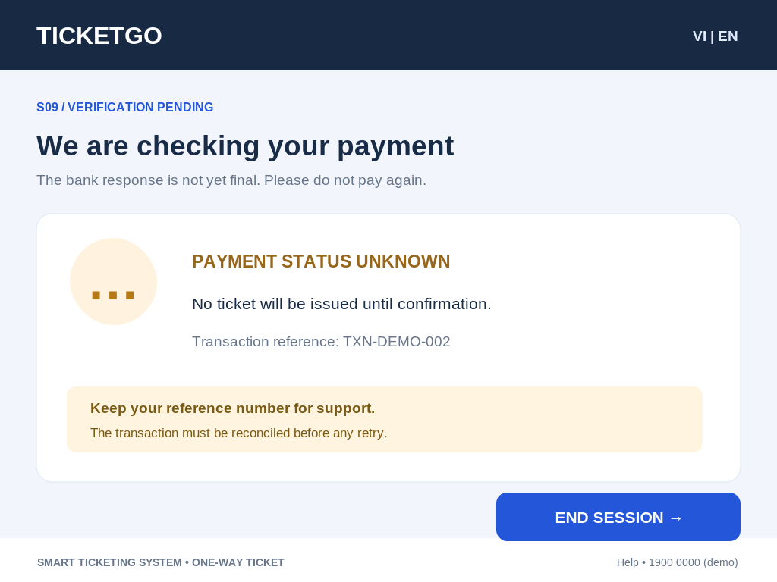 | 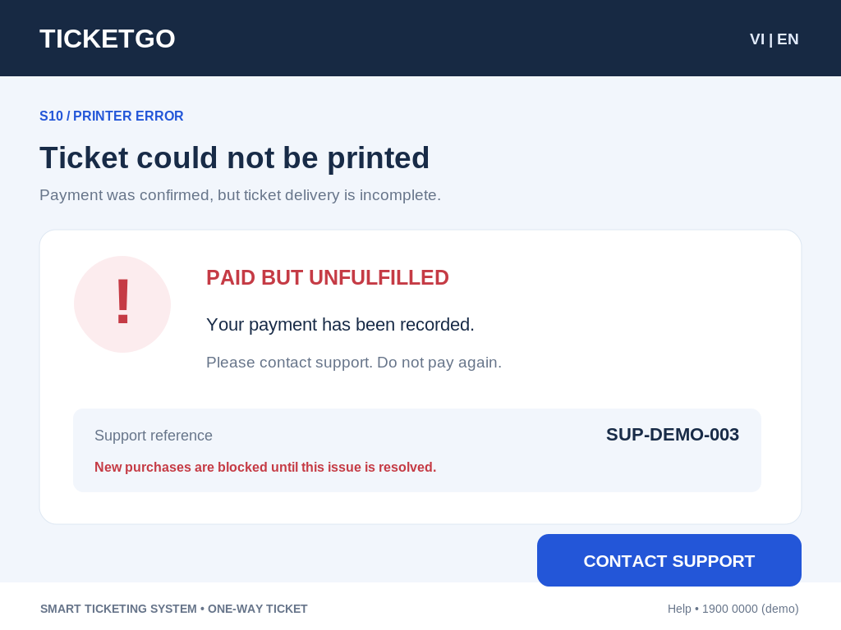
S09_Payment_Pending | S10_Printer_Error

4.1.3 Usability and accessibility considerations
The kiosk screens use prominent primary actions, visible navigation controls, clear payment status labels, and distinguishable success and error screens. Before deployment, the team should verify touch-target size, contrast, language options, readable error messages and accessibility requirements with stakeholders. The three station labels and fares in mockups are demonstration content, not confirmed production tariff data.

4.2 Architectural Design (10 marks)

4.2.1 Architecture Diagram
The proposed logical architecture separates the TVM presentation and orchestration layer from domain entities, business services, persistence, and external hardware/payment adapters. Keeping gateway and SQL operations out of the screen layer makes transaction rules clearer, reduces coupling and makes service-level testing possible.
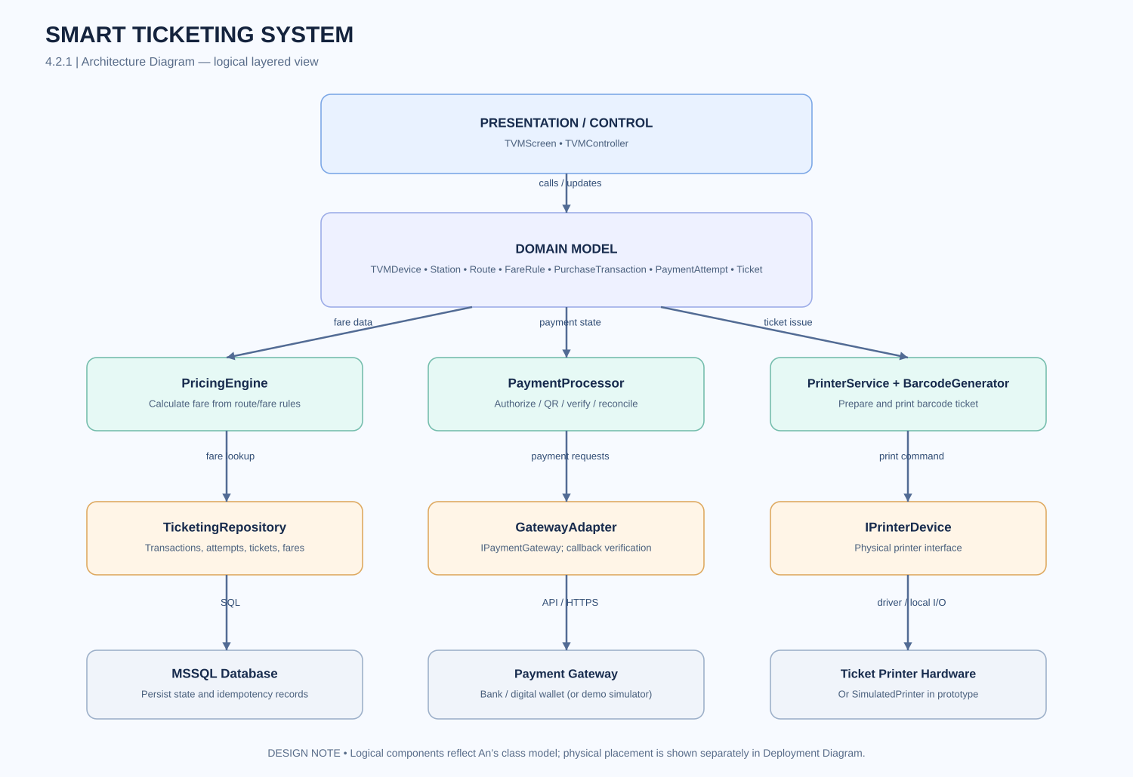
Figure 4.1. TVM logical architecture diagram.
Component | Responsibility
TVMScreen / TVMController | Show the purchase steps and coordinate screen transitions.
Route, Ticket, PurchaseTransaction, PaymentAttempt | Represent route, ticket, transaction and payment-attempt state.
PricingEngine | Apply the agreed fare rules to the destination.
PaymentProcessor / GatewayAdapter | Initiate payment requests; verify gateway responses and support reconciliation.
PrinterService / IPrinterDevice | Request ticket printing, check device response, and report failure.
TicketingRepository / MSSQL | Store route, ticket, payment and transaction data.
Design rationale: the screen does not issue a valid ticket simply because the passenger visited a success view. Payment must first be verified and the ticket output step completed. Uncertain payment states should be recorded for reconciliation. Duplicate external callbacks should not create duplicate tickets. Component names must be reconciled with the group’s final class and sequence diagrams.

4.2.2 Deployment Diagram
The deployment model distinguishes the physical kiosk from a trusted backend and external payment providers. Local peripherals provide touch input, card reading, QR display and ticket printing. The backend coordinates transaction processing and data persistence; external gateway communication crosses a separate network trust boundary.
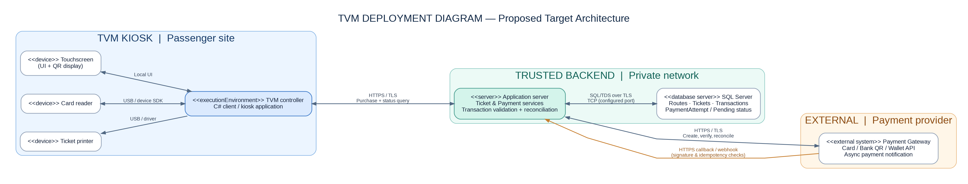
Figure 4.2. Proposed TVM deployment diagram.
Node / component | Description | Connection / direction
TVM kiosk (C# client) | Touchscreen application operated by passengers | Kiosk ↔ backend, HTTPS/TLS (target design)
Touchscreen and QR display | Local user input and QR presentation | Locally attached display/input
Card reader | Card interaction through integrated hardware | Local device link; actual hardware protocol TBD
Ticket printer | Print a paper ticket with barcode | Local USB or other device interface
Application server | Enforce rules and coordinate payment and ticket lifecycle | Kiosk HTTPS; database link; external gateway HTTPS
Microsoft SQL Server | Persist routes, tickets and transaction states | Backend ↔ database, protected SQL connection
Payment gateway API | External bank/wallet authorization, verification and callbacks | Backend ↔ gateway, HTTPS/TLS with verified callbacks
Deployment rationale and scope: external payment services and real kiosk devices are target integrations, not evidence of completed connectivity. The course demo may use a local C# program, local MSSQL instance and mocked hardware/payment responses. The submitted report should clearly distinguish any simulated behavior from actual deployment.

Items to finalize before group submission
□ Replace the Figma link placeholder with a tested viewable URL.
□ Confirm demo station names and fares against the final requirements and fare rules.
□ Confirm that controller/service names match the final class and sequence diagrams.
□ Add a screenshot of the actual Figma prototype if the group wishes to demonstrate the interaction links.
□ Verify the final implementation topology before claiming server/gateway integration.

