**US West Coast Tour - Los Angeles - Las Vegas 7 Days 6 Nights**

Attention:

-Departure point: Hanoi.

-Time: 7 days 6 nights.

-Media: aircraft.

- Tour price: 39000000VND.

-Picture:

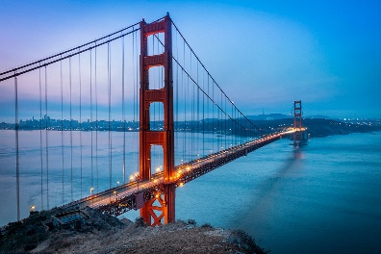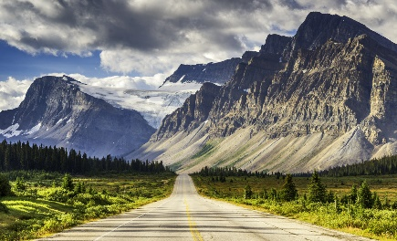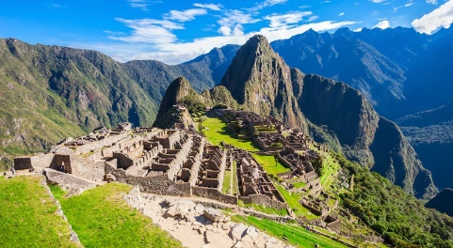

**I.Introduce:**

**AMERICAN TRAVEL**

Travel America - Travel the United States - a vast country that includes 50 states and a federal district. The capital of the United States is Washington DC located between North America and the largest city in the United States is New York. This vast country has many beautiful and poetic landscapes, and many interesting mysteries you should uncover.

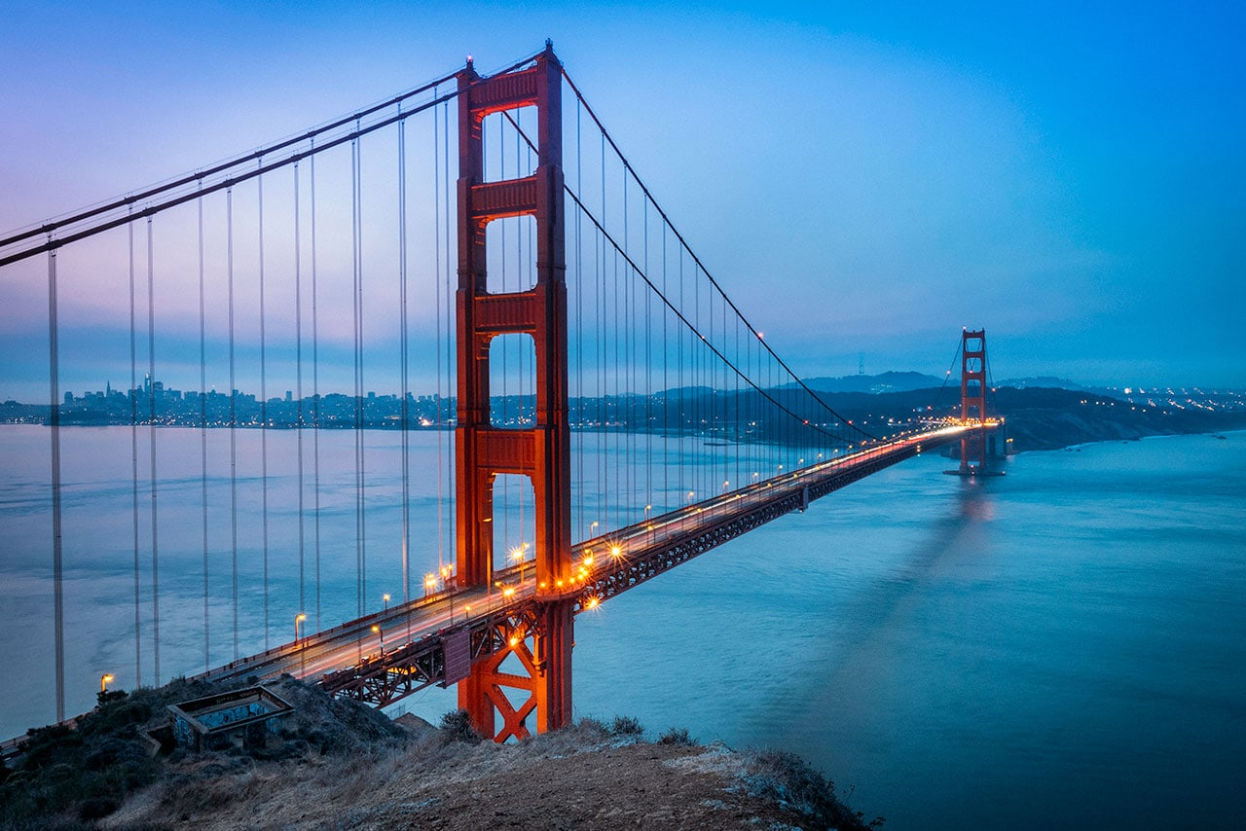

Not only attracted to the beautiful natural landscapes of a miniature world, the United States is also a place of convergence of diverse cultural identity, a major center of the world, so the United States also Dubbed the "Land of Heaven", where everyone in the world aspires to set foot once in a lifetime.

**II.** **Tour schedule:**

**1.Day 1:**

**HA NOI – TAIPEI – LOS ANGELES** _____________________________________________________________________

Morning: The delegation gathered at Tan Son Nhat / Noi Bai International Airport. Tour guides welcome and guide you to check-in procedures.

Group flight to Taipei (CI 782 11:00 - 15:15) and (CI 792 11:35 - 15:15).

Arriving in Taipei, the Group continued connecting flights to Los Angeles (CI 24 18:10 - 13:50).

Eating on the plane.

Rest on the plane.

Evening: Due to change the date, the delegation to Los Angeles the same day of departure. You do entry procedures. Pick up and take you to dinner and go to the hotel to rest.

Overnight at Hotel Huntington Beach 3 * or similar. _____________________________________________________________________ **2.Day 2:**

**LOS ANGELES –LAS VEGAS** _____________________________________________________________________

07:00 Breakfast at the hotel

08:00 After breakfast, depart for Las Vegas by car (about 5 hours)

You have the opportunity to shop at Tanger Outlet Factory, where you can buy branded items at surprisingly low prices.

Group lunch on the way and continue to Las Vegas

Doan to Las Vegas, check in hotel and rest.

19:00 Bus transfer for dinner.

20:00 Depart to visit the monumental, modern and largest architectural works in the world: New York - New York, MGM, Tropicana, Paris Paris, Mote Carlo, Treasure Island ...

You visit the Flower Garden in the Bellagio Hotel, visit the canals of the Venetian Hotel simulating the floating city of Venice, watching the bright lights can be seen from 40km away from the top of Luxur hotel ... .

Return to the hotel to rest.

Overnight at 3 * hotel or similar. _____________________________________________________________________

**3.Day 3:**

**LAS VEGAS – LOS ANGELES** _____________________________________________________________________

09:00 Check out hotel and depart for Los Angeles.

Noon to Los Angeles and lunch at the restaurant.

After lunch, the delegation enjoyed shopping for consumer goods at Walmart, Bestbuy, Macy, Cosco supermarkets.

Dinner at a local restaurant.

Overnight at hotel _____________________________________________________________________

**4.Day 4:**

**LOS ANGELES – SAN DIEGO** _____________________________________________________________________

06:30 Ring the alarm phone. Have breakfast at the hotel.

08:30 Depart for San Diego - The city with many Vietnamese people living in the 4th state of California.

To San Diego. You will admire the enchanting beauty of the most beautiful coastal city in the United States, this place is also the Naval Base of the United States. You will have the opportunity to visit the beautiful bridge across San Diego Bay, visit the splendid villa.

Visit delegation

• Coronado Bridge - 3407m long, beautiful across San Diego Bay, connecting downtown San Diego with Coronado Island.

• Visiting Coronado Hotel (Hotel Del Coronado) is a luxurious hotel located on the famous Coronado beach. This beach was sometimes voted the second best beach in the United States.

• Visit San Diego's Old Town (Old Town San Diego Historic State Park) - the first town of San Diego city, including San Diego's first public school, first court, first public office delivery company and today is Wells Fargo Bank, the oldest church, authentic Mexican restaurants and famous craft shops. In addition, visitors can also hardly ignore the craft stalls making clothes, scarves, stained glass, jewelry, precious stones, paintings typical of Mexican culture and leather crafts. Indian red.

12:30 Have lunch at the restaurant.

After lunch, the bus takes the shopping group.

Dinner at a local restaurant.

After dinner, take the delegation to the hotel to rest. _____________________________________________________________________ **5.Day 5:**

**LOS ANGELES – VIET NAM** _____________________________________________________________________

06:30 Ring the alarm phone. Have breakfast at the hotel.

Depart for Beverly Hill - where the splendid apartments of the stars in American entertainment and expensive fashion shops are located:

• Visit the Walk of Fame (Hollywood Walk of Fame) - a place to list the famous stars who have contributed greatly in the village of film, television, music of the United States.

• Visiting Kodak Theater - where the prestigious Oascar Awards ceremony takes place every year in the US film industry.

• Visit to the Chinese Theater - where premieres introduce Hollywood movies before launching.

• Universal Studios (OPTION): See Ghost House, Shrek 4-D Space Movie, Tram ride to see the whole scene of the film studio, the birthplace of the famous movie: Kingkong ... enjoy the "Under Water World" excerpt, Quy free guests join the game feeling: "Mummy Revenge, Waterfall, ...".

12:30 Have lunch at the restaurant for dinner

Car to go to airport for flight to Vietnam _____________________________________________________________________

**6.Day 6:**

**LOS ANGELES – TAIPEI** _____________________________________________________________________

You have meals on the plane _____________________________________________________________________

**7.Day 7:**

**TAIPEI - HA NOI** _____________________________________________________________________

Morning: Arrive in Taipei, the Group will continue connecting flights to Hanoi (CI 781 07:20 - 10:00) and (CI 791 08:25 - 10:35).

To Noi Bai Airport. You do entry procedures.

End program. Good bye and see you again. _____________________________________________________________________

**III.** **INCLUDED AND TERMS:**

SERVICE PRICE INCLUDES:

• Round-trip airfare: Ho Chi Minh City (Hanoi) - Los Angeles - Ho Chi Minh City (Hanoi)

• Security tax, aviation fuel and airport taxes (subject to change from time to time).

• 04 nights 3 * hotel, 2 people 1 room. Triple room will be arranged if the number of individual guests or guests agree to pay more to stay in a single room. (To ensure the room rate does not increase and convenience for dining, most hotels are far from the center from 10-25km)

• Meals as in the program details (lunch set, afternoon 15USD / meal).

• Transportation to visit the program in the US. Time to use the car 12 hours / day.

• Experienced, enthusiastic Vietnamese tour guide during the tour.

• Gifts: dedicated travel bags, hats, passport pouches.

• Mineral water: 02 bottles / person / day.

• International travel insurance (1,500,000,000 VND).

SERVICE PRICES DO NOT INCLUDE:

• Passport: valid for more than 06 months from the end of the trip.

• US visa fee.

• Entrance fees: Universal Studio

• Personal expenses, excess baggage, telephone, laundry, sightseeing outside the program.

• American domestic baggage charges (if any).

• Single room surcharge (if applicable).

• Fostering for guides and local drivers (8USD / person / day X 7 days tour).

• The costs are not mentioned in the included section.