**Tour of East-West Canada 4 Days 3 Nights**

*Attention:*

-Departure: Ha Noi.

-Time: 4 days 3 nights.

-Vehicle: planes.

-Price: 29190000VND.

-Image:

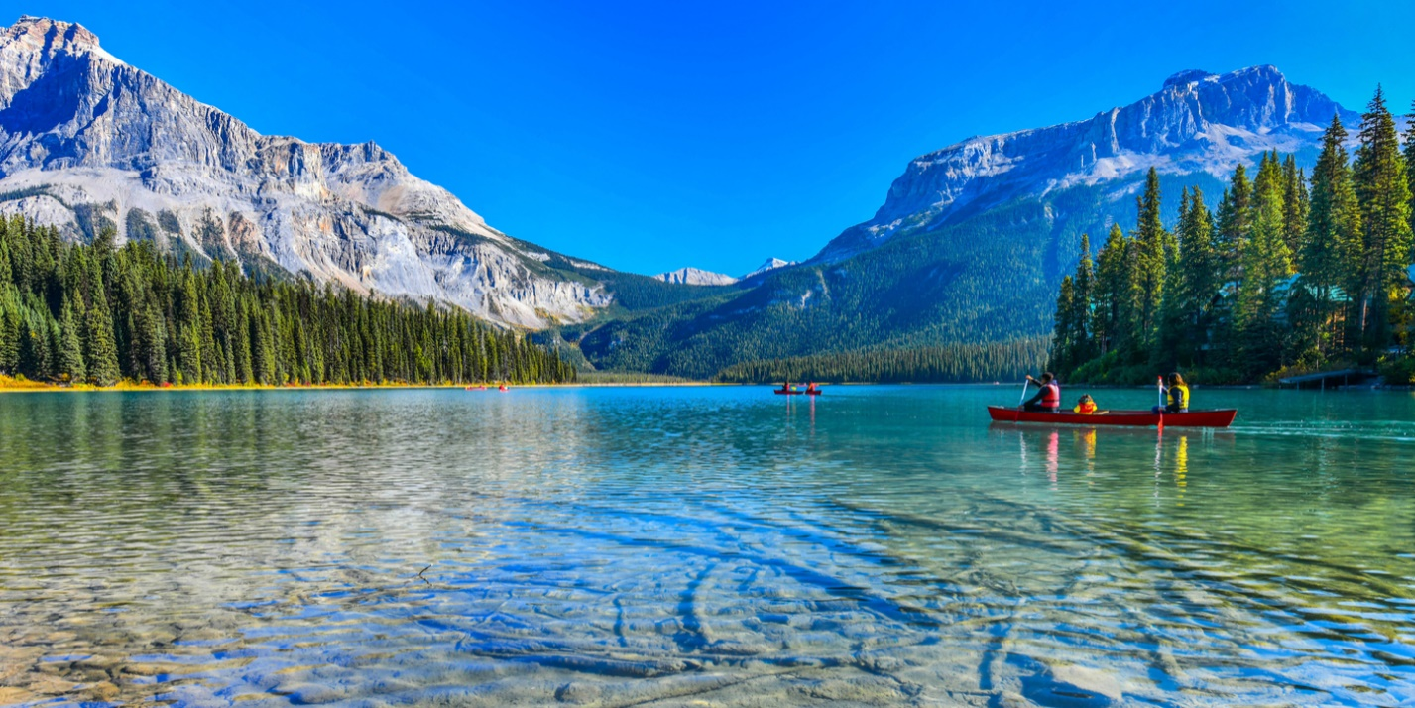

**I.Introduce:**

Canada is famous for the natural beauty of the mountains, glaciers, clear lakes nestled in the jungle. The country of maple leaves also attracts visitors by the friendliness, safety, and cleanliness of a multicultural country. Therefore, Canada has always been considered one of the most livable countries in the world. Very few countries own a large number of world natural wonders like Canada. Including: Canadian Rocky Mountain Parks, Dinosaur Provincial Park, Nahanni National Park Reserve, Cabot Trail, Niagara Falls, Scenic Drives ...

**II.** **Tour schedule:**

**1.Day 1:**

**VIET NAM – TAIPEI – TORONTO** _____________________________________________________________________

The delegation gathered at Noi Bai International Airport / Tan Son Nhat.

Tour guides welcome and guide you to check-in procedures.

Group flight to Taipei (BR 398 12:05 - 15:15).

Arriving in Taipei, the Group continued connecting flights to Toronto (BR 036 19:40 - 21:55).

Flight takes off. You eat and rest on the plane

By crossing the route to change the date, the delegation to Toronto on the same day of departure from Vietnam. You do entry procedures and collect luggage.

Have dinner and check in hotel to rest.

Overnight in Toronto. _____________________________________________________________________

**2.Day 2:**

**TORONTO – NIAGARA FALLS – TORONTO** _____________________________________________________________________

Đến Toronto. Quý khách về khách sạn nghỉ ngơi

06:30   Chuông điện thoại báo thức.

            Ăn sáng tại Khách sạn.

08:30   Đoàn khởi hành bắt đầu chương trình tham quan được trông đợi nhất của mọi du khách khi đến Canada. Đòan sẽ khởi hành đi tham quan thác nước Niagara hùng vĩ (phía bờ Canada).

Thác nước Niagara là thác nước nằm giữa HoaKỳ và Canada, đứng từ bờ Toronto quý sẽ cảm nhận hết vẽ đẹp hùng vĩ mà thiên nhiên bang tặng cho con người. Quý khách sẽ đi thuyền vào lòng thác để thưởng thức hết vẻ hòanh tráng của một trong những thác nước được xếp vào 10 thác nước hùng vĩ và đẹp nhất thế giới. Quý khách chụp hình lưu niệm với thác Niagara, thác Móng Ngựa, tách Dải Khăn Cô Dâu, thác Người Mỹ, … và cảm nhận sự hùng vĩ của khối nước khổng lồ đổ từ trên cao xuống tạo thành những lớp bụi mù dày đặc khi ngồi du thuyền vào lòng thác.

12:00   Đoàn dùng bữa trưa tại nhà hàng địa phương.

Sau bữa trưa, đoàn tham quan:

* Tham quan trang trại trồng nho, xem quy trình làm rượu vang tại địa phương và thưởng thức đặc sản rượu tuyết Canada.
* Mua sắm tại khu Outlet Collection Niagara.

19:00  Đoàn ăn tối tại nhà hàng. Về khách sạn nghỉ ngơi.

_____________________________________________________________________

**3.Day 3:**

**TORONTO** _____________________________________________________________________

07:00 Have breakfast at the hotel

Depart to visit: CN Tower: The symbol of the city of Toronto. Delegation has the opportunity to see the whole city in a reserved location.

Photographed outside the Sky Dome

University of Toronto - the largest school in Canada where 9 Nobel Laureates have been trained

Queen’s Quay Harbourfront - Queen's Harbor.

Visit City Square built over 130 years ago with the favorite architecture of Napoleon the Third King

Photographed outside the old and new City Hall

group lunch at local restaurant.

Bus transfer shopping at the largest shopping center in Toronto - Toronto's Eaton Center.

Dinner, return to the hotel to rest. _____________________________________________________________________

**4.Day 4:**

**TORONTO – THOUSAND ISLAND – OTTAWA – VIET NAM** _____________________________________________________________________

06:30 Have breakfast at the hotel.

07:30 Check out procedures, depart to visit thousands of islands. Upon arrival, take a cruise on the Saint Lawrence River to admire the wonders of the Thousand Islands with more than 1,000 islands, large and small, and many castles of the old nobility built like:

Millionaires Row of millionaires, flanked by magnificent castles of billionaires.

Boldt Castle - The most famous Boldt castle here is an island shaped like a heart and named Heart Island.

Zavikon Island - Zavikon Island. The most photographed island, including two tiny islands located close to each other, near Rockport village. The larger island belongs to Canada, the smaller island belongs to the United States. The tiny pedestrian bridge connecting the two islands is considered the shortest international bridge in the world.

13:00 Have lunch, then depart for Ottawa. Upon arrival, have dinner, return to the hotel to rest. Overnight in Ottawa.

You rest and eat on the plane (BR 009 02:00 - 05:20).

You do entry procedures.

End program. Good bye and see you again.

_____________________________________________________________________

**III.** **INCLUDED AND TERMS:**

INCLUDE:

Round-trip international flight ticket: Saigon (Hanoi) Toronto // Vancouver - Saigon (Hanoi)

Domestic ticket Montreal - Vancouver.

Security taxes, aviation gasoline and airport taxes.

3-star hotel standard double room. Triple room will be arranged if the number of guests is odd. The actual time in Canada is 9 days / 8 nights.

Meals program.

Visiting shuttle program.

Fee to visit the points under the program: ferry, Butchart flower garden, ship 1000 islands, Niagara Falls, wineries, CN tower.

Vietnamese tour guide according to the program.

Gifts: Passport leather, Hats, Travel backpack.

Mineral water: 02 bottles / person / day.

AAA International Travel Insurance.

 NOT INCLUDED:

Passport: valid for more than 6 months from the end of the trip.

Canadian visa application fee (150USD) and translation costs (40USD).

Domestic baggage (if applicable).

Personal expenses, excess baggage, telephone, laundry, sightseeing outside the program.

Surcharge single room (if any).

Fostering for guides and local drivers (10USD / person / day).

The costs are not mentioned in the included section.

NOTE:

Please carefully review the program, tour prices, including and not included are listed in the program details.

Tour price is based on the number of groups of guests in the price list. In case the number of passengers departs less than 07 guests, Vietmytourist and the customer will agree on the departure date or the customer will pay an additional fee to depart on the right date.

The number of days may vary, but the actual number of nights in Canada remains the same.

The program can change the order to suit the actual situation of the delegation but the total number of attractions does not change.

Aviation used: Eva Airlines or China Airlines (or equivalent).

Viet My Tourist is entitled to change many different airlines for the trip: CI, KE, AC ...

Guests not on schedule of the delegation will be charged the difference of air tickets.

The decision on whether or not to enter Canada is made by immigration officials who decide on a case by case basis and may even request an interview for information.

In case you are denied a visa, you will be charged USD 145 visa fee + USD 40 translation fee, notarized documents, invitations.