**Tour Phuong Hoang Co Tran - Truong Gia Gioi - Fly straight - Celebrate Tet 2020**

*Attention:*

-Departure point: Hanoi.

-Time: 4 days 3 nights.

-Media: planes.

-Tour price: 10490000đ.

-Images:

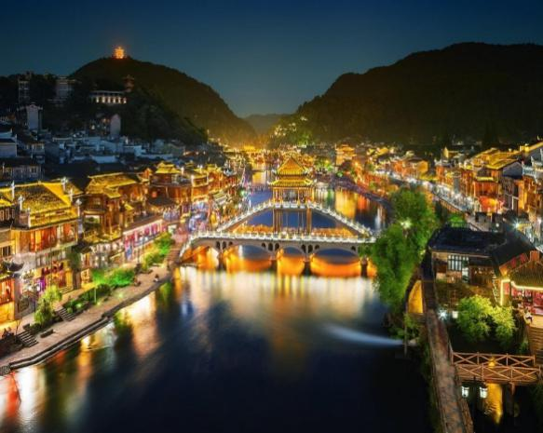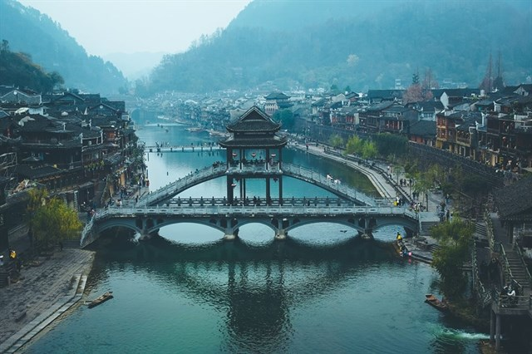

**I.Introduce:**

**PHUONG QUOC TRAVEL - TRUONG GIA GIO**

**Zhangjiajie is located to the northwest of Hunan Province, between the raised area of the highlands of Yunnan and Guizhou provinces. It has Truong Gia Gioi national park, Sach Khe valley in the nature reserve, Vu Lang Nguyen landscape area ... Truong Gia Gioi is like a fairy under the world with more than 3,000 stone columns and cliffs shaped. Natural enemies are created from sandstone, with many towering columns taller than 300m. That's why this place was honored to be inspired to be filmed in the world famous 3D blockbuster AVATAR ...**

Zhangjiajie

Heaven Gate Tianmen Mountain

Ancient phoenix at night

**Phuong Hoang is the name of an ancient town belonging to the Tho Gia, Mieu Tuong Tay in the western province of Hunan, about 53 km from Cat Thu (Can Chau) and about 280 km from Truong Gia Gioi town. Phuong Hoang town is the economic, political and social center of the whole region. Located next to the Da Giang River ... the ancient citadel still preserves many citadels, streets, old houses, jewelry, temples, temples. With 1,300 years old - Phuong Hoang is one of the museums living on ethnic culture.**

**Highlights of the program:**

- Direct flight Hanoi - Truong Gia Gioi, no need to fly to Truong Sa as usual programs.

- No longer have to travel nearly 500 km from Truong Sa to Phuong Hoang Co Tran as usual programs

- No longer have to travel nearly 400km long distance from Zhangjiajie to Changsha as normal programs.

- Save flight time, travel time, to allow plenty of time to visit the attractive routes of Phuong Hoang Co Tran - Truong Gia Gioi.

**II. INCLUDE AND TERMS:**

**PACKAGE COSTS FOR 01 CUSTOMER**

|  |  |
| --- | --- |
| DEPARTURE DAY | PRICE |
| 28/12/2018 | 10.490.000đ |
| 8/2/2019 (4th of Lunar New Year) | 10.990.000đ |

(The price applies for groups of retail guests with 15 guests or more)

**Rates include:**

Hanoi - Truong Gia Gioi plane round trip.

Central hotel standard 4 * Chinese standard. (2 people / double room)

Visa on entry to China (union visa)

Eat 3 meals per day according to the program (RMB 30 / meal)

The main meal is 8 dishes + 1 soup + drinks.

Condition shuttle bus: 10-15 people arrange 19 -26 seats, 16-20 people arrange 26-35 seats

Cost of visiting the first door

Cost of eco-car in the park + cable car in the program

Boat trip to Bao Phong Lake

Easy, experienced Vietnamese guide throughout the tour.

300,000 VND indemnity insurance. Guests 75 years of age or older do not participate in this insurance

Each person a day, a bottle of water on the bus to visit

**Not included:**

- Personal expenses, passport fees, drinks, telephone costs, hotel laundry, VAT.

- Cost of single room

- Tips for drivers and guides are: USD 5 / person / day (USD 25 / person / trip)

- Tickets to the points not mentioned in the program

**Note:**

**Visa procedures include:**

**+ Passport valid for more than 6 months from the end of the tour**

**+ 02 4 x6 photos taken on a white background to apply for a VISA.**

**- Procedures completed before 10 working days (For Visa & air ticket).**

**- Children under 12 years old (under 1.2m high): pay 90% of the tour price, sleep with adults.**

**- Children 12 years and older or children over 1.2m tall: pay by adults.**

**This quote applies to the program that has a mandatory shopping point including: Ngoc Store, silk shop and traditional Chinese store.**