**Tour Shanghai - Hangzhou - Suzhou - Beijing - 7 Days 6 Nights**

*Attention:*

-Departure point: Hanoi.

-Time: 7 days 6 nights.

-Media: aircraft.

-Tour price: 16990000đ.

-Images:

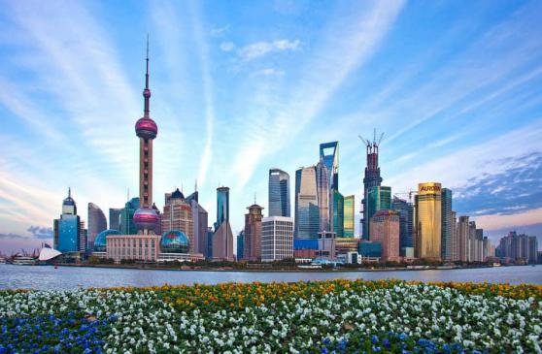 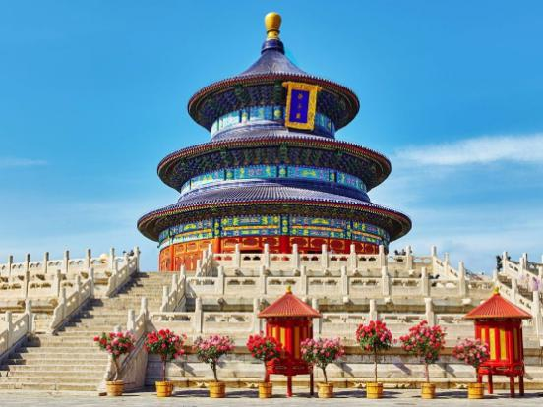 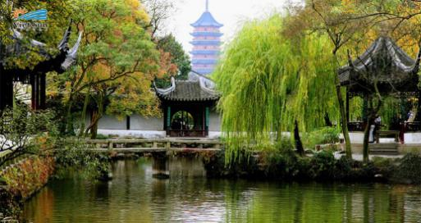 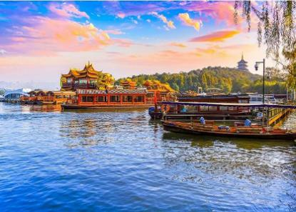

**I.Introduce:**

**EXPLORE SHANGHAI TOURIST - HANGZHOU - EUROPEAN - BEIJING**

**A journey with 4 destinations: Beijing - Shanghai - Hangzhou - Suzhou will take you to Beijing, to the world famous historic and cultural city. It preserves quite a lot of landscapes, ancient landscapes, quintessence of Chinese art and culture. You will admire the majestic Great Wall, coming to Di Hoa Vien the summer palace of kings ...**

**Beijing is the last capital in the four ancient Chinese cities. The city is famous for its luxurious palaces, temples, gardens, tombs, walls and gates, and the art treasures and universities have turned Beijing into a cultural center and art in China.**

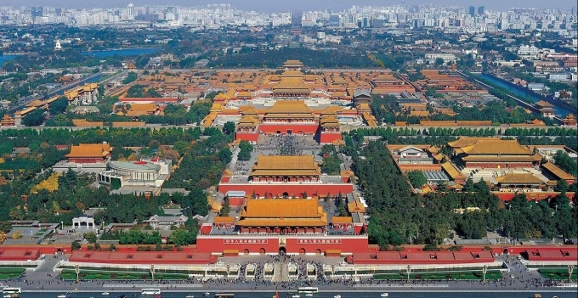

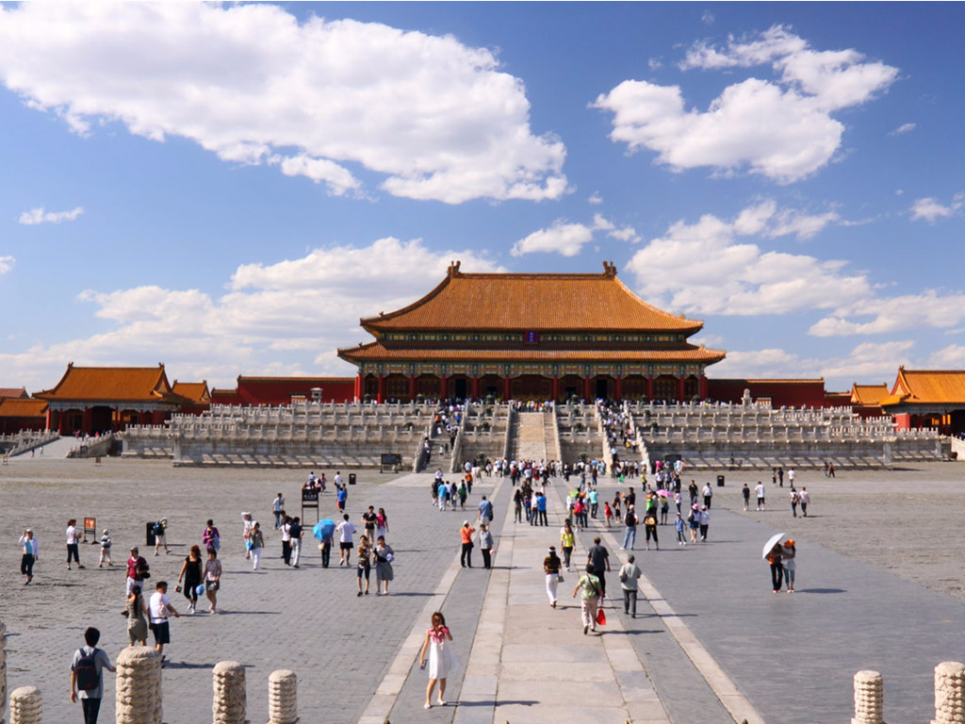

Shanghai - China's largest economic center, is an internationalized modernized city and a famous historical and cultural city. Many historic sites along with the "Ngoai Than architectural complex" have become the epitome of modern-day China; is the convergence of the achievements of China's open-door reform and economic development with open economic zones, modern agriculture, industrial parks and iconic architecture. one of the highest in Asia and in the world. 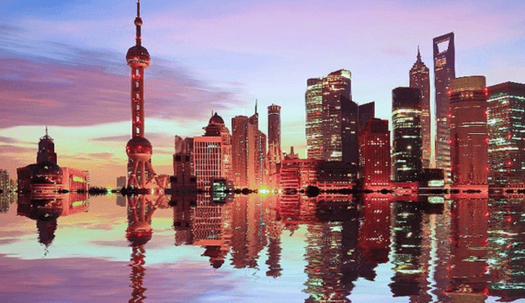

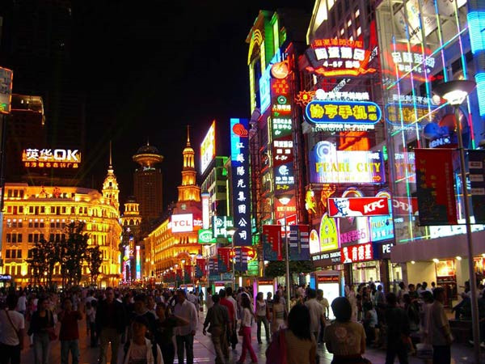

Hangzhou - the capital of Zhejiang province, is one of China's ten most popular tourist destinations - has never disappointed visitors. The charming country, poetic scenery, Hangzhou city is like a huge, vivid picture, which both brings the beauty of the beauty of the female celebrities, and also hides the delicate beauty of the women of the country. Jiangnan.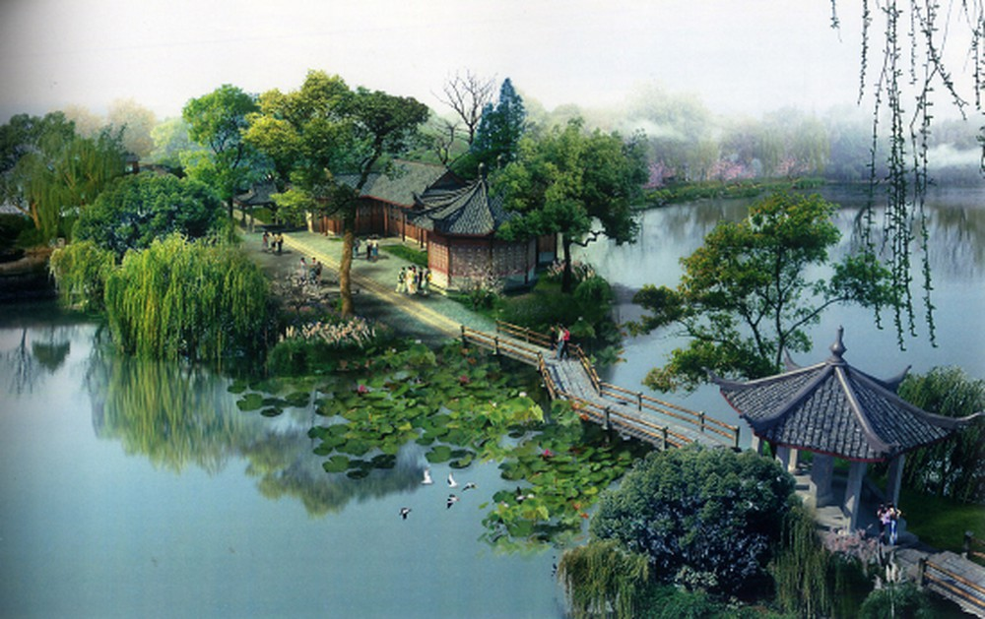

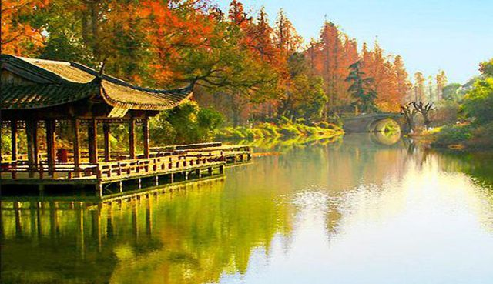

**Suzhou is located in Jiangsu province - China, about 30 minutes from Shanghai by high speed train, once belonged to the poetic and rich Jiangnan land, has gone into thousands of poems. Many beauties in Chinese history are told that living in this magical land has such beauty. Today, Suzhou captivates visitors with its ancient, peaceful and ancient beauty with many hundreds of years old temples, gardens, canals, stone bridges or ancient towns.**

**II.Tour schedule:**

**1.Day 1:**

**HANOI - SHANGHAI (EATING ON AIRPLANE, DINNER)** _____________________________________________________________________

07h00: Car and HDV pick you up at the meeting point to take you to Noi Bai International Airport for flight VN530 at 10h20 to Shanghai.

14h25: Go to Shanghai airport, visit Nam Pho Bridge, Oriental TV Tower of Minh Chau - the highest tower in Asia ranked 3rd in the world (visit outside), the architecture of the new town of Pudong high rise buildings. You continue to visit the Bund, visit the pearl shop.

Dinner at the restaurant. You are free to visit the city or you can join the Yacht Program on the Huangpu River to admire the beautiful banks of the West - East of Shanghai under the colorful lights of high-rise buildings along 2 sides. River or take the subway to explore Shanghai city at night (expenses excluded). _____________________________________________________________________

**2.Day 2:**

**SHANGHAI - HANGZHOU (Breakfast, Lunch, Dinner)** _____________________________________________________________________

After breakfast, you will visit the Jade Buddha Temple where two rare white Buddha statues are located, this modern pagoda and monastery is a spiritual oasis in the heart of Shanghai. Always skeptical of incense sticks to worship glass, Temple of the Emerald Buddha is the most sacred temple in Shanghai. Visiting Thanh Hoang Mieu Ancient Town - Today, the Imperial Palace is both an old town and one of the two most famous shopping streets in Shanghai. Here, after visiting the old town, visitors can comfortably walk, watch, shop for souvenir items.

You leave Shanghai to Hangzhou.

To Hangzhou, you have dinner at the restaurant.

Overnight at hotel. _____________________________________________________________________

**3.Day 3:**

**HANGZHOU - SUZHOU (Breakfast, Lunch, Dinner)** _____________________________________________________________________

After breakfast, take a cruise to visit Tay Ho - a famous tourist complex in Hangzhou with Tam Dan An Nguyet, To De, and Bach De.

Lunch at local restaurant. In the afternoon, you will visit Phi Phi Temple and enjoy the famous Chinese tea art: Longjing Tea, Chrysanthemum Tea, etc.

You leave Hangzhou to Suzhou.

Dinner at the restaurant. Overnight at hotel _____________________________________________________________________

**4.Day 4:**

**TO CHAU - BEIJING (Breakfast, Lunch, Dinner)** _____________________________________________________________________

After breakfast, you will visit the Lion Forest - one of the typical forestry parks of the Jiangnan region, famous in Chinese history, learn about silk culture, Han Son Tu - the ancient temple is located on the wharf The famous Phong Kieu was built over 1,500 years ago, visiting the largest Silk Factory in Suzhou.

Lunch at the restaurant. You get on the train to the high speed train departs for Beijing (05 hours). To Beijing. Car and guide pick you up to dinner at the restaurant. You see the special Circus show of Chinese artists. _____________________________________________________________________

**5.Day 5:**

**BEIJING (Breakfast, Lunch, Dinner)** _____________________________________________________________________

After breakfast, you visit the Great Wall - the only wonder you can see from the moon - You experience the interesting feeling when you step by step on this masterpiece road. Tourists visit the marble shop and the largest jade processing workshop in Beijing, learn about valuable medicinal herbs in Dong Nhan Duong's long-standing heirloom pharmacy.

Lunch at local restaurant.

Afternoon: Visit Thap Tam Lang: Truong Lang - a tomb of the Ming dynasty, excavated in 1958 by the Chinese Government and People, witnessing the artistic masterpieces of Chinese people's sculpture.

Dinner at the restaurant. Overnight in Beijing _____________________________________________________________________

**6.Day6:**

**BEIJING (Breakfast, Lunch, Dinner)** _____________________________________________________________________

In the morning: After breakfast, take the car to visit Tiananmen Square - the political center of China: the Great Hall, the Monument of the Heroes of the Martyrs, the Chairman Mao Memorial House, the Old Palace (Forbidden City) Thành) - Political symbol of the country of China, with 9999 the most magnificent and magnificent electric space in the world, the reign of the two dynasties of Minh Thanh and Đức Thắng.

Lunch at the restaurant. In the afternoon, you visit Di Hoa Vien - Summer Palace of the kings of the Ming and Thanh dynasties with Emperor Tu Hy, Dang Huong Tower, Ho Kunming, Van Tho Duong. You visit Ti Huu store, Ngoc Trai shop,

Dinner at restaurant and overnight at the hotel. _____________________________________________________________________

**7.Day 7:**

**BEIJING - HANOI (BREAKFAST, LUNCH)** _____________________________________________________________________

Morning: After breakfast, you are free to shop at Vuong Phu Tinh,

Lunch at the restaurant. After that, the car takes you to the airport, flight VN513 (15h30 -18h20) to Hanoi

18h20 Arrive at Noi Bai airport, car pick you up to rendezvous in the city.

End program. _____________________________________________________________________

**III.INCLUDED AND TERMS:**

**SERVICE INCLUDES:**

- Air tickets under the program Hanoi-Shanghai / Beijing - Hanoi.

- Visa to China (Visa Union)

- High-speed train ticket: Suzhou - Beijing

- The hotel according to the 4-star standard program, 2 people / room at the hotel, odd guests staying 3.

- Eat meals according to the program, the rate of 30 RMB / 1 customer / 1 meal

- Shuttle cars according to the program.

- Tickets to the attractions according to the program.

- Car drinking water 1 bottle / person / day, cold towels.

- Travel insurance with compensation of 10,000 usd.

**SERVICE NOT INCLUDED:**

- Tips for drivers and tour guide, common standard 5 USD / person / day (Total 35 USD / person)

- Personal expenses such as laundry drinks, Beverages at meals

- Other expenses outside the program.

- Cost of VAT Invoice

**NOTE:**

Price for children sharing a bed with parents, if you require separate sleeping for children please pay 100% of the tour.

The price is applicable to customers from 12 to 69 years of age, from 70 years old and above will pay the difference for premium premiums, from 75 years and older requires a full health certificate to go. foreign travel issued by a competent health authority and accompanied by a healthy relative under the age of 60 years.

Price may change as aviation increases fuel surcharge and visa fees change

Please do not ignore the shopping destinations specified in the program.

The passport must be in use for more than 6 months (from the date of departure)

The program may change the order according to the actual situation, but still be sure to go to the full attractions

You must not leave the union at your own will. If you have a family member in the host country who wants to follow the program, please contact the travel company before departure.

In objective cases such as terrorism, natural disasters ... or due to incidents, changes in schedules of public transport means such as aircraft, trains ... the Company will reserve the right to change. change the route at any time for the convenience and safety of customers and will not be responsible for compensation for damages incurred.

Note:

- Visa procedures include:

+ The latest passport is valid for 6 months from the end of the tour

+ 02 4x6 photos taken on a white background to apply for a visa. (Clear photos, no glasses, dark shirts, photos must clearly show the face including the forehead and 2 ears)

+ Information of countries traveled within 3 years and length of stay in that country

- Procedures completed before 15 working days (To get a Visa & issue air tickets).

- Children under 12 years old (under 1.2m high): pay 90% of the tour price, sleep with adults.

- Children 12 years and older or children over 1.2m tall: pay by adults.