**Japan Tour - Tokyo - Narita - MT.Fuji - Kawaguchi**

*Attention:*

-Departure: Hanoi.

-Time: 6 days 5 nights.

-Vehicle: car.

-Tour price: 37900000đ.

-Images:

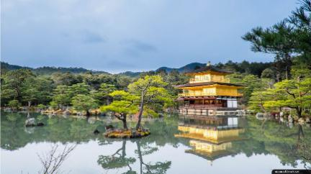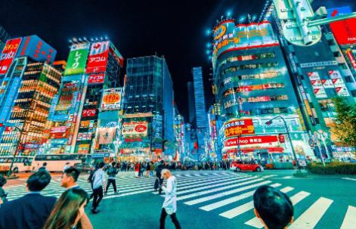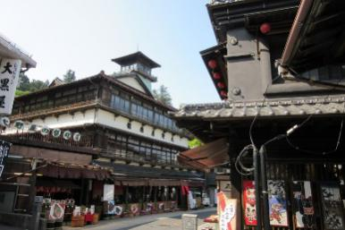

**I.Introduce:**

**JAPAN TOURISM**

**Japan is famous as one of the most beautiful places in the world, with its four-season scenery that captures the hearts of people. Spring with cherry blossoms from the north to the south, the greenery in summer and the temperature is not too hot, the autumn is characterized by red maple leaves, winter with white snow. Coming to the country of the rising sun, visitors can also admire the beauty of the ancient temples carefully designed meticulously, preserving countless historical values. Coming to this beautiful Japan, you will not only be attracted by the pure and traditional scenery but also overwhelmed by the bustle and prosperity of a modern Japan with entertainment areas, shopping centers. big bustling business day and night. Let's explore this beautiful Japan with Vietcenter.**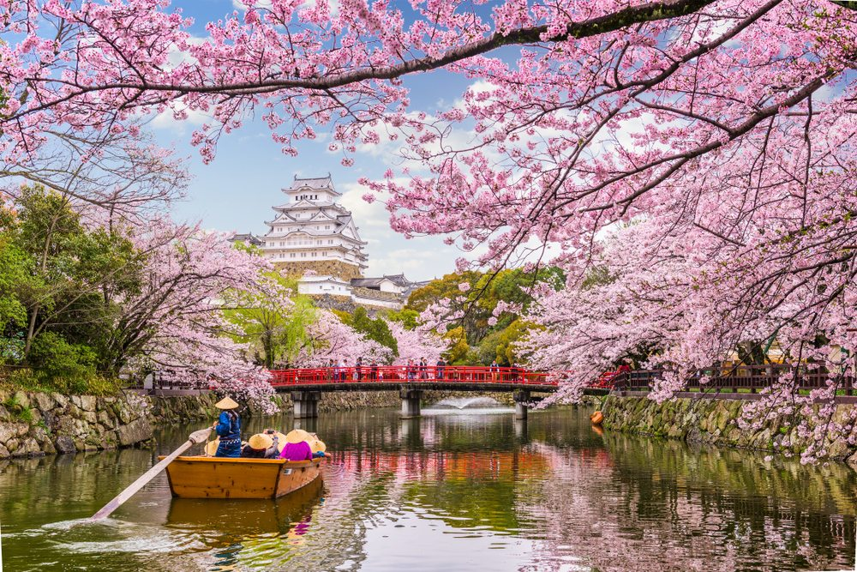 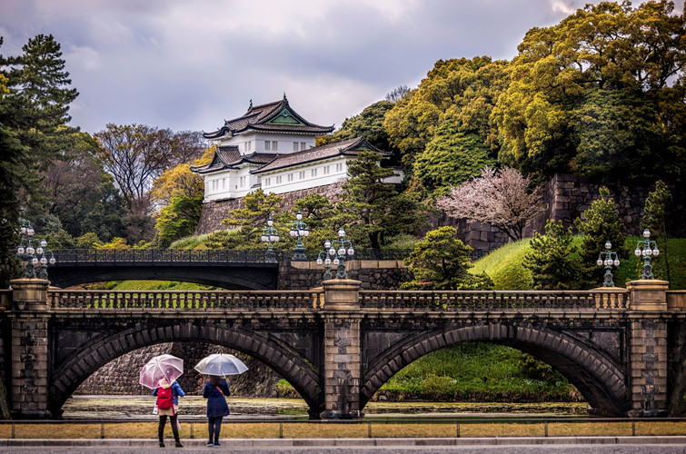

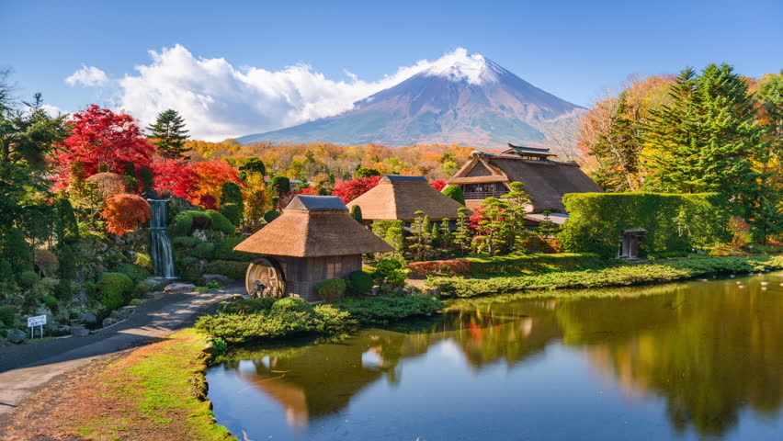 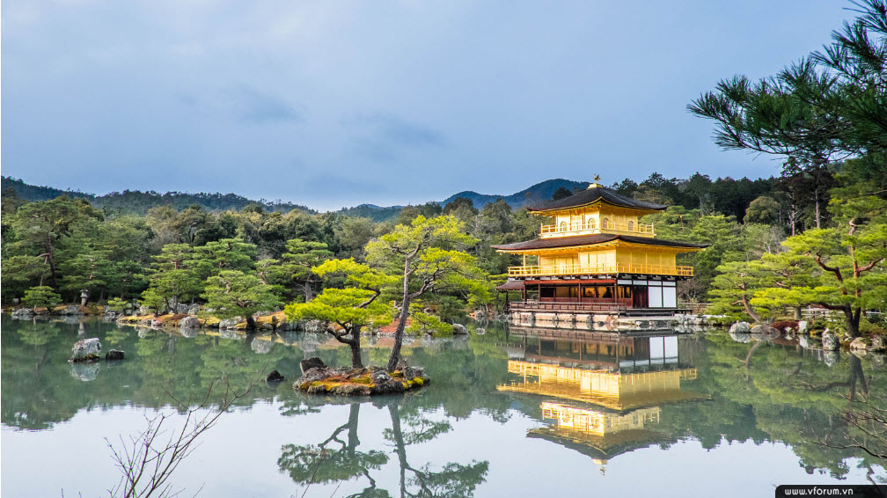

**II.Tour schedule:**

**1.Day 1:**

**HaNoI – TOKYO (Snacks on board)**

_____________________________________________________________________

20h00: Customer gathered at the meeting place in the city, car and HDV welcomed the delegation to the airport to make procedures for flight VN310 to Tokyo.

Overnight & snack on board. _____________________________________________________________________

**2.Day 2:**

**NARITA - TOKYO (LUNCH / Dinner)**

_____________________________________________________________________

Estimated 07:00 local time, aircraft landing at Narita Airport - Japan. Union procedures for entry and luggage. Pick up and departure to visit:

Asakusa Kannon Temple - The oldest temple in Tokyo, built in 645 during the Edo period. This is the place to worship the Goddess of Mercy, also the center of the great annual festivals in Japan. You can visit and shop in the Nakamise neighborhood next to the temple

Freedom to visit and shop on the neighborhood shopping Nakamise souvenirs.

Sightseeing and taking photos outside the Tokyo Skytree TV tower from the Sumida River (Excluding the tower entrance fee).

Lunch: Have lunch at local restaurant. After lunch, depart to visit:

Imperial Palace "Imperial Place": The path to the palace has hundreds of cherry blossom trees (Outside photography)

Ueno Park - one of the most famous cherry blossom viewing spots in Japan. The park has more than 1,000 cherry blossom trees in full bloom during March and April, attracting many Japanese and international tourists.

Freedom to visit and shop at shopping centers: Akihabara - Akkey One, DFS (Lotte), Ginza ...

Evening: Have dinner at the hotel. After dinner, the group freely explore Tokyo at night. Overnight at 3 * hotel in Tokyo _____________________________________________________________________

**3.Day 3:**

**TOKYO – FUJI- KAWAGUCHI (Breakfast / Lunch / Dinner)** _____________________________________________________________________

Morning: Have breakfast at the hotel. Check procedures. Car and HDV welcome the delegation to move to the Mount Fuji area with the journey experience by 1 Shinkansen Speedboat - Japanese pride.

On the way, visit the Fruit Garden, enjoy and buy as gifts for relatives of seasonal

Noon: Group lunch at local restaurant. After lunch, depart to visit:

Mount Fuji - the symbol of Japan is the active volcano peak and the highest in Japan - 3776m high and is covered by 5 lakes surrounding Mount Fuji. You visit the fifth station if the weather is good (in case of bad weather, you will visit and take pictures at the foot of the mountain or Mount Fuji information center).

Noon: Group lunch at local restaurant. After lunch, depart to visit:

Oshino Hakkai– The peaceful ancient village at the foot of Mount Fuji with many traditional Japanese architectural features. Coming to Oshino, visitors can not only immerse themselves in the peaceful atmosphere here, but also can see the whole beautiful Mount Fuji. In addition, Oshino is also famous for its special lake with the bottom structure made of lava mainly due to geological tectonic processes and nourished by the melting snow and ice from Mount Fuji.

Freedom to visit and shop at Gotemba Outlet.

Evening: Have dinner at local restaurant. Guest check in procedures and rest. Osen bat at the hotel. Overnight at 3 * hotel in Kawaguchi. _____________________________________________________________________

**4.Day 4:**

**KAWAGUCHI – OWAKUDANI – TOYOHASHI** _____________________________________________________________________

Morning: Have breakfast at the hotel. Check-out procedures, car and guide pick you up to visit:

Owakudani Valley - a vestige of an active crater. Here, you have the opportunity to enjoy the kind of boiled egg from the hot water from the volcanic veins, the shell is black and slightly smelling sulfur (self-sufficient cost). Legend has it that eating 1 fruit can increase your life span to 7 years.

Have lunch at the restaurant.

Delegation sat on Lake Ashi, enjoying the poetic scenery of one of the five most beautiful lakes in the area.

Next, the bus will take you to Toyohashi. On arrival, have dinner and rest at 3 * hotel in Toyohashi. _____________________________________________________________________

**5.Day 5:**

**TOYOHASHI – KYOTO- OSAKA (Breakfast / Lunch / Dinner)** _____________________________________________________________________

After breakfast at the hotel, the delegation check out. Car and HDV welcome the delegation to depart the ancient capital of Kyoto. Depart to visit:

Thuy Thanh - Kyzomizudera - one of the most sacred temples of the country of cherry blossoms with unique architecture entirely of wood, located on the high ground of Higashiyama hill. The main building is designed to look like a national treasure, supported by 139 pillars 15m high. Kiyomizu Temple was recognized by UNESCO as a Cultural Heritage in 1994.

Nishijin textile center - witness the artisans weaving fabrics to make this traditional costume, taking photos with the shy Japanese girls in Japanese Kimono traditional clothes and Enjoy the Kimono show of the center's models

Watch the Kimono show, traditional costume show of Japan.

Lunch at local restaurant, then you move back to Osaka. Depart to visit:

Take a tour of the famous Osaka Castle - ancient and majestic, free to take photos outside.

Freedom to explore and shop at the bustling commercial area of Shinshaibashi - Nippon Bashi

Evening: Have dinner at local restaurant. Freedom to explore Osaka at night.

Overnight at 3 * hotel near Kansai-Osaka airport. _____________________________________________________________________

**6.Day 6:**

**OSAKA – HA Noi** _____________________________________________________________________

**Morning: Have breakfast at the hotel, check out, transfer to Kansai International Airport for flight VN331 at. The plane landed at Noi Bai airport, the car and the tour guide returned to the original point. End program. Farewell and see you again in the next journey. _____________________________________________________________________**

**III.INCLUDED AND TERMS:**

**Service includes:**

* Return flights Hanoi - Narita // Osaka - Hanoi (Vietnam Airlines).
* 40kg + 7kg checked baggage hand luggage / passenger / one way;
* Japanese entry visa under the program.
* Standard hotel 3 * (2 people per room, triple room will be arranged when needed).
* International travel insurance. Maximum compensation level is VND 1,200,000,000 / case (not applicable to people aged 75 and above)
* Eat meals according to the program (Lunch: 1,500JPY - dinner: 2,000JPY).
* Shuttle and sightseeing fees according to the program.
* Enthusiastic Vietnamese guides, experience throughout the route.
* Drinking water 01 bottle / person / day.
* Donate fruit

**The service does not include:**

* The passport is valid for 6 months from the date of departure
* Excess baggage charge and other personal expenses
* Training fee for local guide 7 US $ / person / day.
* Surcharge single room peak season 6,000 JPY / night / person.

**Price for children:**

* Under 2 years old: 20% of tour price (sharing a bed with an adult)
* From 2 - under 08 years: 80% of the tour price for adults (sharing a bed with an adult). An adult can only accompany 1 child. In case of 2 accompanying children, pay for 1 child as an adult to get an extra bed.
* From 8 years old and up: pay as adult, own bed.

**Attention:**Program may vary depending on actual conditions and flight itinerary