**Tour 5 Countries France - Lux - Germany - Belgium - Netherlands**

*Attention:*

-Departure point: Hanoi.

-Time: 9 days and 8 nights.

-Media: aircraft.

-Price: 49490000VND

-Picture:

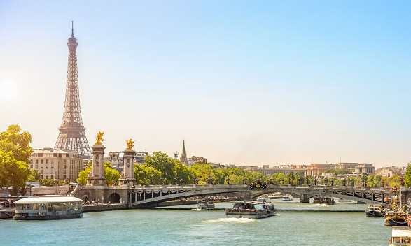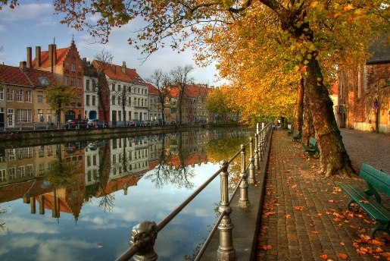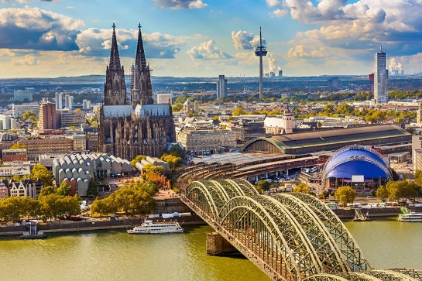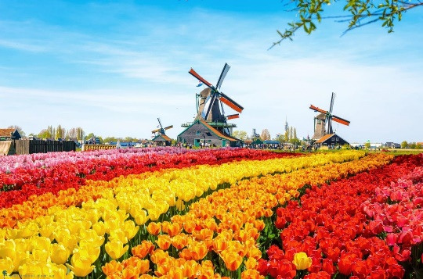

**I.Introduce:**

**Travel Europe: France - Lux - Germany - Belgium - Netherlands**

A journey to explore Europe in 5 countries, you will be moved by the mysterious beauty, diversity of buildings that are both ancient and modern and add admiration for the talented people who created them. You will "burn" a lot of movies of windmills, tulips and peaceful atmosphere of the Dutch countryside. The feeling would be great if cruising on the romantic Seine. Do not forget to buy a ticket to the last floor of the Eiffel Tower, admire the panoramic view of the fashion capital of Paris and catch the pictures of kisses on the Eiffel Tower ...

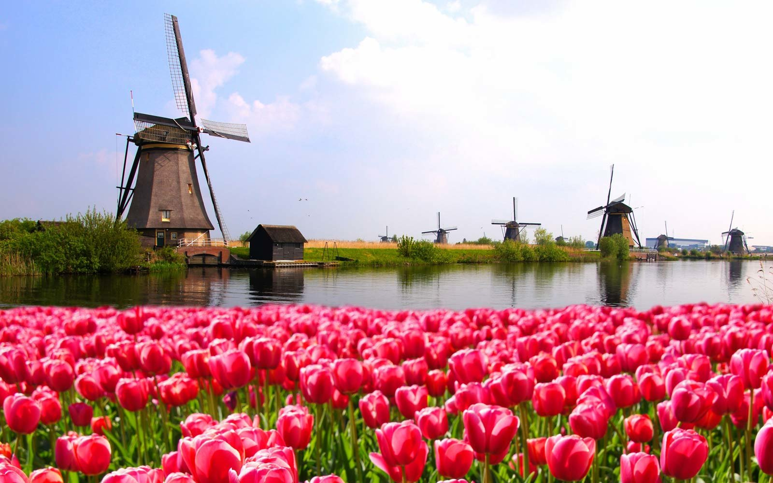

**Highlights:**

**• Support Visa procedures for professional and dedicated customers**

**• 99% visa guarantee rate**

**• Experience Asia's best 5 * airline: CZ (23kg checked baggage 1 piece + 7 kg hand baggage)**

**• 4 * star hotel system of international standards in European countries**

**• Diverse meals according to the program at Vietnamese, Asian and European high-class restaurants**

**• A complete tour of European tangible, intangible and natural cultural heritages**

**• Professional guide, all the way from Vietnam to guide visitors throughout the process in Europe**

**• The highest level of liability worldwide for international travel insurance is USD 50,000**

**The most attractive gift: Travel cap, power plug**

**II.** **Tour schedule:**

**1.Day 1:**

**HANOI – PARIS** _____________________________________________________________________

11h45: Car and guide pick you up at Central Circus and depart for Noi Bai airport, take flight CZ 8316 HAN CAN to Guangzhou. To Guangzhou, HDV take you to dinner while waiting for connecting flights. Continue flight CZ 347 CAN CDG to Charles De Gaulle airport in Paris. _____________________________________________________________________

**2.Day 2:**

**PARIS CITY TOUR** _____________________________________________________________________

06h40: After arriving at Charles de Gaulles airport in Paris, HDV procedures for entry for the delegation and takes you to visit and admire the beauty of Paris - dubbed the light capital of the world. You visit and take pictures

• Arc De Triomphe - Arc de Triomphe: is one of the symbolic works of France, where many important historical events affecting France are held here, Many famous sculptures about the battles Historical reviews are displayed here, in particular the sculpture called "The Marseillaise" by the famous sculptor Francois Rude.

• Champs Elysees - Heaven's Avenue - is the most beautiful Boulevard in the World and also home to many of the most luxurious shops of the "City of Light of Paris."

• Alexander III Bridge

• Electricity Invalides - is a famous construction of the city of Paris. Constructed by the late Louis XIV in the late 17th century, you can review French military history and visit the splendid tomb of Napoleon Bonaparte, the famous dictator of France.

• Concorde Square is one of Paris's famous squares, located at the eastern end of the Champs-Élysées, right on the banks of the Seine, one side adjacent to the Tuileries garden and in District 8. Concorde is a large square Paris, second in France, after Quinconces square in Bordeaux, and 11th in the world

Noon: Have dinner at local restaurant.

Afternoon: You continue the journey to visit the capital Paris with attractive attractions:

• Notre Dame Cathedral (Notre Dam)

• Eiffel Tower You take pictures with the great work of two centuries ago, up to now still the symbol of Paris, the pride of the French. You take a picture below the tower.

• Guests experience 1 hour of Seine River cruise, one of the great options to see the typical landmarks of Paris along the banks of the Seine River such as Notre Dame Cathedral, Alexander III Bridge ...

Evening: Have dinner at the restaurant, free to relax or explore the city at night. _____________________________________________________________________

**3.Day 3:**

**PARIS CITY TOUR – REIMS** _____________________________________________________________________

7:00: Have breakfast at the hotel. HDV then take you depart to visit

• Versailles castle - a symbol of the supreme power of French feudal dynasties with an area and extremely monumental and magnificent buildings. With a 67,000 square meter palace comprising over 2000 rooms, an 815-hectare park, Versailles is one of the most beautiful and largest castles in Europe and the world.

Noon: Have lunch at the restaurant, then depart to Reims (about 169 km)

Evening: Dinner at the restaurant and overnight at the hotel in Reims _____________________________________________________________________

**4.Day 4:**

**REIMS – LUXEMBOURG** _____________________________________________________________________

In the morning: After breakfast at the hotel, the bus will take you from Reims to Luxembourg - the only sovereign Grand Duchy in the world, where there are very rich and prosperous traditional and historical values ​​(about 231 kilometer). After more than 4 hours move you to Luxembourg.

Noon: Have lunch at the restaurant

Afternoon: Visit and take photos at some attractive places in Luxembourg:

• Notre Dam Notre Dame Cathedral is the Roman Catholic Church of Luxembourg City, southern Luxembourg. It was originally a Jesuit church, and its foundation was laid in 1613. This is the only church in Luxembourg.

• Wall of the Corniche:

• Grand Ducal Palace: is a palace in Luxembourg City, in southern Luxembourg. This was the official residence of the king of Luxembourg, and where he performed most of his duties as head of State of the Principality.

• Adolphe Bridge (Adonlphe Bridge): is an arch bridge in Luxembourg City, southern Luxembourg. The Adolphe Bridge has become an unofficial national symbol, representing the independence of Luxembourg, and has become one of Luxembourg's main tourist attractions.

• Place D’Armes (D’Armes Square): an integral part of the pedestrian zone, the square is surrounded by many cafes and restaurants. It has become the main center of the active city, attracting locals and visitors of all ages. Bands and bands visit concerts from the central stage every summer night.

Evening: Dinner at the restaurant then move to the hotel and check in hotel overnight at the hotel. _____________________________________________________________________

**5.Day 5:**

**LUXEMBOURG – COLOGNE – BRUSSEL** _____________________________________________________________________

Morning: Have breakfast at the hotel and check out procedures. Continue to depart from Luxembourg to Cologne (about 229km). After nearly 4 hours move you to Cologne

Noon: Group lunch at the restaurant in Cologne, after the departure to visit photography in Cologne with the following attractions:

• Hohenzollern Bridge

• Notre Dame Cathedral

• City Hall: (Town Hall)

15:00: Transfer to Brussels (about 212km).

Evening: Have dinner at the restaurant, then, move to the hotel to check in, free to rest or explore the city at night.

Overnight at hotel in Brussels _____________________________________________________________________

**6.Day 6:**

**BRUSSELS – AMSTERDAM** _____________________________________________________________________

Morning: Have breakfast at the hotel and check out procedures. Then depart to visit Brussels with famous landmarks:

• ATOMIUM molecular model - 9 iron atomic spheres (165 billion larger than the actual size), considered a new symbol of Belgium despite being born in 1958. This wonder was created with the The goal will be the symbol of the atomic age and the use of atoms for peaceful purposes (visiting and taking pictures outside);

• Manneken Pis monument - the work of master sculptor Jerome Duquesnoy completed in 1619 and by 1817 replaced with a 60cm high bronze statue placed on an outdoor marble monument 2m high;

• The Royal Palace is the official palace of the Belgian king and queen located in the heart of Brussels, but in reality the royal family lives in the Royal Palace in Laeken - suburban Brussels (visiting and taking pictures outside) ).

• You are free to shop

Noon: Have lunch at a restaurant in Brussels. After that, you depart for Amsterdam (about 205 km). After more than 4 hours of moving, you come to Amsterdam and free shopping

Evening: Have dinner at the restaurant and free to explore the city at night. You can freely visit the red light district Red Light (expenses excluded)

Overnight at hotel _____________________________________________________________________

**7.Day 7:**

**AMSTERDAM – ZAANSE SCHANS** _____________________________________________________________________

Morning: Have breakfast at the hotel. Depart to Zaanse Schans village (about 20km) - Zaanse Schans countryside with lovely houses built from the 17th and 18th centuries, moved from nearby areas, especially from Zaandam region and recreated to be a very lively ecological museum with live windmills. Coming to the Zaanse Schans countryside, visitors also visit the wooden clogs workshop, established in 1860, specializing in making traditional clogs by the manual method on square tree wood.

• Windmills in the village of Zaanse Schans: Windmills are the pride of the Dutch people, and are seen in any village, river ... in the Netherlands. Especially the windmill monuments in Zaanse Schans built 3-4 years ago, the windmills here have different architecture, sizes and interiors that are strictly preserved.

• Visit the cheese factory: Dutch cuisine is not too complicated but sophisticated enough to conquer all guests, especially to the Netherlands, visitors can not miss the opportunity to enjoy the cheese here like gold cheese, white cheese, processed cheese with herbs ...;

Noon: Have lunch at the restaurant

13h30: Departure to visit:

• The famous Diamond Workshop “Coaster Diamond” - Tourists can visit the diamond factory where the world's most advanced diamond processing technology is displayed.

• After visiting Amsterdam's famous diamond factory, visitors can choose to cruise along the canals of Amsterdam, this is a great way to explore this unique channel.

• Dam Square is home to the great historic buildings of Amsterdam, and is home to most of Amsterdam's major events.

• Amsterdam Royal Palace: The Palace is a monumental castle complex, with a man-bird statue outside the entrance, a giant shape with a size of 29 tons. The palace with magnificent beauty, was named one of the eighth wonders of the world

• National Monument:

• You are free to go shopping

Evening: Have dinner at the restaurant

Overnight at hotel _____________________________________________________________________

**8.Day 8:**

**AMSTERDAM – VIET NAM** _____________________________________________________________________

Sáng:  Qúy khách dùng bữa sáng và làm thủ tục trả phòng. Sau đó xe đưa đoàn ra sân bay để làm thủ tục về Việt Nam  CZ  308  AMS  CAN  sau đó lại nối chuyến bay CZ  3049  CAN  HAN  về Hà Nội – Việt Nam _____________________________________________________________________

**9.Day 9:**

**HA NOI** _____________________________________________________________________

10:45: The plane landed at Noi Bai airport, car pick you up at the airport to the original gathering point. _____________________________________________________________________

**III.** **INCLUDED AND TERMS:**

**RATES INCLUDE:**

• Airline HANOI –PARIS // AMSTERDAM - HANOI of CZ - China Southern Airlines (23 kg checked baggage 1 piece + 7 kg hand baggage)

• International airport fees, fuel surcharges and aviation insurance.

• Stay at a 4 * hotel (2 people / room, if single men or women will book a room of 3 people). In case the hotel does not have a room of 3, it will be surcharged single room for single guests.

• Eat meals program, at Vietnamese, Asian and European restaurants.

• Air-conditioned cars shuttle the program.

• Fees for visiting landscapes, entertainment according to the program.

• Professional Vietnamese tour guides accompany groups from Vietnam and tour guides in English-speaking Europe.

• Visa entry fee to Europe.

• Gifts from the Travel Company: Plugs, Tour caps

• Global travel insurance with maximum compensation: USD 50,000 / person / case.

**SERVICES NOT INCLUDED;**

• Passport fee.

• Entry visa to Vietnam for foreign nationals.

• Surcharge for single room stay (if any).

• Personal expenses such as drinks, phone, laundry, excess luggage ...

• Other costs not included in the program.

• Tips for driving and driving in other countries (7 EUR / person / day)

**CONDITIONS OF PROMOTION PROGRAM;**

• This is a promotion program, quantity is limited, so right after registration, please deposit 15 million VND / person. And pay the remaining amount 2 weeks before departure.

• In case the group departs on the occasion of major fairs in Europe. The hotel will be located in the appropriate locations and cities but still ensure the attractions and ensure the hotel.

3 - 4 *. The hotel may change until the last day due to the hotel not having enough rooms or the number of guests increases, we will change the hotel but still ensure the hotel 3-4

• The program may change depending on the weather conditions, traffic conditions in the places but ensure that all the attractions in the program are still implemented, the attractions may not be in the order in the program. .