**Tour Da Nang - Ba Na - Cu Lao Cham - Hoi An Ancient Town - Cu Lao Cham - My Khe Beach 5N4Đ**

*Attention:*

-Departure: Ha Noi.

-Time: 5 days 4 nights

-Vehicle: planes.

-Price: 1609000VND

-Image:

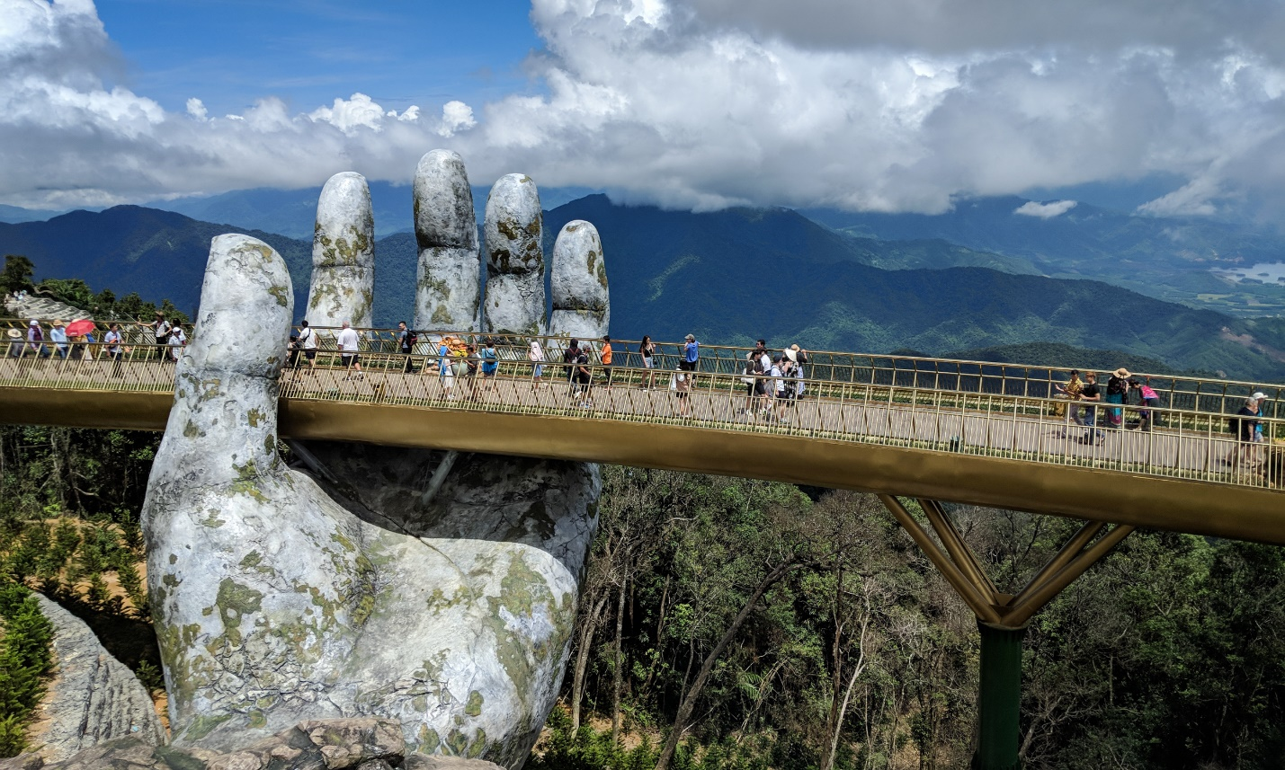

**I.Introduce:**

**DA NANG - LIFE CITY!**

Why do people call Danang the "most livable city" in Vietnam? What is the reason why people call Da Nang with a "pleasant" name? The following reasons will definitely surprise you and respect this city.

Top 10 cities worth the most tourism

According to Therichest, Da Nang is honored to rank 6th in the TOP 10 cities worldwide with countless special things that make this an attractive tourist destination of the World.

Own the most charming beach on the planet

Rated as one of the 6 most beautiful beaches on the planet and the most attractive beach, My Khe Beach of Danang has a total length of up to 900m running around the city, with light, mild and safe waves. for residents and visitors.

In particular, the heat pouring water at My Khe beach is warm all year round, the surrounding scenery is dreaming, beautiful and feels peaceful. This is the wonderful thing contributing to the list of "worth living cities" of Da Nang.

The only spinning bridge in Vietnam is present in Da Nang

Han River Bridge is the only spinning bridge of Vietnam. This bridge is uniquely designed with the span in the middle of the bridge can be converted to serve the movement of large boats.

The center of the bridge can rotate about 90 degrees. You can witness this bridge at 1pm every day. At this time, the bridge is rotated in the direction of the water flow, paving the way for ordinary road vehicles.

Sun Wheel - TOP 10 highest revolutions in the World

Da Nang always knows how to please tourists when building unique infrastructures and interesting tourist destinations. Recently, the focus of the wave among young people is the appearance of the 115m high Sun circle.

With this height, the Sun's rotation in Danang has reached the TOP 10 highest revolutions in the World.

Gather the most luxurious resort villas

Many investors have seen the development potential of Danang in recent years. That is the reason why Da Nang has continuously appeared the most luxurious resort villas in Vietnam.

With the five-star road of Danang - Vo Nguyen Giap Street running along the picturesque My Khe beach, captivating people, surely going through this road you will wish to have a villa to live in. here.

Where no one likes "chopping up" tourists

What makes people love the most in this land, certainly the people here. When arriving in Da Nang, the people of Quang will give you the first gift of smiles. Regardless of where you come from, what job they do, they are considerate and helpful when you want directions, hotel addresses, even some motorbike drivers will cyclo "tour design" for you. first time visitors to Da Nang.

**II.** **Tour schedule:**

**1.Day 1:**

**Ha Noi – Da Nang** _____________________________________________________________________

Evening: Car and HDV of Viet Center Tourist pick you up at the meeting place, departure to Noi Bai airport, flight to Da Nang. After about 1h20 you are at Da Nang airport, the car to welcome the delegation to the hotel.

You are free, Overnight hotel in Da Nang.

_____________________________________________________________________

**2.Day 2:**

**Ba Na Hill** _____________________________________________________________________

Have breakfast at Hotel.

Morning: You get on the car to Ba Na. Car takes you to the foot of Ba Na Mountain, you climb up the mountain by cable car. Stop at Terminal 2, HDV take you to visit L’Jardin Area with the relics of the French. Visit Linh Ung Pagoda.

Continue to Debay Station to take the 2nd cable car to Ba Na peak. You will conquer Mount Chua, visit Linh Linh Temple.

After that, visit the Fantasy Park - one of the large amusement park, you are free to play the game.

You have lunch buffet at the restaurant.

Visiting French Village to "live" in the atmosphere of the old Ba Na resort in the early twentieth century.

Afternoon: Take the cable car and get off at Suoi Mo station. Car to take you to the beach in My Khe Beach.

Evening: Have dinner at the restaurant. Overnight hotel in Danang.

_____________________________________________________________________

**3.Day 3:**

**Cu Lao Cham - Hoi An Ancient Town** _____________________________________________________________________

Have breakfast at Hotel.

Morning: Bus transfer to Hoi An, on the way to visit the beauty of Marble Mountains.

Bus transfer to Cua Dai wharf, take high speed train to Cu Lao Cham - World Biosphere Reserve. Visiting Hai Tibet pagoda over 400 years old, Au boat - a storm shelter for fishermen, residential areas & ancient shrines.

Noon: Lunch seafood at Cu Lao Cham.

Afternoon: Continue to visit the marine conservation area at Bac beach, Long island and participate in diving activities to explore corals, ornamental fishes, etc. Hoi An Ancient Town - World Cultural Heritage.

Evening: Have dinner at the restaurant, enjoy the specialties of Hoi An.

21h00: Bus transfer back to Danang. You roam freely, explore Da Nang at night. Overnight hotel in Danang.

_____________________________________________________________________

**4.Day 4:**

**Son Tra Peninsula - My Khe Beach** _____________________________________________________________________

Morning: Breakfast at the hotel. Car to take you to visit Son Tra Peninsula, stop at Linh Ung Pagoda - where the highest 65m Buddha Statue in Vietnam.

Noon: Lunch at the restaurant

Afternoon: Have a free bath in My Khe beach or stroll, shopping and exploring Danang.

Evening: Have dinner at the restaurant. Freedom to relax. Overnight in Da Nang.

_____________________________________________________________________

**5.Day 5:**

**Da Nang – Ha Noi** _____________________________________________________________________

Have breakfast at the hotel.

Morning: Free walking, visiting, tp. Da Nang until departure time to Danang airport, take a flight ... back to Hanoi.

Go to Noi Bai airport, the car takes you to the original pickup. Farewell to you. End program.

_____________________________________________________________________

**III.** **INCLUDED AND TERMS:**

**Tour price includes:**

New car travel, good air conditioning, shuttle to visit the program in the central region

Tourists have a new life, good air conditioning, shuttle center Hanoi - Noi Bai Airport

Standard 3-star hotel: Golden Sea / Vian / Nhu Minh / Golden Sea / Ocean Haven, ... (2 adults / room, if single Male or Female pair 3 adults / 1 room)

**Eating meals program**

- Breakfast buffet at the hotel.

- 04 main meals with a standard of VND 120,000 / meal / meal

- 01 buffet lunch at Ba Na

- 01 lunch at the Fishing Village (Cu Lao Cham)

One-time admission to attractions in the program.

High-speed boat to visit, explore Cu Lao Cham

Enthusiastic tour guide, thoughtful, shuttle to visit the program.

Travel insurance by day of tour, maximum compensation: 10,000,000 VND / case

Filtered water on car and cold towels on tour day

Pleasant Tour travel cap

**Price does not include:**

Cost of round-trip ticket Hanoi - Da Nang - Hanoi: Vietjet Air return ticket price is expected from 1,800,000 VND / ticket

Round trip cable car to visit Ba Na tourist area (VND 550,000 / ticket)

Tickets to Debay Wine Cellar, Climbing Train, Flower Garden, Wax Museum in Ba Na

Elevator to visit Marble Mountains

Drinks, personal expenses such as telephone, hotel laundry, ... other expenses outside the program and VAT

TIP for HDV and local drivers.

**Tour price for children:**

Children 11 years and older: 100% of the tour price for adults

Children from 5 - 10 years old: 50% of adult tour price (standard as an adult but sharing a bed with family)

Children under 5 years old: free of charge, families take care of their own food, sleep and car seats

Vietjet Air ticket price for children (based on date of birth): Children under 2 years old: free ticket