**Tour Hue - Thuan An Beach - Visit Ancient Land**

*Attention:*

-Departure: Ha Noi

-Time: 4 days 3 night

-Vehicle: planes

-Price: 2790000đ

-Image:

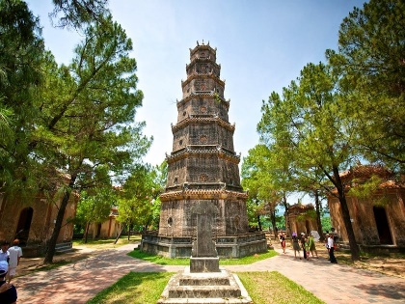 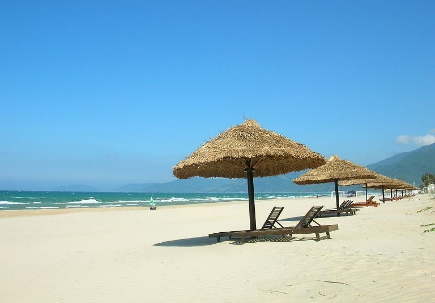 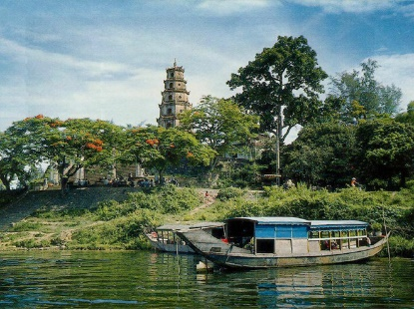

**I.Introduce:**

**HUE TOURISM - THUAN AN PROVINCE**

Hue Tourism is famous for its cultural relics, unique architectural works, and the Nguyen Dynasty's relics complex including palaces, temples, shrines, citadels, tombs, pagodas, The church ... still has the majestic, ancient and dignified features. From the thoughtful and undeserved beauty of the Nguyen kings to the purity at Thien Mu Pagoda or the vastness and immensity of Dai Noi Hue will bring visitors many unforgettable emotions.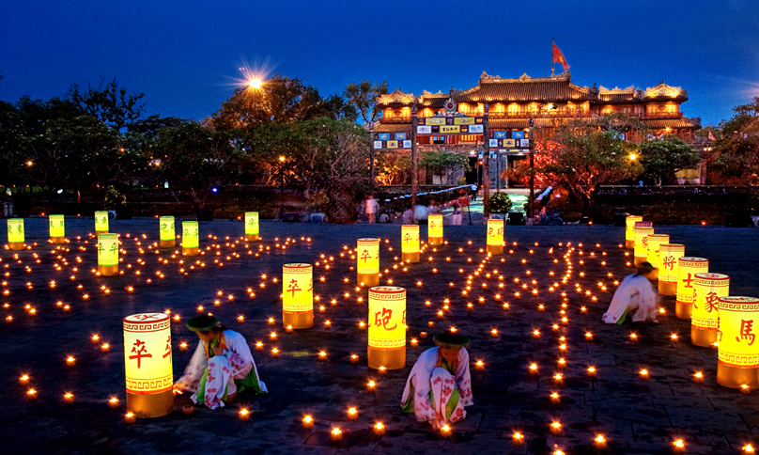Hue dishes, from popular to royal court, from vegetarian to salty, all show a harmonious combination of deliciousness and beauty, creating a unique eating style and special taste of Hue. Every visitor to Hue wants to enjoy the special flavors of this place from Hue beef noodle soup, mussel rice to attractive tea dishes: lotus tea, royal tea or sip lotus tea and sesame ... Craft products Traditional art with many genres and different materials are intricate works of art. Hats poem brings both competition and painting, both the ingenuity, the tenderness of Hue's daughter. The souvenir products carved with bones, embroidery, weaving ... all show the talents of Hue artisans.

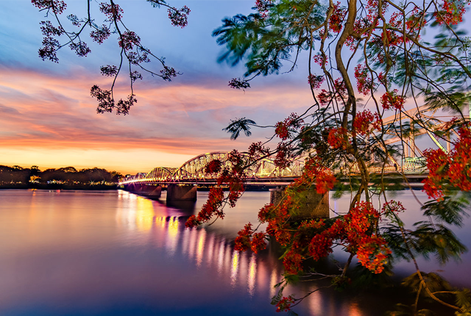Thua Thien Hue is also a place rich in revolutionary traditions, especially the relic system associated with the life of President Ho Chi Minh, the people whose names are associated with the flow of the fighting history. Patriotic and revolutionary paintings like Duy Tan, Phan Boi Chau, Phan Dang Luu, Nguyen Chi Dieu and Nguyen Chi Thanh ...

Nature, tradition with ingenious hands and creative intelligence of the ancient people have made Hue a beautiful Hue poetic, unique style and rich in identity, becoming an address that always attracts Interest on the world travel map. That is the potential, the advantages for Hue tourism growing.

**II.** **Tour schedule:**

**1.Day 1:**

HA NOI – HUE _____________________________________________________________________ In the morning: Tour and HDV of Viet Center Tourist pick up the delegation at the meeting place in Hanoi, departure to Noi Bai airport, procedures for flight to Hue.

Noon: Arrive at Phu Bai airport, bus transfer to the hotel, check in and rest. Group lunch restaurant.

Afternoon: Visit the Citadel and ancient Thien Mu Pagoda.

Evening: Dinner at restaurant with specialties of Hue. Sitting on the Dragon boat, listen to Hue folk songs and release lucky flowers on the Perfume River. Overnight hotel.

_____________________________________________________________________

**2.Day 2:**

HUE TANK- THUAN AN BEACH

_____________________________________________________________________

Morning: Breakfast buffet at the hotel. Bus tour to visit tombs in Hue:

8:00 am-9:00 Visit Minh Mang Tomb.

9h00 –9h45: Visit Khai Dinh Tomb.

11h00: Visit Tu Duc Mausoleum.

Noon: Lunch restaurant. Back to the hotel to rest

Afternoon: Bus transfer to Thuan An Beach. Group freedom by toothpick, or walking on the road to Vi Da village.

17h00: Bus transfer to the hotel, change clothes to rest.

18h00: Bus transfer to restaurant for dinner, Free to explore Hue at night.

_____________________________________________________________________

**3.Day 3:**

LANG CO BEACH _____________________________________________________________________

Morning: Have breakfast. Bus transfer to Lang Co.

10h00: Arrive in Lang Co, tour guide procedures for the delegation to use the beach of the Resort. Free swimming.

Noon: Lunch restaurant at Lang Co with rich seafood menu.

Afternoon: Bus transfer back to Hue, rest at the hotel.

Evening: Dinner at restaurant and hotel in Hue. You are free to enjoy the beauty of the ancient capital of the night with Trang Tien Bridge.

_____________________________________________________________________

**4.Day 4:**

HUE- HA NOI _____________________________________________________________________

Morning: Breakfast at the hotel, free group to buy local specialties Dong Ba market.

Noon: Lunch at the restaurant, check out hotel procedures.

Afternoon: Bus transfer to Phu Bai airport, procedures for flight to Hanoi. Arriving at Noi Bai, the bus takes the delegation back to the original meeting place, the program ends, cordially see you again.

_____________________________________________________________________

**III.** **INCLUDED AND TERMS:**

**Service includes :**

Newer passenger cars for groups according to the program.

Ca Hue Perfume River: Dragon Boat, Musician, Singer + Drop flowers for good luck.

3-star hotel: Standard center 2 adults / room (if single Male or Female pair 3 adults / 1 room)

Eating meals program

03 breakfast at the hotel

07 main meals standard 150,000 VND / meal / meal

One-time admission to attractions in the program.

Guided shuttle to visit the program.

Travel insurance by day of tour, maximum reimbursement: VND 20,000,000 / case

Cold towels and drinks on the car on the tour.

**The service does not include:**

Air tickets according to itinerary (VC tourist will make specific fare according to the itinerary at the time of registration to get the best price for the group).

Drinks at restaurant meals

Laundry, minibar, telephone, ... and other personal expenses out of the program

10% VAT

Tips for tour guides and drivers.

**Note :**

Children under 5 years old, eat, sleep in the same bed with parents: Free, however 2 adults can accompany only 1 child, from the 2nd child charged 50% of the tour

Children 5-9 years old, sharing bed with parents: 50% of tour price

Children 10 and older: Calculated as adults.

**Note :**

Trip schedule may be changed to suit the actual conditions and circumstances but still ensures the full range of attractions in the program

Prices may vary depending on the time of booking, due to the increase in room rates, meals, ticket prices of restaurants and hotels. Please contact us for the most accurate price.