**TOUR BA BE- BAN GIOC- PAC BO- NGUOM NGAO**

*Attention:*

-Departure point: Hanoi.

-Time: 3 days 2 nights.

-Media: car.

-Price: 2250000đ.

-Image:

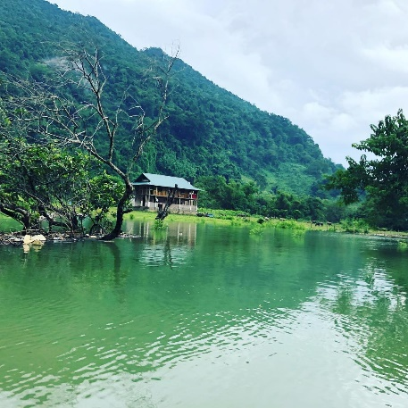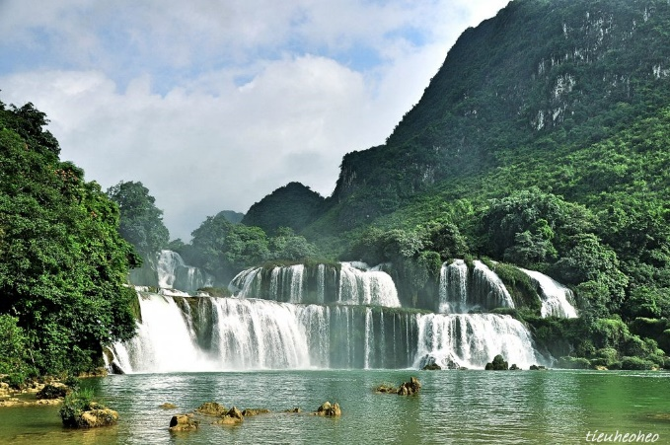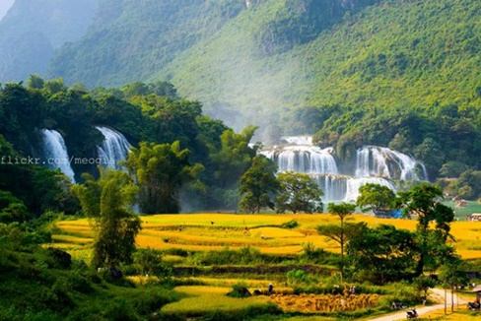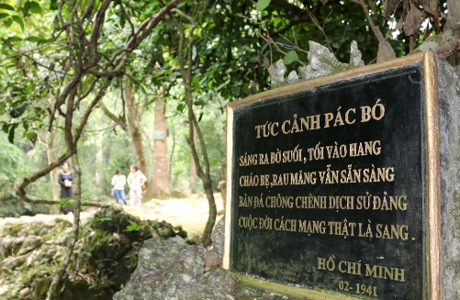

**I.Introduce:**

Tour of Ba Be Lake - Ban Gioc Waterfall - Pac Bo Cave - Nguom Ngao Cave 3 Days 2 Nights will take you to admire the beautiful natural beauty, majestic mountain scenery and many famous historical sites: Pac Bo relic with Suoi Le Nin, Cac Mar mount, Ban Gioc waterfall ... and diverse cultural activities, imbued with the identities of nine ethnic groups (Tay, Nung, Dao, Mong, Kinh, Hoa) , San Chi ...) has made Cao Bang an attractive tourist destination, a tourist destination.

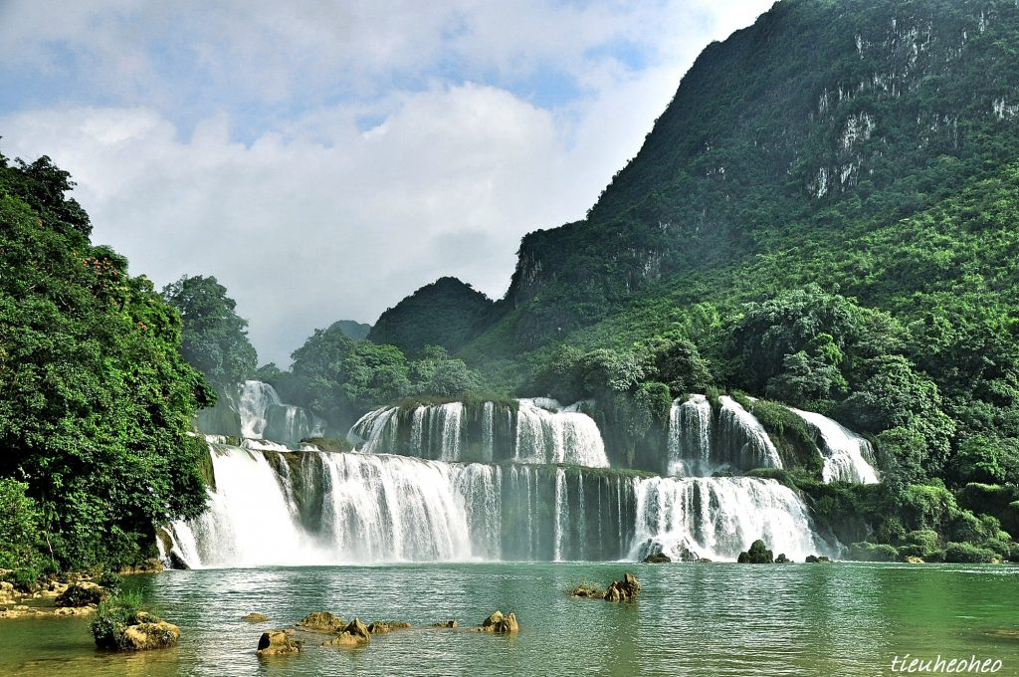

Pac Bo Historic Area is classified as a special national monument by the Prime Minister. The relics include: Uncle Ho memorial house, Coc Po cave (the local name means "upstream"), Lung Lan cave, Nguom Vai cave (both on Cac mountain), Lenin stream, stone table where Uncle Ho works, the floor of Mr. Ly Quoc Gun, the floor of Mr. La Thanh,etc.

.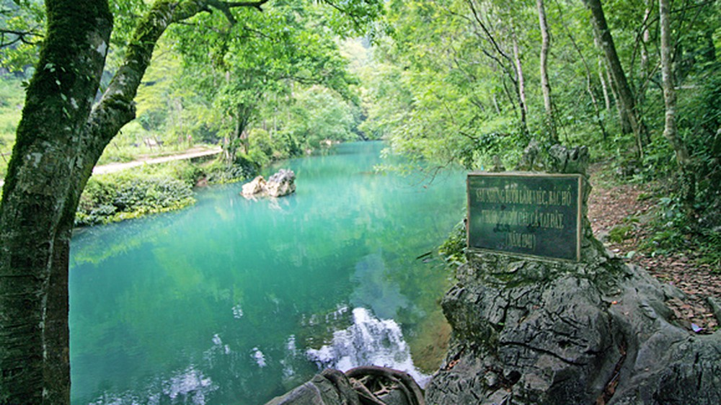

**II.** **Tour schedule:**

**1.Day 1:**

HA NOI – BA BE LAKE

_____________________________________________________________________

06h00: Car and guide company pick you up at Hanoi Opera House depart towards Thai Nguyen - Bac Kan. 08h00: The bus stops to rest along the road for you to rest and free breakfast then continue on the road 11h00: Arrive in Ba Be, Check in at Ba Be Ecolodge then lunch at the restaurant in Ba Be Ecolodge ecotourism area. 13h00: Car and guide take you to the marina to get on a boat trip on Ba Be Lake, you admire the beautiful lake blending between the cloudy sky and visit the following points: - Fairy Pond, Fairy Pond is larger than 3,000m2, surrounded by limestone mountains and primeval forests, clear, cool pond water. Visiting Ao Tien, visitors can also see the footprints on the rock and hear the legendary story about the hunter and the seven fairies. - An Ma Temple, Legend, during the feudal war in the Le - Mac dynasty, the Mac generals lost the battle, ran to Puong Cave and thrived there. Appreciating the spirit of loyalty, the people set up the Mac's temple, but they were removed by the Lê army so they changed their name to An Ma Temple. The two words "An Ma" in the Tay language mean "beautiful tomb," the resting place of the Mac gods. - Widow Island - a lovely small island located right in the center of the lake, associated with the formation of the lake. The boat stops at Ba Widow Island so you can wear a life jacket and immerse yourself in the cool and blue water of the lake (about 30 minutes for swimming). 16h00: Boat return to the wharf, car to welcome you back to Ba Be Ecolodge bathing and resting. 18h30: Have dinner outside and enjoy rocket pig specialties turned directly on charcoal and participate in cultural exchanges, campfire, listening to the Tay singing performance of the Tay people.   
_____________________________________________________________________

**2.Day 2:**

BA BE lake– BaN GIoC waterfall– NGuoM NGAO cave

_____________________________________________________________________

06h00: Have up for breakfast, then the car and HDV take you to depart for Cao Bang 11h30: Arrive Cao Bang, have lunch with famous specialties as high as Green Palm Leaf Restaurant. 13h00: Depart for sightseeing and taking pictures at Ban Gioc Waterfall - Dubbed as the most beautiful waterfall in Vietnam. 15h30: Depart to Cao Bang. On the way back, you will visit Nguom Ngao Cave - the largest cave in the North and also one of the biggest caves in Vietnam; and visit the famous Phuc Sen Forging Village. 18h30: Arrive in Cao Bang, Have dinner by the river at the restaurant of the fish nest hotpot - Fork of the river.After dinner, you check in hotel to rest and take a bath. You are free to explore Cao Bang town at night. Overnight in Cao Bang.

_____________________________________________________________________

**3.Day 3:**

CAO BANG – PAC BO - HA NOI

_____________________________________________________________________

06h00: Have breakfast, check out then go to Pac Bo Relic Site. 07h30: Arrive at Pac Bo Historic Site, you will visit President Ho Chi Minh's residence and activities during the years of resistance from 1941 to 1945, the delegation took a photo at Suoi Le Nin - Nac Mac Mountain, Visit Coc Bo cave. On the way back, the delegation paid a visit to the tomb of heroic martyrs Nong Van Den (the tomb of Mr. Kim Dong). Then continue to the car to Lang Son. 11h30: Lunch at the Restaurant. After lunch, you rest on the spot 13h30: Depart for Hanoi. 18h30: Arrive in Hanoi. End tour. HDV goodbye and see you again!  
_____________________________________________________________________

**III. INCLUDED AND TERMS:**

**TOUR PRICE INCLUDES:** • Newer touring cars with shuttle program, enthusiastic driving fun • Professional, enthusiastic, thoughtful guide service throughout the tour • Meals in the program, 5 meals standard 120k / person / meal + 2 breakfasts • Hotel: Night 1: Stay at Ba Be Ecolodge, 03 - 04 guests / room. • Night 2: Standard hotel 2 stars in Cao Bang, 03 - 04 guests / room • Tickets to all points in the program. • Tickets to visit Ba Be National Park Boats to visit Ba Be Lake • Drinking water served on cars, 01 500ml bottle / person / day. • Travel insurance for the whole tour: VND 20,000,000 / person / case. • Drinking water on the vehicle **TOUR PRICE DO NOT INCLUDE:** • 10% VAT. • Drinks at meals and in the hotel • Other sightseeing expenses and other personal expenses. **PRICE FOR CHILDREN:** • Children aged 1-4 free (parents take care of all related expenses) • Children 5 years old 50% of tour price (Separate meals, sleeping with parents) • Children aged 6-9 years old will be charged 75% of the tour price (with own meal, with separate sleeping rate)

• Children 10 years of age and older as adults.