**[Tour Mai Châu - Moc Chau](javascript:void(0))**

*Attention:*

-Departure point: Hanoi.

-Time: 2 days 1 night.

-Media: car.

-Price: Contact.

-Image:

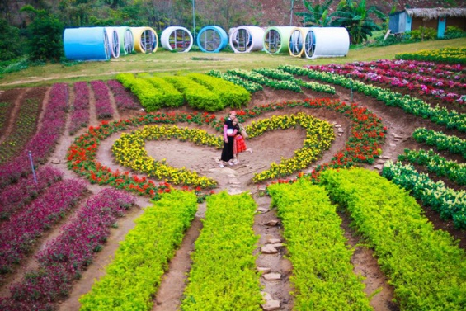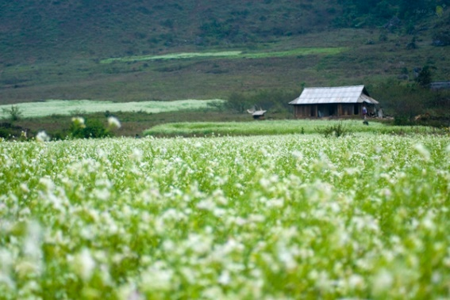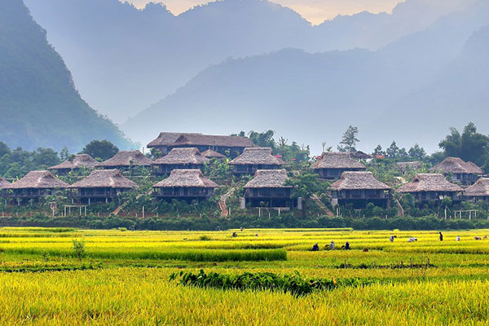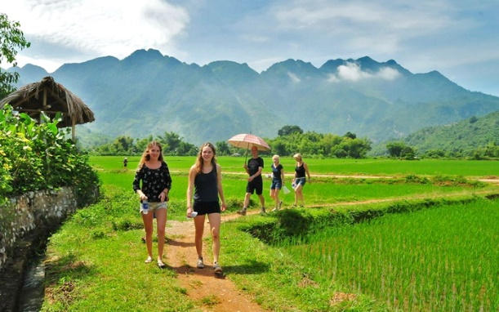

**I.Introduce:**

## **TOUR MAI CHAU – MOC CHAU**

Located in the Northwest of Hoa Binh province, surrounded by mountains, Mai Chau is a convergence and exchange of land of many ethnic groups. In addition to captivating scenery, Mai Chau cuisine has a strong flavor of mountains and forests that has left a lot of impressions in the hearts of visitors. Indispensable in Mai Chau culture are the traditional dances, spreading, lyrics and lyrics.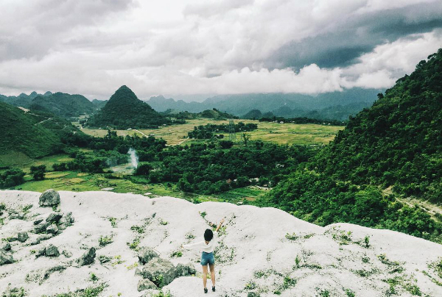

**Mai Chau Tourism will bring visitors relaxing moments, natural that can not be found anywhere else. Once here, visitors will remember this peaceful land forever.**

**Moc Chau is the most concentrated tourism resource of Son La and the Northwest mountainous region - Northern region. Climate is a special tourist resource with the specific characteristics of Moc Chau. In the middle of Moc Chau plateau is a sub-climate area with cool summers with an average temperature of 20 degrees C and winters drier than other regions.**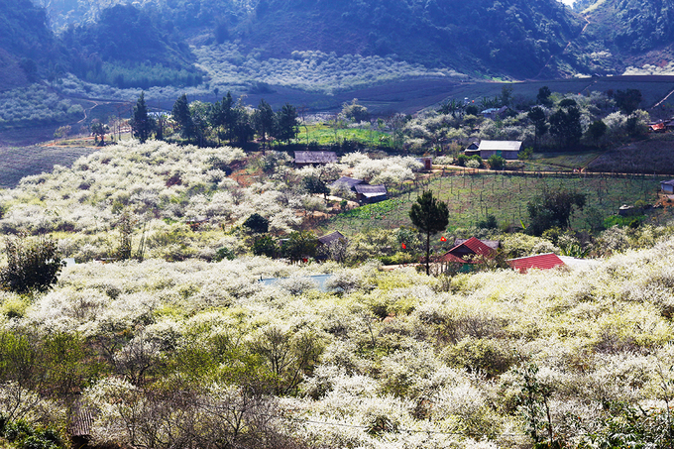

Visitors have the opportunity to come to Moc Chau once whether summer or winter, sunny days spread on the forest of spring dream or winter fog white mountains ... all have a beautiful impression of this plateau through the ruins. history such as Son Moc Huong cave, pine forest, Chuan Vien pagoda, strip Yem waterfall, Phieng Luong peak, and cultural writings of the Mong and Dao people in Van Ho with folk songs of alpine dance and specialty dishes ethnic and handicraft products bearing a long cultural identity.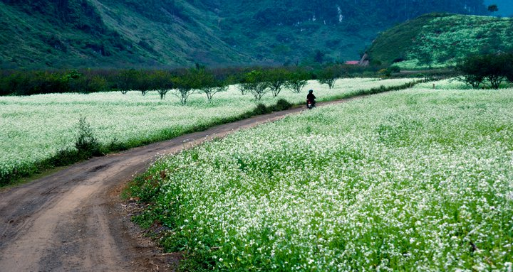

**II.** **Tour schedule:**

**1.Day 1:**

HA NoI – MAI CHaU _____________________________________________________________________ **07h30 - 08h00: Car and guide are picked up at the meeting point of departure to Ban Lac (Mai Chau, Hoa Binh) - 130km from Hanoi. 10h30: Stop sightseeing and take photos at Thung Khe Pass, panoramic view of Mai Chau valley from above. 11h30: Arrive in Lac Village, take a rest and have lunch. Get to rest on stilts. 13h30: Tour guide take you to visit the beautiful Mai Chau Valley, explore and understand the daily life of ethnic minorities here with: Lac 1, Lac 2, Pom Coong villages - here It is the home of Thai people with 5 families of Ha, Lo, Vi, Mac and Loc. Free shopping brocade, souvenirs. 18h30: Dinner at the restaurant, enjoy the Northwest specialties. After dinner you can focus on the program of cultural exchanges and campfires to drink alcohol (expenses outside the program).**

_____________________________________________________________________

**2.Day 2:**

MAI CHAU – MOC CHAU – HA NOI _____________________________________________________________________

**05h30: Get up early to see the sunrise, depart for Moc Chau. 09h00: Go to Moc Chau, visit Doan Yen waterfall - one of the most beautiful waterfalls in the Northwest. 10h00: You visit Nong Truong Tea, see the process of processing and producing tea, manually picking baskets of young tea buds, enjoy the fragrance of fresh tea buds. 11h30: Have lunch with a special veal dish of Moc Chau. 13h00: Get on the bus to Hanoi. On the way stop at Ba Vi milk to rest and buy things as gifts. 18h30: Arrive in Hanoi, HDV bid farewell to the delegation. End program. See you again!** _____________________________________________________________________

**III.** **INCLUDED AND TERMS:**

**Service includes:** • New cars of 16 to 29 seats are shuttleed according to the program.• 03 main meals according to the program, breakfast at stilt house.• Sleeping in a homestay on a shared stilts clean and comfortable• Tickets to the points in the program• Guides are enthusiastic, fluent and thoughtful throughout the tour• Travel insurance for the whole tour, the maximum compensation is VND 20,000,000 / person / case• Drinking water in the car, 01 bottle of 500ml daily **Services not included:** • VAT invoice of 10%.• Cost of campfire, cultural exchange if required• Drinks for meals, accommodations and other personal expenses.• Other sightseeing expenses and other personal expenses.• Tips for directions and driving. **The exact tour price depends on the time of departure, the number of guests and the standard of service. Please contact us soon to get the BEST OFFER price**