**[Tour Ha Long - Cat Ba 3 Days 2](javascript:void(0)) Nights**

*Attention:*

-Departure point: Hanoi.

-Time: 3 days 2 nights.

-Media: car

-Price: 2790000đ.

-Image:

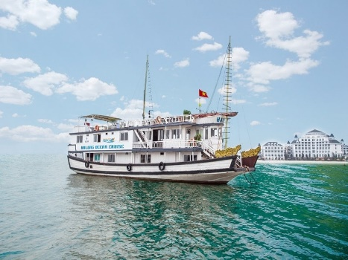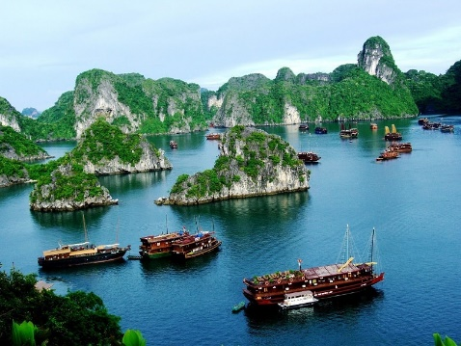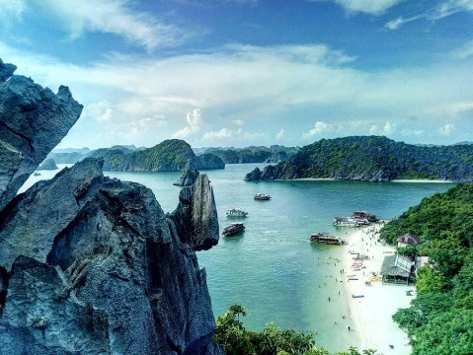

**I.Introduce:**

**HA LONG TOURISM - CAT BA**

Traveling Ha Long Bay - Cat Ba is a famous sights of Quang Ninh province with natural scenery captivating people. One is Ha Long Bay - a world natural heritage and a famous natural wonder at home and abroad. One is the Cat Ba Island - a famous landscape complex with the title of world biosphere reserve with long white sand beaches mixed with majestic beauty of the mountains .... So please join **Pleasant Tour** to explore the endless beauty of these two world-famous tourist sites with a 3-day-2-night Ha Long-Cat Ba tour.



**II.** **Tour schedule:**

**1.Day 1:**

**HA NOI – HA LONG – CAT BA** _____________________________________________________________________

07h45 - 08h30: Car and HDV welcome you to depart for Ha Long. 2h30: Go to Ha Long tourist ship port, you board the ship to visit Ha Long Bay. 13h00: Enjoy lunch on board, admire Ha Long Bay - World Natural Heritage. 14h30: Visit Thien Cung Cave - one of the most magnificent, fanciful and beautiful caves of Ha Long Bay. 15h00: Admire the Stone Dog, Dinh Huong Islet, Ga Choi Islet, Yen Ngua Islet 16h30: Ship arrives at Gia Luan port, Cat Ba archipelago. Bus pick you up in Cat Ba town, check in and rest, swim Cat Co,… 19h00: Have a free time enjoying bar, cafe, karaoke,... _____________________________________________________________________

**2.Day 2:**

**CAT BA – LAN HA – DAO KHI** _____________________________________________________________________

Morning: You get up early to catch the dawn and have breakfast at the hotel, free to roam to visit the Fortress Cong, or explore Cat Ba National Park (costs not included). 11h30: Return to the restaurant / hotel for lunch and rest 14h00: Bus pick you up to Beo station to board the boat to visit and swim at Monkey Island 17h00: Boat dock, you get back to the hotel to rest and have dinner. In the evening: After dinner, you are free to roam bar, cafe, karaoke, .. _____________________________________________________________________

**3.Day 3:**

**CAT BA – HA LONG – HA NOI** _____________________________________________________________________

Morning: You can get up early to swim, watch the dawn welcome the new day, have breakfast at the hotel. 08h00: Goodbye Cat Ba, car to welcome you back to Gia Luan pier. 09h00: Get on board to join the games organized by guides or free to relax while the train returns to Ha Long harbor. 11h00: Have a small boat to move to the wharf and lunch at the restaurant. 12h30: Pick up and return to Hanoi, rest on the road for 20 minutes. 16h30 - 17h00: Go to Old Quarter area, say goodbye to customer, end the program. _____________________________________________________________________

**III.** **INCLUDED AND TERMS:**

**TOUR PACKAGE PRICE FOR 01 GUEST:** • Option 1: 2 Night Sleeping Hotel 2 *: VND 2,790,000• Option 2: 2 Night Sleeping Hotel 3 *: VND 3,050,000• Option 3: 2 Night Sleeping Resort 3 *: 3,650,000 VND **Tour includes:** • Newer passenger cars to visit on tour• Tickets to the attractions of the program• Boat ticket to visit Lan Ha Bay and Monkey Island beach• Eat 5 meals, 02 breakfast menus according to the program• Bedroom of hotel / resort Cat Ba (02 pax / room)• English and Vietnamese speaking guide• Gifts: Drinking water, cold towels, basic medical supplies,...Not included:• Tax• Tips for tour guides, drivers, and service staff• Cost to visit Cat Ba National Park, Fortress of the Gong• Food, drink, single room, expenses incurred outside the program **Please note:** 1. Children 1 - 4 years free (parents take care of their own meals)2. From 5-6 years old 50% of tour price (half rate, eat with parents)3. From 7-8 years old 75% of tour price (eat separately, sleep with parents)4. From 9 years old and above 100% of tour price as adults5. You take care of personal belongings or personal safe deposit box