**Tour Hanoi - Discover the capital of a thousand years of civilization**

*Attention:*

-Departure point: Hanoi.

-Time: 1 day and night.

-Media: car.

-Price: 620000đ.

-Image:

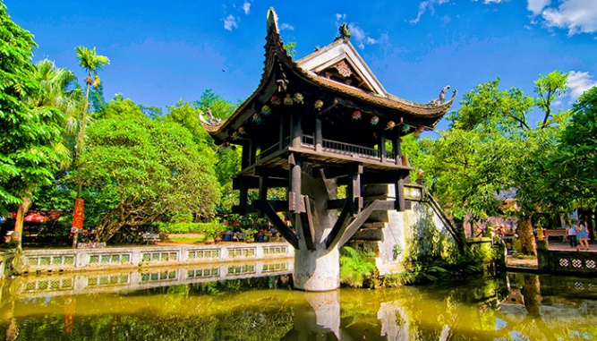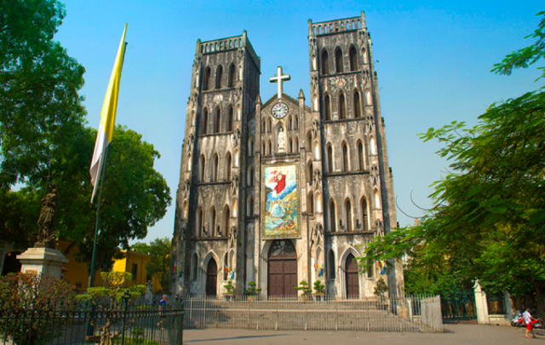

**I.Introduce:**

**TOUR HA NOI**

Hanoi City is the Capital of a thousand years of civilization with ancient relics and peaceful life. If you've ever visited Hanoi, surely you can not forget the typical atmosphere here, with Ho Guom, West Lake, taciturn cafes, small streets and heaps of street vendors.

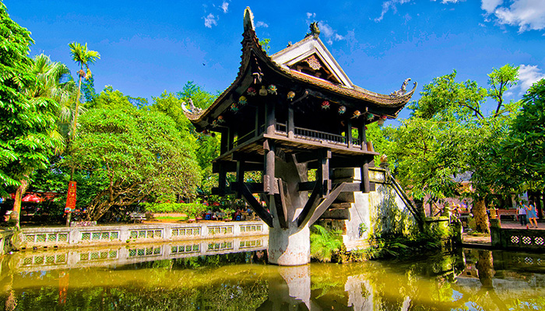

Hanoi owns a large-scale museum system. Some other prominent relics of Hanoi are Van Mieu Quoc Tu Giam (the first university in Vietnam), One Pillar Pagoda (symbolizing the cradle of Buddhism and Taoism), Ngoc Son Temple, Quang Ba Dinh school (where Uncle Ho read the declaration of independence), Hanoi Cathedral, Opera House, etc.



In addition, the civilization of Hanoi people fascinate many tourists around the world. Because Hanoi is famous for fine handicraft products in craft villages such as Bat Trang ceramics, Ngu Xa bronze casting and Yen Thai village; at the same time with delicious food and lots of different cultural festivals throughout the year.

**II.** **Tour schedule:**

**1.Day 1:**

**DISCOVER HANOI** _____________________________________________________________________

07h30 - 08h30: Car and tour guide pick you up at the meeting place, depart to visit Tran Quoc Pagoda - one of the most ancient and sacred temples in Hanoi. 09h30: Visit the vestiges of President Ho Chi Minh - the final resting place of the beloved leader of the Vietnamese nation. 10h30: Next visit One Pillar Pagoda - an ancient temple with a unique architecture with the appearance of a lotus rising in the middle of the lake. 11h00: Have a car to visit the Museum of Ethnology, where to store and display cultural artifacts of 54 ethnic groups in Vietnam. 12h30: Take a rest, have lunch at a restaurant in Old Quarter area. 14h00: Visit Van Mieu Quoc Tu Giam - the first university of Vietnam. 15h00: Take a photo tour of Hoan Kiem Lake - Ngoc Son Temple 15h30 - 16h00: Back to the hotel, farewell to end the program. _____________________________________________________________________

**III.** **INCLUDED AND TERMS: Service includes:** Tour bus 07 - 29 seats, shuttle program English and Vietnamese speaking guide Tickets to the sights according to the program Lunch at the restaurant's standard seasonal menu Gifts: Drinking water, cold towels, anti-drunk drugs,... **The service does not include:** VAT, self-service drinks, Tickets for water puppet performance, cyclo, and tram Tips for guides, drivers, waiters, etc. **Please note:** Baby from 1-4 years old free (parents are self-sufficient) Children from 5-6 years old will be charged 50% of tour price (half rate) From 7-8 years old 75% of tour price (eat as an adult) From 9 years old upwards 100% of the tour price as adults **Monday, Friday mausoleum, Uncle. Ethnic Minorities replaced by Hoa Lo or Bat Trang.**