**Tour Yen Bai - Mu Cang Chai - Tu Le - Discover Northwest**

*Attention:*

-Departure point: Hanoi.

-Time: 3 days 2 nights.

-Media: car

-Price: 2400000đ to 2100000đ.

-Image:

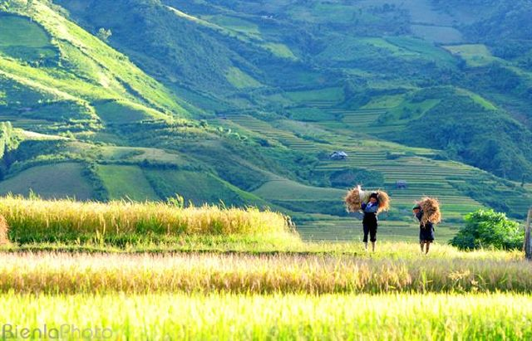 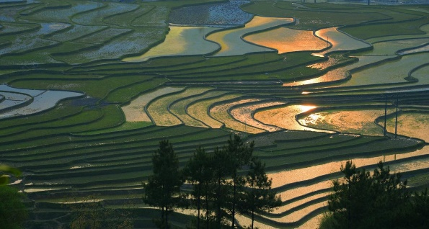 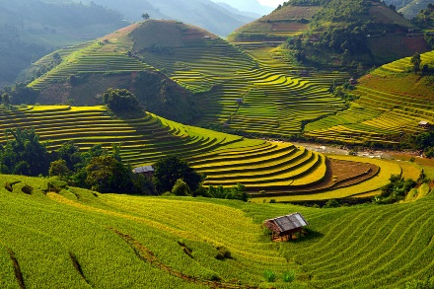 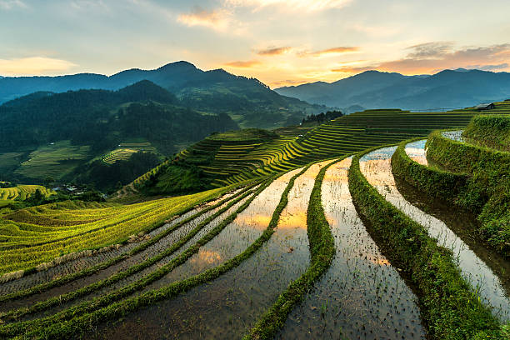 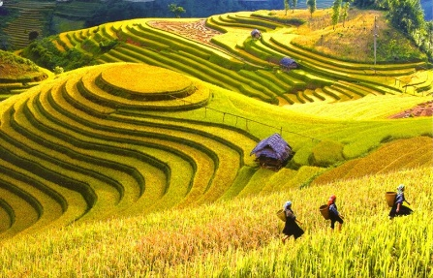

**I.Introduce:**

**Tour Yen Bai - Mu Cang Chai - Tu Le - Discover Northwest**

**Mu Cang Chai**

In recent years, Mu Cang Chai tourism has become a destination for many tourists, researchers, photographers. Coming to Mu Cang Chai, even once, visitors can feel the wealth of nature, the speciality of culture, the warmth of human love.

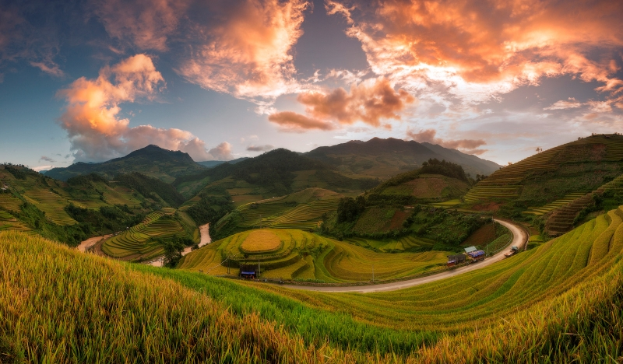

The culture of terraced farming of the Mong people in La Pan Tan, Che Cu Nha, and De Su Phinh has changed the name of Mu Cang Chai (or dry tree village) into a verdant hill of green crops. Each step rises to the sky. This makes the Cang Cang Tour interesting to visitors here to admire the terraces as giant ladders connecting land and sky.

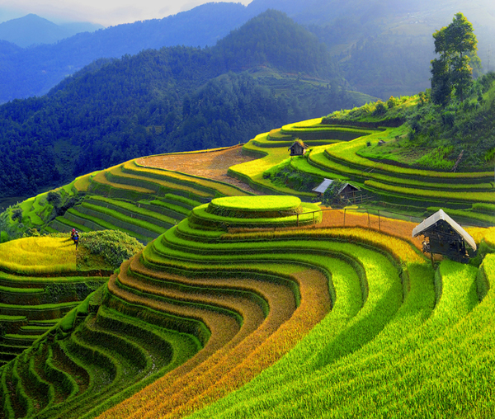

**Tu Le**

A valley in Van Chan district, Yen Bai province, Tu Le is one of the favorite destinations of many tourists who love the natural beauty. Tu Le in the middle of autumn, the rice is ripe and yellow like a mountain wave. The harvest season was bustling with excitement, the smell of new rice followed the wind. Tu Le can be compared to a very beautiful mountain girl

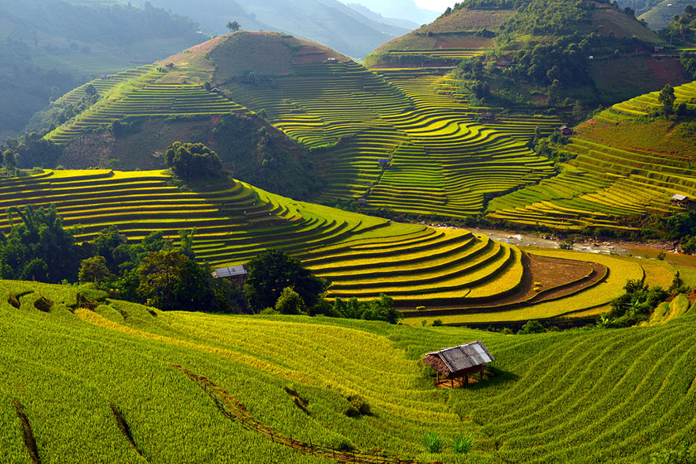

Here at night, especially on the full moon days, the bright moonlight, silhouettes of travelers traveling down the road along the town. Somewhere in the distance was the murmur of bamboo, the sound of the wind blowing softly, coolly, the light of the street cast enough to see silhouettes of people passing by. Scattered through the small road leading to the field, standing on a suspension bridge watching the moonlight reflect down on the sparkling stream, a poetic and romantic scene that is hard to see in urban places. Not only impressed by tourists for its natural beauty, Tu Le attracts people to hunt for photos by the traditional, pristine routine of "bathing fairy" by the Thai stream. In Tu Le, there is a hot spring more than 1 km from the center of town. Warm groundwater flows into streams, which is stopped by the people, cracking to relax after a hard working day.

**II.** **Tour schedule:**

**1.Day 1:**

HA NOI – TU LE – MUA CANG CHAI _____________________________________________________________________

**Morning: Pick up at the city rendezvous. Depart for Yen Bai. Follow Highway 32 in the direction of Son Tay to Nghia Lo. Noon: Have a lunch break in Nghia Lo town. After lunch, continue the journey to Mu Cang Chai. Afternoon: On the way to Mu Cang Chai, stop to visit Tu Le. 16h30: Union to Mu Cang Chai, check in hotel, free at rest Evening: Dinner at restaurant, enjoy Northwest specialties, free to visit the town of Mu Cang Chai at night. Overnight at hotel.** _____________________________________________________________________

**2.Ngày 2:**

MU CANG CHAI – NGHIA LO _____________________________________________________________________

**Morning: Breakfast at the hotel. After breakfast, the car will take the delegation to visit the points: Che Cu Nha terraced fields, Che Xu Phong terraced fields, La Pan Tan - national tourist attraction. Pine Hill is a romantic love between couples. Noon: Lunch at Mu Cang Chai. Afternoon: Back to Nghia Lo Town. 16h00: Arrive Nghia Lo, check in and free to rest. Evening: Have dinner at the restaurant, free to visit and explore Nghia Lo town at night. Overnight at hotel.** _____________________________________________________________________ **3.Ngày 3:** NGHIA LO- SUOI VANG- HA NOI ____________________________________________________________________

**Morning: Breakfast at the hotel. Check procedures. Departure back on the way visit Suoi Giang Ecological Park. Noon: Lunch at the restaurant. Get on the bus and continue to Hanoi. Afternoon: Go to the original meeting place. End program. Farewell to you.** _____________________________________________________________________

**III.** **INCLUDED AND TERMS:**

**Service includes:** • Newer tourist cars, air-conditioned shuttle scheduled• Standard hotel in Mu Cang Chai and 2 stars in Nghia Lo (02 pax / room, if single men or women graft 3 guests).• Eat meals according to the program: 05 meals + 02 breakfast• Sightseeing: Tickets to the attractions in the program.• Bathing tickets for the Hoc hamlet• Tour guide: Enthusiastic, energetic, serving the union during the tour.• Travel insurance: According to the date of the tour, the maximum level of compensation is VND 20,000,000 / case.• Gifts: a travel cap, cold towels, and mineral water.The service does not include:• VAT, laundry, drinks• Single room and personal expenses not mentioned in the program.