**Bai Dong Tour- Explore the wild sea**

Attention:

-Departure point: Hanoi.

-Time: 2 days 1 night.

-Media: car

-Price: ~~1900000đ~~ to 1200000đ.

-Image:

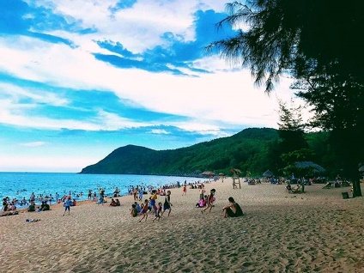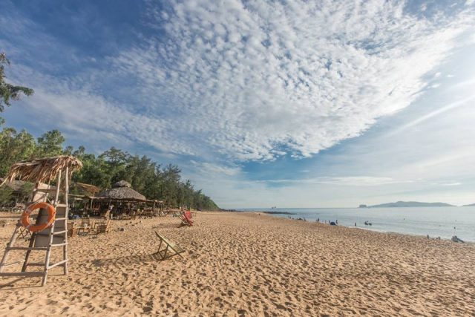

**I.Introduce:**

**Bai Dong Tour- Explore the wild sea**

This summer, if you are too bored with Sam Son "fall", there is Bai Dong - a wonderful new beautiful beach waiting for you to "cool off" the summer.

Bai Dong is a beach on Nghi Son peninsula, Tinh Gia district, Thanh Hoa. Referring to Thanh Hoa, people often only think of Sam Son, Hai Hoa, Hai Tien, ... so Bai Dong is still a new and wild destination that this summer, if you want to find a private beach "of your own yourself ", Bai Dong is a perfect choice for you.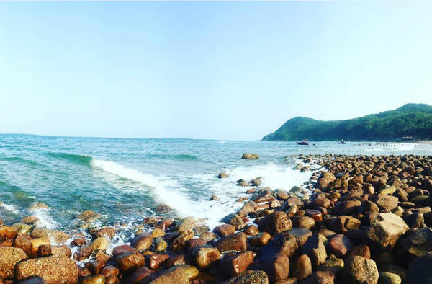

Not crowded, not hustle and bustle like other famous beaches, peaceful and gentle Bai Dong landscape makes anyone here also really relax and rest. The beach here is still quite wild so still naturally beautiful, blue sea and white sand will "attract" any visitor to the East Beach.

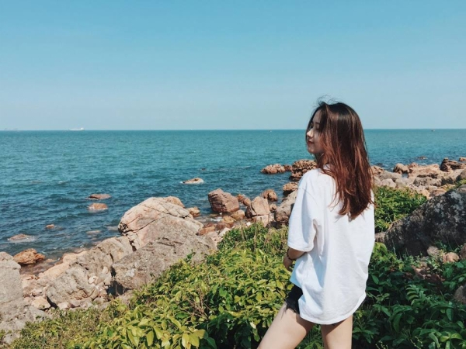

Come here, feel free to take a dip in the cool water, have fun with your close friends in the waves without feeling embarrassed. Or simply lying by the beach, reading, listening to music and mixing with the open sea air, all tiredness and sadness seem to disappear.



Although Bai Dong is still pristine, new on the map of Vietnamese tourism, the followers moved very quickly to come here to be able to enjoy the most relaxing and wonderful moments on this deserted beach. So if you do not hurry to Bai Dong right now, you will have to regret a lot.

**II.** **Tour schedule:**

**1.Day 1:**

HA NOI – BAI ĐONG THANH HOA

_____________________________________________________________________

06h00: Pleasant Tour car and guide pick you up at the meeting point of departure to Bai Dong - the beach of Nghi Son peninsula, Tinh Gia district, Thanh Hoa. Bai Dong is still

is a new, wild destination of this summer. On the way, stop to rest, have breakfast at Phu Ly (Self-sufficient expenses).

11h30: Arrive in Nghi Son, Thanh Hoa, have lunch at the restaurant, then check in hotel and rest.

Afternoon: Free time walking, swimming. Not crowded, not hustle and bustle like other famous beaches, peaceful and gentle Bai Dong landscape makes anyone here also really relax and rest. The beach here is still quite pristine so still naturally beautiful, blue sea and white sand will "Attract" any visitor.

18h30: Have dinner at the restaurant, free to explore Bai Dong at night.

Overnight at hotel.

_____________________________________________________________________

**2.Day 2:**

BAI ĐÔNG – HA NOI

_____________________________________________________________________

Morning: You get up early to watch the sunset at sea. Breakfast at the hotel.

11h30: Union procedures for hotel rooms, lunch at the restaurant.

13h00: Get on the bus back to Hanoi. On the way, stop to rest, shopping for specialty Thanh Hoa, Ninh Binh (spring rolls, coconut, pineapple ...).

18h00: Bus transfer to the original meeting place. End of program. Goodbye and see you again in the following programs.

_____________________________________________________________________

**III.** **INCLUDED AND TERMS:**

Service includes:

- Newer passenger cars for group tour. Safe and responsible driving.

- Standard hotel: 2 guests / room. Fully equipped rooms.

- Food ration according to program standards:

• 01 breakfast at the hotel

• 03 standard meals at 150,000 VND / meal / meal.

• Vietnamese tour guide shuttle to visit the program.

• Travel insurance by day of tour, maximum reimbursement: VND 20,000,000 / case.

• Cold towels and drinks on the car on the tour.

• Viet Center Tourism Hats.

The service does not include:

• Drinks at restaurant meals.

• Laundry, minibar, telephone, ... and other personal expenses out of the program.

• 10% VAT.

• Tips for tour guides and drivers.

Note:

• Children under 5 years old, eat, sleep in the same bed with parents: Free, however 2 adults can accompany only 1 child, from the 2nd child charged 50% of the tour.

• Children from 5-9 years old, sharing bed with parents: 50% of tour price

• Children 10 years and older: Calculated as adults.